Reg: 2021-04-02100

**Introduction to computer networks (IS171)**

**Lab 4. Cisco Packet Tracer**

**Introduction:**

Packet Tracer is a proprietary tool of Cisco. It is used to create & simulate network virtually. It

gives same environment virtually as it exists physically. So what you do need to do and work same

on all virtually provided devices as you are working with them physically. This is the beauty of this

tool. This tool is widely used in CCNA training.

This tool gives all type of network devices require to create one real time working network and

also provide same interface as if you are working on real device.

Packet Tracer has two different views

* • Logical Workspace  
* • Physical Workspace  

Packet Tracer also has two modes of operation

* • Real-time Mode  
* • Simulation Mode  

At startup, you are in the Logical Workspace in Real-time Mode, and you can build your

network and see it run in real time in this configuration, also you can switch to Simulation Mode to

run controlled networking scenarios.

Several types of devices and network connections can be used. For this experiment we will

keep it simple by using End Devices, Switches, Hubs, and Connections.

**Objective:**

•

Was to learn how to configure a different networks in Cisco packet tracer.  

**Equipment used:**

Cisco Packet Tracer Program

**Experiment procedure:**

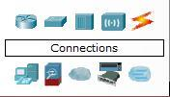

* Using above tools in the program to put devices, routers, switches, hubs, cables, …etc.  
* First, built a simple network topology with just two PCs by Selecting “End Devices” and then click at “Generic” and click on the main area. Then repeated it to the second device.

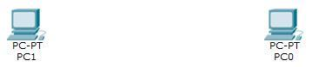

* Select “Connections” from Power Cycle Devices and click on “Copper Cross-Over”, - two end devices needs a cross-over connection in-between - , then draw connections from the first NIC (Ethrnet0)of PC0 to the second NIC (Ethrnet0) PC1.

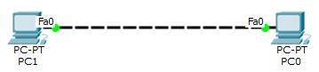

* Double click on a PC, a box will appear. Click on the “Desktop” tab, then select “IP configuration” , Write the IP address of your network and click at the Subnet mask filed. Subnet Mask will appear automatically. Repeat it to set the IPs for all the PCs.  
* By using "Place Note" Tool, write the IP address for each device under it.

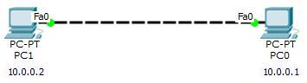

* Initialized packet simulation by these steps:  
  + Select “Add simple PDU”.

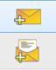

* + Drag and Drop the message to the source device and then to the Destination device. In this case my source device is PC0 and destination device is PC1.
  + Select the Simulation Mode at the bottom right corner.
  + Click at “Auto Capture / Play”.
  + Observe the path of the Message from source to destination, and back from the
  + destination to the source.6. Finally observe the marks. If the source PC is marked correct it means you
  + have successfully established the connection.

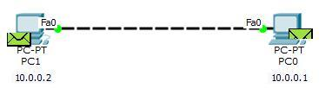

**Conclusion:**

From all simulations different IP addresses were used in configurations. In the first simulation (Connection between two computers) PC1 had 192.168.43.1 and 255.255.0.0 as subnet mask and PC2 had 192.168.43.2 and 255.255.0.0. After adding Simple PDU message, the message went from PC1 to PC2. On arrival it displayed a green check mark then returned back to PC1 with the same green check mark (✓)

Using Hub simple PDU went from the source to the hub then to all devices . Only the destination accepted the message and returned it to the hub then to the source.

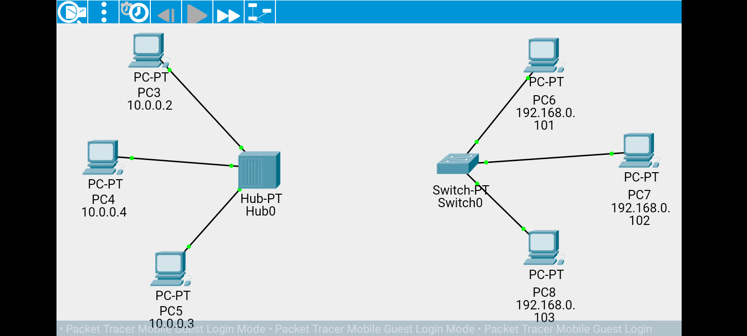 The Switch was the same at the first, but it has a learning attribute that let it build a table

contains of MAC address and IP address for each end device that connect to it, so after the first

message between two devices, it doesn't send the message to all devices, but to the destination

device directly. And this was the result for test using the Hub: (from PC3 to PC5)

At the first the Switch behave the same, then it send the message directly to the destination,

This was our test for Switch: (from PC7 to PC8)