Artificial Intelligence in Air Conditioner To Reduce Electricity Consumption And Maximize User Comfort

By: Lau Ying Yeung

Supervisor: Professor Chen, Chun

Final Year Project Interim Report

Submitted in Partial Fulfillment of the

Requirements for

The Degree of Bachelor of Engineering

Department of Mechanical and Automation Engineering

The Chinese University of Hong Kong

December 2019

Contents

Problem description 3

Result of literature review 3

Infrared communication 3

Supervised learning 3

Reinforcement learning 3

Realtime database connection 3

Different modules programs 3

Power consumptions calculation in AC 4

Approach to the problem 4

Divide and conquer 4

Current progress 4

List of remaining tasks 4

Work schedule for completion of remaining tasks 4

References 4

# Problem description

Due to an increased requirement for user comfort and convenience, smart appliances are all over the globe. At the same time, different environmental topics raised the importance of energy-efficient appliances. By combining both aspects, it becomes a trend that smart appliances should be able to improve our quality of life and cost less damage to the environment. However, there are two main reasons which prevent smart appliances from integrating into a normal household. Firstly, the price is usually higher than traditional appliances. Secondly, users do not need to replace their appliances immediately. Therefore, instead of replacing the traditional appliance, by adding a device between the user and the appliance which aims to control more precisely and tactical could be a solution to deal with the transition period of the traditional appliance to smart appliance.

The purpose for this device is to transform a traditional remote of an air conditioner (AC) to a smart remote by adding an artificial intelligence (AI) function into its design, so that it can automatically set the temperature of the AC. There are three technical problems in this device which need to be tackled. Firstly, an algorithm needs to be developed so that the remote could automatically figure out an optimal control tactic which minimize the user's discomfort and the energy usage. Secondly, it needs to distinguish the user's preferences on temperature settings. As different users may have different preferences due to their sensual feelings, the algorithm needs to find the user’s control pattern. Thirdly, it requires different hardware and software components to construct the remote.

# Result of literature review

## Infrared communication

To tackle the replacement of remote, we need to understand the working principal behind the remote. The control method home appliances use is called the infrared (IR) communication. The IR frequency could lie in the range of 3kHz to 300GHz [1], but most of the infrared remote controls facilitate a modulated square wave which is between 32kHz to 40kHz [2]. The basic circuit involves three main components which are an IR Receiver, an IR LED and a development board (e.g. Arduino board, NodeMCU, etc.). To send the data to the appliance, the data is needed to encode, and it will be transmitted to the receiver by blinking the IR LED according to the pulse distance from the encoded data [3]. There are different protocols for encoding the data, NEC Infrared Transmission Protocol is one of the common protocol which uses pulse distance to encode the message bits. [4]

## Supervised learning

## Reinforcement learning

## Realtime database connection

## Different modules programs

## Power consumptions calculation in AC

# Approach to the problem

## Divide and conquer

In this project, as the main problem consists of different modules and topics, we could ease the problem by using the divide and conquer methods. By conquering different subproblems recursively, we combine the solutions from each sub problems to get the ultimate solution [5]. Firstly, the main problem “developing a device that can set temperature and save energy” could be divided into two subproblems which are “developing an AI control algorithm” and “developing a control device” (Figure 3‑a). Secondly, “developing an AI control algorithm” consists of “collecting inputs for the AI to learn” and “developing AI learning algorithm”. While the control device consists of “replacing the air conditioner remote” and “updating AI algorithm of the device”.

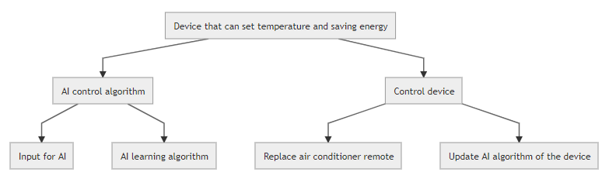

Figure 3‑a Main Problem Division

From the Figure 3‑b to Figure 3‑e, the subproblems are divided into smaller subproblems which will be solved accordingly. The following sections will show different methods to solve different subproblems.

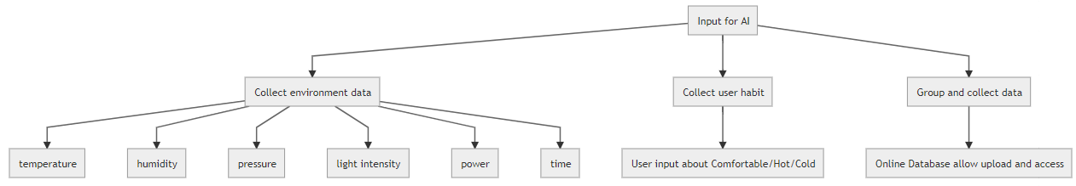

Figure 3‑b Subdivision of Input for AI

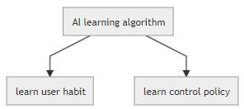

Figure 3‑c Subdivision of AI learning Algorithm

|  |  |
| --- | --- |
| Figure 3‑d Subdivision of replacing AC remote | Figure 3‑e Subdivision of updating AI algorithm of the device |

## AI control algorithm

### Inputs for AI to learn

The inputs for the AI to learn consists of a set of relatable environment data and the user input. It helps the AI learn about how user like to control their AC, and the inputs could act as different states in the reinforcement learning program. The collections of data are crucial to both parts of the learning algorithm.

#### Collection of environment data

To collect the temperature, humidity, pressure and light intensity, we can use different sensors and an Arduino development board to read and access the values. There are three sensors which can be used to measure the four environment properties which are BMP180, BH1750 and HTU21D (Figure 3‑f to Figure 3‑h). To collect the power data of the AC and access the values, we need to have a power meter module that supports measuring alternating current circuit. The PZEM-004T module is used in this part (Figure 3‑i). It consists of two parts which are the board and the current sensor. For the board, it is used to measure the alternating voltage. And the current sensor is used to measure the alternating current. To collect the time, we can simply use a time module for record the time of each data.

|  |  |  |
| --- | --- | --- |
| Figure 3‑f BMP180 for collecting barometric pressure | Figure 3‑g BH1750 for collecting light intensity | Figure 3‑h HTU21D for collecting termperature and humidity |
| Figure 3‑i PZEM-004T and current sensor for collecting power of the AC | | |

#### Collection of user input

Collecting the user input, which is about whether the user feels comfort, hot or cold, could help create data set of the user’s preferences on temperature setting. To achieve this, we could use three buttons for the user to input his feedback. By connecting the three buttons to the Arduino development board, we could simply program each button for different meaning. Two types of button working principle could be selected, which are active-low and active-high (Figure 3‑j) [6].

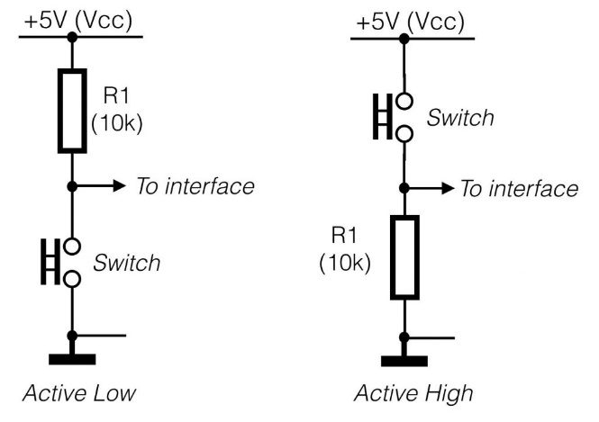

Figure 3‑j Configuration of Active Low and Active High

#### Group and collect data

As there are a set of environment data and user input that need to be processed by the AI algorithm, it is necessary to organize and re-group the data. In order to organize the data, the environment data and user input should be recorded at a certain period, which is 1 minute in this project. As the indoor temperature takes time to change by the AC, 1 minute should be an appropriate period for recording. As the user may not have the time to input every minute, and also it is not user-friendly, it is important that we count the missing input as another feedback which is similar to comfortable, but not the same level as the user input, and we call it “acceptable”. Therefore, we currently split the user feedback into four states, which are hot, cold, acceptable and comfortable.

Besides, we need to group the data in the program and send it to a platform or directly to the AI algorithm to analyze the data. In this project, we choose to use a platform to save the data we have, as it could keep things more organized, and the data could be reused. To send the data to platform, we first select a platform for storing the real-time data. As a result, this project uses the Firebase from Google to save the data (Figure 3‑k).

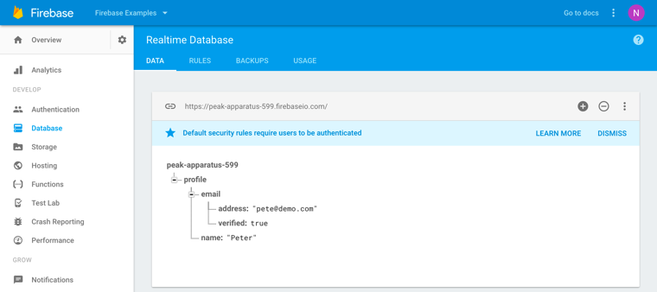

Figure 3‑k Realtime database from the Firebase

### AI learning algorithm

#### Learning user’s habit

To figure out the user’s preferences on setting the suitable temperature, we could tackle the problem by applying the supervised learning to learn the relation between the user’s feedback and the environment data. For example, we know that all the environment data that will make the user feel hot, the algorithm will try to classify the unknown case that is hot or not. Therefore, learning the user’s preference is a classification problem in supervised learning. For classification problem in supervised learning, it is necessary to have the labeled data for the learning process. And we need to use logistic regression instead of linear regression, as it involves using logistic function. The environment data acted as the inputs xn to the neural network, which n is the number of the environment data, and the user input acted as the actual output y­. We want our hypothesis function hθ as close as the actual output y (Figure 3‑l). Therefore, we will need to minimize the cost function and using gradient descent to find the optimal solution, in this case which is classifying the data according the user preference.

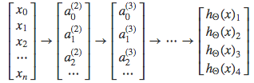

Figure 3‑l The relationship between input xn and hypothesis function hθ. The hidden layer an is between input and output layer.

#### Learning control policy

To figure out the optimal control policy for the agent, we could apply the reinforcement learning to solve the problem. By giving the current state information, the agent will apply an action that maximize the return from the environment.

# Current progress

To collect the temperature, humidity, pressure and light intensity, this device (Figure 4‑a) used three integrated modules, which are BMP180, BH1750 and HTU21D. For BMP180, it collects the barometric pressure. For BH1750, it collects the light intensity from the sun. For HTU21D, it collects the indoor temperature and humidity. By using the corresponding Arduino libraries, the device can receive the signals generate by different sensors and output the correct value.

|  |  |
| --- | --- |
| Figure 4‑a connection betweeen the three integrated modules and Arudino Mega 2560 | Figure 4‑b the test of reading the indoor environment |

# List of remaining tasks

# Work schedule for completion of remaining tasks

# References

|  |  |
| --- | --- |
| [1] | Ankit Jandial,Sujit Kumar,Rajat Butola,Manoj Kumar Pandey, "IR Based Home Appliances Control System," *International Journal on Recent and Innovation Trends in Computing and Communication,* vol. 5, no. 5, pp. 628-631, 2017. |
| [2] | Santosh.M.Nejakar, "Wireless Infrared Remote Controller for Multiple," *International Journal of Electrical and Electronics Research,* vol. 2, no. 1, pp. 25-35, 2014. |
| [3] | "IR Communication," SparkFun Electronics, 7 2 2013. [Online]. Available: https://learn.sparkfun.com/tutorials/ir-communication/all. [Accessed 29 12 2019]. |
| [4] | "NEC Infrared Transmission Protocol," Altium, [Online]. Available: https://techdocs.altium.com/display/FPGA/NEC+Infrared+Transmission+Protocol. [Accessed 13 9 2017]. |
| [5] | M. Manley, "Divide and Conquer Paradigm," ACM Transactions on Computational Logic, Los Angeles. |
| [6] | "How to connect," IPSON, [Online]. Available: http://www.ipson.nl/how-to-connect/. [Accessed 29 12 2019]. |