數學符號(Symbolic)和數值
內容
一. SymPy符號運算入門 2
1.. 首先, Jupyter Notebook中import SymPy and 啟用 LaTeX printing: 2
2. 分數表逹 2
2.1數值和符號(Sym)的分別 2
2.2分數sp.Rational(1,2) 或 sp.S(1)/ 2 或 sp.Integer(1)/2 3
2.3分數的指數及evaluate=False 3
3. 簡單符號運算 4
3.1 var(x,y,z ) 宣告符號變數全域namespace 4
3.2 x , y=symbols(‘x y’) 在函數內或區域內使用 4
3.3. 帶x 符號數學表逹式 4
3.4. 這些式子相等?expr1==expr2 4
3.5. 可以用simplify(expr1 – expr1) -> 0 來檢查值的相等. 4
3.6 例子: 符號 x,y,z 和 函數 f , g 4
3.7 文字轉式子parse_expr(str, evaluate=False), 簡化 simplify, 5
3.8 方程式Eq 解方程 solve 5
3.9 十字相乘法因式分解factor 6
3.10. 常用函數subs, 替代substitution, x 用 其他值代入.subs(x, expr) 7
3.11. 有理數 sp.Rational(a,b), sp.S(1) /2 7
3.13. lambdify() symbolic expre 轉為 Python Lamba function 7
二. 解方程式及不等式Solving equations and inequalities 8
1. Let's define a few symbols: 8
2. solve(x**2-a,x) (default right-hand side=0) 8
3. solve_univariate_inequality(x**2>4,x) 9
4. 方程組 solve([x+2*y+1,-3*y-2],x,y) 9
5. Nonlinear systems are also handled: 9
6. Singular linear systems 9
7. solve a linear system using matrices 10
8. the augmented matrix 10
9. nonsingular in order to have a unique solution 10
四. 分析实值函數 Analyzing real-valued functions 11
五. 概率及亂數Computing exact probabilities and manipulating random variables 12
六. 數論A bit of number theory with SymPy 15
七. 從真值表查布林命題公式Finding a Boolean propositional formula from a truth table 18
八. 分析非線性微分系統洛特卡－沃爾泰拉方程Analyzing a nonlinear differential system — Lotka-Volterra (predator-prey) equations 20
九 附錄 23
LaTeX 23
來源 24

一. SymPy符號運算入門
介紹SymPy:
安裝
pip install numpy
pip install sympy
pip install jupyterlab
Jupyter Notebook,數學表逹使用LaTeX,(MathJax JavaScript library) 即是出版數學格式.

1.. 首先, Jupyter Notebook中import SymPy and 啟用 LaTeX printing:
from sympy import *
init_printing()

2. 分數表逹

2.1數值和符號(Sym)的分別
import sympy as sp
a=99
b=-120
c= a/b
print(c)
# 第1次使用Sym
c= sp.Integer(a) / sp.Integer(b) # + - * / **
print(c)
display(c)

2.2分數sp.Rational(1,2) 或 sp.S(1)/ 2 或 sp.Integer(1)/2
"""
Sym 的簡單運算
"""
a=sp.Rational(1,2)
display(a)
display(sp.Rational(1,2))

2.3分數的指數及evaluate=False
display(sp.Pow(sp.Rational(2,3),-2))
display(sp.Pow(sp.Rational(2,3),-2,evaluate=False) )

a=1
b=2
c=3
St=r"$ {\huge (%s)}^{%s} $" % (sp.latex(sp.Rational(a,b)),c)
display(Latex(St))
#方法1:
expr=sp.Pow(sp.Rational(a,b),sp.Integer(c),evaluate=False)
Val=sp.simplify(expr)
#方法2:
fenM=sp.Integer(b)
fenX=a / fenM
Val= fenX ** c
display(Val) #標準答案

3. 簡單符號運算

3.1 var(x,y,z ) 宣告符號變數全域namespace
var('x y')
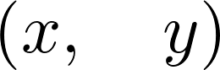

3.2 x , y=symbols(‘x y’) 在函數內或區域內使用
x, y = symbols('x y')

3.3. 帶x 符號數學表逹式
expr1 = (x + 1) ** 2
expr2 = x**2 + 2 * x + 1

3.4. 這些式子相等?expr1==expr2
expr1 == expr2
False

3.5. 可以用simplify(expr1 – expr1) -> 0 來檢查值的相等.
These expressions are mathematically equal, but not syntactically identical. To test whether they are mathematically equal, we can ask SymPy to simplify the difference algebraically:
simplify(expr1 - expr2)


3.6 例子: 符號 x,y,z 和 函數 f , g
import sympy as sp
x=sp.Symbol('x')
y,z=sp.symbols('y,z')
f=sp.Function('f')
f=x**2 + y**2 + z**2
display(f)
g= (x**2 + y**2 + z**2) / (x-y-y)
display(g)

3.7 文字轉式子parse_expr(str, evaluate=False), 簡化 simplify,
from sympy.parsing.sympy_parser import parse_expr
import sympy as sp
a=random.choice([-5,-4,-3,-2,-1,1,2,3,4,5]) #亂數a,b,c, 非零 [-5:+5]
b=random.choice([-5,-4,-3,-2,-1,1,2,3,4,5])
c=random.choice([-5,-4,-3,-2,-1,1,2,3,4,5]) #print(f"a={a},b={b},c={c}")
# 文字轉式子
St_str=f" {a} - ( {b} - ({c}) ) "
St=parse_expr(St_str, evaluate=False) # parse_expr, evaluate為False,不作運算.
display(St)
ans=input("請作答:")
Val=sp.simplify(St) # simplify
if int(ans)==Val:
print("答對!")
else:
print(f"答案錯誤, 標準答案:{Val} ")
#整式的加減法,帶符號式子簡化
express_str=f"{a}*x + {b}*x + {c} " #題型 express_str ax+bx+c
St=parse_expr(express_str, evaluate=False) #字串解釋為可運算式子 expression
display(St) #題目
Val=sp.simplify(St)
display(Val) #解

3.8 方程式Eq 解方程 solve
#Eq
a = 1
p=random.choice([-5,-4,-3,-2,-1,1,2,3,4,5])
q=random.choice([-5,-4,-3,-2,-1,1,2,3,4,5])
b=p+q
c=p*q
#一元一次方程 ax + b =c 求解
express_str=f" {a}*x + {b} " # f(x)= ax + b
QizStat=parse_expr(express_str, evaluate=False) #字串解釋為可運算式子 expression
fx=sp.Eq( QizStat, c ) # f(x)=c ,
display(fx)
Val=sp.solve(fx) #求根,得出標準答案
display(Val)
# 一元二次方程式
express_str=f"{a}*x**2 + {b}*x + {c} " # print(express_str + "=0")
QizStat=parse_expr(express_str, evaluate=False) #字串解釋為可運算式子 expression
fx=sp.Eq(QizStat,0) #f(x)=0
display(fx)
Val=sp.solve(fx) #求根[x1,x2]
display(Val)

3.9 十字相乘法因式分解factor
express_str=f"{a}*x**2 + {b}*x + {c} "
St=parse_expr(express_str, evaluate=False) #字串解釋為可運算式子 expression
display(St)
Val=sp.factor(St) #因式分解,得出標準答案
display(Val)
x²+x(−1)−12
(x−4)(x+3)

3.10. 常用函數subs, 替代substitution, x 用 其他值代入.subs(x, expr)
A very common operation with symbolic expressions is the substitution of a symbol by another symbol, expression, or a number, using the subs() method of a symbolic expression:
expr1.subs(x, expr1)
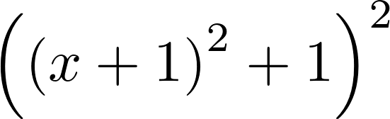
expr1.subs(x, pi)
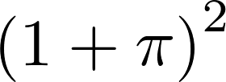

3.11. 有理數 sp.Rational(a,b), sp.S(1) /2
A rational number cannot be written simply as 1/2 as this Python expression evaluates to 0.5. A possibility is to convert the number 1 into a SymPy integer object, for example by using the S() function:
expr1.subs(x, S(1) / 2)
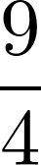
3.12. 轉為數值evalf()
Exactly represented numbers can be evaluated numerically with evalf():
_.evalf()
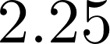

3.13. lambdify() symbolic expre 轉為 Python Lamba function
We can easily create a Python function from a SymPy symbolic expression using the lambdify() function. The resulting function can notably be evaluated on NumPy arrays. This is quite convenient when we need to go from the symbolic world to the numerical world:
f = lambdify(x, expr1) # a Python function from a SymPy symbolic expression
import numpy as np
f(np.linspace(-2., 2., 5))
array([ 1., 0., 1., 4., 9.])
A core idea in SymPy is to use the standard Python syntax to manipulate exact expressions. Although this is very convenient and natural, there are a few caveats. Symbols such as x, which represent mathematical variables, cannot be used in Python before being instantiated (otherwise, a NameError exception is thrown by the interpreter). This is in contrast to most other computer algebra systems. For this reason, SymPy offers ways to declare symbolic variables beforehand.
Another example is integer division; as 1/2 evaluates to 0.5 (or 0 in Python 2), SymPy has no way to know that the user intended to write a fraction instead. We need to convert the numerical integer 1 to the symbolic integer 1 before dividing it by 2.
Also, the Python equality refers to the equality between syntax trees rather than between mathematical expressions.

二. 解方程式及不等式Solving equations and inequalities

1. Let's define a few symbols:
from sympy import *
init_printing()
var('x y z a')
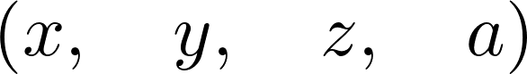

2. solve(x**2-a,x) (default right-hand side=0)
We use the solve() function to solve equations (the right-hand side is 0 by default):
solve(x**2 - a, x)
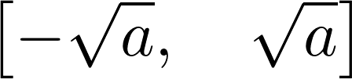

3. solve_univariate_inequality(x**2>4,x)
We can also solve inequalities. Here, we need to use the solve_univariate_inequality() function to solve this univariate inequality in the real domain:
x = Symbol('x')
solve_univariate_inequality(x**2 > 4, x)

4. 方程組 solve([x+2*y+1,-3*y-2],x,y)
The solve() function also accepts systems of equations (here, a linear system):
solve([x + 2*y + 1, x - 3*y - 2], x, y)
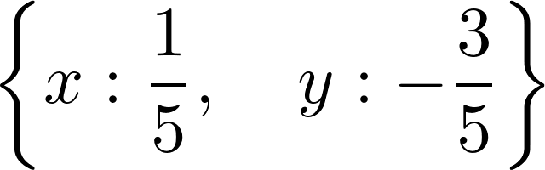

5. Nonlinear systems are also handled:
solve([x**2 + y**2 - 1, x**2 - y**2 - S(1) / 2], x, y)
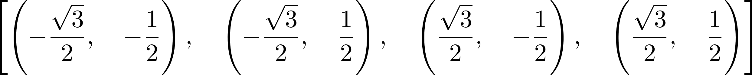

6. Singular linear systems
Singular linear systems can also be solved (here, there is an infinite number of solutions because the two equations are collinear):
solve([x + 2*y + 1, -x - 2*y - 1], x, y)
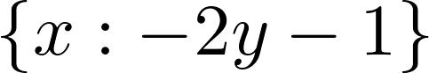

7. solve a linear system using matrices
Now, let's solve a linear system using matrices containing symbolic variables:
var('a b c d u v')

8. the augmented matrix
We create the augmented matrix, which is the horizontal concatenation of the system's matrix with the linear coefficients and the right-hand side vector. This matrix corresponds to the following system in x,yx,y: ax+by=u,cx+dy=vax+by=u,cx+dy=v:
M = Matrix([[a, b, u], [c, d, v]])
M
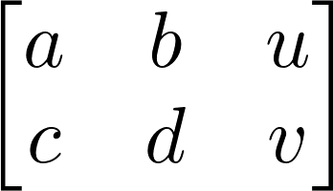
solve_linear_system(M, x, y)
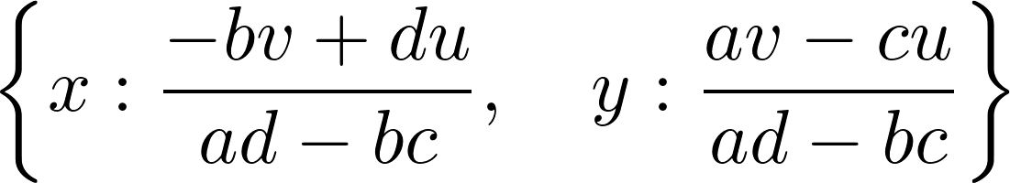

9. nonsingular in order to have a unique solution
This system needs to be nonsingular in order to have a unique solution, which is equivalent to saying that the determinant of the system's matrix needs to be nonzero (otherwise the denominators in the preceding fractions are equal to zero):
det(M[:2, :2])

Matrix support in SymPy is quite rich; we can perform a large number of operations and decompositions (see at http://docs.sympy.org/latest/modules/matrices/matrices.html).
Here are more references about linear algebra:
- Linear algebra at https://en.wikipedia.org/wiki/Linear_algebra#Further_reading
- Linear algebra on Wikibooks, at http://en.wikibooks.org/wiki/Linear_Algebra
- Linear algebra lectures on Awesome Math, at https://github.com/rossant/awesome-math/#linear-algebra

四. 分析实值函數 Analyzing real-valued functions
1. Let's define a few symbols and a function (which is just an expression depending on x):
from sympy import *
init_printing()
var('x z')
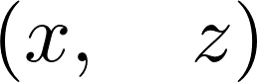
f = 1 / (1 + x**2)
2. Let's evaluate this function at 1:
f.subs(x, 1)
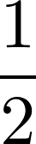
3. We can compute the derivative of this function:
diff(f, x)
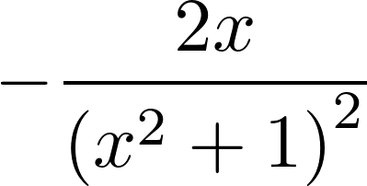
4. What is ff's limit to infinity? (Note the double o (oo) for the infinity symbol):
limit(f, x, oo)

5. Here's how to compute a Taylor series (here, around 0, of order 9). The Big O can be removed with the removeO() method.
series(f, x0=0, n=9)
6. We can compute definite integrals (here, over the entire real line):
integrate(f, (x, -oo, oo))
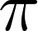
7. SymPy can also compute indefinite integrals:
integrate(f, x)
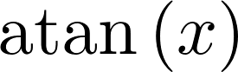
8. Finally, let's compute ff's Fourier transforms:
fourier_transform(f, x, z)
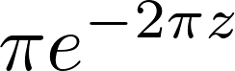
SymPy includes a large number of other integral transforms besides the Fourier transform (http://docs.sympy.org/latest/modules/integrals/integrals.html). However, SymPy will not always be able to find closed-form solutions.
Here are a few general references about real analysis and calculus:
- Real analysis at https://en.wikipedia.org/wiki/Real_analysis#Bibliography
- Calculus , at http://en.wikibooks.org/wiki/Calculus
- Real analysis on Awesome Math, at https://github.com/rossant/awesome-math/#real-analysis

五. 概率及亂數Computing exact probabilities and manipulating random variables
1. Let's import SymPy and the stats module:
from sympy import *
from sympy.stats import *
init_printing()
2. Let's roll two dice, X and Y, with six faces each:
X, Y = Die('X', 6), Die('Y', 6)
3. We can compute probabilities defined by equalities (with the Eq operator) or inequalities:
P(Eq(X, 3))

P(X > 3)

4. Conditions can also involve multiple random variables:
P(X > Y)
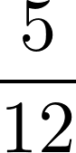
5. We can compute conditional probabilities:
P(X + Y > 6, X < 5)

6. We can also work with arbitrary discrete or continuous random variables:
Z = Normal('Z', 0, 1) # Gaussian variable
P(Z > pi)
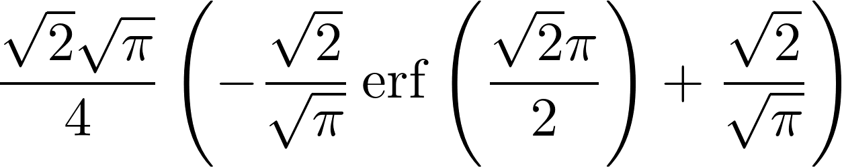
7. We can compute expectancies and variances:
E(Z**2), variance(Z**2)
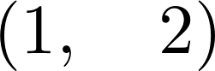
8. We can also compute densities:
f = density(Z)
var('x')
f(x)
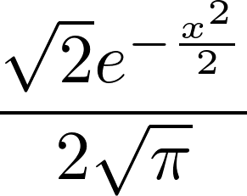
9. We can plot these densities:
%matplotlib inline
plot(f(x), (x, -6, 6))
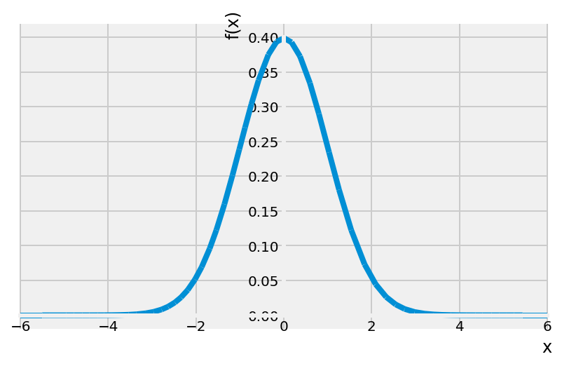
SymPy's stats module contains many functions to define random variables with classical laws (binomial, exponential, and so on), discrete or continuous. It works by leveraging SymPy's powerful integration algorithms to compute exact probabilistic quantities as integrals of probability distributions. For example, P(Z>π)P(Z>π) is:
Eq(Integral(f(x), (x, pi, oo)),
simplify(integrate(f(x), (x, pi, oo))))
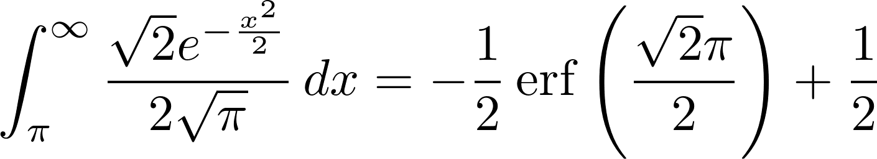
Note that the equality condition is written using the Eq operator rather than the more standard == Python syntax. This is a general feature in SymPy; == means equality between Python variables, whereas Eq is the mathematical operation between symbolic expressions.
Here are a few references:
- SymPy stats module documentation at http://docs.sympy.org/latest/modules/stats.html
- Probability lectures on Awesome Math, at https://github.com/rossant/awesome-math/#probability-theory
- Statistics lectures on Awesome Math, at https://github.com/rossant/awesome-math/#statistics

六. 數論A bit of number theory with SymPy
To display legends using LaTeX in matplotlib, you will need an installation of LaTeX on your computer (see this chapter's introduction).
1. Let's import SymPy and the number theory package:
from sympy import *
import sympy.ntheory as nt
init_printing()
2. We can test whether a number is prime:
nt.isprime(2017)
True
3. We can find the next prime after a given number:
nt.nextprime(2017)
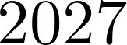
4. What is the 1000th prime number?
nt.prime(1000)
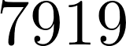
5. How many primes less than 2017 are there?
nt.primepi(2017)
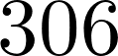
6. We can plot π(x)π(x), the prime-counting function (the number of prime numbers less than or equal to some number xx). The prime number theorem states that this function is asymptotically equivalent to x/log(x)x/log⁡(x). This expression approximately quantifies the distribution of prime numbers among all integers:
import numpy as np
import matplotlib.pyplot as plt
%matplotlib inline
x = np.arange(2, 10000)
fig, ax = plt.subplots(1, 1, figsize=(6, 4))
ax.plot(x, list(map(nt.primepi, x)), '-k',
label='$\pi(x)$')
ax.plot(x, x / np.log(x), '--k',
label='$x/\log(x)$')
ax.legend(loc=2)
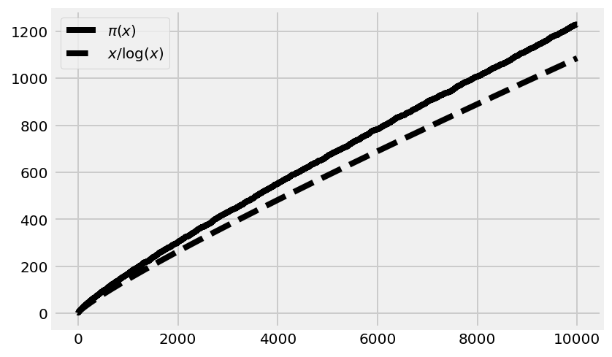
7. Let's compute the integer factorization of a number:
nt.factorint(1998)
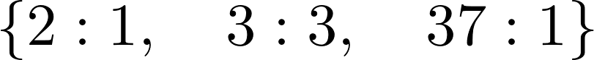
2 * 3**3 * 37
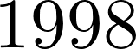
8. Finally, a small problem. A lazy mathematician is counting his marbles. When they are arranged in three rows, the last column contains one marble. When they form four rows, there are two marbles in the last column, and there are three with five rows. How many marbles are there? (Hint: The lazy mathematician has fewer than 100 marbles.)

The Chinese Remainder Theorem gives us the answer:
from sympy.ntheory.modular import solve_congruence
solve_congruence((1, 3), (2, 4), (3, 5))
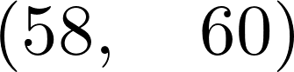
There are infinitely many solutions: 58 plus any multiple of 60. Since there are less than 100 marbles, 58 is the right answer.
SymPy contains many number-theory-related functions. Here, we used the Chinese Remainder Theorem to find the solutions of the following system of arithmetic equations:
nn≡a1modm1⋮≡akmodmkn≡a1modm1⋮n≡akmodmk
The triple bar is the symbol for modular congruence. Here, it means that mimi divides ai−nai−n. In other words, nn and aiai are equal up to a multiple of mimi. Reasoning with congruences is very convenient when periodic scales are involved. For example, operations involving 12-hour clocks are done modulo 12. The numbers 11 and 23 are equivalent modulo 12 (they represent the same hour on the clock) because their difference is a multiple of 12.
In this recipe's example, three congruences have to be satisfied: the remainder of the number of marbles in the division with 3 is 1 (there's one extra marble in that arrangement), it is 2 in the division with 4, and 3 in the division with 5. With SymPy, we simply specify these values in the solve_congruence() function to get the solutions.
The theorem states that solutions exist as soon as the mimi are pairwise co-prime (any two distinct numbers among them are co-prime). All solutions are congruent modulo the product of the mimi. This fundamental theorem in number theory has several applications, notably in cryptography.
Here are a few textbooks about number theory:
- Undergraduate level: Elementary Number Theory, Gareth A. Jones, Josephine M. Jones, Springer, (1998)
- Graduate level: A Classical Introduction to Modern Number Theory, Kenneth Ireland, Michael Rosen, Springer, (1982)
Here are a few references:
- Documentation on SymPy's number-theory module, available at http://docs.sympy.org/latest/modules/ntheory.html
- The Chinese Remainder Theorem on Wikipedia, at https://en.wikipedia.org/wiki/Chinese_remainder_theorem
- Applications of the Chinese Remainder Theorem, given at http://mathoverflow.net/questions/10014/applications-of-the-chinese-remainder-theorem
- Number theory lectures on Awesome Math, at https://github.com/rossant/awesome-math/#number-theory

七. 從真值表查布林命題公式Finding a Boolean propositional formula from a truth table
The logic module in SymPy lets us manipulate complex Boolean expressions, also known as propositional formulas.
This recipe will show an example where this module can be useful. Let's suppose that, in a program, we need to write a complex if statement depending on three Boolean variables. We can think about each of the eight possible cases (true, true and false, and so on) and evaluate what the outcome should be. SymPy offers a function to generate a compact logic expression that satisfies our truth table.
1. Let's import SymPy:
from sympy import *
init_printing()
2. Let's define a few symbols:
var('x y z')
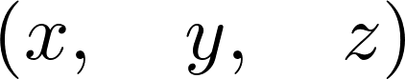
3. We can define propositional formulas with symbols and a few operators:
P = x & (y | ~z)
P
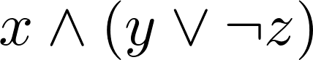
4. We can use subs() to evaluate a formula on actual Boolean values:
P.subs({x: True, y: False, z: True})

5. Now, we want to find a propositional formula depending on x, y, and z, with the following truth table:
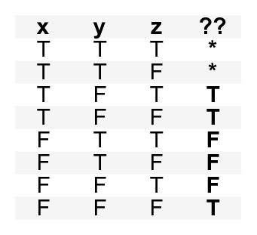
6. Let's write down all combinations that we want to evaluate to True, and those for which the outcome does not matter:
minterms = [[1, 0, 1], [1, 0, 0], [0, 0, 0]]
dontcare = [[1, 1, 1], [1, 1, 0]]
7. Now, we use the SOPform() function to derive an adequate formula:
Q = SOPform(['x', 'y', 'z'], minterms, dontcare)
Q
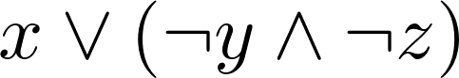
8. Let's test that this proposition works:
Q.subs({x: True, y: False, z: False}), Q.subs(
{x: False, y: True, z: True})
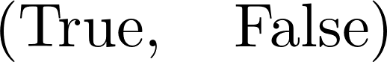
The SOPform() function generates a full expression corresponding to a truth table and simplifies it using the Quine-McCluskey algorithm. It returns the smallest Sum of Products form (or disjunction of conjunctions). Similarly, the POSform() function returns a Product of Sums.
The given truth table can occur in this case: suppose that we want to write a file if it doesn't already exist (z), or if the user wants to force the writing (x). In addition, the user can prevent the writing (y). The expression evaluates to True if the file is to be written. The resulting SOP formula works if we explicitly forbid x and y in the first place (forcing and preventing the writing at the same time is forbidden).
Here are a few references:
- SymPy logic module documentation at http://docs.sympy.org/latest/modules/logic.html
- The propositional formula on Wikipedia, at https://en.wikipedia.org/wiki/Propositional_formula
- Sum of Products on Wikipedia, at https://en.wikipedia.org/wiki/Canonical_normal_form
- The Quine–McCluskey algorithm on Wikipedia, at https://en.wikipedia.org/wiki/Quine%E2%80%93McCluskey_algorithm
- Logic lectures on Awesome Math, at https://github.com/rossant/awesome-math/#logic

八. 分析非線性微分系統洛特卡－沃爾泰拉方程Analyzing a nonlinear differential system — Lotka-Volterra (predator-prey) equations
Here, we will conduct a brief analytical study of a famous nonlinear differential system: the Lotka-Volterra equations, also known as predator-prey equations. These equations are first-order differential equations that describe the evolution of two interacting populations (for example, sharks and sardines), where the predators eat the prey. This example illustrates how to obtain exact expressions and results about fixed points and their stability with SymPy.
For this recipe, knowing the basics of linear and nonlinear systems of differential equations is recommended.
1. Let's create some symbols:
from sympy import *
init_printing(pretty_print=True)

var('x y')
var('a b c d', positive=True)
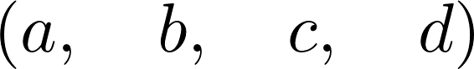
2. The variables xx and yy represent the populations of the prey and predators, respectively. The parameters aa, bb, cc, and dd are strictly positive parameters (described more precisely in the How it works... section of this recipe). The equations are:
dxdtdydt=f(x)=x(a−by)=g(x)=−y(c−dx)(1)(2)
(1)dxdt=f(x)=x(a−by)
(2)dydt=g(x)=−y(c−dx)
f = x * (a - b * y)
g = -y * (c - d * x)
3. Let's find the fixed points of the system (solving f(x,y)=g(x,y)=0f(x,y)=g(x,y)=0). We call them (x0,y0)(x0,y0) and (x1,y1)(x1,y1):
solve([f, g], (x, y))
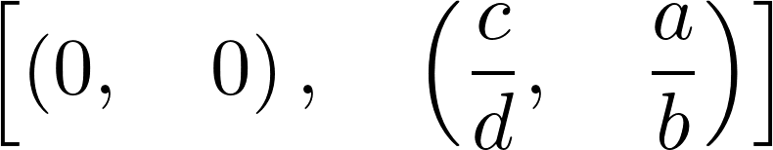
(x0, y0), (x1, y1) = _
4. Let's write the 2D vector with the two equations:
M = Matrix((f, g))
M
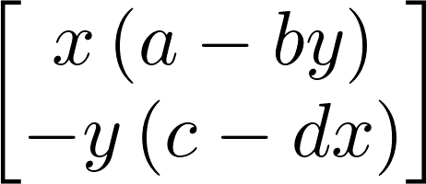
5. Now, we can compute the Jacobian of the system, as a function of (x,y)(x,y):
J = M.jacobian((x, y))
J
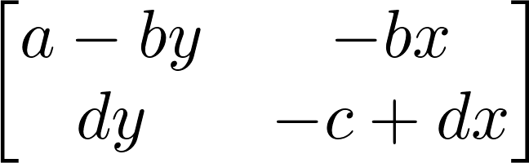
6. Let's study the stability of the first fixed point by looking at the eigenvalues of the Jacobian at this point. The first fixed point corresponds to extinct populations:
M0 = J.subs(x, x0).subs(y, y0)
M0
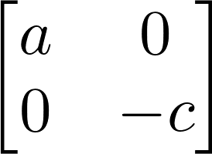
M0.eigenvals()
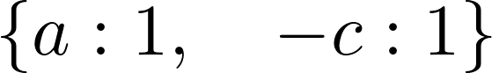
The parameters aa and cc are strictly positive, so the eigenvalues are real and of opposite signs, and this fixed point is a saddle point. As this point is unstable, the extinction of both populations is unlikely in this model.
7. Let's consider the second fixed point now:
M1 = J.subs(x, x1).subs(y, y1)
M1
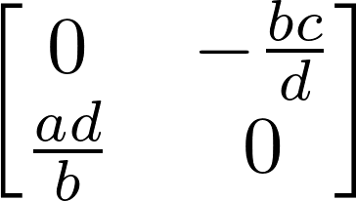
M1.eigenvals()
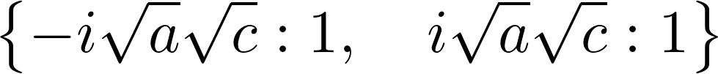
The eigenvalues are purely imaginary: thus, this fixed point is not hyperbolic. Therefore, we cannot draw conclusions from this linear analysis about the qualitative behavior of the system around this fixed point. However, we could show with other methods that oscillations occur around this point.
The Lotka-Volterra equations model the growth of the predator and prey populations, taking into account their interactions. In the first equation, the axax term represents the exponential growth of the prey, and −bxy−bxy represents death by predators. Similarly, in the second equation, −yc−yc represents the natural death of the predators, and dxydxy represents their growth as they eat more and more prey.
To find the equilibrium points of the system, we need to find the values xx, yy such that dx/dt=dy/dt=0dx/dt=dy/dt=0, that is, f(x,y)=g(x,y)=0f(x,y)=g(x,y)=0, so that the variables do not evolve anymore. Here, we were able to obtain analytical values for these equilibrium points with the solve() function.
To analyze their stability, we need to perform a linear analysis of the nonlinear equations, by taking the Jacobian matrix at these equilibrium points. This matrix represents the linearized system, and its eigenvalues tell us about the stability of the system near the equilibrium point. The Hartman–Grobman theorem states that the behavior of the original system qualitatively matches the behavior of the linearized system around an equilibrium point if this point is hyperbolic (meaning that no eigenvalues of the matrix have a real part equal to 0). Here, the first equilibrium point is hyperbolic as a,c>0a,c>0, but the second is not.
Here, we were able to compute symbolic expressions for the Jacobian matrix and its eigenvalues at the equilibrium points.
Even when a differential system is not solvable analytically (as is the case here), a mathematical analysis can still give us qualitative information about the behavior of the system's solutions. A purely numerical analysis is not always relevant when we are interested in qualitative results, as numerical errors and approximations can lead to wrong conclusions about the system's behavior.
Here are a few references:
- Matrix documentation in SymPy, available at http://docs.sympy.org/latest/modules/matrices/matrices.html
- Dynamical systems on Wikipedia, at https://en.wikipedia.org/wiki/Dynamical_system
- Equilibrium points on Scholarpedia, at http://www.scholarpedia.org/article/Equilibrium
- Bifurcation theory on Wikipedia, at https://en.wikipedia.org/wiki/Bifurcation_theory
- Chaos theory on Wikipedia, at https://en.wikipedia.org/wiki/Chaos_theory
- Further reading on dynamical systems, at https://en.wikipedia.org/wiki/Dynamical_system#Further_reading
- Lectures on ordinary differential equations on Awesome Math, at https://github.com/rossant/awesome-math/#ordinary-differential-equations
https://github.com/ipython-books/cookbook-2nd-code

九 附錄

LaTeX
LaTeX is a document markup language widely used to write publication-quality mathematical equations. in the browser with the MathJax JavaScript library. SymPy uses this system to display equations in the Jupyter Notebook.LaTeX equations can also be used in matplotlib. In this case, it is recommended to have a LaTeX installation on your local computer.
- LaTeX on Wikipedia, at https://en.wikipedia.org/wiki/LaTeX
- LaTeX in matplotlib, described at http://matplotlib.org/users/usetex.html
- Display eq with SymPy, available at http://docs.sympy.org/latest/tutorial/printing.html
- To install LaTeX on your computer, refer to http://latex-project.org/ftp.html

來源
https://ipython-books.github.io/chapter-15-symbolic-and-numerical-mathematics/
https://github.com/eddylin2015/mathsym

