You could modify this variable for testing with that cube sizes.

You can test as console application.

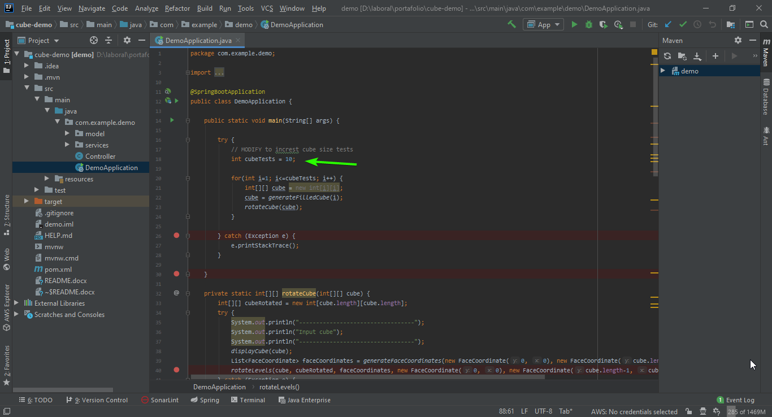

On console you can see the logs, input cube and output cube.

