To use Modbus SHT20

Refer to XY-MD02 manual.

Use SSCOM to communicate with XY-MD02 via RS485 module

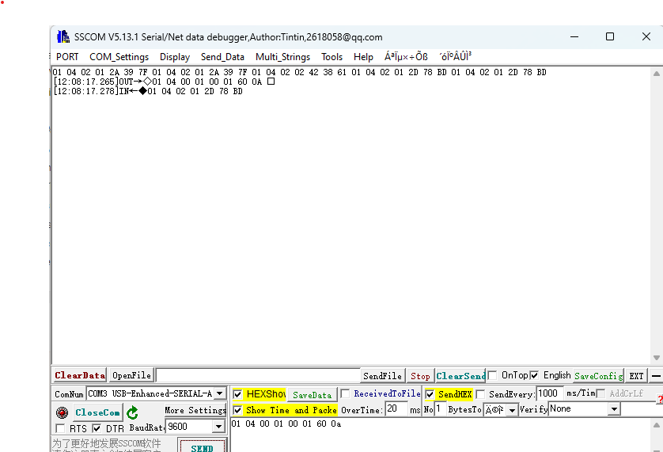

Check the HexShow to display the message received in hex mode

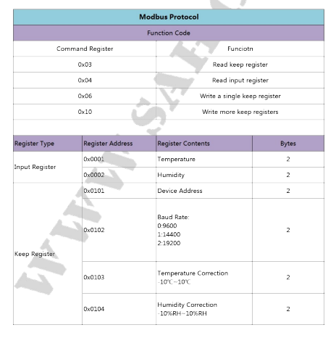

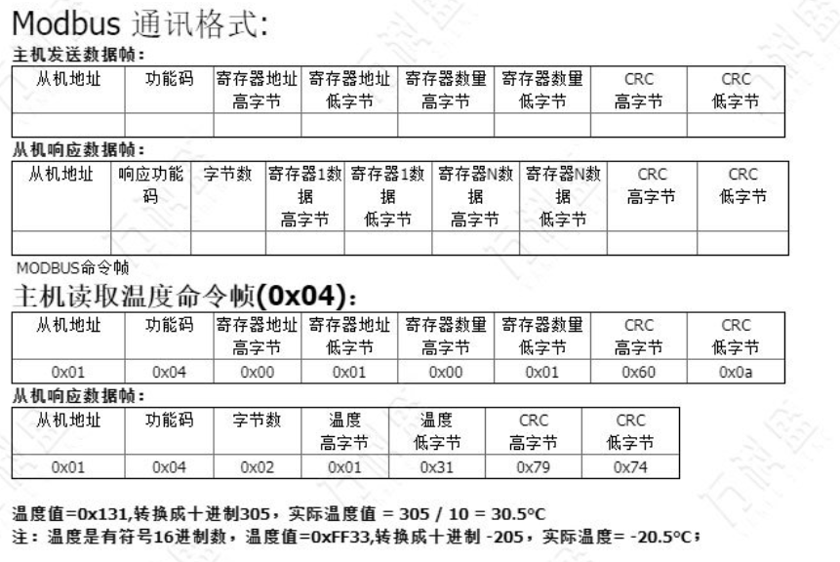

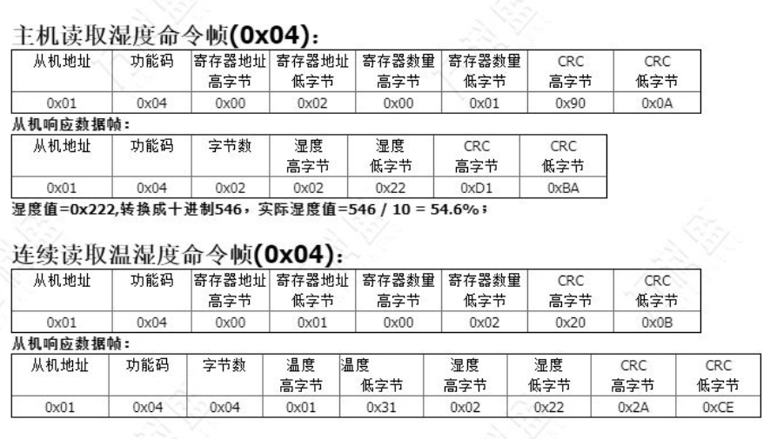

For CRC calculation

<http://www.sunshine2k.de/coding/javascript/crc/crc_js.html>

CRC width – CRC-16

CRC16_Modbus

Polynomial 0xA001

Initial value 0xFFFF

Final xor value 0x 0

Send -> 01 03 01 02 00 01 24 36 (read baud rate)

Received - >01 03 02 25 80 A3 74 (baud rate 0x2580 i.e 9600)

Send -> 01 03 01 03 00 01 75 F6 (read temperature correction)

Received -> 01 03 02 00 00 B8 44 (by default temperature correction is 0 )

Send -> 01 06 01 03 00 01 B9 F6 (modify the temperature correction to 1)

Received - > 01 06 01 03 00 01 B9 F6

0x01 0x06 0x01 0x03 0x00 0x02 F9 F7 ((modify the temperature correction to 2)

0x01 0x06 0x01 0x03 0x00 0x05 B8 35 ((modify the temperature correction to 5)

If -2, 0010 -> 1110 ->E

0x01 0x06 0x01 0x03 0x00 0x0E F9 F2 modify the temperature correction to -2

Send -> 01 03 01 04 00 01 C4 37 (read humidity correction)

Received - > 01 03 02 00 00 B8 44