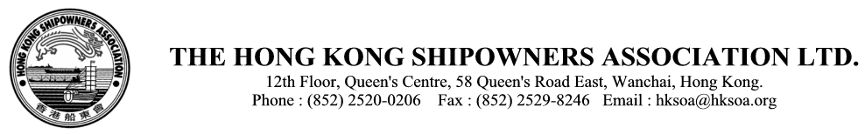

Cir. Ref: A(14)13

TO ALL MEMBERS 21 January 2014

Association Afternoon Seminar

**“Fleet Optimization**

**with new fuel efficiency solutions***”*

Mr. Till F. Braun and Dr. Thilo Dückert

Maritime Advisory, DNV GL

Date : Wednesday, 26 February 2014

Time : 3.00pm to 5.30pm, Tea/coffee from 2.30pm

Place : United Conference Centre,

10/F United Centre, 95 Queensway, Hong Kong

Energy efficiency is prevailing as the dominant topic for the shipping industry. There are numerous efficiency levers that are known and used already today by ship operators, such as slow-steaming, vessel maintenance (e.g., through propeller or hull cleaning) and optimized voyage execution. However, there are still vast opportunities to increase ship-operating efficiency and reduce energy consumption. Our presentation will give an overview of possible levers both from an organizational and technical perspective. We will present the latest operational fuel efficiency tools such fleet performance management and trim optimization as well as the possibilities of retrofitting an existing fleet.

Agenda

* Introduction
  + Improving fuel efficiency by anchoring Energy Management in the organization
* Operational efficiency optimization
  + Implementing ship performance management
  + Trim optimization and fuel consumption prediction
* Efficiency optimization through retrofitting
  + Scope and possibilities of a retrofit program

Till F. Braun is a Market Development Manager, Maritime Advisory.

Till has a professional background in marine engineering. Having served as Engineer on various ships in international trade, he continued his career with an engine manufacturer, being responsible for propulsion system design & layout in different applications. Through his employment with Germanischer Lloyd he was involved in classification matters as well as consultancy services, software applications, and training. As a Market Development Manager, he is currently responsible for sales and client relationships for fuel efficiency related products of Maritime Advisory.

Dr. Thilo Dückert is Project Manager Technology, Maritime Advisory.

Thilo has a background in Mechanical Engineering and holds a Doctoral degree in Business Administration. He has over 7 years experience as a project manager with McKinsey & Company, working mainly for industrial clients in both organizational redesign and operations optimization. After that he spent 3 years in Corporate Development at Germanischer Lloyd, working on several maritime advisory related assignments. Currently, Thilo leads DNV GL's vessel performance management related activities.



# To: The Hong Kong Shipowners Association

# Fax: 2529-8246

Afternoon Seminar – Wednesday, 26 February 2014

#### Topic: “**Fleet Optimization with new fuel efficiency solutions**”

The following will attend the above seminar :-

|  |  |  |
| --- | --- | --- |
| Mr./Ms. |  | (Please type) |
| Mr./Ms. |  | (Please type) |
| Mr./Ms. |  | (Please type) |
| Mr./Ms. |  | (Please type) |
| Mr./Ms. |  | (Please type) |
| Mr./Ms. |  | (Please type) |
| Mr./Ms. |  | (Please type) |
| Mr./Ms. |  | (Please type) |
| Mr./Ms. |  | (Please type) |
| Mr./Ms. |  | (Please type) |

|  |  |  |  |  |  |
| --- | --- | --- | --- | --- | --- |
| Company Name | : |  | | | |
| Contact Person | : |  | Tel | : |  |

Notes:

1. Please avoid hand-written names which could cause unwelcome misspellings and telephone queries.
2. Reservations for all events are accepted and confirmed WITHOUT telephone/fax follow-up. Seats cannot be guaranteed for walk-ins.