Section8:networking

1.igconfig

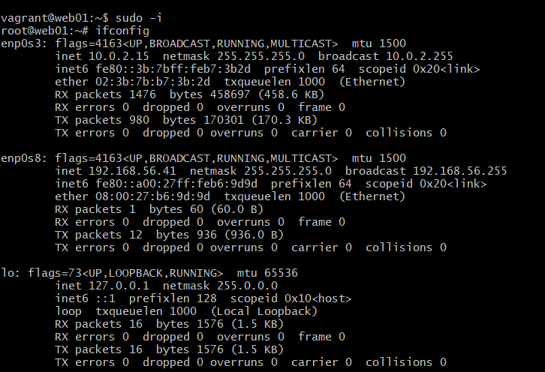

2. ip addr show :alt of ifconfig to check out own ip address

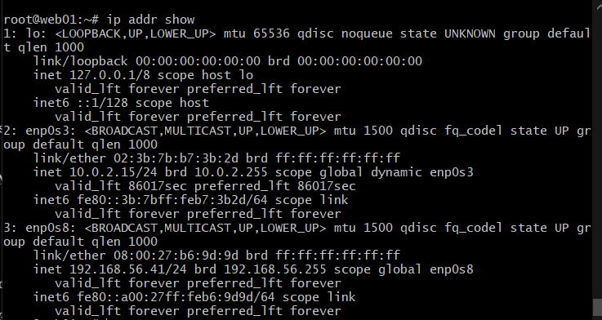

3.ping cmd

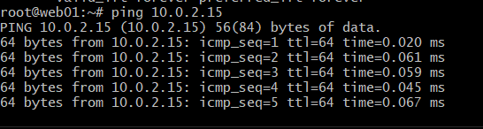

4.make change to this file



-make changes in the bottom

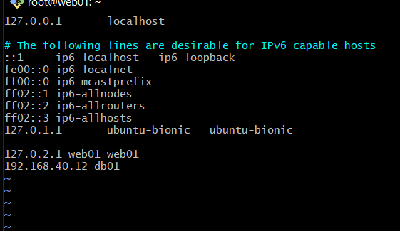

5.traceroute

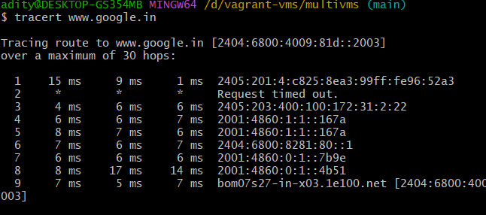

6.netstat

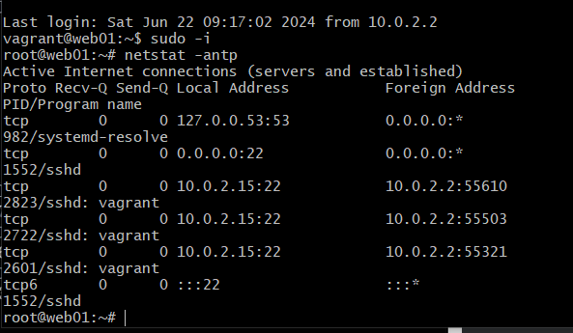

7.this cmd will ping all the vm

