Networking Day 2 DNS and Network Models
Chapter 2 DNS name resolution and Chapter 3 OSI TCP IP models
This study guide turns Day 2 networking notes into a clear explanation of two linked ideas. DNS helps people use domain names while the OSI and TCP IP models explain how information travels across a network. By the end, you should be able to describe a DNS lookup, identify the responsibility of each network layer, and explain why TCP and UDP serve different needs.

Learning map
Chapter | Main question | Outcome
2 DNS | How does a domain name become an IP address? | Explain the resolver, hierarchy, caching, and authoritative answer.
3 Network models | How does data move from one application to another? | Map OSI to TCP IP and follow a packet through encapsulation.

Chapter 2 DNS and Name Resolution
DNS stands for Domain Name System. A person can remember a name such as www.example.com, but a network routes traffic using an IP address. DNS is the distributed system that maps names to records such as IPv4 addresses, IPv6 addresses, mail servers, and aliases.

What happens during a lookup
- The browser and operating system first check local caches. A valid cached record avoids a new lookup.
- If no answer is cached, the client sends a query to a recursive resolver, usually provided by an ISP, organisation, or public DNS service.
- The resolver asks the root infrastructure which servers handle the relevant top level domain.
- The resolver asks the TLD server, which directs it to the domain’s authoritative name server.
- The authoritative name server returns the requested resource record. The resolver returns it to the client and caches it according to the TTL.
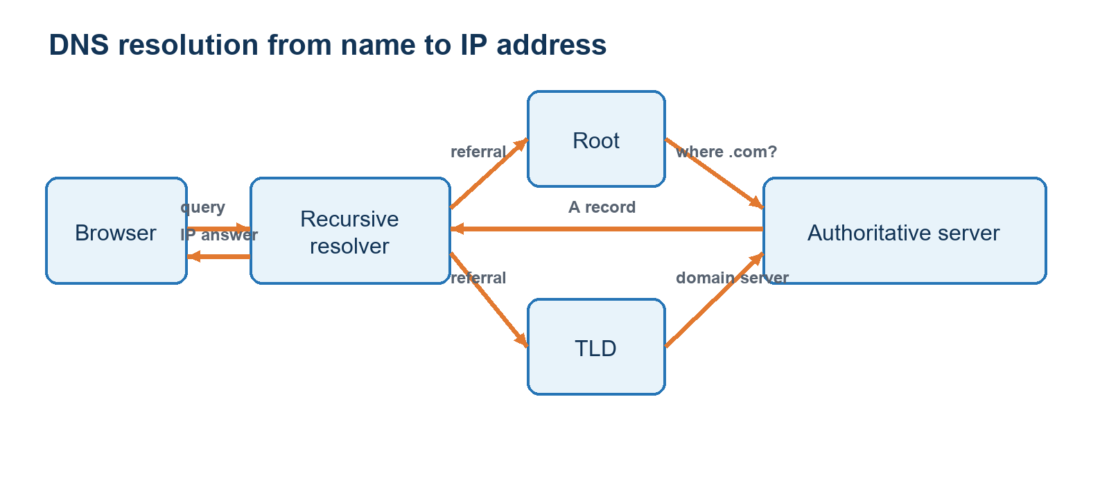
Figure 1. A simplified DNS lookup. In practice, referrals form a sequence; the resolver performs the work for the client.

DNS hierarchy
DNS distributes responsibility. Root servers do not hold every domain record. Instead, they point to top level domain servers. TLD servers point to authoritative servers, and authoritative servers publish the records for a particular domain.
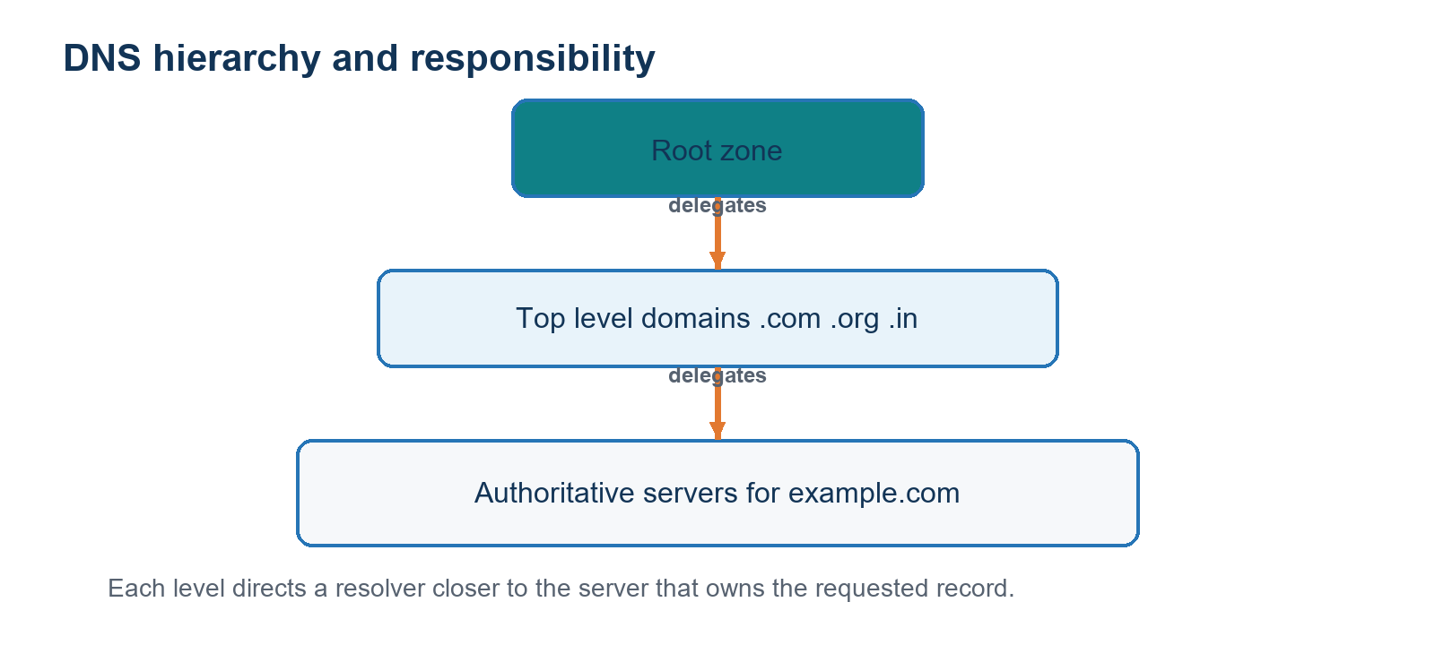
Figure 2. The hierarchy delegates responsibility from the root zone to the server that owns a domain’s records.

Terms to remember
Term | Meaning
Recursive resolver | Performs DNS lookups for the client and commonly keeps a cache.
Root server | Directs a resolver to the correct top level domain servers.
Top level domain | The final label of a domain, such as .com, .org, .edu, or .in.
Authoritative server | The source of truth for the records of a domain.
A record | Maps a name to an IPv4 address.
AAAA record | Maps a name to an IPv6 address.
TTL | Time to live. It controls how long a cached response may be reused.

Chapter 3 OSI and TCP IP Models
The OSI model is a seven layer framework for understanding network communication. TCP/IP is the protocol suite used across the internet and is often shown in four layers. The models do not compete: the OSI model helps us reason about responsibilities, while TCP/IP describes the protocols used in practice.
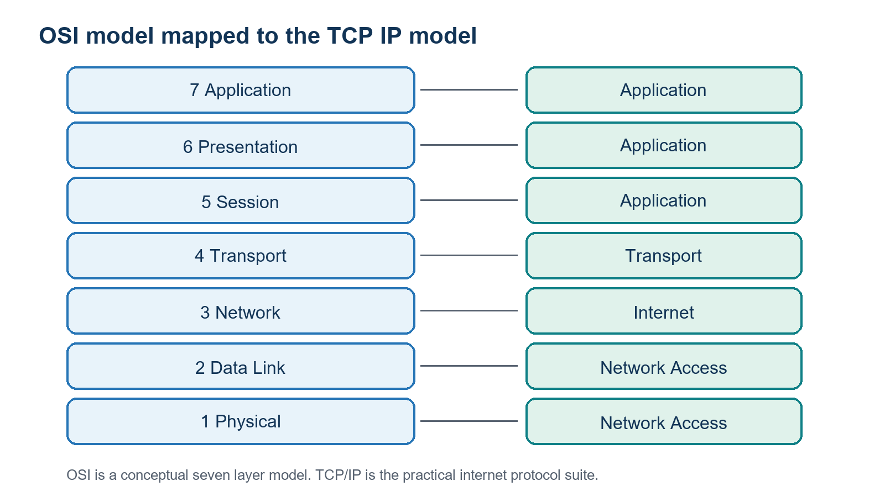
Figure 3. OSI layers can be grouped into the four TCP IP layers used to describe internet communication.

What each OSI layer does
OSI layer | Responsibility | Example
Application | Network services used by applications. | HTTP, DNS, SMTP
Presentation | Data representation, encryption, and compression. | TLS encryption, character encoding
Session | Starts, manages, and closes conversations. | Session control in application protocols
Transport | End to end delivery, ports, reliability choices. | TCP and UDP
Network | Logical addressing and routing between networks. | IP and routers
Data Link | Frames and local network delivery using MAC addresses. | Ethernet and Wi Fi
Physical | Bits carried as electrical, optical, or radio signals. | Cable, fibre, radio

Data moving through the layers
At the sender, each layer adds information for its own job. This is encapsulation. The transport layer identifies application endpoints with port numbers. The network layer adds source and destination IP addresses so routers can forward the packet between networks. The data link layer uses local MAC addresses to deliver a frame on the next hop. At the receiver, decapsulation removes these headers in reverse order.
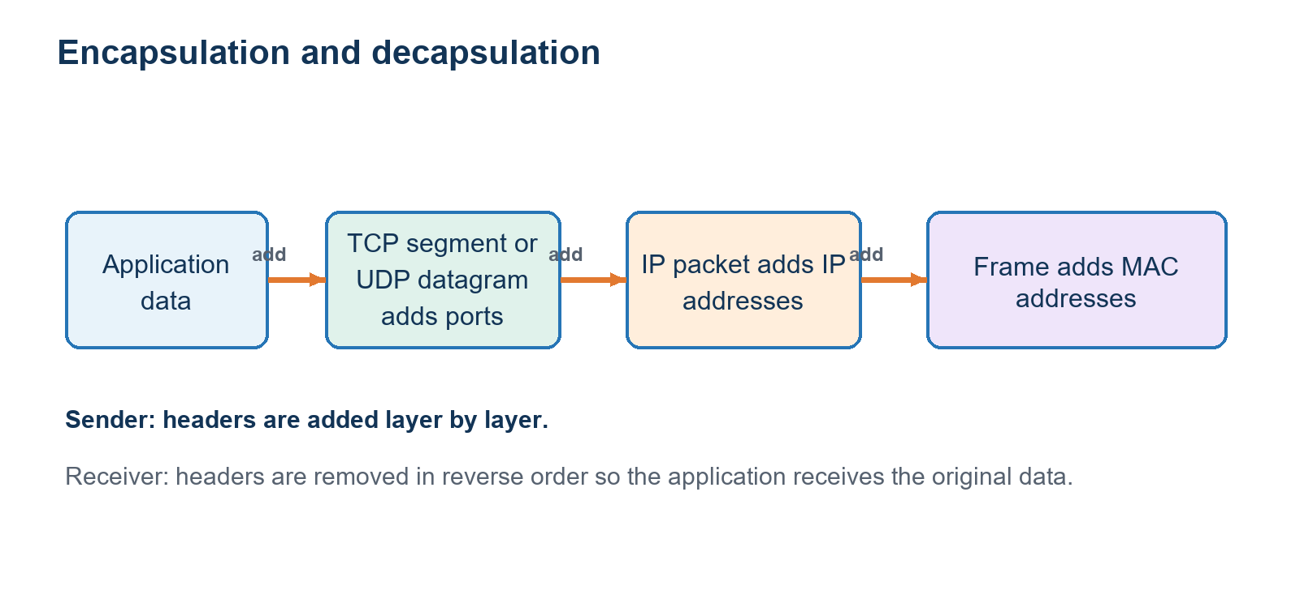
Figure 4. Encapsulation adds headers on the sending side; decapsulation removes them at the receiving side.

TCP compared with UDP
Protocol | Strength | Trade off | Common use
TCP | Reliable, ordered byte stream with connection setup, acknowledgements, and retransmission. | More overhead and latency than UDP. | Web traffic, file transfer, email.
UDP | Lightweight datagrams with no connection setup. | No built in guarantee of delivery, order, or duplicate protection. | Live media, games, DNS queries.

Practical example
When a device opens a website, DNS may first resolve the domain name to an IP address. The browser then uses an application protocol such as HTTPS. TCP or QUIC provides transport behaviour, IP routes the traffic, and Ethernet or Wi Fi moves frames across the local link. The layers work together, each solving a different part of the same communication problem.

Quick recap
- DNS converts domain names into usable network records through a distributed hierarchy and caching.
- The OSI model separates networking into seven responsibilities; TCP/IP groups those responsibilities into four practical layers.
- Encapsulation adds transport, IP, and link information as data is prepared for the network.
- TCP provides reliable ordered delivery; UDP reduces overhead but does not promise delivery.

