DevOps Security Practical
Nginx firewall HTTPS AWS security groups and VPC traffic flow
This practical consolidates the security concepts studied for an Nginx web workload. It explains how host firewall rules, HTTPS, AWS security groups, and VPC routing work together to reduce unnecessary network exposure.

Learning objectives
- Control inbound and outbound traffic using UFW.
- Explain the relationship between HTTPS, TLS, certificates, and port 443.
- Apply least-privilege rules in an AWS security group.
- Describe public and private subnets and the NAT gateway role.

1 Nginx and host firewall
UFW is a firewall on the Linux host. Nginx profile rules provide a convenient way to allow the ports used by a web server.
UFW profile | Ports | Use
Nginx HTTP | TCP 80 | Unencrypted web traffic or an HTTP to HTTPS redirect.
Nginx HTTPS | TCP 443 | Encrypted web traffic.
Nginx Full | TCP 80 and 443 | A site serving HTTP and HTTPS during setup or redirect configuration.

Commands studied:
sudo ufw app list
sudo ufw allow 'Nginx Full'
sudo ufw status verbose
sudo systemctl status nginx
For an HTTPS-only site, test the certificate and HTTP-to-HTTPS redirect before removing port 80. A firewall rule should match the real service requirement.

2 HTTPS TLS and ports
HTTPS is HTTP protected by TLS. TLS encrypts communication and uses certificates so the client can validate the server identity. SSL is an older protocol family; modern deployments should use TLS.
Protocol | Default port | Purpose
HTTPS | 443 | Encrypted web traffic
SSH | 22 | Secure remote administration
SMTP submission over TLS | 465 | Encrypted email submission
FTP | 21 | File-transfer control connection

3 AWS security groups
A security group is a stateful virtual firewall at the cloud-resource boundary. It should allow only the intended protocol, port, and source.
Rule | Protocol | Port | Recommended source
HTTPS | TCP | 443 | Your public IP in CIDR form for restricted testing; a public range only when the website is intentionally public.
SSH | TCP | 22 | A trusted administrator IP or protected access path; do not expose it broadly by default.

Security groups and UFW provide separate layers of protection. Cloud rules control which traffic reaches the instance, and UFW controls which traffic the operating system accepts.

4 VPC public private subnets and NAT
A public subnet has a route to an internet gateway and can host a public-facing service. A private subnet is used for resources that should not accept direct internet connections, such as application or database tiers. A NAT gateway gives private-subnet resources outbound access for tasks such as updates without making them directly reachable from the internet.
Traffic flow:
Internet -> Internet Gateway -> Public subnet -> Private subnet -> NAT Gateway for outbound private-subnet access

Verification checklist
- Confirm the Nginx service is running.
- Confirm the UFW status and only the needed Nginx profile.
- Review AWS security-group source ranges and open ports.
- Test HTTP-to-HTTPS redirect if port 80 is exposed.
- Install and validate a TLS certificate before treating the site as secure.
- Review VPC route tables for public and private subnet intent.

Source notes
The following notebook pages supplied with this practical record the original study notes for the firewall HTTPS and VPC NAT topics.

Firewall ingress egress and Nginx notes
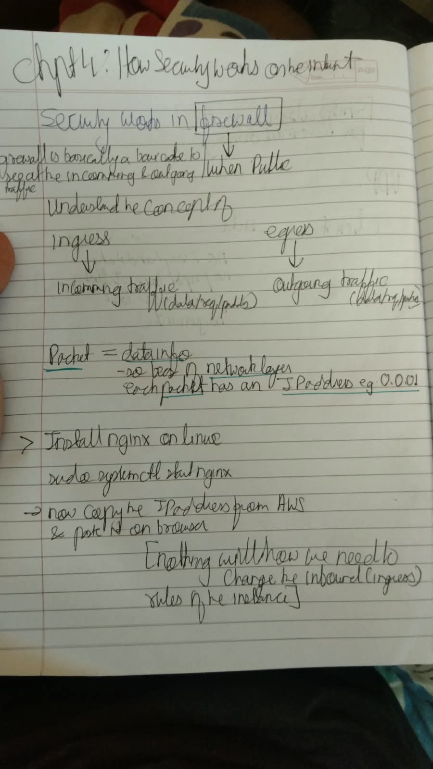

HTTPS TLS and certificate notes
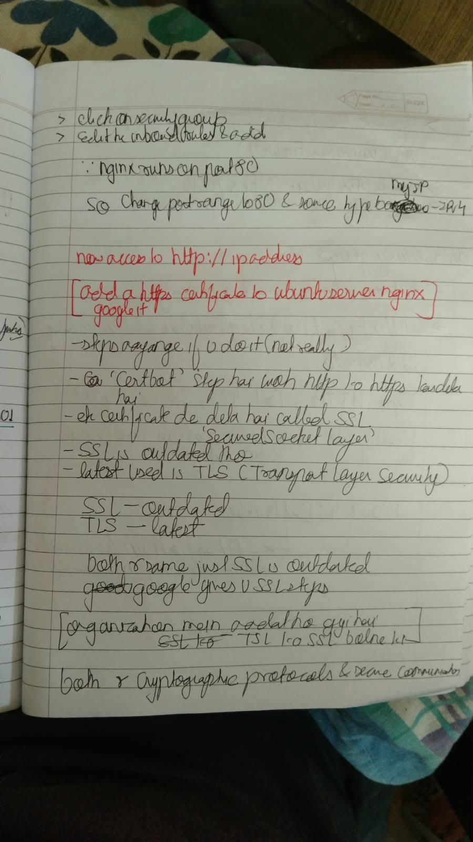

VPC public private subnet and NAT notes
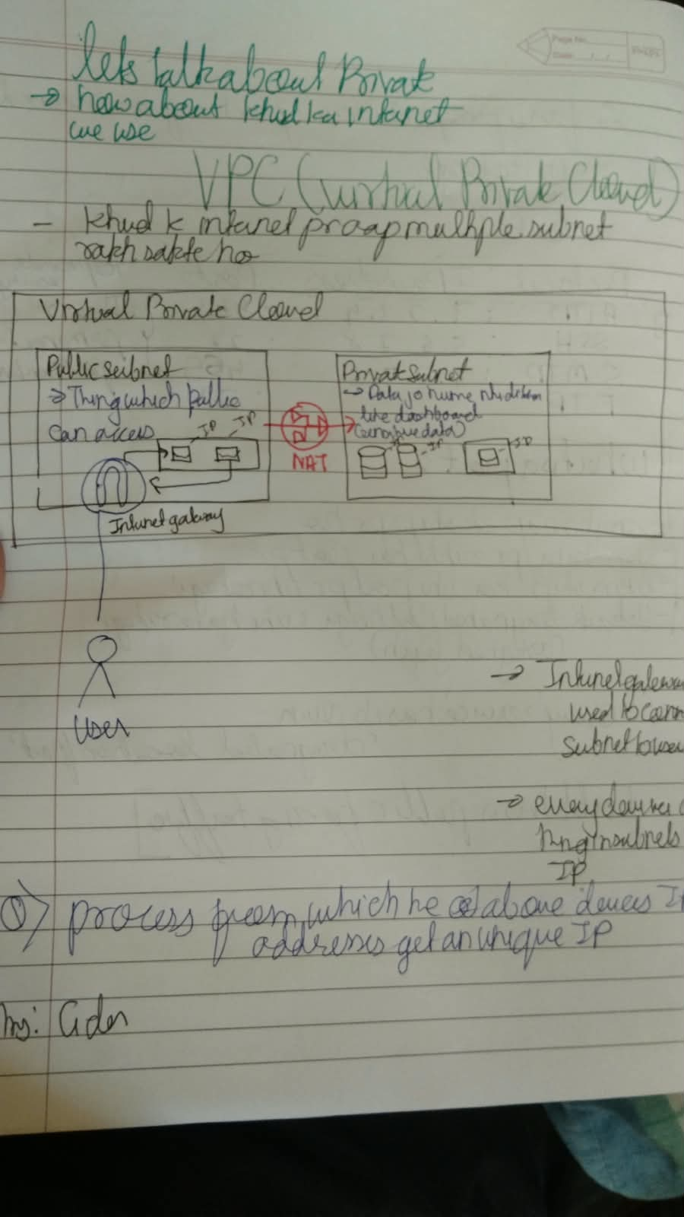

Practical evidence screenshots
These screenshots were embedded in the supplied Security Word document. They show the practical Nginx installation, security-group configuration, successful Nginx response, HTTPS rule, and VPC setup.

Figure 1. Nginx installation and service start on the Ubuntu instance.
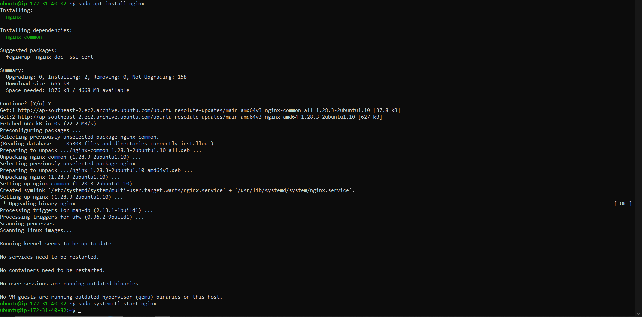

Figure 2. Initial AWS security-group inbound rules showing HTTP and SSH.
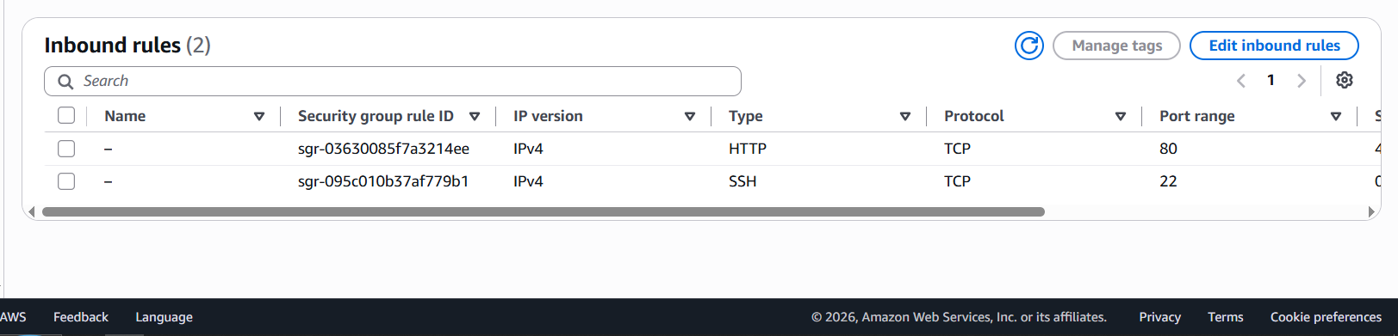

Figure 3. Browser successfully reaching the Nginx default page over HTTP.
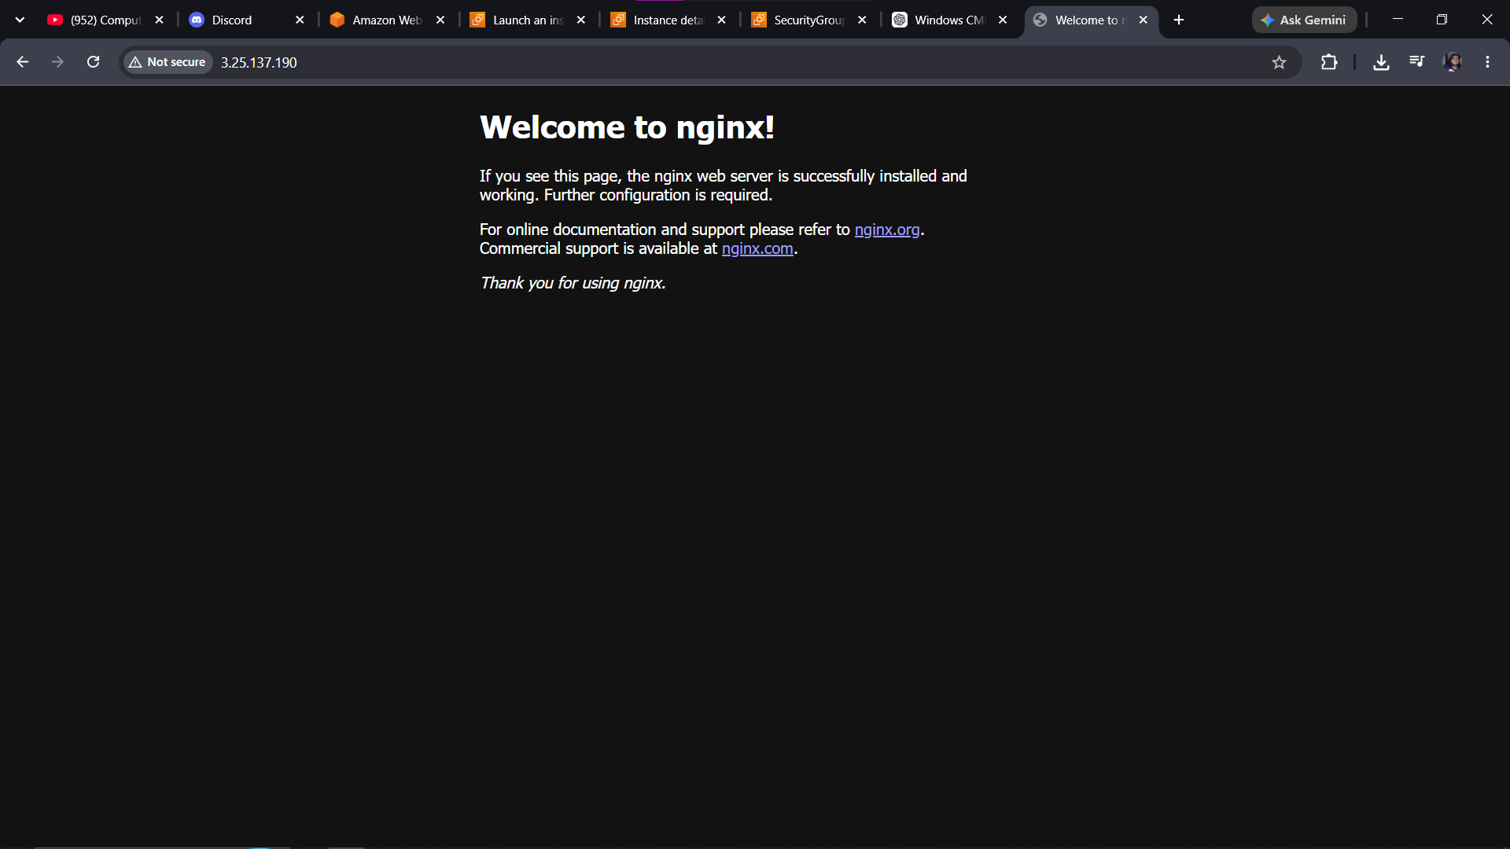

Figure 4. AWS security group updated with an HTTPS rule on TCP port 443.
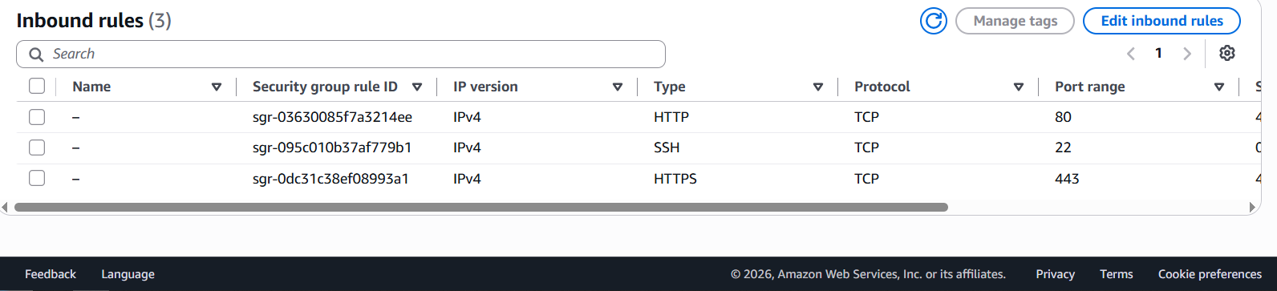

Figure 5. AWS VPC creation screen showing VPC and subnet resources.
