Application of Neural Network in Face Recognition

A measure part in Artificial Intelligence is to let an agent think like a human. In Neural Networks technology we try to represent the human brain and how it acquire, store and uses prior knowledge to create new knowledge. An important part of human brain is to recognize difference object and distinguishes between them.

Facial recognition (or face recognition) is a type of biometric software application that can identify a specific individual in a digital image by analyzing and comparing patterns. Facial recognition systems are commonly used for security purposes but are increasingly being used in a variety of other applications. (source: http://whatis.techtarget.com/definition/facial-recognition)

In this part of this write-up, we will see how Neural Network is used in face recognition. System for face recognition is consisted of two parts: hardware and software. This system is used for automatic recognition users or confirmation of password. For input is used either digital pictures or video frame from same video. State institution and some private organization are using this systems for face recognition especially for identification face by video cameras like input parameter or for biometrics system for checking identity using cameras and 3D scanners. System must to recognize where is face on some picture, to take it from picture and to do verification. There are many ways for verification, but the most popular is recognition of face’s characteristics. Face has about 80 characteristic parameters some of them are: width of nose, space between eyes, high of eyehole, shape of the zygotic bone and jaw width. Face specification is made of these parameters and inserted in database as a representation of that person. Except this, there is a process of face recognition where system has a database with pictures taken from different angles. In this case, system first recognizes a position of face at picture, and with this information compares face with others from database in similar position.

An Application that uses Face Recognition

Face Recognition is essential in many applications, including mugshot matching, surveillance, access control and personal identification, and forensic and law enforcement applications. In this problem, we have a database of a face images for a group of people. Then, given an unknown face image, we want to answer the question: “which person in our database does this image belong to?” Many algorithms and techniques have been proposed for solving such a problem. This application (image below) propose a simple and reliable approach for face recognition that results extremely effective for real-time applications.

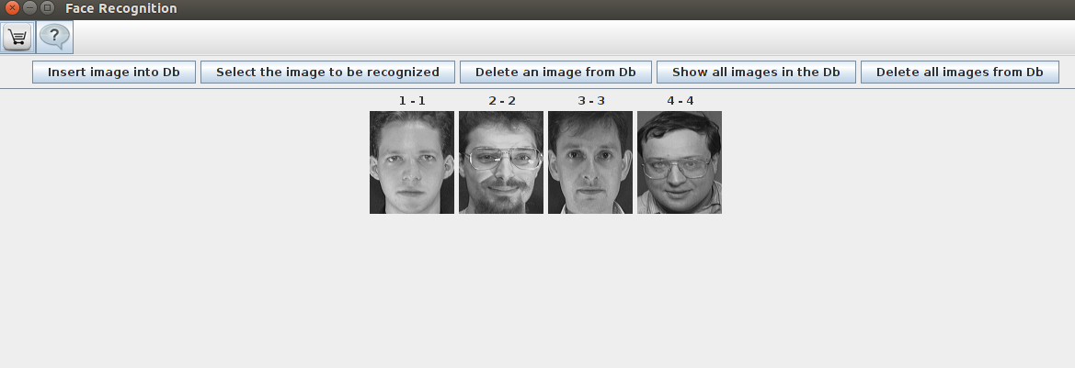

The picture above is show a small Java based program to illustrate the concept of face recognition.
The main aim of the application is to illustrate Face Recognition and thus important aspect of software design like proper documentation and user friendly interfaces are ignored. The code was developed with Java 1.7.0_01. The code has to be considered "as is" and it is without any kind of warranty. The authors (Luigi Rosa) deny any kind of warranty concerning the code as well as any kind of responsibility for problems and damages which may be caused by the use of the code itself including all parts of the source code. The application is an Open Source application for learning purposes.

Facial recognition in this application is carried out using the method of eigenvectors and eigenvalues, and the metric used is the Euclidean distance.

Eigenfaces is the name given to a set of eigenvectors when they are used in the computer vision problem of human face recognition. The approach of using eigenfaces for recognition was developed by Sirovich and Kirby (1987) and used by Matthew Turk and Alex Pentland in face classification.[2] The eigenvectors are derived from the covariance matrix of the probability distribution over the high-dimensional vector space of face images. The eigenfaces themselves form a basis set of all images used to construct the covariance matrix. This produces dimension reduction by allowing the smaller set of basis images to represent the original training images. Classification can be achieved by comparing how faces are represented by the basis set.

How The Application Works?

The application has SEVEN features which are all need to illustrate Face Recognition as seen below

1.Insert image into DB:
Clicking on this button will open a window to select the image to be inserted into the database

2. Select the image to be recognized
Clicking on this button will open a dialog box to choose the image to be recognized. The image to be recognized must be the same size (width, heigth) of images in the database.

3. At the end of the recognition process, you will see a panel in the upper part of which is the image to be recognized, while at the bottom there are all the pictures of the class picture unknown.

4.Delete an image from Db
Clicking on this button will open up the panel that displays all images in elimination mode only: the images can be deleted from the database by clicking on them.

5. Show all images in the Db
Clicking on this button will open up the panel displays all the images in view mode only, each image has a caption which consists of the class code and the ID of the image in the database, separated by a hyphen.

6.Delete all images from Db
Clicking on this button will delete ALL the images in the database at once, the elimination is preceded by a prompt to perform the operation.

7.Toggle Layout
Clicking on this button will change the way images are displayed, moving from the horizontal arrangement to vertical and vice versa

The figure below show a matching Face Recognition.

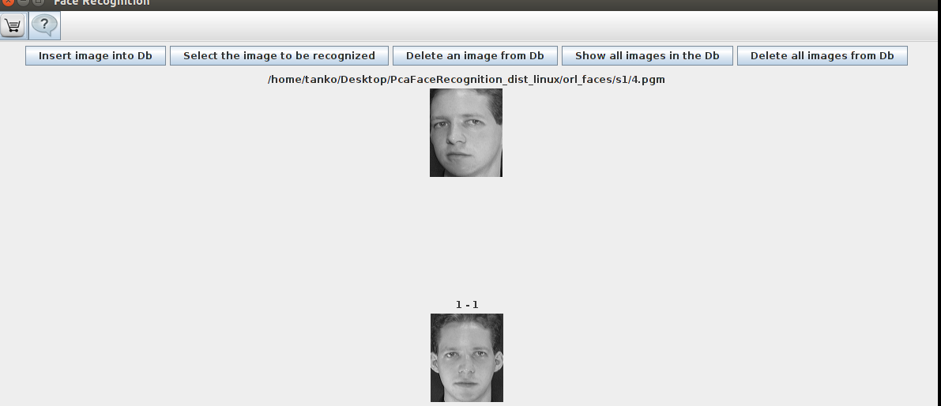

The application can be downloaded at: http://www.advancedsourcecode.com/javaface.asp and it has been Microsoft Windows and Linux version

