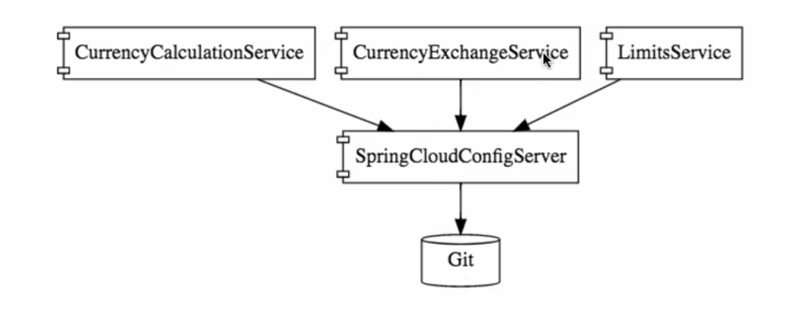
LimitService

This is a simple REST service that returns two values; maximum and mininum form a configuration properties. In this service the configuration of max and min values are taken from the SpringCloudConfigServer

SpringCloudConfigServer

This is a SpringCloudServer, Keeps all application configuration in one place. The spring CloudConfig server read property values from a local git repo. When values change in the git repo, the SpringCloudConfig server picks the updated values automatically.

To connect the configurations of a service(my-service) to SpringCloudConfig,
- Rename the application.properties file to bootstrap.properties
- Put the URI of the SpringCloudServer Service in the bootrap.properties files

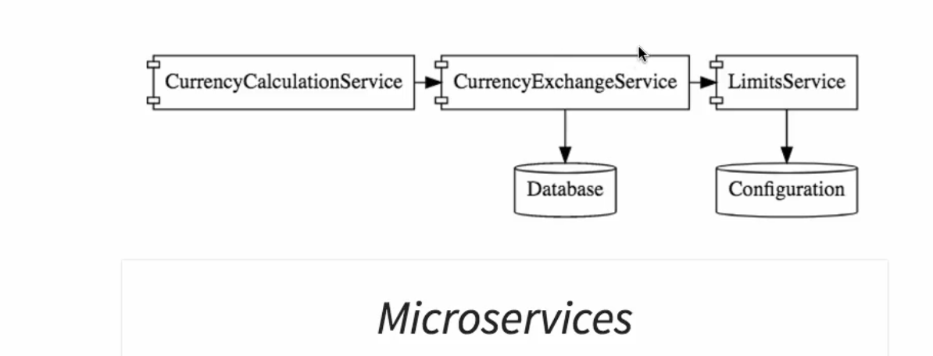
CurrencyExchangeService

Gives the rate of conversion from a currency to another currency

CurrencyCalculationService (CurrencyConversionServices)

Give the currency conversion of an amount from one currency to another

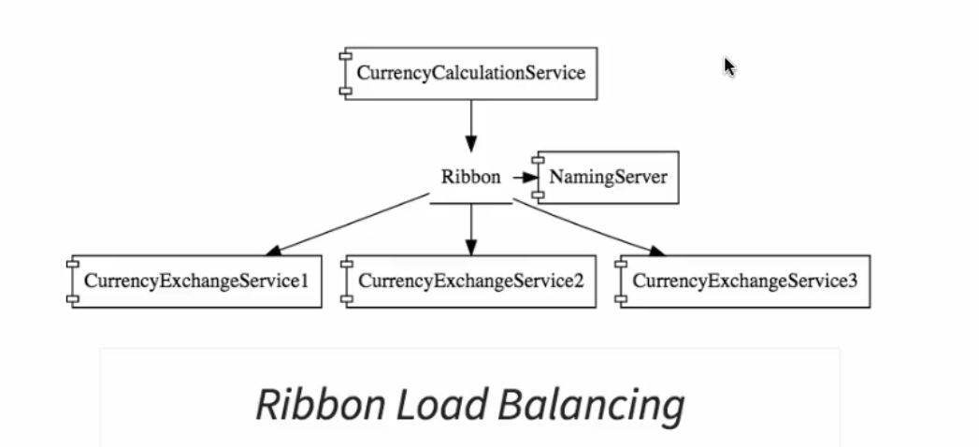

SpringCloud: COMPONENTS

Feign

- Makes it very easy to invoke other rest services
- It provide integration with Ribon (Clientside load balancing)

Ribbon

- Make use of Feign Configuration to distribute the call to different instances of a service (client side load balancing)
- Has a register of list of Ports of all the running instances
- Distributes load between these registered intances

Euraka Nanimg Server

- Helps to make Ribon more efficient by scaling down and up new instances as load increases.
- Dynamically register new instances of a microservice
- The two importance features of naming server are Service registration and service discovery
- For your services to use Euraka, you have to add Eureka dependency on the services package

MONITORING

API Gateways : Zuul API Gateways Server

- Authentication, Authorization and security
- Rate Limit – limit certain calls per hours or perday
- Fault Tolerance
- Service Aggregation (Call multiple services and provide one calls)
Instead of calling a service directly, we make sure that all service calls go through the API Gateways.
The API Gateways, because all service call goes through API Gateway, it serve a a great place for debuging and analitics

To call a service through the API GATEWAYS we use

http://localhost:PORT/{application-name}/{service-uri}

Distributed Tracing (Spring Cloud Sleuth)

- Help Tracing a specific request as it goes to different services
- Spring Cloud Sleuth : Assign a unique ID to a request to identify the request as it goes through different components
- Every Components (Services) should include the SpringCloud Sleuth
  - add dependency in the service Pom.xml
  - Trace the request by creating a Sampler Bean in the main class of the Service

ZipkinDistributedTracingServer

This is a centralized logging components.
- Used RabitMQ to add request (logs or Traces) from all services. When ever there is a trace, the microservices will add it on the RabitMQ and the ZipkinDistributedTracingServer will pull out from the RabbitMQ and display in a centralized Dashboard
- Tipically, the ZipKin Distributed Tracing Server is connected to a Database to keep these traces(logs)

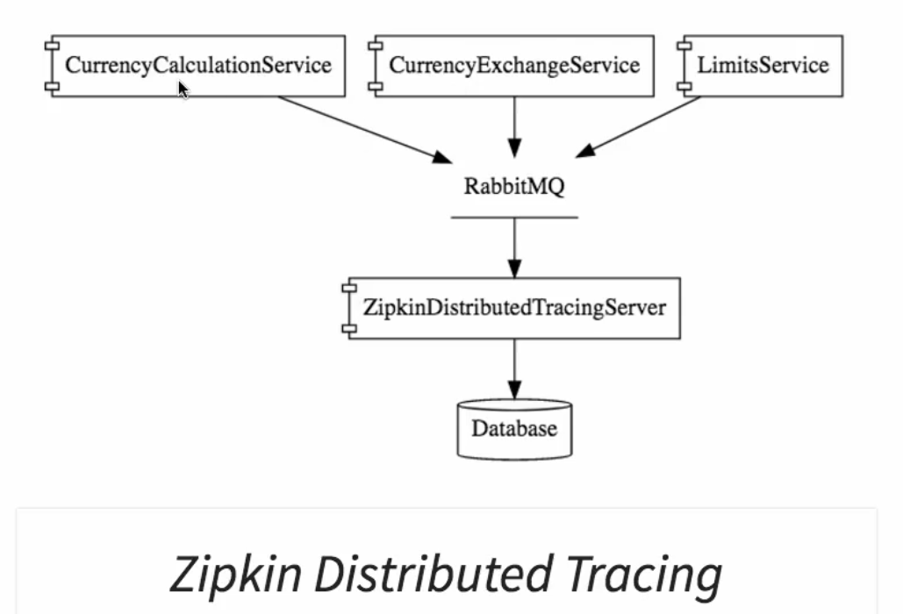

Installing RabbitMQ

- Directory to install(Windows): https://www.rabbitmq.com/install-windows.html, https://www.youtube.com/watch?v=gKzKUmtOwR4
- To install RabbitMQ, you will need to install erlang (download :Window, Linux and installs)
- RabbitMQ runs as a backgroung Service on your system (OS)

Setting Up Zipkin Distributed Tracing Server

- Zipkin Distributed Server will listen to the RabbitMQ and then is connected to a Database
  - Google: quickstart zipkin
  - Use the Java 8 Zipkin jar
  - Download the exec-jar and run java -jar zipkin-server-2.10.1-exec.jar
  - This will start the zipkin server : type http://localhost:9411
  - Make sure your rabbitMQ Server is running
  - To tell Zipkin to connect to RabbitMQ (windows) use:
    - SET RABBIT_URI=amqp://localhost
    - java -jar zipkin-server-2.10.1-exec.jar

Connecting Microservices to put message on RabbitMQ

- Add these dependency on all microservices
  - spring-cloud-starter-sleuth-zipkin
  - spring-cloud-starter-bus-amqp

FAULT TOLERANCE

Hysterix
- Help to manage fault tolerance. If a service goes down all the other services that depence on this services should not go down.
- Add the dependency

Characteristics of Microservices

- Small functionality/ components
- Independent deployment
- Simple Communication using HTTP
- Stateless
- Automated Build and Deployment

SpringBoot

@SpringBootApplication those three things
- Indicate that this is a Spring Context file: Has all the initailized beans
- it Enable AutoConfiguration: Configure, Dispatcher Servlet, View Resolver etc. When SpringBoot see the present of a Bean in the class path, it auto configures the bean
- It Enable Component Scan

- Spring Framwork takes control of all the Beans and all the dependency and autowired them. In the technique call IOC.
- SpringBoot Looks at what is available on the class path and then provide automatic configuration e.g if it see Sping-mvc on the class path, it automatically configure the dispatcher servlet, View Resolver etc
- Spring-boot-starter-actuator is used for monitoring(what are the configured bean, how many times a service is called, the health of the application). To browse through the data provided by actuator, we can use the spring-data-rest-hal-browser. In the application.properties file you can enable what you wish to manage in your actuator (beans, auditeven, health,condition, loggers etc)
- spring-boot-devtools helps to automatically restart you application when you make code change as you are developing

