**E-DOKTA MOBILE APPLICATION**

**2019**

# Abstract

Health is and always has been one the most crucial aspects of human life. A healthy life is a happy life. This therefore means that we need to employ the best means to take care of our health. In Kenya and Africa at large, we have several recognized hospitals and specialists to assist with the same. Currently, to access medical care from hospitals, most people walk in to one, get diagnosed and treated then pay for the service physically either through insurance, cash or card. Patient health and treatment records are kept in the hospital for them. This means that if a patient visits a different hospital it will be difficult to access their records. To counter this issue, we intend to come up with an application that will be installed on the patient’s mobile phone and will allow the patient to access hospital services such as bill payments and access to medical records/ reports conveniently from wherever they are. The mobile application will also be integrated with relevant assurance services to assist in the same. This level of convenience will be advantageous to both the patients and the hospitals as it will reduce significantly the time consumed during the whole process and the resources required. It will also ensure accurate records are retrieved thus better medical care in general.

You should work with us because we work in development sprints so you can see the progress in real-time and offer feedback, we want to make sure you get exactly what you want. That’s why we work in short development “sprints.” You’ll be able to see the progress at the end of each two-week period to offer your feedback and make sure the product matches your vision. We also help with application launch and marketing, our team doesn't just hand off your application to you and disappear. We’ll use our experience to guide you through the common pitfalls of launching and marketing the application. Our approach balances functionality and design, we have designers and developers because we understand the importance of both of those elements. Our team has a lot of experience in working together to deliver beautiful, functional applications; we’ll make these factors work together for you instead of forcing you to choose one over the other. We have vast experience in mobile application design, development and launching.

Table of Contents

sAbstract i

Chapter 1: Introduction 1

1.1 Problem Statement 1

1.2 Aim 1

1.3 Specific Objectives 1

2.1. Introduction 2

1.4 Scope 2

Chapter 2: Development Methodology 3

2.3. Design 3

2.2. Requirements 3

2.2.1. Functional requirements 3

2.2.2. Non-functional requirements 4

2.4.Implementation and Testing 4

2.5. Development Tools 4

2.6. System Modules 5

Terms and conditions 5

Conclusion 6

# Chapter 1: Introduction

## 1.1 Problem Statement

Over the years, patients have been having to physically go to the hospital to pay their bills either using cash, card or insurance. This means that they have to unnecessarily spend a lot of time and resources going all the way there, waiting in lines and going back. Patients have also not been accustomed to keeping proper, updated and accurate medical records. Records are currently being kept by the hospital the patient visits. This is inefficient because to such records are kept separately in each hospital the patient visits making it hard to generate reports and retrieve accurate records for better understanding of the patient’s condition.

## 1.2 Aim

The aim is to come up with an application that will be installed on the patient’s phone and therefore be easily accessible to them anytime, anywhere. The mobile application will ensure patients can conveniently access and acquire hospital services and make payments. The app will be basically convert the physical card to a virtual card for hospital bill payments. It will be integrated to assurance service providers as well as other payments service providers to enable instant checkout from the mobile application. Most importantly, eDokta will keep track of all the patient’s medical records and they will be able to print them out or just pull a report for their next doctor’s visit. eDokta will ensure that this data can only accessed by the patient or a kin that they will have registered during signup therefore guaranteeing confidentiality and safety.

## 1.3 Specific Objectives

* To investigate the challenges facing those that will use the system i.e. patients currently.
* To analyse the existing way of doing things, it’s impact and shortcomings.
* To develop a hospital services mobile application system- eDokta.
* To test the mobile application system.

## 2.1. Introduction

System development methodology refers to the particular framework used to structure, plan and control the process of developing a system. It is a set of related activities whose sequence when followed leads to the production of a software product.

eDokta will be developed using Object Oriented Analysis and Design (OOAD). This development model is advantageous because it allows re-using of code in future.

To develop the application the **Waterfall model** will be used. This model is sequential such that it follows a plan from one process to another. It is our preferred model because all the system requirements are well known and it will ensure an orderly manner of development and consequently better customer delivery.

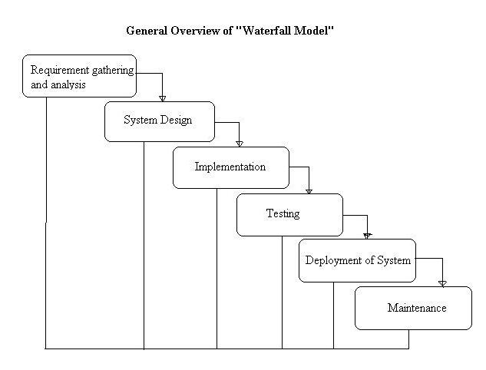

Figure 1: Overview of the waterfall model

## 1.4 Scope

This proposed mobile application will be available online for download by the public on google playstore. It will require an android based environment to run. Users will be able to pay their hospital bills online, keep, maintain, retrieve and generate reports of their medical records whenever they like and from wherever they are using this application. eDokta will also be integrated with insurance companies to enable patients with such payment plans do it conveniently from the app.

# Chapter 2: Development Methodology

## Design

We have come up with the architecture/ design of the application i.e. in this case the three tier (presentation, business logic and database) design, the user interface design the system will have (the forms user will us to input into the system) and the database design in terms how data will be stored and how to enable easy retrieval.

## 2.2. Requirements

### 2.2.1. Functional requirements

Functional requirements define the exact function of the system i.e. how it should react to user input, output to the system. The functional requirements of the mobile application include;

* 1. The system will enable users to register and therefore login and logout of the system.
  2. Users will be able to pay hospital bills online.
  3. Users will be able to add, view and delete records.
  4. Users will be able to pull, view, export and print reports.

### 2.2.2. Non-functional requirements

These are requirements that give criteria that could be used to critique or judge the operation of a system. They could be defined as the system attributes. Non-functional requirements of eDokta include;

1. *Operational*

eDokta requires a smart mobile phone with android environment and active internet to be used.

1. *Security*

eDokta ensures the patient’s information is secure by providing proper authentication.

1. *Performance*

eDokta has a simple user interface and ensures smooth running of the entire process.

## 2.4.Implementation and Testing

We will avail the application to our software analysts and the public to test the flow of the system and correct on any critique points to ensure it runs smoothly.

## 2.5. Development Tools

These are the languages and programs used to develop the system.

1. PHP

PHP is a scripting language used to create interactive and dynamic web pages. It will be used to implement the business logic and rules of the warehouse in the system.

1. Laravel

This is an application framework that uses the Model-View-Controller pattern which enables fast development of web applications that are easy to maintain.

1. Javascript, HTML, CSS

These are development languages that are used to create and design the user interface of the system.

1. MySql

This is used to create and store the system’s database. It will be accessed using MySql workbench.

## 2.6. System Modules

1. User management module

This module will enable users to register themselves in the application and therefore be able to login (using their email and password) and logout.

1. Payments module

This module will enable the user to view their hospital bills and pay for them from the app either using their insurance plan or other payment services such as mpesa, visa card etc.

1. Records module

This module will enable users to view, add, edit or delete their medical records.

1. Reports module

This module will enable users to generate, export and print reports.

# Terms and conditions

*(Fill in payments terms etc)*

# 

# Conclusion

eDokta is a mobile application that will impact the medical world dynamic positively. It will ensure convenience on all accords regarding hospital services and efficiency during the entire process.