**EXPLOIT TELNET**

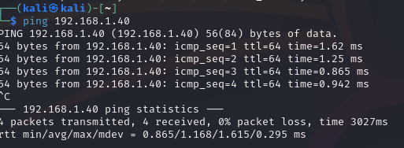

Ping to verify.

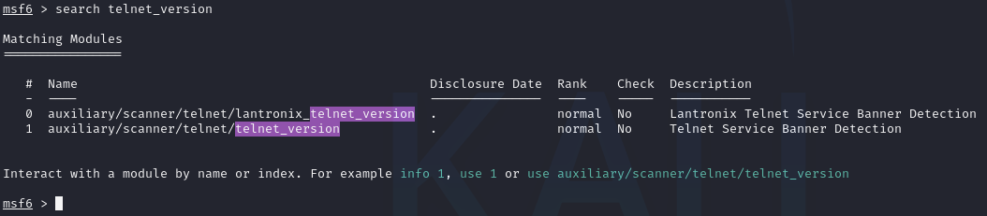

search for auxiliary telnet_version

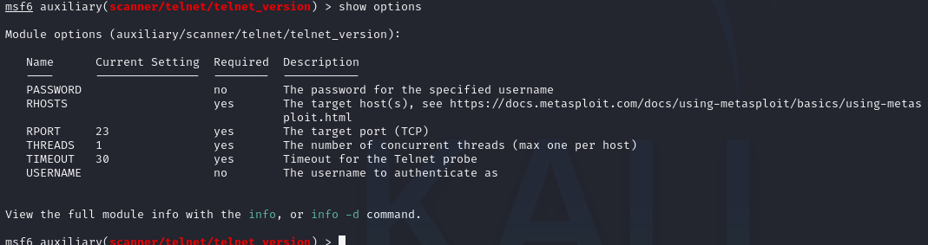

use this auxiliary module to scan telnet version

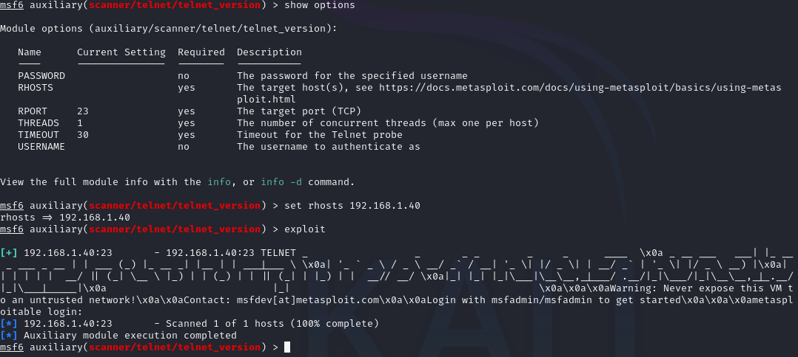

The framework gives back username and password for login

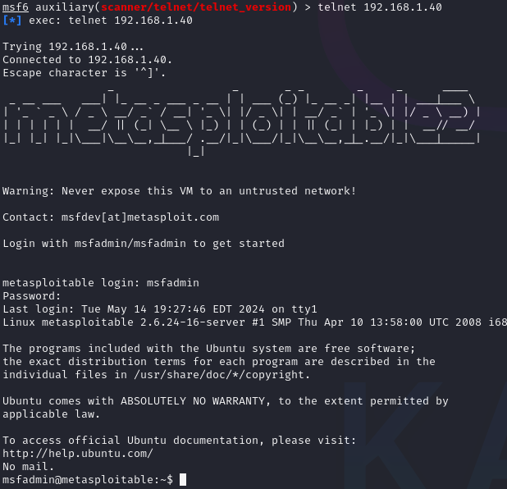

Log into telnet and we get access.