**BUFFER OVERFLOW.**

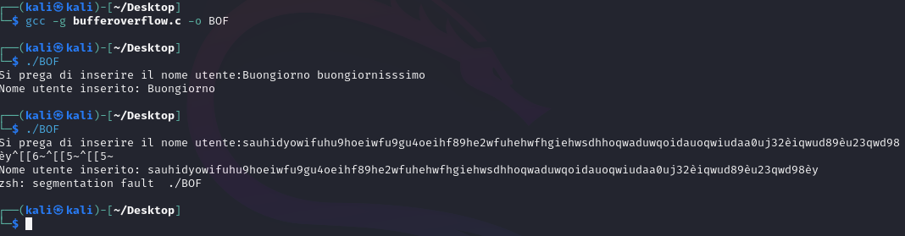

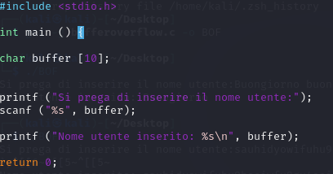

I’m going to modify the char buffer to 30.

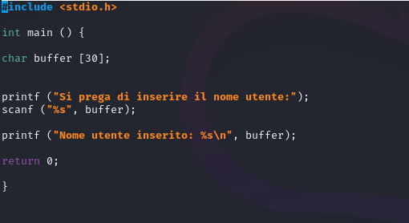

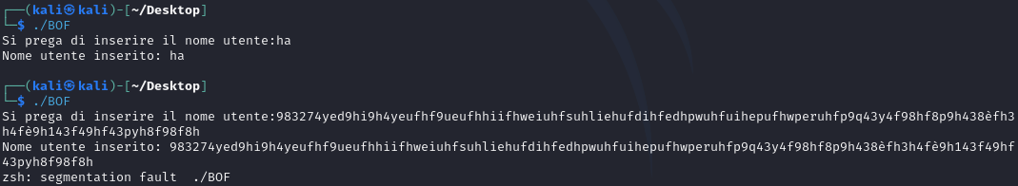

More than 30 characters, it will give us the error again.