Open CMDER.

Navigate on the command line to the location where you’ve saved the repository folder as below in the screenshot. (eg. on you desktop)

Type ‘ipython’ to run this interactive version which will run the scripts when you choose them.

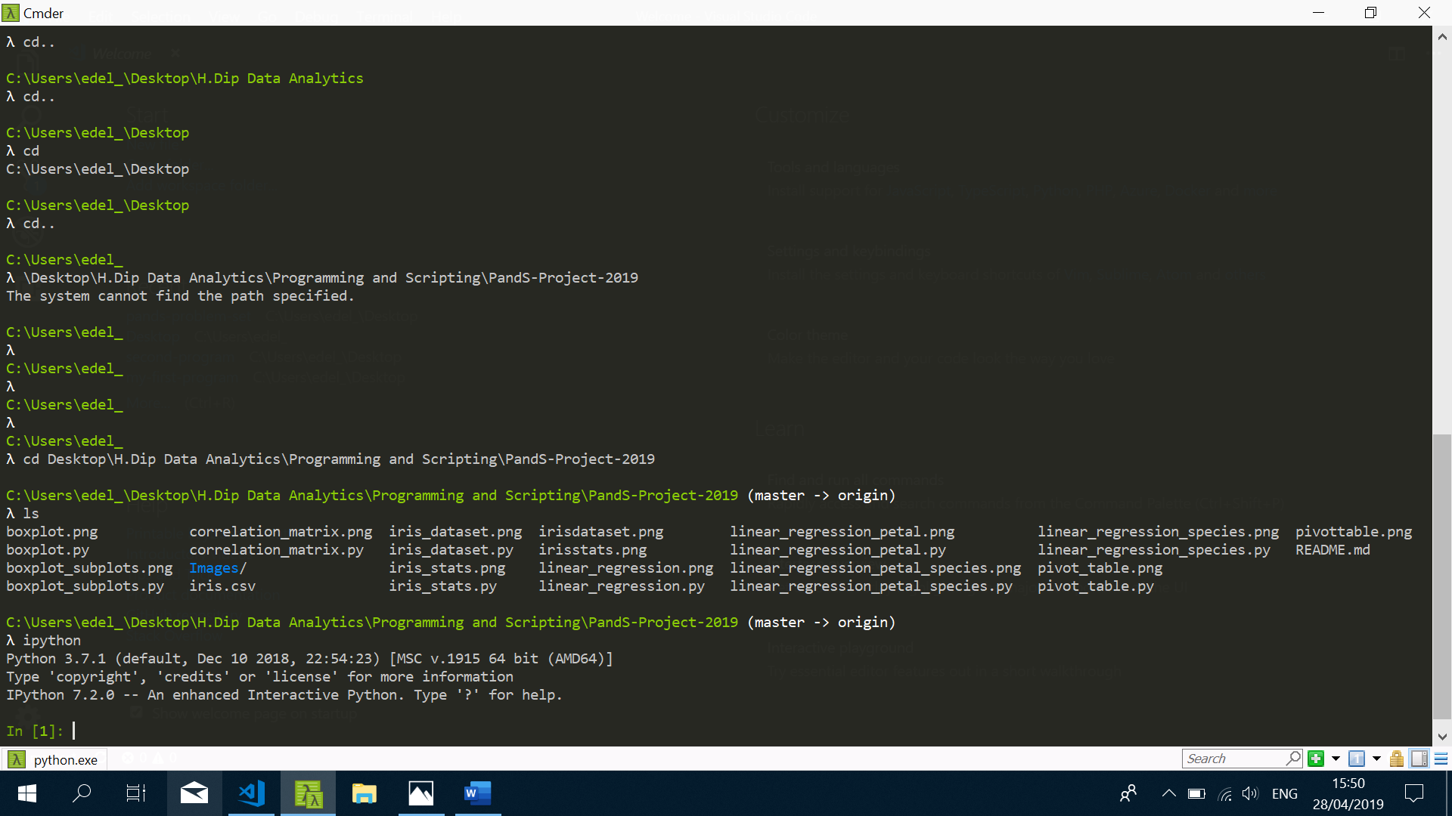

For example if you type ‘run iris_dataset.py’ then ipython will run that script of code which will output the whole dataset for you to view.

You can do this for all the python script files.

