WeatherTop

Programming & Web Development

Joint Assignment Briefing

*Version 1.1*

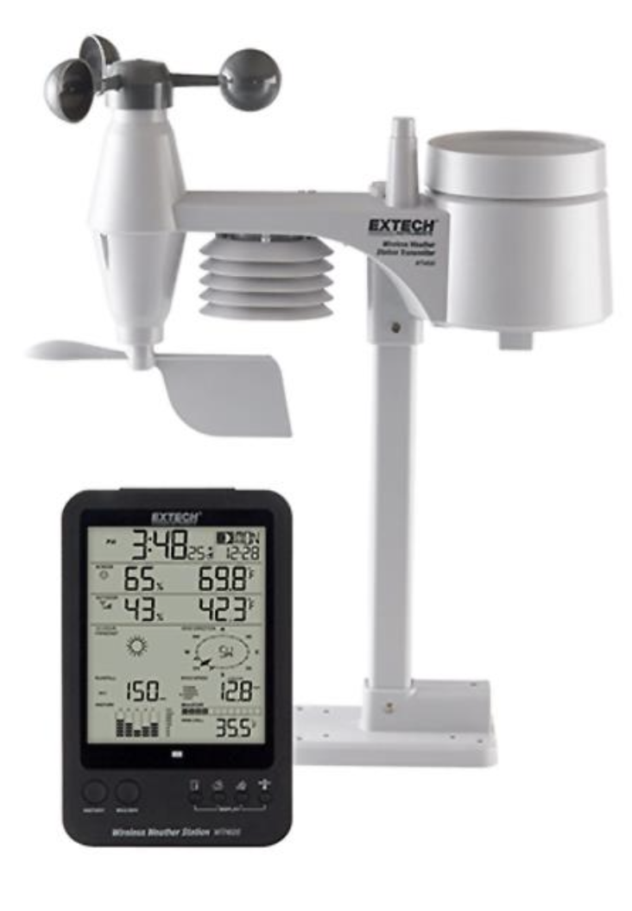

Table of Contents

WeatherTop 1

Scope 4

Project Deliverables 4

Version 1: Starter 5

Version 2: Baseline 6

Outputs 6

Version 3: Release 1 8

Outputs 8

New Features 8

1. Add Station 8

2. Add Reading 9

Submitting 9

Version 4: Release 2 10

New Features 10

1 User Accounts System. 10

2 Location 11

3 Current Weather Icon 11

4 Max/Min 11

Submitting 11

Version 5: Release 3 12

New Features 12

1. Trends 12

2. Date/Time stamp on each reading 13

3. Station Summary 14

4. Delete Support 14

5. Deployed 14

6. Member Details 14

Submitting 14

Appendix A: Conversions/Codes/Calulators 15

(i) Weather Codes 15

(ii) Celsius to Fahrenheit Conversion 15

(iii) kM/hr to Beaufort Conversion 15

(iv) Wind Direction Compass 16

(v) Wind Chill Calculator 16

APPENDIX B: YAML (.YML) FILES 17

Version 1 (starter) - data.yml 17

Version 2 (baseline) - data.yml 18

Version 3 (Release 1) - data.yml 19

Version 4 (Release 2) - Data.yml 20

Version 5 (Release 3) - Data.yml 22

APPENDIX C: Q & A with WeatherTop Inc. 24

APPENDIX D: Code Style 25

APPENDIX E: Video Guide 26

APPENDIX F: Payment/Grading Rubric 28

# Scope

WeatherTop Inc. produce a modular weather station called the *WeatherTop 1000*. This low-cost device takes a set of meteorological readings and displays these on a simple LCD display. WeatherTop Inc. are seeking a Web companion application for the device. This document is the specification for this application.

## Project Deliverables

As WeatherTop Inc. are new to the software industry they are looking to ameliorate any risk by insisting on a working version of the application, even if not all of the features they requested are implemented. They have structured an incremental payment schedule accordingly, with 5 versions as follows:

|  |  |  |
| --- | --- | --- |
| Version | Package Label | Payment |
| 1 | **Starter** | 0%-20% |
| 2 | **Baseline** | 20%-45% |
| 3 | **Release 1** | 45%-60% |
| 4 | **Release 2** | 60%-70% |
| 5 | **Release 3** | 70%-100% |

They will pay based on the quality of the implementation – Appendix D summarizes the features/payment schedule[1].

They will accept the most complete version only, as one of the following:

1. A zipped archive of all code for the version (named version-codename.zip)
2. A GitHub repository

They have a preference for (2), but are happy to accept (1)

When reading this document:

* **Appendix A** will help explain how codes, conversions, and calculations can be computed as required in the different versions.
* **Appendix B** shows the file structure of DATA.YML used for each version. Differences between each are highlighted. These are also available as an archive for testing.

# Version 1: Starter

The application launches and reads a YAML file (.yml) of readings for a small number of weather stations. Each reading consists of:

* Weather Code (number in range 100-800), integer
* Temp (C) decimal
* Wind Speed (kM/hr) decimal

The application then presents these readings on a dashboard:

The application has informational + attractive graphic images on the About and Main views (not shown). WeatherTop are open to interesting proposal for these views – they should not contain any data, just interesting information about the application and the Weather domain in general.

# Version 2: Baseline

This version includes all features in *Starter­,* with one additional piece of data in the reading for each station:

* Pressure (hPa) Number

## Outputs

The dashboard for the application should present, for each station, the *Latest Weather* at that station. The latest weather is derived from the most recent (**last**) reading for the station, and should contain:

1. Station Name
2. Weather conditions - code presented as a description *see Appendix A (i)*
3. Temp in both C & F *see Appendix A (ii)*
4. Wind in Beaufort *see Appendix A (iii)*
5. Pressure *(as read in)*

The dashboard above is an example display, you are free to present alternative (either simpler or enhanced) designs.

# Version 3: Release 1

This version includes all features in *baseline,* with one additional piece of data in the reading for each station:

* Text

  Description automatically generatedWind Direction, number 0-360

## Outputs

For each station, the wind summary is to be expanded to include:

* Wind Compass *see Appendix A (iv)*
* Wind Chill *see Appendix A (v)*

## New Features

The application is to permit 2 additional features:

1. Add Station
2. Add Reading

### 1. Add Station

The default view of the application is changed to now present a list of station names on the dashboard (without current conditions or readings):

A station can be added via the “Add Station” button, accepting the Station name.

Clicking on the Folder button will open station view, summarising the latest weather at the station (as before).

### 2. Add Reading

When the Station is opened, current conditions + readings appear:

New readings can be entered and submitted as shown above.

## Submitting

As this is Release 1, version control is an issue for WeatherTop Inc. This they would ideally like a Github repo of this version (but will accept a zipped archive).

# Version 4: Release 2

## New Features

This version includes all features in the previous release, plus 4 new capabilities

1. User Accounts
2. Location of Station
3. Current Weather Icon
4. Max/Min

### 1 User Accounts System.

To use this version of the application users **must** log in (or signup/register first). When the application launches, a login page is presented. Unregistered users can access a signup form. Users and their associated stations and readings can be loaded from the data.yml file.

### 2 Location

When **creating** a station, the user must also enter the **latitude** and **longitude** for the station. Accept and store in decimal degrees (DD) format. Note this changes the data.yml file.

### 3 Current Weather Icon

Each weather code is associated with a corresponding icon. This icon is part of the Fomantic UI library (<https://fomantic-ui.com/elements/icon.html> ).

### 4 Max/Min

The station report should now include maximum and minimum values of the following readings:

* Temperature
* Wind Speed
* Pressure

## Submitting

As this is Release 2, WeatherTop Inc. expect the application to be deployed and the Github repo tagged.

# Version 5: Release 3

## New Features

This version includes all features in the previous release, plus 6 new capabilities

1. Trends
2. Date/Time stamp on each reading
3. All Stations Summary
4. Station/Reading delete support
5. Deployed to the cloud
6. Members can edit their personal details

### A picture containing graphical user interface Description automatically generated1. Trends

Trends are required for

* Temperature,
* Wind Speed
* and Pressure.

A trend can be:

* Rising ( ): the three most recent measurements are increasing
* Falling ( ): the three most recent measurements are falling
* Steady: neither of the above

### A picture containing graphical user interface Description automatically generated2. Date/Time stamp on each reading

When a reading is added, it is time stamped with the current time.

### 3. Station Summary

On the main dashboard, show the **latest conditions** (but not the readings) for each station.

### 4. Delete Support

Delete buttons next to each reading and station

### 5. Deployed

Application deployed to a **cloud** service

### 6. Member Details

Provide option to enable Member details to be edited

## Submitting

As this is Release 3, WeatherTop Inc. expect the application to be deployed and the Github repo to be tagged, but also show a commit history.

# Appendix A: Conversions/Codes/Calulators

## (i) Weather Codes

|  |  |
| --- | --- |
|  |  |
| 100 | Clear |
| 200 | Partial clouds |
| 300 | Cloudy |
| 400 | Light Showers |
| 500 | Heavy Showers |
| 600 | Rain |
| 700 | Snow |
| 800 | Thunder |

## (ii) Celsius to Fahrenheit Conversion

*T*(°F) = *T*(°C) × 9/5 + 32

## (iii) kM/hr to Beaufort Conversion

|  |  |  |
| --- | --- | --- |
| Beaufort | Beaufort Label | Km/h |
| 0 | Calm | 1 |
| 1 | Light Air | 1-5 |
| 2 | Light Breeze | 6-11 |
| 3 | Gentle Breeze | 12-19 |
| 4 | Moderate Breeze | 20-28 |
| 5 | Fresh Breeze | 29-38 |
| 6 | strong Breeze | 39-49 |
| 7 | Near Gale | 50-61 |
| 8 | Gale | 62-74 |
| 9 | Severe Gale | 75-88 |
| 10 | Strong storm | 89-102 |
| 11 | Violent Storm | 103-117 |

## (iv) Wind Direction Compass

|  |  |
| --- | --- |
| Compass Direction | Degree Range |
| N | 348.75 - 11.25 |
| NNE | 11.25 - 33.75 |
| NE | 33.75 - 56.25 |
| ENE | 56.25 - 78.75 |
| E | 78.75 - 101.25 |
| ESE | 101.25 - 123.75 |
| SE | 123.75 - 146.25 |
| SSE | 146.25 - 168.75 |
| S | 168.75 - 191.25 |
| SSW | 191.25 - 213.75 |
| SW | 213.75 - 236.25 |
| WSW | 236.25 - 258.75 |
| W | 258.75 - 281.25 |
| WNW | 281.25 - 303.75 |
| NW | 303.75 - 326.25 |
| NNW | 326.25 - 348.75 |

## (v) Wind Chill Calculator

Wind chill = 13.12 + 0.6215 **T** – 11.37 (**V**^0.16) + 0.3965 **T** (**V**^0.16)

* **T** = Temperature in degrees Celsius
* **V** = Wind velocity in kilometers per hour

# APPENDIX B: YAML (.YML) FILES

Subsequent versions show structure differences highlighted in yellow.

## Version 1 (starter) - data.yml

Reading(r1):  
 code: 800  
 temperature: 0.5  
 windSpeed: 3.5  
  
Reading(r2):  
 code: 600  
 temperature: 6.0  
 windSpeed: 2  
  
Reading(r3):  
 code: 700  
 temperature: 8.0  
 windSpeed: 1  
  
Reading(r4):  
 code: 200  
 temperature: 0.5  
 windSpeed: 3.5  
  
Station(s1):   
 name: Tramore  
 readings:  
 - r1  
 - r2  
  
Station(s2):  
 name: Dunmore  
 readings:  
 - r3  
 - r4

## Version 2 (baseline) - data.yml

Reading(r1):  
 code: 800  
 temperature: 0.5  
 windSpeed: 3.5  
 pressure: 1001  
  
Reading(r2):  
 code: 600  
 temperature: 6.0  
 windSpeed: 2  
 pressure: 1004  
  
Reading(r3):  
 code: 700  
 temperature: 8.0  
 windSpeed: 1  
 pressure: 1000  
  
Reading(r4):  
 code: 200  
 temperature: 0.5  
 windSpeed: 3.5  
 pressure: 999  
  
Station(s1):  
 name: Tramore  
 readings:  
 - r1  
 - r2  
  
Station(s2):  
 name: Dunmore  
 readings:  
 - r3  
 - r4

## Version 3 (Release 1) - data.yml

Reading(r1):  
 code: 800  
 temperature: 0.5  
 windSpeed: 3.5  
 windDirection: 220  
 pressure: 1001  
  
Reading(r2):  
 code: 600  
 temperature: 6.0  
 windSpeed: 2  
 windDirection: 200  
 pressure: 1004  
  
Reading(r3):  
 code: 700  
 temperature: 8.0  
 windSpeed: 1  
 windDirection: 90  
 pressure: 1000  
  
Reading(r4):  
 code: 200  
 temperature: 0.5  
 windSpeed: 3.5  
 windDirection: 120  
 pressure: 999  
  
Station(s1):  
 name: Tramore  
 readings:  
 - r1  
 - r2  
  
Station(s2):  
 name: Dunmore  
 readings:  
 - r3  
 - r4

## Version 4 (Release 2) - Data.yml

Stations have new fields for latitude and longitude (decimal degree format). Members are appended to the end.

Reading(r1):  
 code: 800  
 temperature: 0.5  
 windSpeed: 3.5  
 windDirection: 220  
 pressure: 1001  
  
Reading(r2):  
 code: 600  
 temperature: 6.0  
 windSpeed: 2  
 windDirection: 200  
 pressure: 1004  
  
Reading(r3):  
 code: 700  
 temperature: 8.0  
 windSpeed: 1  
 windDirection: 90  
 pressure: 1000  
  
Reading(r4):  
 code: 200  
 temperature: 0.5  
 windSpeed: 3.5  
 windDirection: 120  
 pressure: 999  
  
Station(s1):  
 name: Tramore  
 latitude: 52.1623500

longitude: -7.1524400  
 readings:  
 - r1  
 - r2  
  
Station(s2):  
 name: Dunmore

latitude: 52.1499994

longitude: -6.9833294  
 readings:  
 - r3  
 - r4

Member(m1):  
 email: homer@simpson.com  
 password: secret  
 firstname: Homer  
 lastname : Simpson  
 stations :  
 - s1  
 - s2

## Version 5 (Release 3) - Data.yml

Reading(r1):

date: 2021-01-19 08:31:00  
 code: 800  
 temperature: 0.5  
 windSpeed: 3.5  
 windDirection: 220  
 pressure: 1001  
  
Reading(r2):

date: 2021-01-20 09:34:00  
 code: 600  
 temperature: 6.0  
 windSpeed: 2  
 windDirection: 200  
 pressure: 1004  
  
Reading(r3):

date: 2021-01-20 10:31:00  
 code: 700  
 temperature: 8.0  
 windSpeed: 1  
 windDirection: 90  
 pressure: 1000  
  
Reading(r4):

date: 2021-01-19 09:31:00  
 code: 200  
 temperature: 0.5  
 windSpeed: 3.5  
 windDirection: 120  
 pressure: 999  
  
Station(s1):  
 name: Tramore  
 latitude: 52.1623500

longitude: -7.1524400  
 readings:  
 - r1  
 - r2  
  
Station(s2):  
 name: Dunmore

latitude: 52.1499994

longitude: -6.9833294  
 readings:  
 - r3  
 - r4

Member(m1):  
 email: homer@simpson.com  
 password: secret  
 firstname: Homer  
 lastname : Simpson  
 stations :  
 - s1  
 - s2

# APPENDIX C: Q & A with WeatherTop Inc.

*Q: Is this the complete specification?*

A: No, we are currently developing additional feature concepts – we will release these in another week or so.

*Q: Will you accept partial implementations of a version if we run out of time?*

A: Yes

*Q: Must we complete all features specified in a version before attempting the next version?*

A: No, we are happy to accept partial implementations of each version.

*Q: How will you know which features we have implemented?*

A: We will run all the versions. In addition, we ask that you submit a rubric/reflection grid indicating your achievements + a short demo video

*Q: Can we attempt any innovations over and above the specification?*

A: Yes, but this only makes sense if you have completed the entire specification.

*Q: Should we follow the ‘Design Ideas’ below precisely?*

A: Not necessarily - if you have other ideas, we are happy to see them and they may be rewarded with additional payments.

# APPENDIX D: Code Style

Coding Style Guides are often adopted by development teams to ensure consistent code layout, naming and recommended method, class and file sizes. These guidelines aid developers moving between projects – and also working with components authored by different team members within a single project. WeatherTop industries have adopted the default IntelliJ code style – with the following settings:

We expect the Java code to be formatted with the above, which can be triggered automatically via *“Code->Reformat Code*” menu option in the IDE. In addition to the above, we are also supporters of sensible choices as itemized on this [short guide here](https://rhamedy.medium.com/a-short-summary-of-java-coding-best-practices-31283d0167d3). However, we are not expecting strict adherence to this guide. Nevertheless, we are fussy about:

* Indentation as enforced by the above settings
* Blank lines used very sparingly
* Reasonably short methods – typically < 15 lines. Although the conversion/analytic methods will be longer for certain algorithms.

*A note on Comments:* We have no objection to comments if individual developers like to use them as a learning tool, documenting their knowledge. However, we support [Self Documenting Code](https://en.wikipedia.org/wiki/Self-documenting_code), with good name choices + simple algorithmic approaches preferred over complicated over optimized techniques.

We expect HTML code to follow the same indentation + blank lines policies as above.

# APPENDIX E: Video Guide

The advice here is similar to Programming Assignment 2. You must include a video (screen recording) [min 5 mins, max 10 mins] to present your assignment. The video must include voice audio (microphone).

Before recording, plan out your video.

**Structure of the video:**

| **Part** | **Description** | **Duration** |
| --- | --- | --- |
| **Intro** | Here you should use the rubric to introduce the versions you completed successfully, or partially completed.  You are now in a position to **estimate** **payment** **and request this**. The remainder of the video explains why you deserve that payment! | (<1 min) |
| **Demo** | Demonstrate the working features of your latest version of the application (as already highlighted in the intro).   For the version you have reached, (a particular row in the rubric), demonstrate the features working in that row for each column that are working. If you have gone further in other columns demonstrate those features also. Mention any elements from particular cells in the rubric that are NOT working. | (<3 mins) |
| **Code Walkthrough** | You’ve demonstrated what’s working above. Now, Explain how your code works to implement what you’ve demonstrated, opening up the relevant files and sections as they would be called. | (<6 mins) |

Start by filling in the rubric. Tick off all the boxes that are complete. If a box is partially complete, tick the parts that are complete, and circle the parts that are not. This will enable you to present very concisely what you have managed to do and will focus the subsequent interview. Add commentary to summarise what is completed in the rubric, and for any elements that are attempted but incomplete (for each column). You have now completed a written reflection.

There are many software programs that enable you to record the desktop as a video. Use whatever works for you but record at a **minimum** of HD (720p), **maximum** of Full HD (1080p). Examples include:

* Apple Quicktime
* OBS (free open source)
* Screencast-o-matic
* Zoom
* Loom
* Camtasia (PC)
* ScreenFlow (Mac)
* SnagIt
* Jing
* ShareX

You will need to upload your video to YouTube as **unlisted**. Use your student number to login to YouTube. Copy the **URL** and include in the reflection where shown.

Do NOT submit a video file to Moodle.

Allow plenty of time to do your Reflection, make your video, and upload it to YouTube especially if you're broadband is slow.

# APPENDIX F: Payment/Grading Rubric

|  | Reading | Station | Member | Features | Code |
| --- | --- | --- | --- | --- | --- |
| Starter | Code Temp Wind Speed | Station Name | None | Load and display stations + their readings from Yaml file | Zipped archive |
| Baseline | + Pressure | + Latest weather, Temp C, F, Wind Bft, pressure | None | + display latest weather for station | Zipped archive + Readme |
| Release 1 | + Wind Direction | + Wind Chill, Wind Compass | None | Dashboard shows station list + button to open station view. Include forms to add new Station + new reading | Github repo |
| Release 2 |  | +Lat, Lng  Max/Min (Temp, Wind, Pressure) | First Name, Last Name, Email, Password  + Stations | Members can signup/log in. Members may create any number of weather stations. Members + sample stations + readings loaded from YAML | Deployed +  Github repo  + history |
| Release 3 | + Time/Date | Temp, Wind Pressure Trends | User can edit their personal details. | Member dashboard list summary lists latest conditions for all stations.  (alphabetically). Members can delete reports or stations | Deployed +  Github repo  + history  tags) |

1. Payment == mark range