# SAMSON settings for rendering of figures

The SAMSON Preferences is at Edit->Preferences.

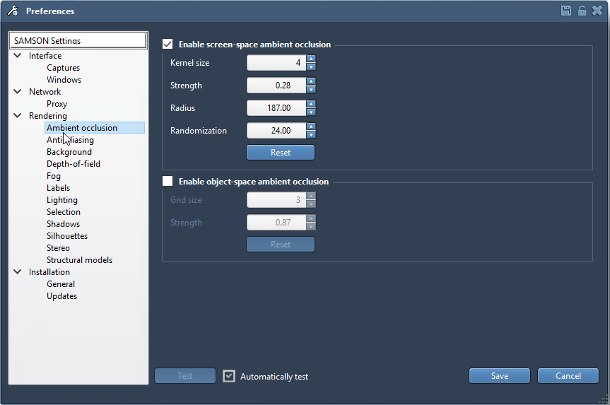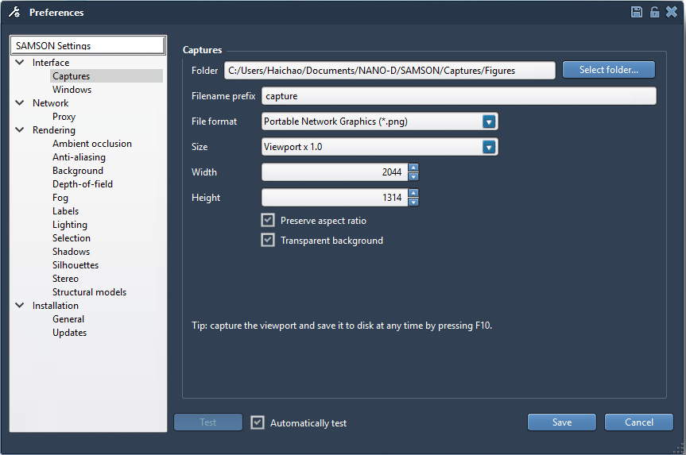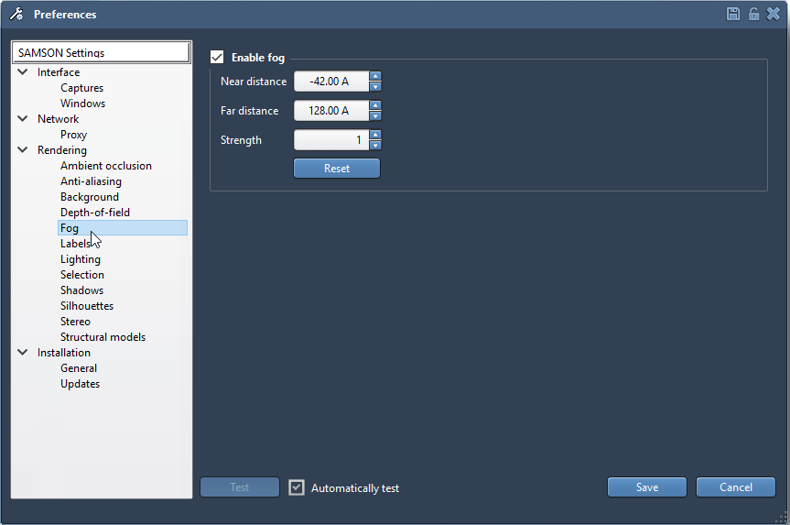

The Fog near and far distance parameters depend on the sizing of you structure and have to be adjusted accordingly.

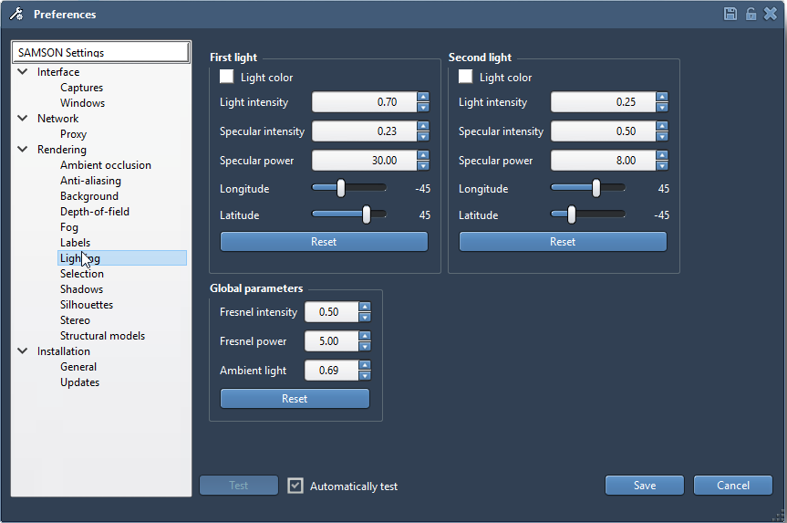

Light color can also be changed depending on whether a warm or cold look is preferred. White for now works just fine for the “illustrative” style.

