Process Overview
Purpose
Use this procedure to block the transfer or sale of national warehouse stock.
Process Trigger
A National Warehouse Administrator may choose to classify certain items as "Restricted Stock" in order to raise the price of remaining goods, by adjusting supply and demand. Therefore, the Administrator would use this transaction to place a block on the transfer or sale of national warehouse stock.
Prerequisites
- National warehouse stock must exist
- User must know the material, plant, storage location, batch, and unit of entry
Portal Path
Follow the Portal path below to complete this transaction:
- Select Operations tab Warehouse Management tab Inventory Management folder Perform Goods Movement to go to the Transfer Posting Other screen
Tips and Tricks
- The R/O/C represents Required, Optional, or Conditional field entry
- Go to the Portal help for additional information
- Call Tech support for assistance
- Remember to always check your work

Procedure
1. | Start the transaction using the following Portal path: Operations tab Warehouse Management tab Inventory Management folder Perform Goods Movement

Transfer Posting Other
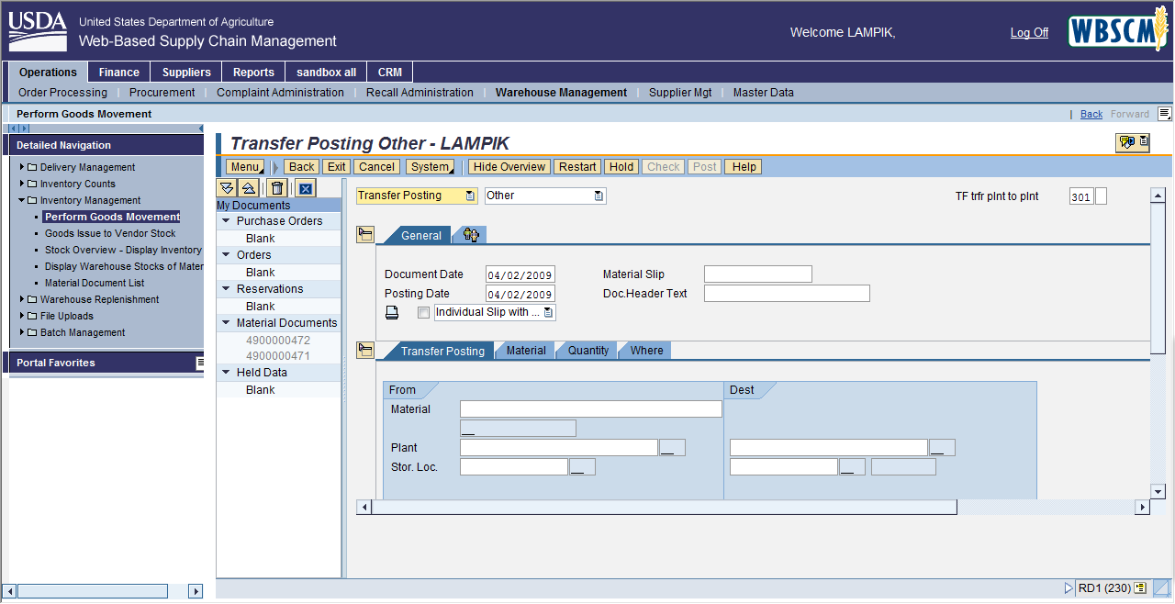

2. | As required, complete/review the following fields:

 | Field | R/O/C | Description
 | Material | R
  Substance or commodity that is bought or sold on a commercial basis, or is used, consumed, or created in production; a material can also be a service. Also, a number identifying a material master record.
  Example:
  100262
 | Plant | R
  Also known as a Warehouse, it is a place where materials are produced, or goods and services are provided. Is also used for the physical location where commodities are stored for future disbursement.
  Example:
  2000
 | Stor. Loc. | R
  The physical location within a plant where the material is stored.
  Example:
  1000
 | Batch | R
  Also known as Lot, it is a number that uniquely assigns a material manufactured in a lot. The batch material is managed separately from other sets of the same material. Also, used to describe the running of multiple non-manual transactions in SAP.
  Example:
  NWTS18

Transfer Posting Other
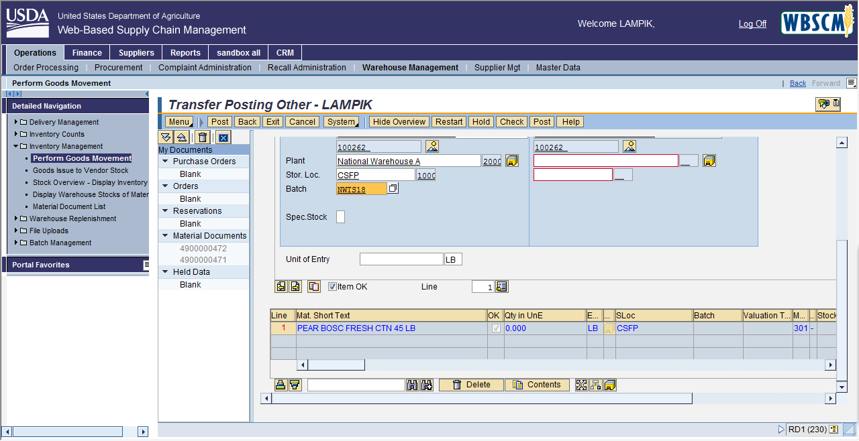

3. | As required, complete/review the following fields:

 | Field | R/O/C | Description
 | Unit of Entry | R
  Unit by which quantities are to be measured. Some examples include: pound, gram, meter, and liter.
  Example:
  50

Transfer Posting Other
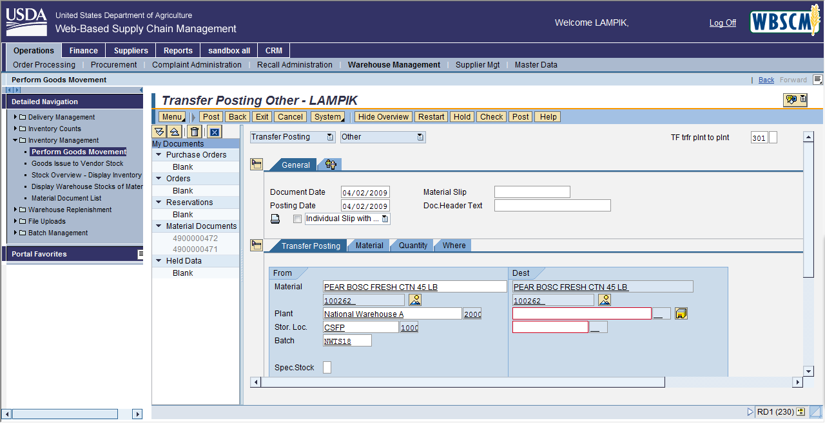

4. | Click the tab to enter Movement Type information and continue.

Transfer Posting Other
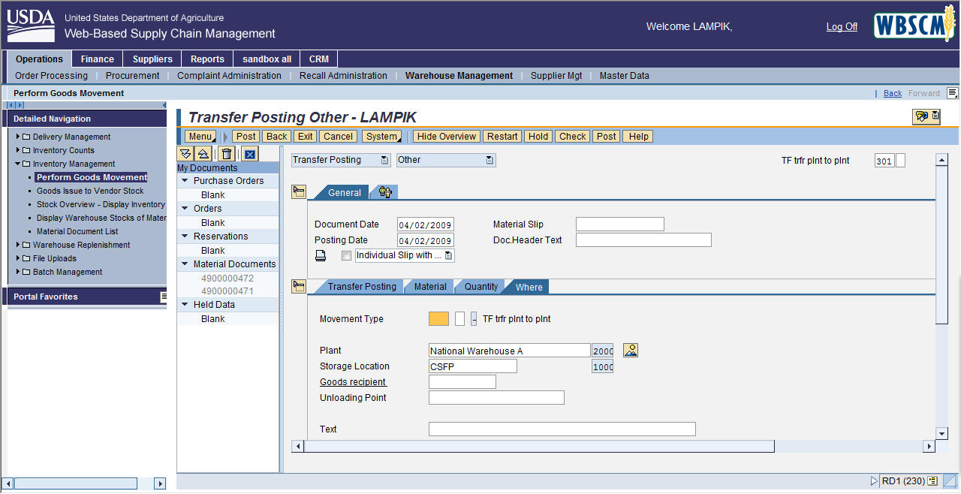

5. | As required, complete/review the following fields:

 | Field | R/O/C | Description
 | Movement Type | R
  Code used during the creation of the stock transfer order. Each different type of warehouse movement is represented by a different movement type code. For example, ods issue to production, ods receipt with purchase order, etc.
  Example:
  344

 |  | The Movement Type field dictates whether National Warehouse Stock can be moved, transferred, sold, or blocked. "344" is always the code that will be used for blocking stock.

6. | Click to post the transaction and save your entries.

Transfer Posting Other
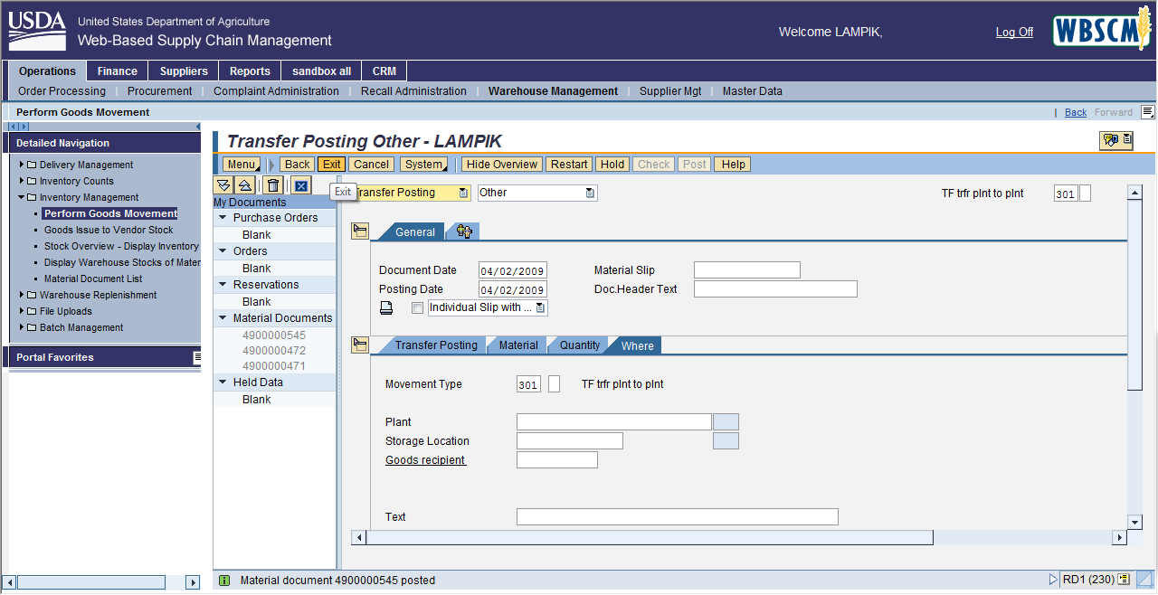

7. | Click to exit to exit the transaction.

Upon successful completion, the system displays the message "Material document XXXX posted."

8. | You have completed this transaction.

