WWPRT 3.4 EC – File Format Validator Tool.

Requirements Specification

Scope
IBM has a Worldwide Pricing Tool Cost which takes from several different sources, provided by different groups and systems. Those files come in different formats with different content.

Competition Purpose:
The application proposed in the contest allows users to validate their file format prior to uploading into the Pricing Tool. This avoids issues related to processing files that will be rejected in the future by the application due to incorrect formats.
The main advantage of File Format Validation Tool (FFVT) is saving user time and application process time by allowing a way to proactively perform those validations.
The user will notice there is an issue detected by the application prior to uploading it to the Pricing Tool. If that’s the case he can take the following corrective actions to solve the issue:
- Work with the information providers and understand whether a change is required along the generating process.
- Notify Pricing Tool team if the file format should be acceptable – request a fix in the application.

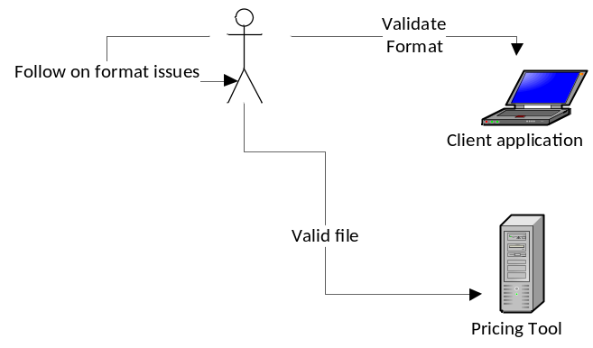

Overview
FFVT overview:
This component consists of 2 parts:

- The Core Application: This piece is in charge of performing the validations, based on 2 files:
  - The Price Tool input file provided by the user
  - A configuration file, used to validate the previous file.

This application is a desktop application – It should run in the user’s desktop with no need to access databases or external services. As an output it provides a result validation file containing validation results and a list of issues found. The user runs the application and provides the 2 input files as parameters to the process.

All files should have at least 2 line types (optionally more):
- Header – relates to first line/lines of the file;
- Body – relates to the data records, normally applies to most lines in the file
- Footer – relates to the last line/lines of the file
- Comment lines (to be ignored)

This application needs to handle 2 different types of file:

- A text file with fixed format column. In the configuration file, column ranges related to data types should be provided
- A text file where each element in each line is separated by a delimiter character. The options we have so far for this character are comma (“,”) and tab ().

Parameters loaded through configuration file will determine:
- File type
- Number of lines for each line type
- A pattern defined for each line type. For instance, check the example below:
File Type = Comma delimited
Header Line
Type (char 1) | Sequence (integer) | Date (MM-DD-YYYY)
H,00123,10-08-2010

Body Line
Product (String)| value (dec 2) | Valid From Date | Valid To Date
A00123,1230.30,01-01-2010,03-03-2012

- The elements on each line can be (relating to Java types):
  - String / char(n)
  - Integer
  - BigDecimal – for prices
  - Date (MM-DD-YYYY or different formats, but only with day, month and year)

- The configuration file will be loaded by the user,or optionally as an XML file that will be loaded by the application automatically as the default.

Application workflow is following:
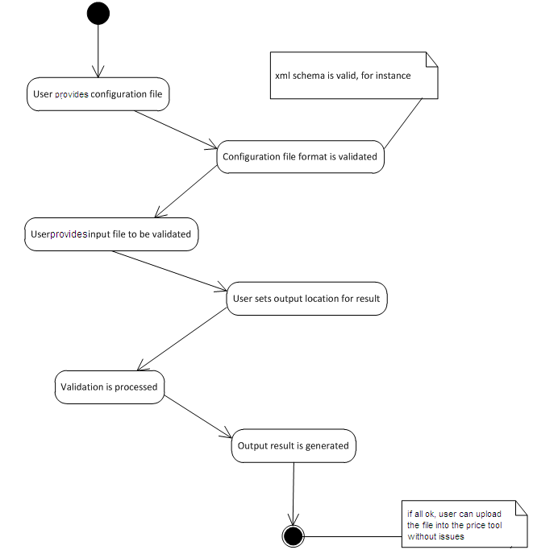

Logic Requirements

Scope
Validation and loading of parameters functionality are in scope of this component

Deployment set-up
Since this is a client application we don’t need to deploy it on any application server. An executable jar file shall suffice.

Threading
Application expectation is to run on user local environment validating one file at a time, but it’s desirable to be thread-safe and scale as needed.

Configuration
A metadata for the configuration file should be provided, and we suggest XML format to be used (we have several approved Spring libraries that can be used).

An Example of this configuration (supposing a customized namespace) inside of the file could be as follow:

<namespace:file>
<property=”type” value=”txt”/>
<namespace:input type="header" regex="H*..">
<namespace:lines min="1" max="1"> <!-- config for header line -->
<namespace:coll from="1" to "10" type="java.lang.String" format="regex mask"/>
<namespace:col from="11" to "20" type="java.math.BigInteger" format="default"/>
<namespace:col from="21" to "23" type="java.util.Date" format="yyyy-MM-dd"/>
</namespace:lines>
< namespace:input type/>
<!-- config for data record … -->
…
<!-- config for footer record if applicable… -->
</namespace:file>

Logging
Log4J should be used, and the Apaache Commons Logging Wrapper library should be used.
The exceptions should be logged by default with ERROR level

Exception Handling
Designer is responsible for creating custom exception.

Input Example
Follow 2 examples of input files.

CSV
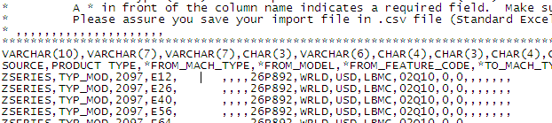

Fixed format:
H 01413 D 631 2009-10-15-11:09:36 USD
D 4611 1085 F 000000020.38 2009-10-31
D 9119 9440 F 000000000.00 2010-06-30
D 9119 9441 F 000000000.00 2010-06-30
D 9119 9442 F 000000000.00 2010-06-30
D 9119 9443 F 000000000.00 2010-06-30
D 2094 2094 7631 7641 U 000006947.00 2010-06-30
D 2094 2094 7632 7642 U 000003768.00 2010-06-30
D 2094 2094 7633 7643 U 000003768.00 2010-06-30
T 01413 00000029 000000233500.38

Non functional requirements

Scalability

System needs to be able to process volumes up to 500K lines for a file. Loading the file entirely into memory is allowed.

Future Component Direction
None

Interface Requirements

Graphical User Interface Requirements
A simple GUI that allows a user to load those 2 files and configure output location. After processing the validation the user should check the file and follow on based on results.

External Interfaces
None

Environment Requirements
- Development language: Java 1.5
- Compile target: Java 1.5

Package Structure
com.ibm.tools.ffvt

Software Requirements

Administration Requirements

What elements of the application need to be configurable?
See sections 1 above

Technical Constraints

Memory
Check expectations in Scalability section (Component Design Spec). Check scalability item (1.4.1).

Are there particular frameworks or standards that are required?
- Junit 4.3- It´s recommended for this application to be provided with JUnit tests in several scenarios
- Log4j / Apache common logging wrapper.
- We suggest Swing or JDNC for UI Components (alternatives can be analyzed)
- We suggest Spring/Spring Batch features for the loading/validation

TopCoder Software Component Dependencies:
  - No TopCoder catalog components are allowed

Third Party Component, Library, or Product Dependencies:
See section 3.2.2

QA Environment:
The following technologies will be used to implement this application:
- Java 1.5
- Should run on Linux / Windows (XP, Vista, 7)
- Spring 2.5.5 (optional)
- Any external library used is subject to approval according to IBM standards.

Design Constraints
The component design and development solutions must adhere to the guidelines as outlined in the TopCoder Software Component Guidelines.

Required Documentation

Design Documentation
- Use-Case Diagram
- Class Diagram
- Sequence Diagram
- Component Specification
- XSD for the configuration file

Help / User Documentation
- Design documents must clearly define intended component usage in the ‘Documentation’ tab of the TopCoder UML Tool.

