SVM – **Theory. Ex.3**

(a)

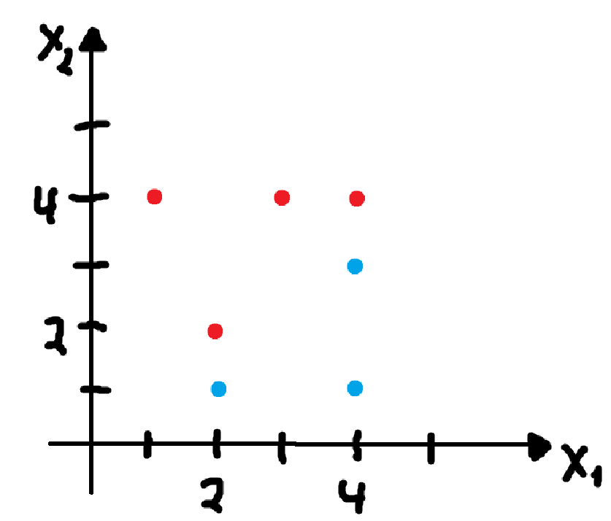

(b)

$$slope=\frac{3.5-1.5}{4-2}=\frac{2}{2}=1 \\ point=\left(2,1.5\right)$$ Hyperplane:

$$X_{1}-2=X_{2}-1.5 \\ X_{1}-X_{2}-0.5=0$$

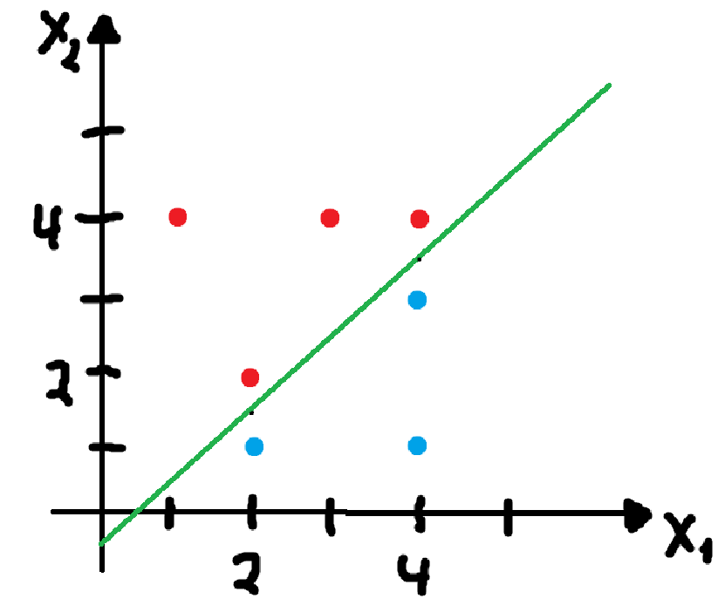

(c)

The classification rule is: Classify to Red if $X_{1}-X_{2}-0.5>0$ and blue otherwise.

(d)

The margin is:

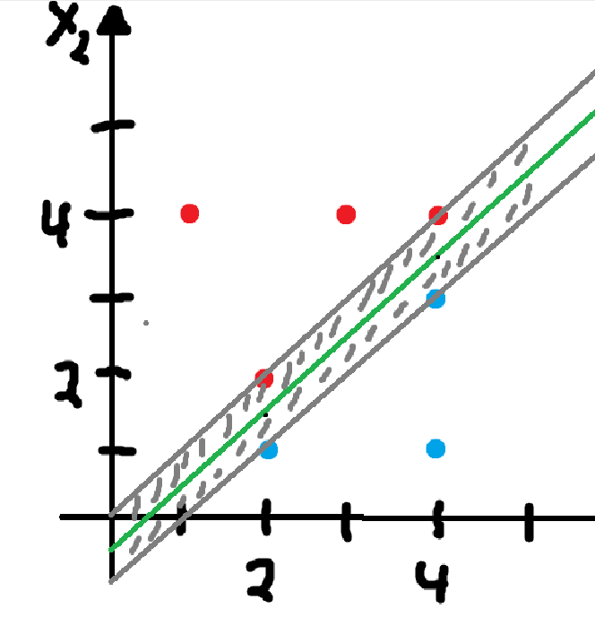

(e)

The support vectors are:

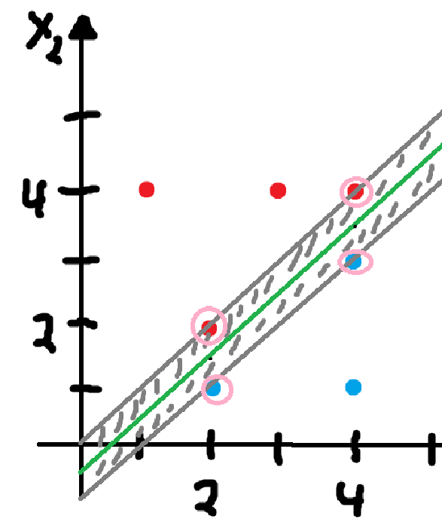

(f)

Slight movement of the bottom would not effect the the maximal margin because that point does not contribute to the margin calculation.

(g)

This is not an optimal separating hyperplane:

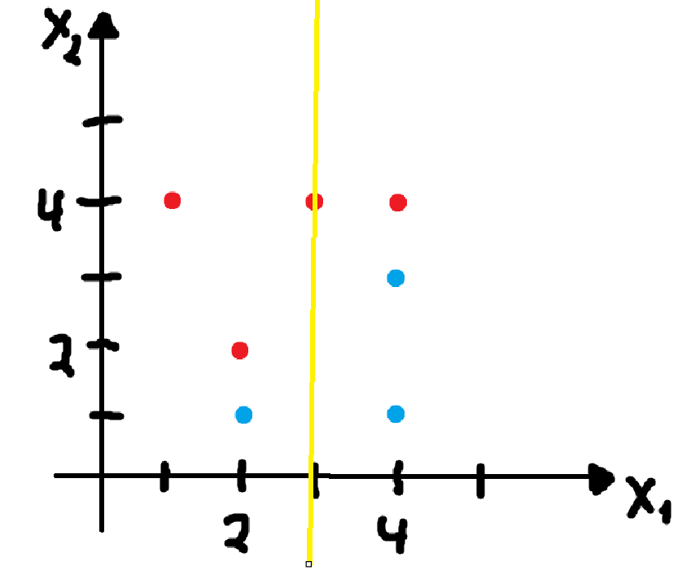

Equation:

$$X_{1}-3=0$$

(h)

This dataset cannot be separated by a hyperplane.

