### chapter 2 – basic probability, conditional probability, random variables:

1. True or False:
   1. False. Consecutive coin tosses are independent.
   2. False. There are red face cards thus the events are not exclusive.
   3. True. Aces are not face cards thus drawing an ace and a face card are mutually exclusive events.
2. Wheel with 38 slots: 18 red, 18 black, and 2 green.
   1. As the events are independent, the probability remains $p=\frac{18}{38}=\frac{9}{19}$.
   2. 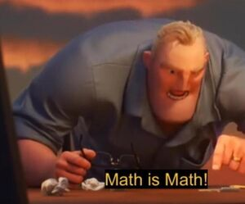Same as a.
   3. Yes.
3. If you flip a fair coin 10 times, what is the probability of:
$p\left(getting all tails\right)={0.5 }^{10}$

$p\left(getting all heads\right)={0.5}^{10}$

$p\left(getting at least one tails\right)=1-p\left(getting no tails\right)=1-{0.5}^{10}$

4. 14.6% of Americans live below the poverty line, 20.7% speak a language other than English (foreign language) at home, and 4.2% fall into both categories.
   1. Living below the poverty line and speaking a foreign language at home are not disjoint as there are people that are in both categories.

### Chapter 3 – Normal distribution

16.

$$p\left(x>2100 | x>1900\right)=\frac{p\left(x>2100\right)}{p\left(x>1900\right)}=\frac{p\left(z>2\right)}{p\left(z>\frac{4}{3}\right)}=0.25$$