执行效果，测试数据大概20多秒完成。结果有9623条记录

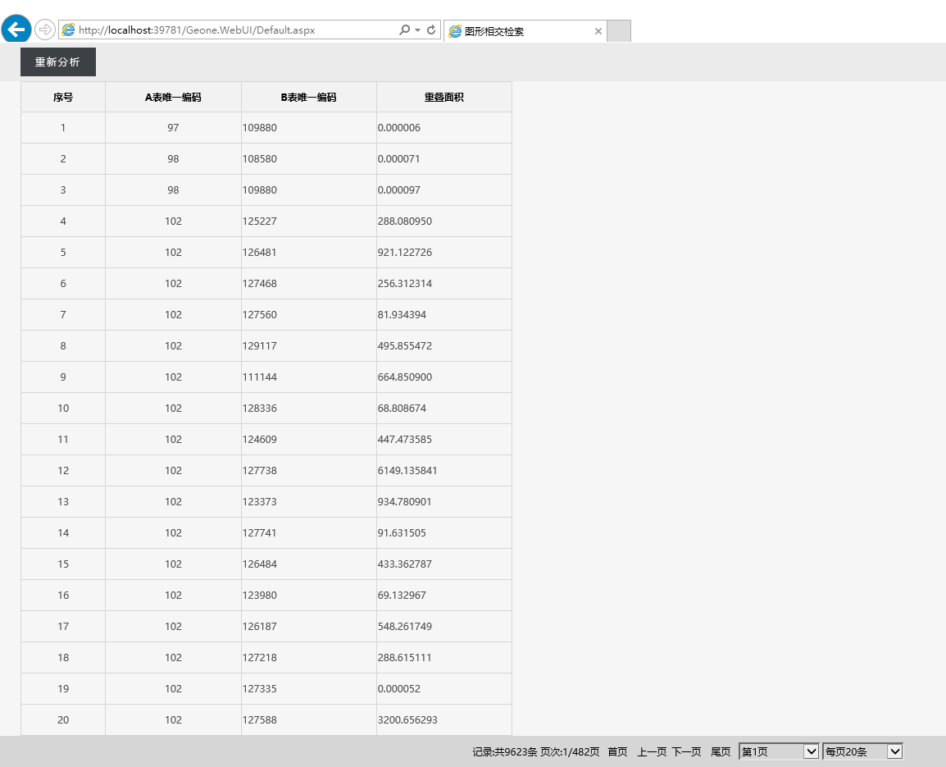

下面说一下操作步骤

1. 把库注册成空间数据库

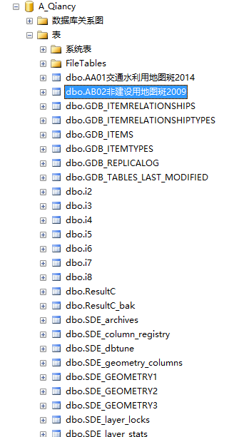

1. 把表转为地理空间表，增加空间索引

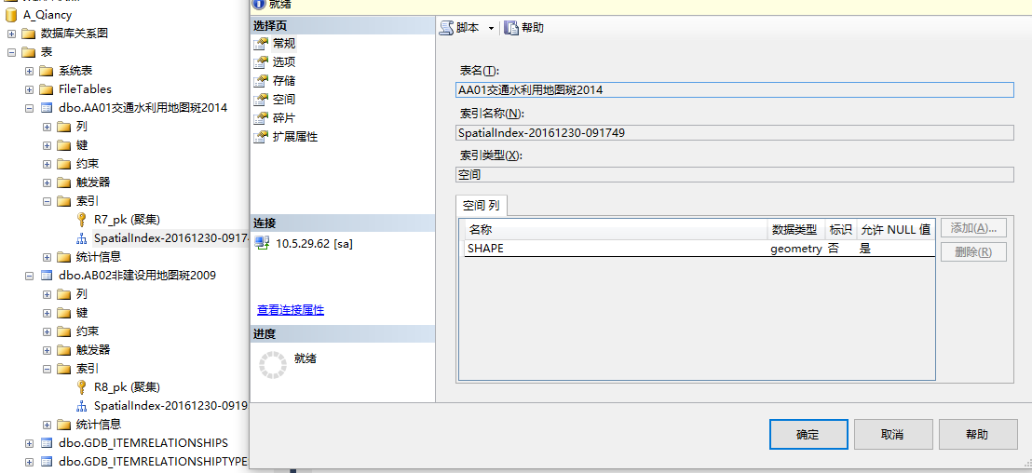

1. 创建结果表

CREATE TABLE [dbo].[ResultC](

[id] [bigint] IDENTITY(1,1) NOT NULL,

[AA01_ID] [int] NULL,

[AA02_ID] [int] NULL,

[STArea] [decimal](18, 6) NULL,

CONSTRAINT [PK_ResultC] PRIMARY KEY CLUSTERED

(

[id] ASC

)WITH (PAD_INDEX = OFF, STATISTICS_NORECOMPUTE = OFF, IGNORE_DUP_KEY = OFF, ALLOW_ROW_LOCKS = ON, ALLOW_PAGE_LOCKS = ON) ON [PRIMARY]

) ON [PRIMARY]

GO

1. 修改web程序中webconfig数据库配置



1. 浏览default.aspx网页