# let and const Exercise

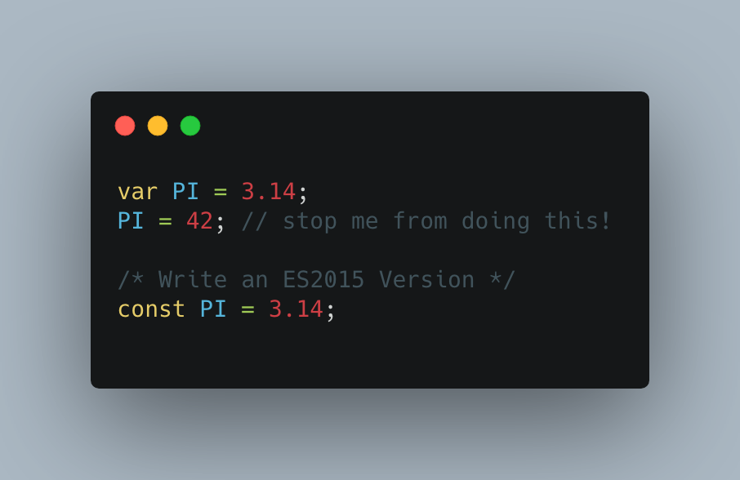

* What is the difference between **var** and **let**?
  + *var* is function scope while *let* is block scope
  + *var* can be re-declared while *let* cannot
  + *var* will be hoisted while *let* will not
* What is the difference between **var** and **const**?
  + *var* is function scope while *const* is block scope
  + *var* can be re-declared while *const* cannot
  + var can be re-assigned while *const* cannot
  + *var* will be hoisted while *const* will not\
* What is the difference between **let** and **const**?
  + *let* can be re-assigned while *const* cannot
* What is hoisting?
  + Hoisting is the result of JavaScript looking at the value of variables at initialization. The values become immediately available as opposed to returning an error message of trying to access a variable before it is declared.