C950 Task-2 WGUPS Write-Up

(Task-2: The implementation phase of the WGUPS Routing Program).
(Zip your source code and upload it with this file)

Diego Cuadros
ID 011746822
dcuadro@wgu.edu
02/21/2025

C950 Data Structures and Algorithms II

A. Hash Table
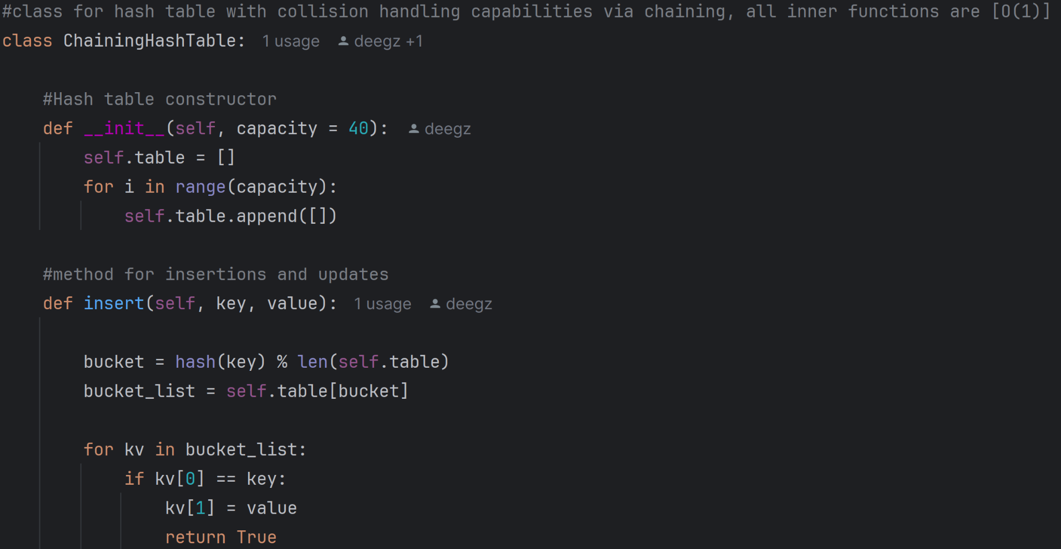

B. Look-Up Functions
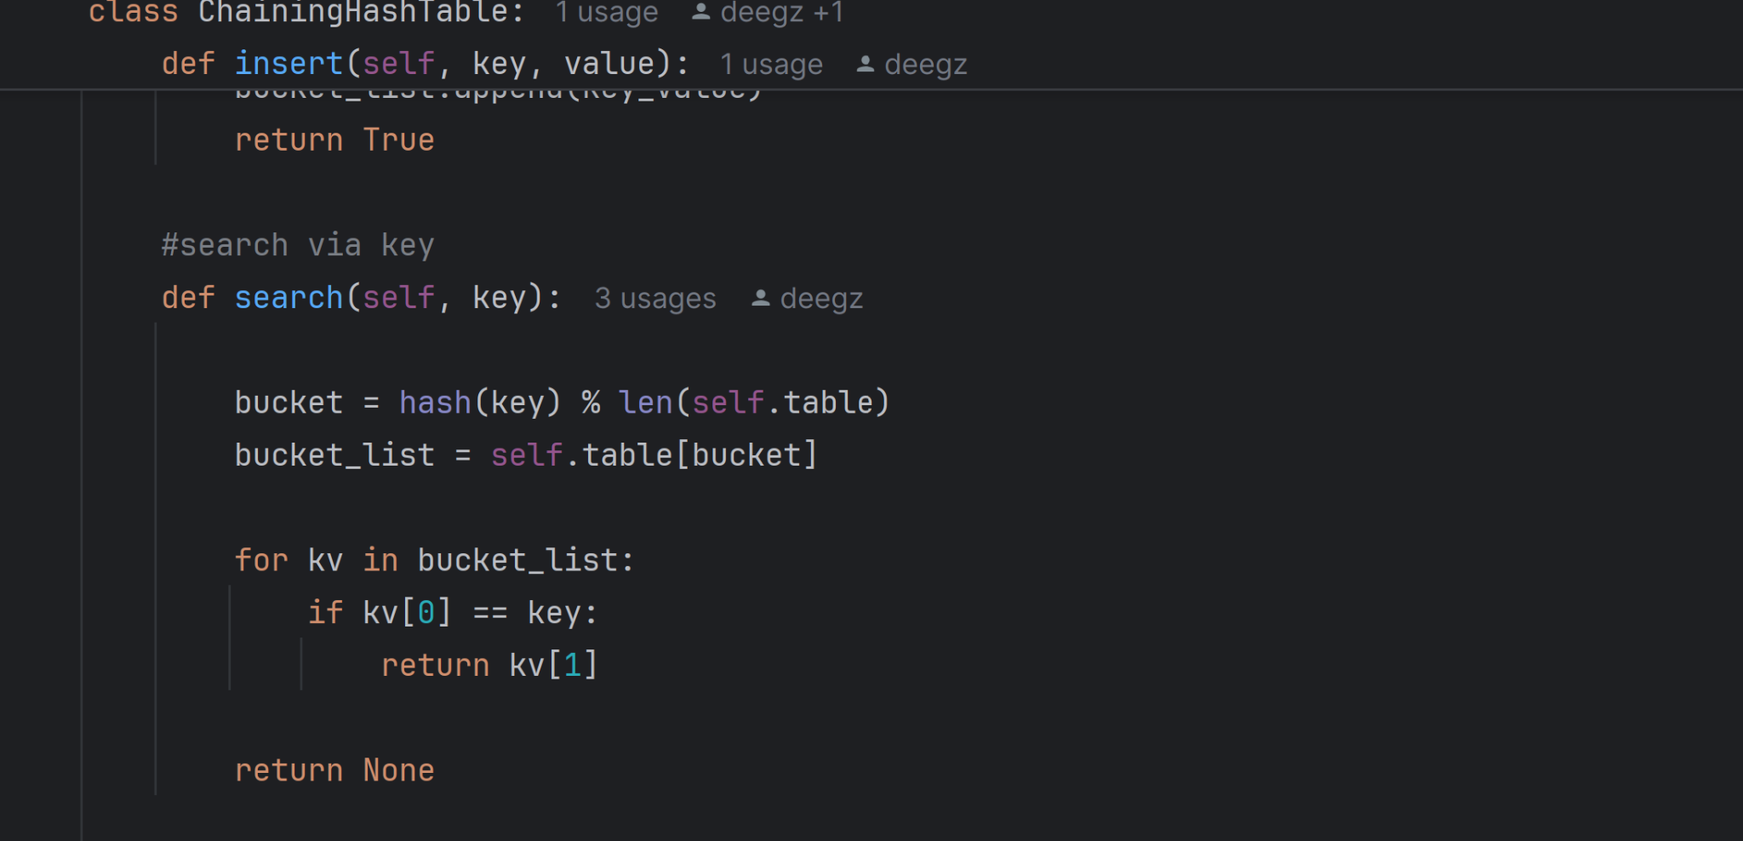

C. Original Code
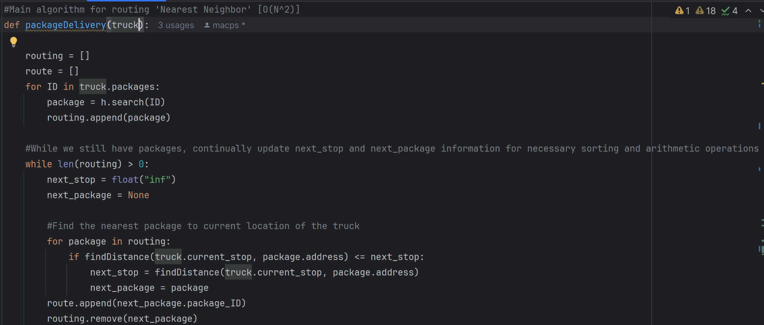
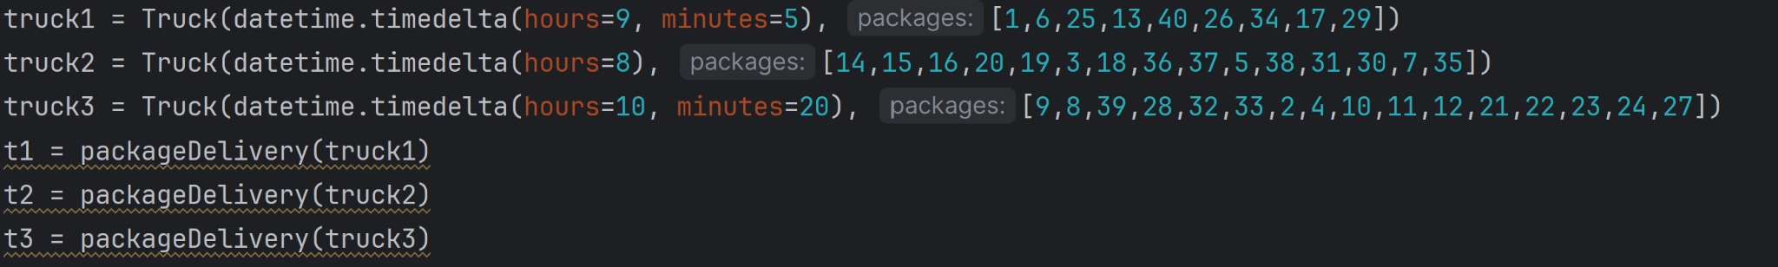

C1. Identification Information
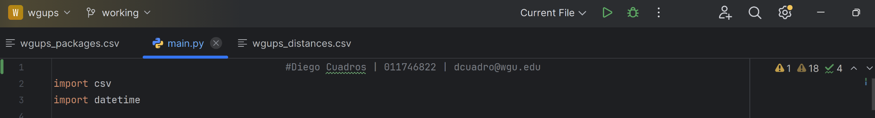

C2. Process and Flow Comments
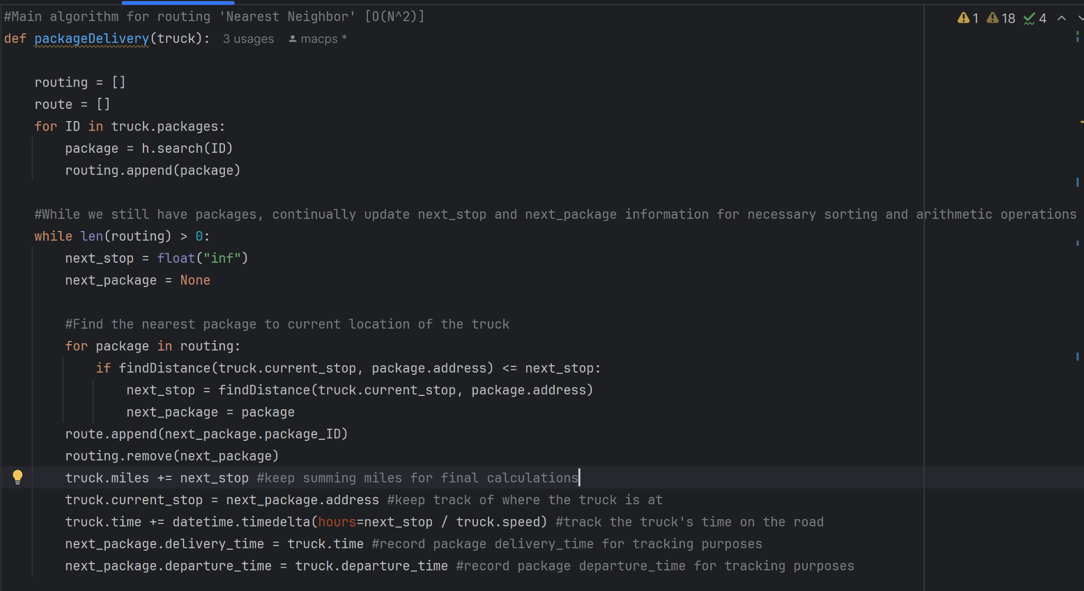

D. Interface
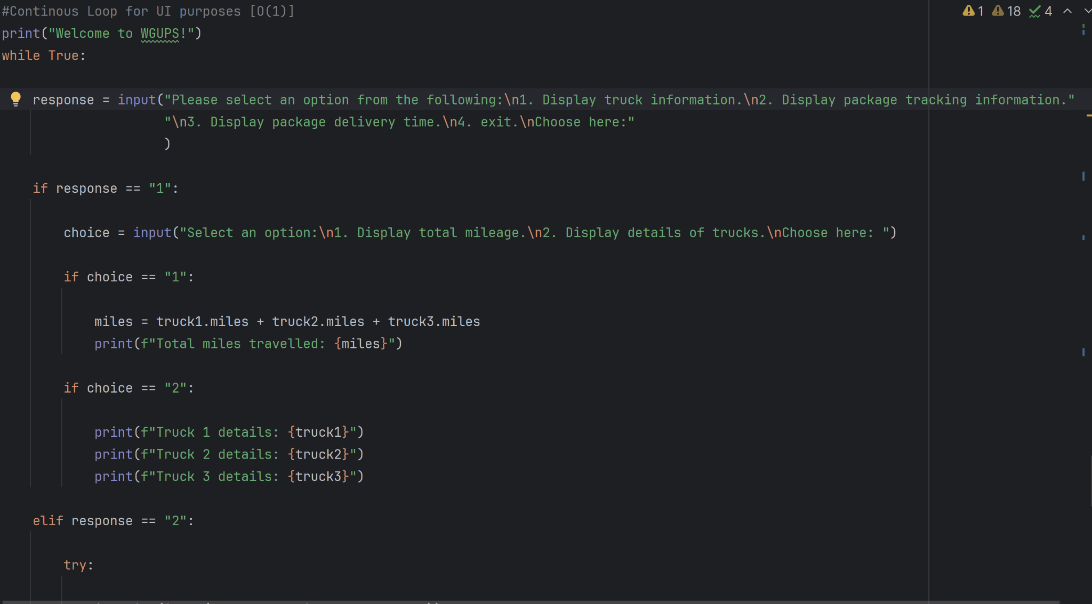
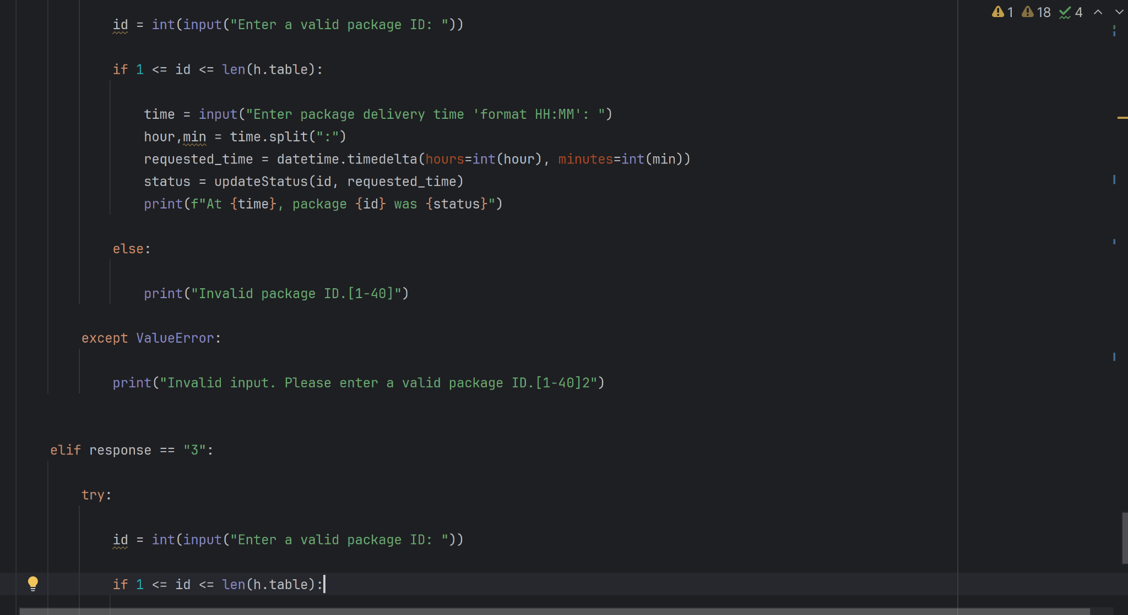
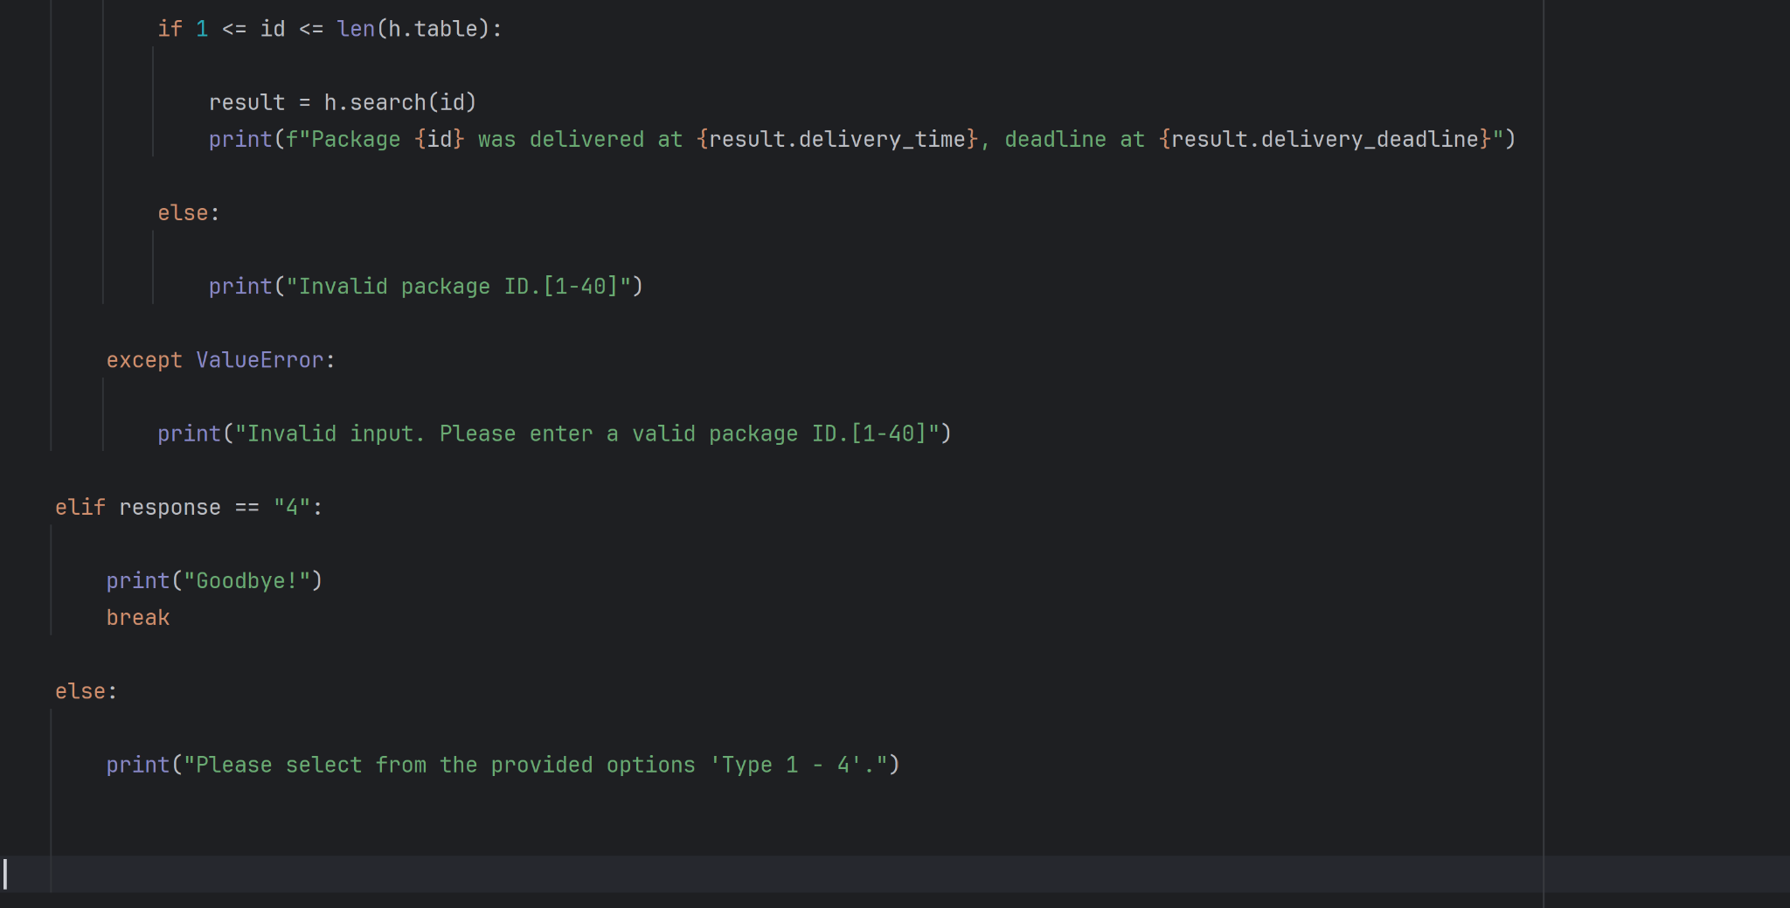

D1. First Status Check
Status at 9 A.M
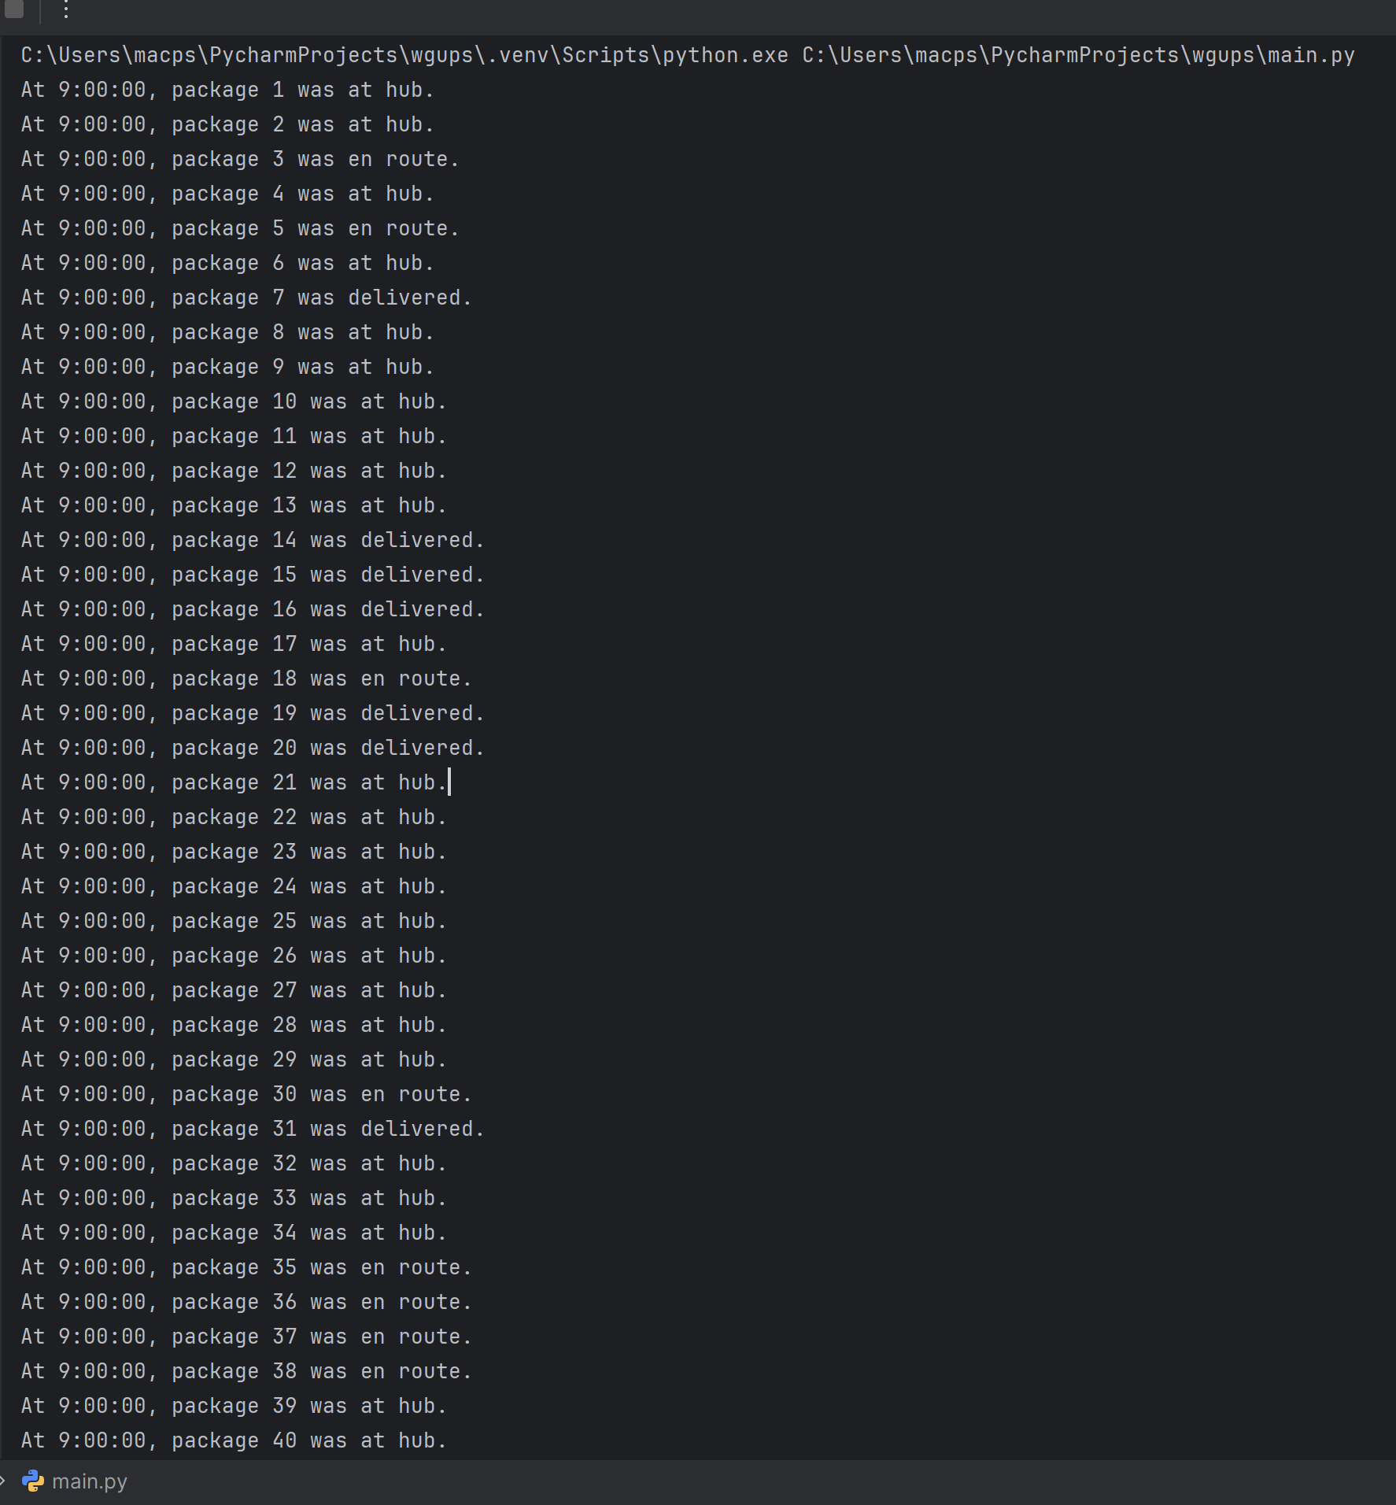

D2. Second Status Check
Status at 10 AM
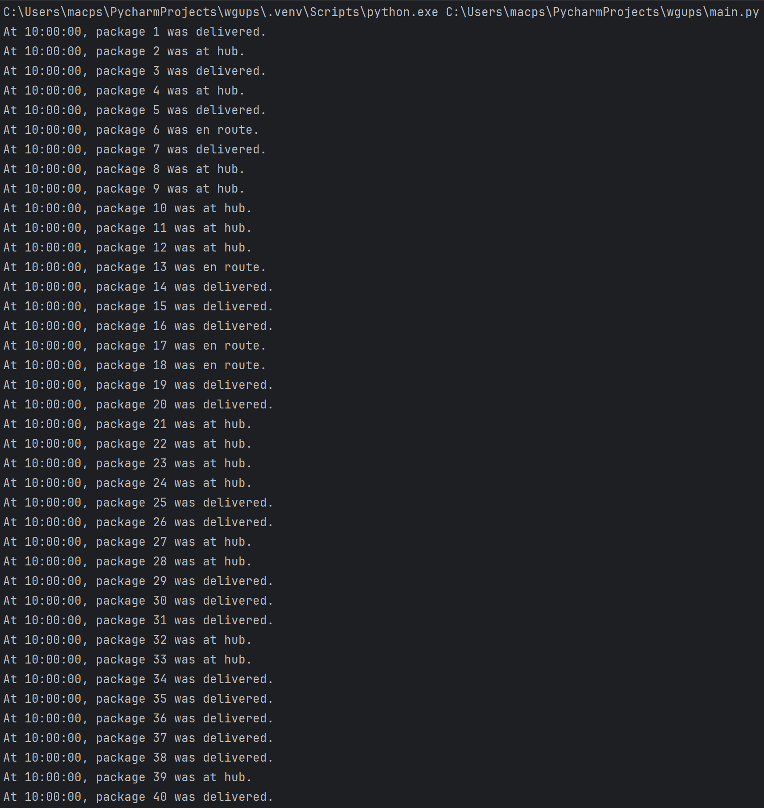

D3. Third Status Check
Status at 1 PM
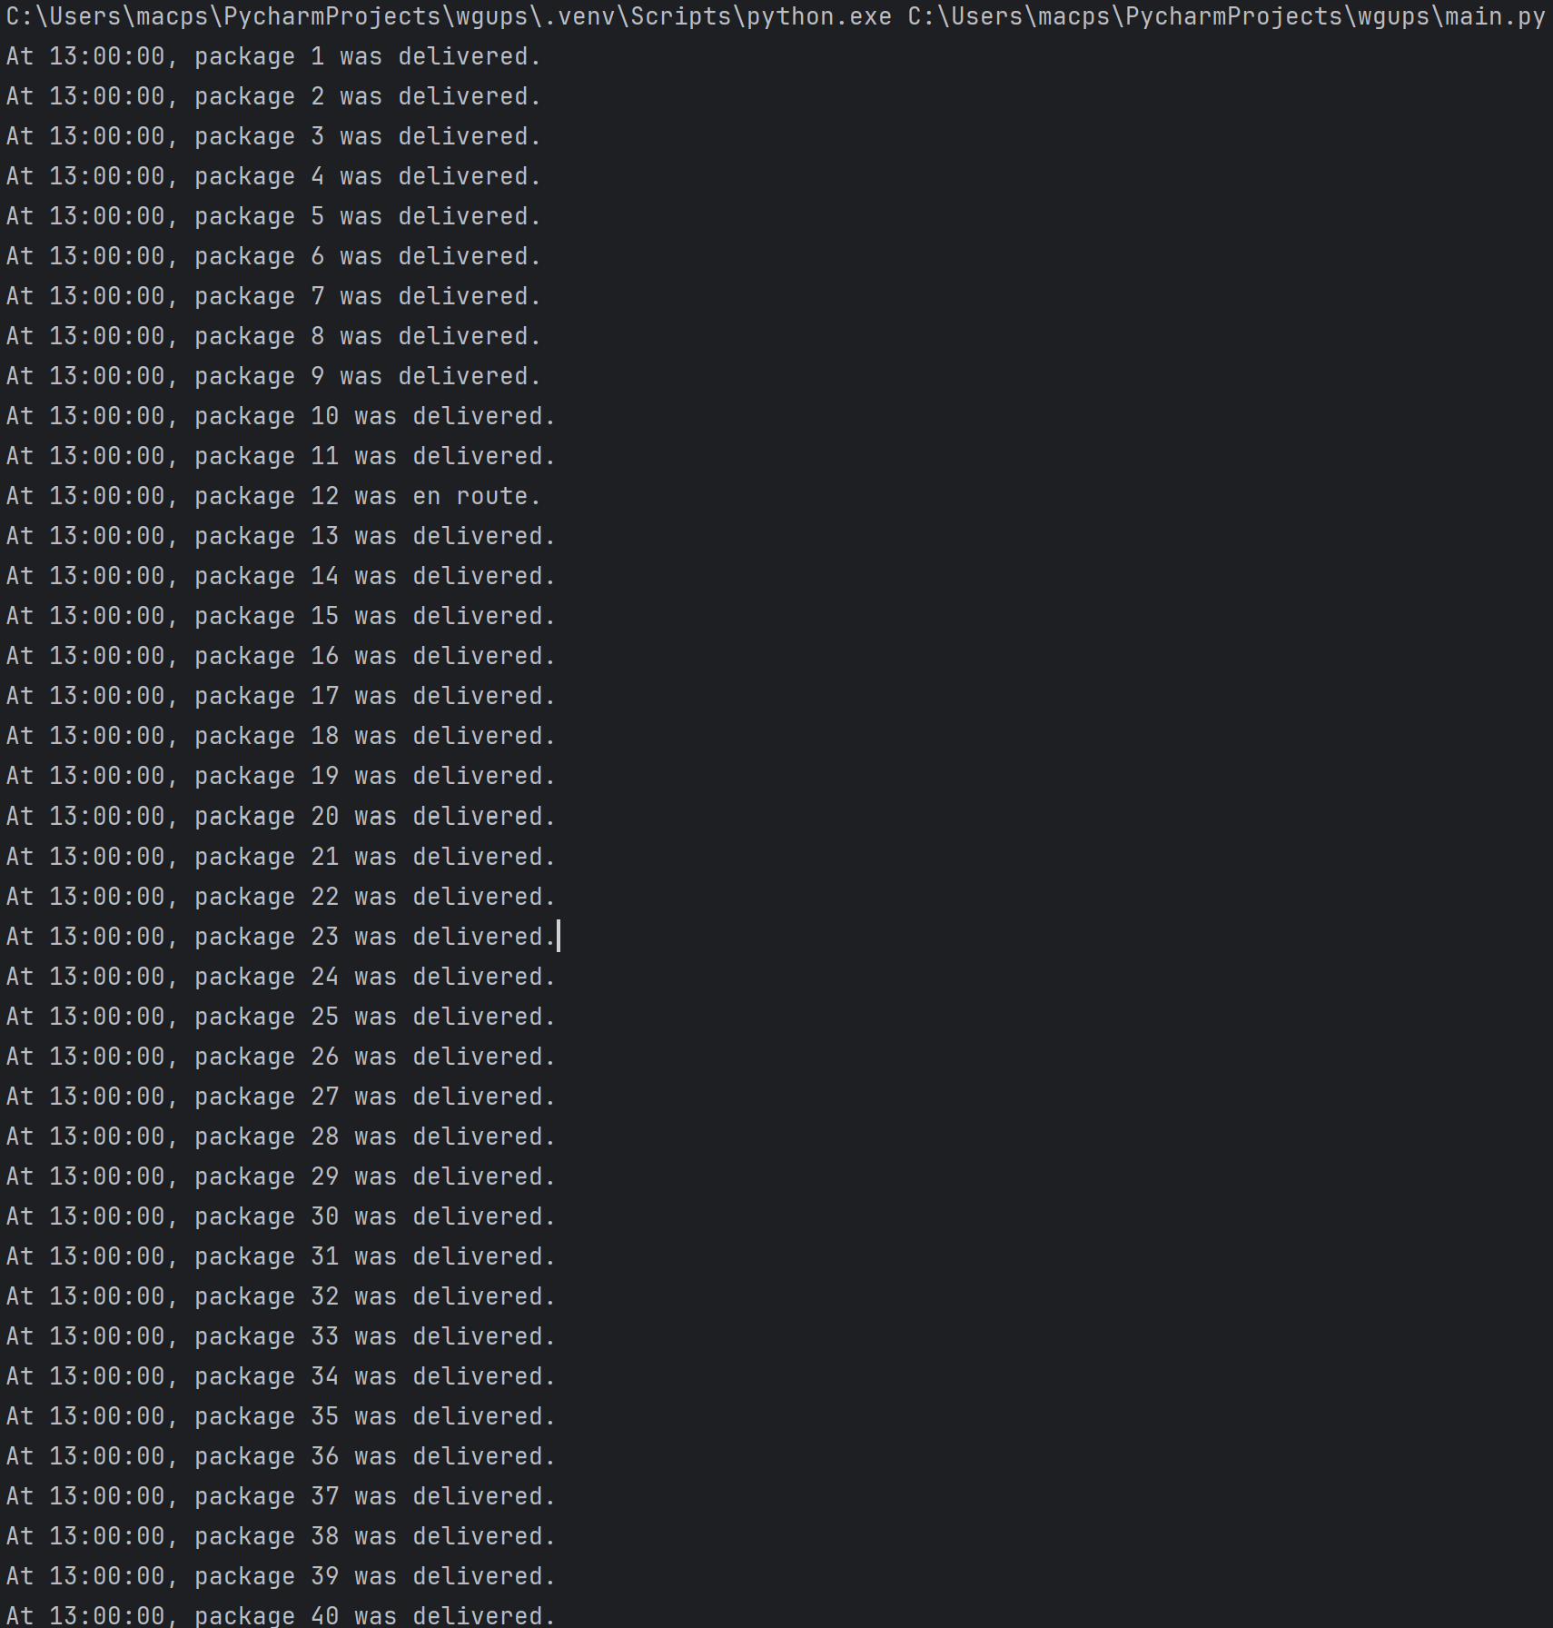

E. Screenshot of Code Execution
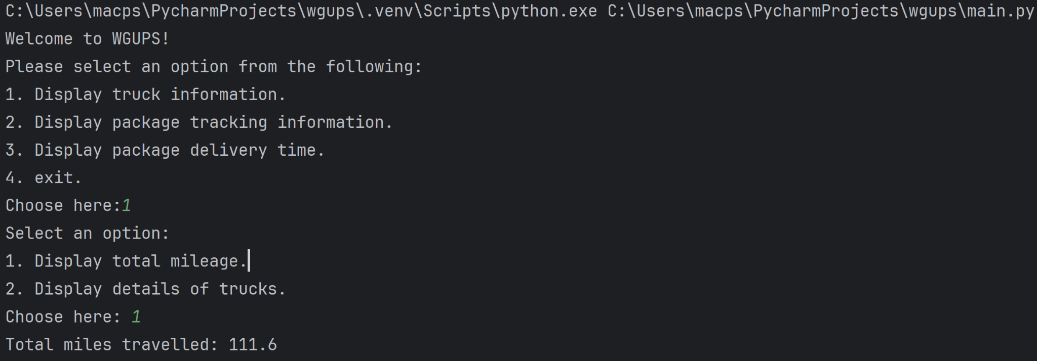

F1. Strengths of the Chosen Algorithm
The chosen algorithm Nearest Neighbor has a myriad of strengths but for our sake, it was chosen due to the following:
- Simplicity: The algorithm is straightforward and concise making it very easy to implement and maintain.
- Approximation acceptability: While the algorithm is relatively efficient it is not necessarily optimal. However in real world applications such as package delivery routing the optimal route is not required, therefore efficient approximate solutions are satisfactory.

F2. Verification of Algorithm
The algorithm in combination with the Truck class verifiably complies with every requirement of our solution. It employs its greedy logic to provide routing for package deployment that meets deadlines and constraints from both the packages and the trucks themselves. It takes in Truck objects as arguments which are themselves crafted with the necessary attributes to implement the following:
- The trucks leave at the earliest 8 a.m. utilizing the departure_time attribute
- The depature_time attribute when combined with an auxiliary function for grabbing distance data and the speed attribute also facilitates the algorithm tracking of packages when en route. Utilizing datetime objects to record package departure and delivery times.
- The trucks are manually loaded with a package attribute that is a list of package object ID numbers, this list facilitates the algorithm's logic by providing the necessary inputs for route creation. It's crafted with constraints such as deadlines, delays, groupings, and the specificity of trucks in mind.
- No truck can have more than 16 packages.

F3. Other Possible Algorithms
Other potential algorithms include Christofides and Lin-Kernighan algorithms.

F3a. Algorithm Differences
The main differences between stated algorithms are as follows:
- Christodes uses minimal spanning trees and even adds edges to create and further improve a circuit to serve as its tour, while NNA typically builds its connections 1 by 1 through information.
- Lin Kernighan starts with a random solution and slowly improves upon it by iteratively doing k-opt moves on said solution, progressing until it finds the best possible solution, this is opposed to the NNA which creates its solution quickly through local means but is often far from optimal.

G. Different Approach
Going forward I have some concerns about growing data sets, as presented the program works as intended. However, in future applications with a growing set of information the way package IDs are manually loaded into the truck class objects can and likely will become impractical. As such implementing a dynamic way to load the truck objects would be a worthwhile investment, while I also suspect that changing the manner in which data is collected initially would be a much appreciated first step. Additionally, should the program expand I imagine the UI would need expansion as well. Auxiliary functionalities would likely result in refactoring of the program to keep it neat and easily readable, separating functions and data structures from the main_py logic.

H. Verification of Data Structure
The hash table serves to fulfill all requirements presented in the following manner:
- The table's hash key functionality enables efficient O(1) lookups for any package object utilizing the package_ID attribute as the keys.
- all the package object attributes as compiled in the table as values for their corresponding key
- A combination of the lookup function along with the package attribute values serve to assist the algorithm on many of its routing functionalities

H1. Other Data Structures
Other data structures that could have been utilized in a different environment include doubly linked lists and priority queues.

H1a. Data Structure Differences
A priority queue differs from a hash table in how the queue organizes its items via priority levels whereas a hash table focuses on its key-value pairs, specifically the key for its organization. This structure could be particularly useful with deadlines as priority levels.
A doubly linked list differs from the hash table with its use of pointers as references to each "linked" item. This structure can be beneficial in situations such as a package needing to be rerouted since the backtracking capabilities help facilitate updates.

I. Sources
Weru, L. (2021, August 24). 11 Animated algorithms for the traveling salesman problem. STEM Lounge. https://stemlounge.com/animated-algorithms-for-the-traveling-salesman-problem/

GeeksforGeeks. (2025, January 30). Data Structures tutorial. GeeksforGeeks. https://www.geeksforgeeks.org/data-structures/?ref=shm

