Final Project Write-Up
Advanced Topics in Machine Learning
Traffic Crashes Injury Prediction: Will There Be an Injury?
Eden Misan
Hadar Yakir
GitHub repository: edenmisan/project: Is there an injury?
Section 1 – Introduction
Background and Problem Definition
Traffic accidents pose a major public safety challenge in urban environments, resulting in significant human and economic costs. While traffic crashes are common, only a subset leads to injuries. Identifying the conditions under which injuries are more likely to occur is essential for improving road safety and supporting data driven policy decisions. This project focuses on predicting whether a reported traffic crash results in an injury based on environmental, temporal, and infrastructural characteristics recorded at the time of the crash.
Motivation and Significance
Distinguishing between injury related and non-injury crashes enables stakeholders to identify high risk scenarios and prioritize preventive interventions. Using real world traffic crash data, this study aims to uncover patterns related to environmental conditions, roadway characteristics, traffic control devices, and temporal factors. Accurate injury prediction can support municipalities and transportation authorities in more effective resource allocation and targeted safety planning.
Project Objectives
The primary objective of this project is to develop and evaluate an end-to-end machine learning pipeline for binary injury prediction in traffic crashes. The study compares multiple supervised classification models, analyzes their strengths and limitations, and complements the supervised task with unsupervised learning techniques to identify latent patterns in crash characteristics. Emphasis is placed on rigorous preprocessing, appropriate evaluation metrics, and result interpretability.

Section 2 – Dataset and Features
Dataset Description and Data Source
The dataset used in this project is the publicly available Traffic Crashes – Crashes dataset from the Chicago Data Portal. Each observation represents a reported traffic crash in the city of Chicago and includes attributes describing environmental conditions, roadway characteristics, traffic control devices, temporal information, and crash circumstances. The dataset was provided in a structured CSV format and downloaded directly from the official source, ensuring data reliability and consistency.
The target variable was defined as a binary indicator of injury occurrence, where crashes involving any reported injury were labeled as 1 and non-injury crashes as 0. The distribution of the target variable is imbalanced, with approximately 79% non-injury crashes and 21% injury-related crashes, motivating the use of recall oriented evaluation metrics.
Data Preprocessing
Several preprocessing steps were applied to prepare the data for modeling. Irrelevant identifiers and non informative features were removed to prevent data leakage and reduce noise. Missing values were handled through numerical imputation and categorical consolidation when necessary. Categorical variables were encoded using one hot encoding, while numerical features were standardized when required to support distance-based and margin-based models. The dataset was then split into training, validation, and test sets.
Feature Engineering and Selection
Feature engineering focused on capturing temporal and contextual patterns related to injury risk. Temporal variables such as crash hour, day of week, and month were included, along with derived indicators for night time and weekend crashes. Feature selection was guided by domain knowledge and exploratory analysis to retain informative variables while reducing redundancy and supporting model generalization.
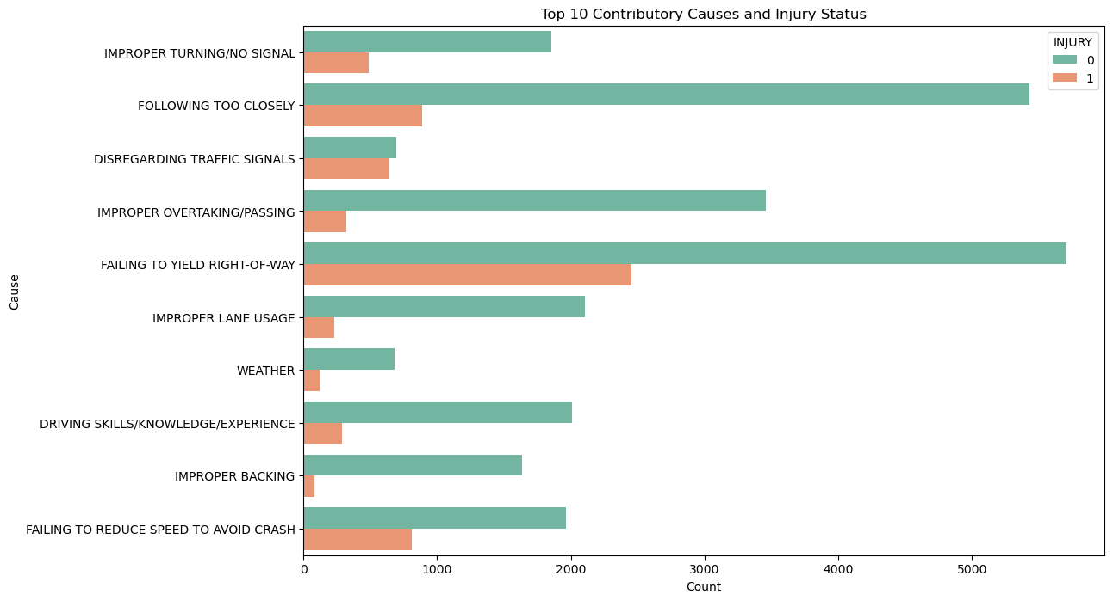
Figure X shows the ten most frequent primary contributory causes of traffic crashes by injury outcome. Differences in the distribution between injury and non-injury crashes indicate that certain driving behaviors are more strongly associated with injury risk, supporting the inclusion of contributory cause variables as key predictors in the supervised models
Section 3 – Methodology
Problem Formulation
The task addressed in this project is formulated as a binary classification problem, aiming to predict whether a reported traffic crash results in an injury. Given the safety critical nature of the problem, emphasis was placed on correctly identifying injury related crashes rather than solely maximizing overall accuracy.
Data Splitting Strategy
The dataset was divided into training, validation, and test sets. The training set was used for model fitting, the validation set for hyperparameter tuning and decision threshold selection, and the test set was reserved for final performance evaluation to prevent information leakage and ensure unbiased generalization assessment.
Model Selection and Rationale
A diverse set of supervised learning models was selected to represent different modeling paradigms. Logistic Regression served as an interpretable baseline, while Random Forest and Gradient Boosting were chosen for their ability to capture complex non-linear relationships. Support Vector Machines and k-Nearest Neighbors were included to represent margin based and distance based approaches, respectively. This selection enabled a comprehensive comparison across multiple learning strategies.
Evaluation Metrics and Optimization Strategy
Due to the imbalanced distribution of injury outcomes and the higher cost of false negatives, accuracy alone was insufficient. The Fβ-score with β = 2 was therefore selected as the primary optimization metric to emphasize recall. Decision thresholds were optimized using the validation set, and final performance was reported on the test set. ROC-AUC and Precision–Recall AUC were additionally computed to assess overall discrimination robustness.
Unsupervised Learning Approach
In addition to supervised classification, unsupervised learning techniques were applied to explore latent structures within the crash data. Clustering methods were used to identify groups of crashes with similar characteristics, providing complementary insights beyond the injury label.

Section 4 – Experiments and Results
Experimental Setup and Evaluation Metrics
The experimental evaluation was conducted using a consistent and controlled setup. All supervised models were trained on the training set, with hyperparameters and decision thresholds tuned on the validation set. The test set was reserved exclusively for final performance evaluation.
Model parameters were selected to balance model complexity and generalization. For ensemble methods such as Random Forest and Gradient Boosting, key parameters were chosen to reduce overfitting while maintaining the ability to capture non linear relationships. Class imbalance was addressed using class weighting, reflecting the higher importance of injury-related crashes.
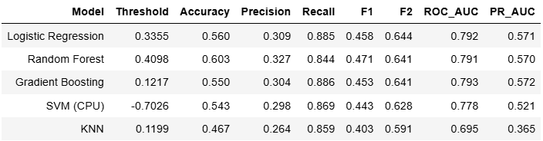
Due to the imbalanced dataset and the higher cost of false negatives, accuracy alone was insufficient. Therefore, precision, recall, and the Fβ-score were emphasized, with β = 2 selected to prioritize recall. ROC-AUC and Precision Recall AUC were also computed to evaluate overall discrimination performance across different decision thresholds.

Table X presents a comparative evaluation of the supervised learning models using multiple performance metrics. As the dataset is imbalanced and the primary objective is to correctly identify injury-related crashes, the models were ranked according to the F2-score, which emphasizes recall.
The results indicate that Logistic Regression and Gradient Boosting achieve the highest F2-scores, reflecting a strong balance between recall and precision. Random Forest demonstrates higher precision and overall accuracy but slightly lower recall, leading to a marginally lower F2-score. SVM and KNN exhibit weaker performance, particularly in recall and PR-AUC, suggesting limited effectiveness in capturing injury-related patterns.
Overall, ensemble-based methods outperform simpler baselines, highlighting their ability to model complex, non-linear relationships in traffic crash data
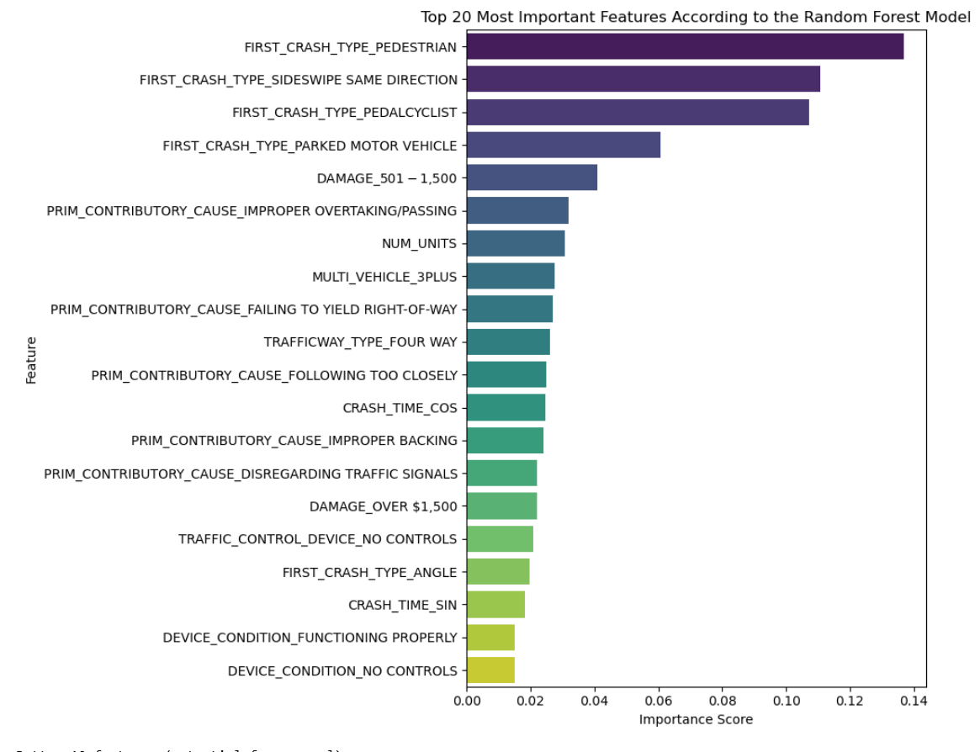 Figure X presents the top 20 most important features as identified by the Random Forest classifier. The results indicate that the type of initial crash, particularly crashes involving pedestrians and cyclists, plays a dominant role in injury prediction. In addition, variables related to crash severity, such as the number of involved vehicles and estimated damage levels, were found to be highly influential. Temporal features, including cyclic representations of crash time, as well as traffic control and roadway characteristics, also contribute to the model’s decision process. This analysis enhances model interpretability and provides insights into the key factors associated with injury-related traffic crashes
Based on the Random Forest feature importance scores, a feature selection step was applied. Features with importance greater than 0.005 were retained, reducing the feature set from 115 to 37. This reduction improved model interpretability and efficiency while preserving predictive performance
Supervised Model Performance Comparison
The evaluated models exhibited varying performance characteristics. Logistic Regression provided an interpretable baseline but showed limited ability to capture complex feature interactions, while k-Nearest Neighbors demonstrated less stable performance due to sensitivity to feature scaling and local data structure. Ensemble based models, particularly Random Forest and Gradient Boosting, consistently outperformed other approaches on recall-oriented metrics, making them more suitable for injury prediction.
Decision Threshold Optimization and Final Model Evaluation
Decision thresholds were optimized on the validation set to maximize the F2-score rather than relying on the default threshold of 0.5. This approach led to improved recall at the cost of a moderate reduction in precision, reflecting a deliberate trade off aligned with the project’s objectives. Final evaluation on the test set confirmed robust injury detection with acceptable precision.
Unsupervised Analysis Results
To complement the supervised classification task, unsupervised learning techniques were applied to explore latent structures within the crash data. The KMeans clustering algorithm was used to group crashes based on similarities in environmental, temporal, and infrastructural features, without relying on the injury label.
The number of clusters was selected based on a combination of clustering quality metrics, including the Elbow method, Silhouette score, and Davies Bouldin index, in order to balance cluster compactness and separation. The resulting clusters revealed distinct groups of crashes that are primarily differentiated by crash timing. Post hoc analysis further showed differences in injury rates between the clusters, indicating that temporal patterns play a central role in defining crash profiles. Other features, such as roadway configuration and traffic control conditions, exhibited more limited variation across clusters and appear to play a secondary role in cluster differentiation. This analysis provides complementary insight into latent temporal patterns associated with crash severity that are not directly captured by the binary injury outcome.

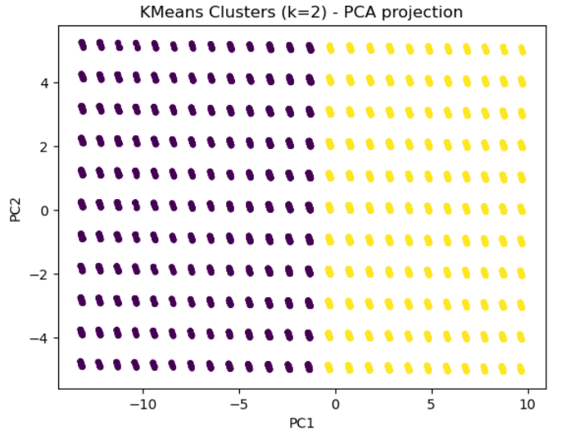
The PCA projection of the KMeans clustering (k=2) illustrates a clear separation between clusters, indicating the existence of latent structure in the crash data even without using the injury label. This supports the relevance of unsupervised analysis for identifying meaningful crash pattern.
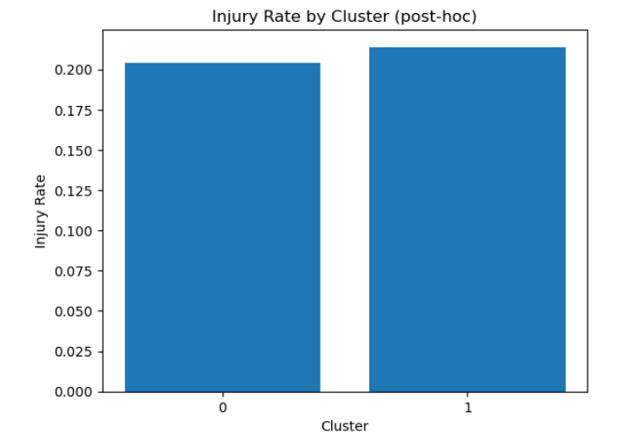
Although injury labels were not used during clustering, the resulting clusters exhibit different injury rates, indicating that the unsupervised analysis captures meaningful risk-related patterns.
Discussion of Findings and Limitations
Overall, the results demonstrate that ensemble learning methods combined with recall focused optimization are well suited for injury prediction in safety critical contexts. However, the analysis is limited to recorded crash attributes and does not incorporate external factors such as traffic volume or driver behavior. Despite mitigation efforts, class imbalance remains a challenge, suggesting future work should explore cost sensitive learning, richer feature representations, and temporal modeling approaches.

Section 5 – Conclusion and Discussion
Project Summary and Contributions
This project presented an end-to-end machine learning framework for predicting injury outcomes in urban traffic crashes using real world data. Through comprehensive preprocessing, comparison of multiple supervised models, recall oriented optimization strategies, and complementary unsupervised analysis, the study demonstrates the applicability of machine learning to safety critical decision making problems. A key contribution is the alignment between model evaluation and real-world priorities, emphasizing recall sensitive metrics such as the F2-score. The results highlight the effectiveness of ensemble based models in capturing complex, non linear relationships in crash data.
Team Roles and Contributions
The project was conducted through close collaboration between Eden and Hadar, with responsibilities shared equally across all stages, including problem formulation, data preparation, model development, experimentation, and report writing.
Discussion and Implications
The findings emphasize the importance of selecting evaluation metrics and decision thresholds that reflect domain-specific costs in imbalanced and safety sensitive classification tasks. Ensemble learning methods combined with recall focused optimization demonstrated robust performance and practical relevance for injury prediction in transportation safety contexts.
Future Work
Future research may explore the incorporation of additional contextual features, such as traffic volume and driver behavior, as well as temporal modeling approaches to capture evolving crash patterns. Cost sensitive learning and advanced class imbalance handling techniques also represent promising directions for improving injury detection and model reliability.
References
Chicago Data Portal – Traffic Crashes Dataset

