Prospectus

Eric Denovellis

## Project Summary

The overall goal of this research is to elucidate the cellular and circuit mechanisms underlying flexible behavior in the prefrontal cortex. We are often faced with situations in which the appropriate behavior in one context is inappropriate in others. If these situations are familiar, we can perform the appropriate behavior without relearning how the context relates to the behavior — an important hallmark of intelligence. Neuroimaging and lesion studies have shown that this dynamic, flexible process of remapping context to behavior (task switching) is dependent on prefrontal cortex, but the precise contributions and interactions of prefrontal subdivisions are still controversial.

This project investigates two prefrontal areas that are thought to be involved in distinct, but complementary executive roles in task switching — the dorsolateral prefrontal cortex (dlPFC) and the anterior cingulate cortex (ACC). Using existing electrophysiological recordings from macaque monkeys, Aim #1 will determine the impact of coherent network oscillations on context representations (rules) and whether they provide a mechanism for flexibly coordinating groups of neurons during task switching. Aim #2 will use the same dataset to compare how rule representations are changed at the cellular level when more control is needed. Finally, Aim #3 will develop a set of web-enabled interactive visualization tools designed to provide a multi-dimensional integrated view of the dataset. Results from this study will contribute to our understanding of task switching by investigating new mechanisms for coordination of neurons in prefrontal cortex and providing visualization tools that enhance exploration and understanding of large, complex and multi-scale electrophysiology data.

## Specific Aims

Goal-directed behavior requires the ability to rapidly and flexibly change behavior based on context (task switching). Behavior that is appropriate in one context is often inappropriate in another. The prefrontal cortex is necessary for supporting context-dependent behavior — prefrontal lesions result in perseverative, context-inappropriate behavior (Stuss and Benson, 1984) and neurons in prefrontal cortex reflect context and behavioral responses (Wallis et al., 2001) — but little is known about the circuit and cellular mechanisms that enable flexibility.

Previous studies suggest that two subdivisions of the prefrontal cortex, the anterior cingulate cortex (ACC) and dorsolateral prefrontal cortex (dlPFC) play functionally distinct, complementary roles in enabling the mapping of context to behavior. The prevailing model, based on studies of neural activity in human and rhesus macaque monkeys, asserts the dlPFC is responsible for maintaining and biasing attention to context-relevant sensorimotor information and the ACC is responsible for determining and adjusting the amount of attention needed for a given context (Shenhav et al., 2013). This model predicts that in situations where more attention is needed — such as when the expected value of meeting task demands increases (Shenhav et al., 2013) or when unexpected outcomes occur (Alexander and Brown, 2011) — coordination increases within and between ACC and dlPFC to maintain or adjust the link between relevant sensory information and the appropriate response. However, scant evidence for such coordination exists — particularly at the cellular and circuit level. Therefore, we propose to investigate this model, using multi-electrode electrophyisological recordings in the macaque monkey, by completing the following aims:

**Specific** **Aim #1****: To identify circuit-level coordination within and between ACC and dlPFC during task switching.** Phase coherence is a potential mechanism by which groups of neurons communicate at the circuit-level (Fries, 2005). We hypothesize that phase coherence of local field potentials (LFPs) within and between dlPFC and ACC (1) is context-dependent and (2) increases when more attention is needed during the task, such as when the context changes or errors occur in the previous trial.

**Specific** **Aim #2****: To understand the functional contribution of ACC and dlPFC neurons to circuit-level dynamics and behavior during task switching.** Specifically, we will investigate the context selectivity of individual neurons in relation to (1) attentionally-demanding task factors, (2) population firing rates of ACC and dlPFC, and (3) behavior. If successful, this aim will show the specific contributions of ACC and DLPFC neurons to behavioral performance and their relationship to circuit level dynamics.

**Specific** **Aim #3****: To build web-enabled interactive visualization tools that enhance exploratory analysis, checking of raw data and statistical modeling assumptions, and data presentation for large, complex and multi-scale electrophyisological data.** In particular, these tools will allow for rapid multi-dimensional investigation of task-dependent neural dynamics over time at the single neuron and circuit-level.

Taken together, these combined aims provide an integrated view of the circuit level and cellular mechanisms in prefrontal cortex that contribute to flexible behavior. Our approach is innovative because we consider novel mechanisms for coordination of neural activity related to context within the prefrontal cortex and investigate a large collection of multi-dimensional models for ACC and dlPFC activity, which is enabled by our interactive visualization tools.

## Research Strategy

### A. Significance

#### Clarifying the roles of prefrontal subdivisions, particularly ACC

Current theories of prefrontal cortex attribute different functions to anatomical subdivisions (Dias et al., 1996; Miller and Cohen, 2001; Rushworth et al., 2011). Because these functions are thought to underlie some of our more complex and diverse behavior, research is needed to tease apart the specific contributions of prefrontal subdivisions. For example, despite the wealth of studies on ACC, there is little agreement on its function (Shenhav et al., 2013) – primarily due to the diversity of findings of its involvement in processing errors, reward, conflict and attention. This has led to a number of attempts to unify these findings under a single overarching function of cognitive demand (Alexander and Brown, 2011; Holroyd and Yeung, 2012; Shenhav et al., 2013) but the complexity of this function requires careful accounting of the numerous factors that could affect ACC. A novel focus of this proposal is understanding the contribution of ACC during task switching while acknowledging the complexity of this function. We do this through the use of multi-dimensional regression in Aim #2 and interactive visualization in Aim #3.

Additionally, research on prefrontal cortex has primarily focused on the differences between the subdivisions, but little is known about how they interact. Another focus of this proposal is understanding the complementary functions of prefrontal divisions through the use of multi-electrode electrophysiology. Because our recordings are simultaneous in ACC and dlPFC, we can investigate how the activity of one prefrontal area relates to the activity of another without the uncertainties associated with between study comparisons. We relate activity from ACC and dlPFC in Aims #1 and #2.

#### Understanding the relationship of different spatial scales in the brain

Another contribution of our project is its focus on the interaction of different spatial scales in the brain. Our data analysis (Aim #2) and interactive visualization tools (Aim #3) are targeted at relating how individual neurons are affected by changes at the circuit level and how these changes differ by prefrontal subdivision. This is important because we do not understand how complexity on the cellular level impacts circuit level representations and how this relates to anatomical subdivisions. Understanding the information gained and lost at different levels of spatial organization can help inform future studies in terms of choice of recording technique, because different recordings techniques (e.g. fMRI, ECoG, Electrophysiology, and EEG) have different spatial and temporal resolutions.

#### Enabling rapid analysis of multi-dimensional datasets through interactive visualizations

Electrophysiology datasets are becoming richer and more complex as data is collected on multiple scales, dataset sizes increase, and more sophisticated questions are asked of the data. Visualization is an essential tool for understanding these datasets at all stages of analysis, but the current practice of producing static visualizations is limited in its ability to reflect this richness and complexity.

Complex analyses and hypotheses necessitate an increase in the number of static visualizations or further summarization of the data (dimensionality reduction) to deal with the number of dimensions — often both. For example, a common visualization of spiking data from a neuron would be a raster plot and/or a histogram. These are typically visualized with respect to a particular experimental stimulus or event (e.g. a saccade); each event requiring a new visualization. To investigate the firing rate of 1000 neurons in multiple conditions implies visualizations for each neuron or aggregation in some form (e.g summarization by brain area) once the visualization becomes too ineffective to support perceptual comparison. Because analysis is an iterative process, a typical analysis might require hundreds of visualizations as different sets of experimental conditions are examined or as more data is added.

A large number of static visualizations results in more researcher time spent switching between visualizations, which can not only extend the time to analyze the data, but also has a meaningful impact on our ability to explore and understand the data. For example, Liu and Heer (2014) found that even a 500 millisecond delay between visualizations could reduce the amount of the dataset explored and affect the number of hypotheses and observations formed. Similarly, Brutlag (2009) found that users performed fewer web searches if there was as little as a 200 millisecond delay in the return of search results.

Summarization, while often necessary, can obscure complexity and variability in the data — as in the well-known case of Anscombe’s dataset (Anscombe, 1973). It does not obviate the need to understand and check statistical assumptions. This can be a problem with large datasets, where going back and forth between raw data and summaries is difficult because of the amount of data. Moreover, multi-dimensional summaries require careful checking and understanding of assumptions as more structure in the data is assumed (Gelman, 2004) and overfitting — fitting to more parameters than the data can support, resulting in lack of generalizability of results — becomes a concern. Finally, the sophisticated computational algorithms used to compute the summaries can result in errors, and visualizations play an important role in catching such errors.

Aim #3 of this proposal is significant because interactive visualizations — visualizations where the viewer can manipulate the state of the visualization — allow us to navigate between alternate views with minimal delay and make comparisons between complex representations. We can leverage this and the computational ease of fitting multi-dimensional models to explore a large collection of models for ACC and dlPFC neurons, instead of restricting ourselves to single task factor models or even a single model that considers multiple task factors. This is important to our work — because of the disagreement about the role of ACC and the number of possible task factors — and to future electrophysiology studies — as the datasets become richer and more complex.

### B. Innovation

Our proposal to study task switching in prefrontal cortex is innovative in its computational methods, overall methodological philosophy, and topic.

Computationally, our approach to analysis of electrophysiological data is innovative, particularly in Aim #2, because we seek to build statistical models for prefrontal neurons that allow for a large amount of flexibility in terms of dynamics over times and control for many of the possible influences of task factors. While this approach has been employed for other brain areas (Kelly et al., 2010; Pillow et al., 2008), it has not been employed for prefrontal areas –– an area we believe could benefit from such models due to its heterogeneous selectivity (Rigotti et al., 2013). Additionally, as a result of our ability to record from many neurons simultaneously, this approach is innovative in terms of the scale at which this technique will be applied.

Methodologically, we take a unique approach in examining a large collection of models that incorporate a range of task factors rather than simply examining each factor individually or asserting only one model. This is motivated in part by the heterogenity of function for prefrontal neurons and the multitude of theories for ACC. We are able to do this through the combination of multi-dimensional statistical models and interactive visualizations – which allow us to navigate through the results of the models in a manageable way.

Finally, topically we are innovative because there are few electrophysiology studies that examine the effect of changing context on ACC (a notable exception is Johnston et al. (2007)) and those that do rarely have simultaneous recordings in dlPFC and ACC and are not able to compare the dynamics within and between the areas. We will be the first study to compare the effect of changing context on coherence between local populations of neurons within prefrontal cortex.

### C. Approach

##### Background: the role of ACC and dlPFC in supporting flexible behavior

In order to investigate the neural mechanisms underlying flexible behavior in prefrontal cortex, it is important to understand both the differences in function between anatomical subdivisions and how they work together. The dorsal ACC (areas 24a, 24b, and 24c in the macaque monkey) and dlPFC (area 46) are frontal subdivisions that are simultaneously active in attentionally-demanding tasks (Luks et al., 2002) and anatomically connected (Bates and Goldman-Rakic, 1993; Medalla and Barbas, 2009). Their roles in supporting flexible behavior are thought to be distinct, but complementary. To motivate our approach, we briefly review the current hypotheses about the role of context in ACC and dlPFC.

The dlPFC is the prefrontal subdivision most commonly associated with visual attention. It receives sensory input from the dorsal and ventral visual streams and projects to motor areas such as supplementary motor area, basal ganglia and superior colliculus (Jacobson and Trojanowski, 1977; Schwartz and Goldman-Rakic, 1984; Yeterian and Pandya, 1994) – putting it in an ideal position to influence visual sensory information and motor outputs (Miller and Cohen, 2001). Neurons in dlPFC are selective to context (even if the context is cued under different modalities) and sustain their activity over delays in tasks that require the memory of a cue (Fuster, 1973; Wallis et al., 2001). Moreover, lesions of the dlPFC impair the ability to cognitively adjust to changed contexts (Dias et al., 1996). Thus, the role ascribed to dlPFC is that of context maintenance/updating and attentional biasing of other brain areas (Miller and Cohen, 2001).

The role of ACC is more controversial — as evidenced by the sheer number of hypotheses about its role. Early studies found that error related potentials could be localized to ACC and hypothesized that it acted as a comparator between the response made and the correct response (Bush et al., 2000; Carter et al., 1998; Gehring and Fencsik, 2001). A later formulation extended this to a model where basal ganglia signal “surprise” via phasic dopamine and ACC learns to select the correct process based on this dopamine signal (Holroyd and Coles, 2002). A similar hypothesis by Brown and Braver (2005) proposed that ACC learns to associate error with the stimulus-response representation active just prior to the error, meaning ACC detects the situations in which an error is more likely.

Another influential hypothesis, inspired primarily by neuroimaging results, suggests that ACC acts as a detector of conflict between information processing pathways; that is, anytime there is interference between concurrent processes, the ACC signals the need for greater attention (Botvinick et al., 2001). The original hypothesis focuses on conflict between response processes, but later papers suggest this can be extended to conflict between stimuli processes and conflict between tasks (Botvinick et al., 2004).

Yet another formulation of ACC function, driven primarily through findings from monkey electrophysiology, arose through observations that the ACC responds both to error and reward (Rushworth et al., 2011). ACC’s role in this formulation is as an area which learns to associate possible responses with the reinforcement values of their outcomes, both positive and negative. It signals when revisions to response need to be made, based on the value of the outcome (Rushworth and Behrens, 2008).

Finally, more recent views of ACC function have tried to reconcile these disparate hypotheses. Alexander and Brown (2011) suggest that conflict, error likelihood, and reward findings can be explained by ACC (and other medial prefrontal areas) detecting unexpected outcomes — more specifically, ACC learns to predict the probability and timing of responses and outcomes for a given context. Holroyd and Yeung (2012) propose that ACC learns to value, select and maintain the appropriate context and the amount of attention needed. Shenhav et al. (2013), taking a related approach, propose that ACC weighs the expected costs and rewards of increasing attention in a given context and chooses the appropriate amount of attention and biasing signal.

While all of the recent hypotheses propose different roles for ACC, there are several commonalities, especially with regard to the role of context. First, each proposes that context plays an important function in ACC – either in determining the possible responses and outcomes likely to occur, maintaining and selecting context, or evaluating the amount of attention needed for a given context. Second, each proposes that ACC activity varies with the predicted amount of attention needed — the “cognitive demand” — in a context-dependent manner — either because more than one possible response-outcome might occur or because there are different values of attending in that context. Third, each hypothesis proposes that dlPFC (along with basal ganglia) is responsible for implementing context-dependent attentional signals from ACC.

Despite this agreement, there is little evidence that context alters activity in ACC. One previous study, Johnston et al. (2007), examined task switching in ACC, but their experimental design limited their ability to separate the contributions of context from attentionally demanding factors. Their task involved un-cued, error-driven switches between pro-saccades and anti-saccades — making it difficult to separate out the effect of congruency, previous errors and context. Our experimental design, described in the following section, allows us to separate out the contributions of these factors.

#### The Dataset

This research will use a previously collected, previously unpublished dataset provided by the Miller lab. In this dataset, simultaneous recordings of local field potentials (LFPs) and single neurons were made by electrodes placed in dlPFC and ACC of two macaque monkeys while they switched between two rules — respond to the color or orientation of a stimulus (Figure 1A). Each trial began with the monkey fixating at the center of the screen while the rule cue was presented at the borders of the screen; the rule cue indicated the relevant feature dimension of the upcoming stimulus. After a brief randomized delay (96 – 496 ms), the stimulus appeared at the center of the screen. The stimulus had a color value (red or blue) and an orientation value (vertical or horizontal) to which subjects were trained to associate with a rightward or leftward saccade to targets on either side of the fixation dot (Figure 1B, top). By heeding both the rule cue and the relevant feature dimension of the stimulus, the trained monkeys correctly made a leftward or rightward saccade for a juice reward, with a modest error rate. The rule cue can be thought of as defining a context that dictates the relevant features and behavior in the environment needed for receiving a reward (the goal). In order to investigate flexible switching between contexts, the same rule was repeated in blocks of at least 20 trials before probabilistically switching to the other rule (Figure 1B, bottom).

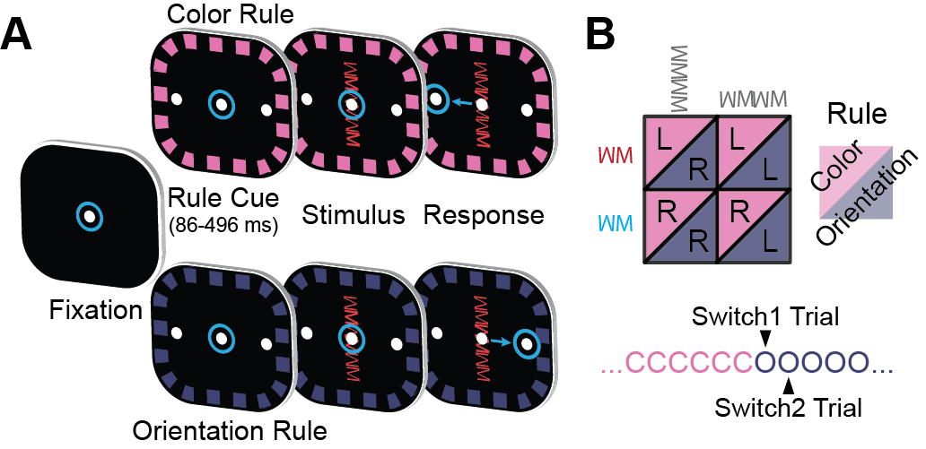

Figure 1: Task Design: (A) Task timeline. Eye position is indicated by the blue circles. Animals initiated trial by fixating the center dot. After presentation of a border cue indicating the rule, the stimulus was presented. (B) The animal integrated the rule and stimulus in order to make a decision about the required saccade: under the color rule, red stimuli meant saccade left and blue stimuli meant saccade right; under the orientation rule, vertical meant saccade right and horizontal meant saccade left. The rule in effect was blocked and switched randomly after a minimum of 20 trials.

#### Task factors that affect the amount of attention needed

In this dataset, there are four task factors which can change the amount of attention needed (summarized along with other important factors in Table 1) — which for the purpose of this proposal we denote attention factors. We summarize the attention factors here to make explicit our predictions in Aim #1 and Aim #2 with regard to the task.

We expect that in the first few trials after the rule changes (*Number of Rule Repetitions*, Figure 1B bottom) more attention is needed than in subsequent trials. This is motivated by the behavioral phenomenon known as switch cost, where responses are slower and errors are higher just after the context changes (Monsell, 2003). We have parameterized this by comparing the first five trials (individually) after the rule changes to all subsequent trials.

We also expect that after an error has been made (*Previous Error History*), more attention is needed to execute the next several trials correctly compared to later trials. Behaviorally, this can manifest as post-error slowing and higher accuracy after errors. Like rule repetitions, we parameterize this as a comparison of the first five trials after an error has been made to all subsequent trials.

We expect that more attention is needed when the stimulus *congruency* is incongruent. The stimulus is congruent if the correct saccade direction is the same under either rule. The stimulus is incongruent if the correct direction is different depending on the rule.

The fourth is the amount of time given between the rule cue and the stimulus (*Preparation Time*) and its subsequent effect on the processing of the test stimulus. As less time is given to process both the rule cue and the stimulus cue, more attention is needed after the stimulus is presented. We parameterize this by comparing the lower third of preparation time (more attention needed) to the upper third of preparation time (less attention needed).

Finally, we expect that each of these four factors interacts with *rule*. That is, we expect the amount by which attention is increased to be dependent on the rule cued for individual neurons.

Table 1: Description of the factors expected to modulate ACC and dlPFC activity. Levels marked in bold are the levels expected to require the least amount of attention in the task.

|  |  |  |
| --- | --- | --- |
| FACTOR | LEVELS | DESCRIPTION |
| *Rule* | Color, Orientation | Identity of the context cued. |
| *Number of Rule Repetitions* | Rep1, Rep2, Rep3, Rep4, Rep5, **Rep6+** | Number of trials since the rule changed. |
| *Previous Error History* | PrevError1, PrevError2, PrevError3, PrevError4, PrevError5, **PrevError6+** | Number of trials since an error was made. More attention is needed after an error. |
| *Congruency* | **Congruent**, Incongruent | Congruent: response to the stimulus is the same in either rule; Incongruent: response is different depending on the rule. More attention is needed when stimulus is incongruent. |
| *Preparation Time* | Low, Medium, **High** | Amount of time between the rule cue and the stimulus. More attention is needed when preparation time is low relative to when preparation time is high. |
| *Response Direction* | Right, Left | Direction of saccade to target |

### Specific Aim #1: To identify circuit level coordination within and between ACC and dlPFC.

#### The role of prefrontal rhythms and coherence in circuit-level communication

Neurons tend to fluctuate rhythmically in excitation – both through intrinsic currents at the cellular level and as groups (Ainsworth et al., 2012). This rhythmicity has been observed throughout the brain and changes with cognitive, sensory and motor state (Buschman and Miller, 2007; Lakatos et al., 2007; Pesaran et al., 2008). A benefit of rhythmic excitation is when multiple excitatory inputs arrive at nearly the same time to a target neuron, the effect on the targeted neuron is greater than a simple addition of the inputs (Nettleton and Spain, 2000; Salinas and Sejnowski, 2000).

Neuronal rhythms also influence the temporal effectiveness of inputs to a group of neurons. If inputs arrive at peak times of group excitability, there is an increased chance of neurons in the group firing. Conversely, if the inputs arrive when the group is less excitable, either due to inhibition from interneurons or refractory currents, there is less chance of neurons in the group firing (Burchell et al., 1998).

These observations have led to the suggestion that stable phase relationships (measured by coherence) between groups of neurons enable selective communication between the groups – the so-called *Communication through Coherence* hypothesis (Fries, 2005). If two groups of neurons are coherent at the same frequency and the conduction delays between the groups are sufficiently short, the groups can mutually excite each other at times of peak excitability, allowing effective communication between the groups. If the groups are not coherent, their oscillations are not sufficiently narrowband, or the conduction delays are long enough to result in anti-phase coherence, then signals between the groups are less effective and communication is diminished.

An important feature of phase-coherence is that it enables rapid and flexible routing of information between groups of neurons, allowing them to be selected and de-selected in a task-dependent manner (Akam and Kullmann, 2010, 2012). Moreover, this selection of neuronal groups does not strictly depend on the underlying anatomical connectivity, which can only change on a much slower timescale. This makes phase-coherence an ideal mechanism for the context-dependent linking of neurons. Context switches and shifts of attention can occur in hundreds of milliseconds, so the mechanism that supports them must also be able to change on this timescale (Singer, 2013).

Supporting this, several studies have found evidence for increased coherence between prefrontal cortex and distant brain areas during tasks that require visual attention. For example, Buschman and Miller (2007) found beta (22-34 Hz) coherence was stronger between parietal and prefrontal cortex of monkeys when the task required top-down attention. Similarly, Gregoriou et al. (2009) found spike-field coherence between LFPs in prefrontal cortex and neurons in visual cortex was enhanced when attending to a stimulus in their shared receptive field. Attentionally-enhanced coherence between prefrontal cortex and other areas also appears to be wide-spread among subdivisions of prefrontal cortex — electrodes placed in multiple subdivisions of prefrontal cortex were coherent in a content-specific manner with electrodes in the parietal lobe during a visual working memory task (Salazar et al., 2012).

So, based on evidence that coherence coordinates prefrontal cortex subdivisions with distant brain areas during attention and changes on the appropriate timescale, we hypothesize in this study that coherence also coordinates within and between prefrontal subdivisions in a context-dependent manner. This coordination may be important for two reasons: first, subdivisions of prefrontal cortex have different functional roles, but those roles seem to depend on context, so coherence may be a way for prefrontal subdivisions to flexibly communicate based on context; second, even within prefrontal subdivisions, neurons tend to be sensitive to multiple aspects of a task, so coherence may be a way to dynamically select context-appropriate neurons from a greater, heterogeneous population.

#### Comparisons and Outcomes

Local field potentials (LFPs) reflect the local activity of groups of neurons. Therefore, we will compute the coherence between pairs of simultaneously recorded LFPs to measure communication between groups of neurons.

To measure if communication is context-dependent, we will compute the difference in coherence between rules (Color Rule – Orientation Rule). In previous work (Buschman et al., 2012), we successfully identified context-dependent differences in coherence in the beta band (19-40 Hz) between electrodes in the dlPFC (see Figure 2). Here we would like to determine if this is true for electrodes within ACC and between ACC and dlPFC.

Additionally, to assess if these context-dependent differences change with the attention factors, we will compare the difference between rules in the least attention-demanding situations (see levels in Table 1 marked baseline) to the difference between rules in the most attention demanding. For example, for the factor *Congruency*, we will compare the difference in coherence between rules in the congruent condition to the difference in coherence between rules in the incongruent condition.

We expect in all of these situations that the amount of context-dependent coherence should increase for the preferred context (the rule for which the coherence is greater overall) in more attentionally-demanding conditions.

#### Potential Pitfalls and Alternative Approaches

Coherence is only one mechanism by which groups of neurons might communicate – it is possible that not all areas communicate via the frequency domain (Friston, 2000). In particular, rhythms have to be sufficiently narrowband for coherence to be an effective mechanism of communication and the influence of ACC on dlPFC may be more modulatory than driving (Medalla and Barbas, 2010). Therefore, transient signals in the time domain may matter more in their communication. As part of Aim #2, we examine how population firing in ACC and dlPFC affect the firing rate of individual neurons. This analysis is in the time domain and could capture communication between the areas that is not frequency-dependent.

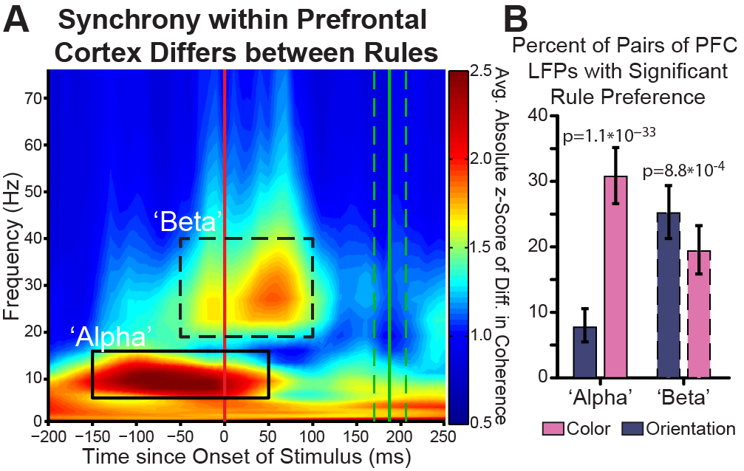

Figure 2: Rule-Selective Synchrony in PFC (A) Synchrony between electrodes within prefrontal cortex differs for rules. Synchrony is quantified by the coherence in simultaneously recorded local field potentials during each rule. The difference in synchrony (rectified to capture synchrony differences that prefer either rule) was compared to a trial-shuffled null distribution, resulting in a Z score of observed rule difference (color axis). Absolute synchrony differences are shown across time relative to stimulus onset (x axis) and frequency (y axis). Two time-frequency regions of interest (ROIs) are seen—an ‘‘alpha,’’ 6–16 Hz, prestimulus ROI (solid outline) and a ‘‘beta,’’ 19–40 Hz, peristimulus ROI (dashed outline). (B) Percentage of recorded pairs of electrodes with a significant rule preference during the ‘‘alpha’’ and ‘‘beta’’ time-frequency regions of interest (solid/ dashed outlines in A). Error bars indicate 95% confidence interval. Significantly more electrode pairs prefer color within the alpha ROI and orientation within the beta ROI.

### Specific Aim #2: To understand the functional contribution of ACC and dlPFC neurons to circuit-level dynamics and behavior during context switching

In Aim #1, our goal is to understanding how groups of neurons interact at the circuit level. In Aim #2, our goal is to characterize the cellular-level contributions of ACC and dlPFC neurons and their relationship to the circuit-level activity. This is important because it relates how activity in ACC and dlPFC works at different spatial scales.

#### Statistical methods: generalized linear models

Our approach is to employ multi-dimensional generalized linear regression models (McCullagh and Nelder, 1989) that account for many task factors simultaneously. In most analyses, linear regressions with Gaussian noise or ANOVAs are used to partition the contributions of task factors on neuronal firing rate. While this is often times adequate if the signal-to-noise ratio is high, generalized linear models make more efficient use of the data in several ways.

First, firing rates are strictly positive. They are bounded below by zero. In a linear model or ANOVA, this can cause problems because these models can predict negative firing rates, thus overestimating the contribution of a task factor. This is particularly a problem for cortical neurons, because the distribution of firing rates over a population of neurons is typically skewed toward lower firing rates (Buzsáki and Mizuseki, 2014). *Generalized* linear models allow for a non-linear transformation of the data so that all predictions are strictly positive.

Second, spike counts of neurons are discrete (spikes are typically recorded as spike or no spike over a specified time range). The most common distribution used to model variation in discrete counts is the Poisson distribution. Generalized linear models allow for the use of the Poisson distribution whereas the normal linear model and ANOVA do not.

Finally, generalized linear models are an extremely flexible framework. They can incorporate and efficiently estimate effects of spike history (refractory period, bursting), non-linear firing rate changes over time, and dependence on other neurons or groups of neurons (e.g. estimate the contribution of other neurons or groups of neurons to the firing rate of a single neuron). This last feature, the ability to efficiently estimate the contribution of other neurons or groups of neurons, is especially important to this aim because it allows us to relate circuit-level activity to the individual neuron.

#### Why multi-dimensional models for prefrontal cortical neurons?

The most common neuron in prefrontal cortex, like other cortical areas, is the pyramidal neuron — 70-85% of all neurons in cortex are pyramidal (DeFelipe and Fariñas, 1992). Because of this, most neurons recorded by an electrode are pyramidal. Therefore, when considering how to statistically model prefrontal neurons, we should consider the properties of pyramidal neurons in prefrontal cortex.

Pyramidal neurons in prefrontal cortex have more spines than those in other cortical areas (Elston, 2003), meaning individual neurons have a greater capacity to integrate input than other areas. Prefrontal neurons also receive convergent input from many other cortical areas (Schwartz and Goldman-Rakic, 1984), meaning each neuron is potentially influenced by multiple types of information. This is borne out in recordings of prefrontal neurons, which exhibit heterogeneous selectivity – they are often sensitive to many parameters of a task (Rigotti et al., 2013).

While this multi-dimensional representation seems to be beneficial to encoding a large number of task rules (Rigotti et al., 2010), it also implies that care should be taken when a task involves many different factors. Failing to account for factors simultaneously may overestimate their contribution.

#### Fitting a collection of models instead of only one model

As we described previously, the role of ACC neurons in task switching and in general is highly debated and more than one factor may affect the firing rate of prefrontal neurons. This leads to the statistical problem of model selection — determining the set of task factors which “best” describe the neuron’s firing. Fitting too many irrelevant task factors will result in lack of generalizability of the results. Fitting too few may overestimate the contribution of task factors. Determining what is the “best” is a difficult problem that typically is solved by compromising between bias (imposing strong assumptions on which task factors are involved or by invoking Occam’s razor style arguments) and variance (allowing for more model flexibility in terms of degrees of freedom and fitting more task factors). Selection of the best model — based on, for example, how well the model predicts future datasets — can often ignore equally plausible models for the data.

Our approach, following Wickham et al. (2015), is to fit a collection of models, ranging from a simple model — constant firing rate over time and no task factors affecting the neurons to a complex model — attentional task factors (as in Table 1) that may or may not impact the firing rate depending on the context. This approach does not escape the bias-variance tradeoff in model selection, but it does allow for several candidate best models, which we feel is more appropriate when uncertainty about the theory underlying functioning in ACC is so high.

#### Evaluation of the models – cross-validation, area under the curve, and posterior predictive checks

As a precaution against overfitting noise, we will examine the performance of the model in predicting withheld data versus simpler models. This will measure the ability of our model to generalize to new data. We will do this using five-fold cross validation, which means we will examine how a model fit on four-fifths of the data can predict performance on a withheld fifth of the data — alternating the particular withheld fifth of the data and averaging the predictive performance over all of them.

To evaluate predictive performance, we will use a receiver operating characteristic measure called Area Under the Curve (AUC). In this measure, the predicted firing rate distribution when a spike occurs is compared to the predicted firing rate distribution when no spike occurs. AUC measures how discriminable the two populations of firing rates (spike versus no spike) are from each other. One advantage of using AUC compared to other methods is that AUCs are easily comparable from neuron to neuron (Kelly et al., 2010), making it easier to evaluate how a model is doing over a population of neurons.

Finally, we will visually compare the model-generated data (spikes simulated from the model) to the real data. This technique is known as posterior predictive checking (Gelman et al., 1996; Rubin, 1984). Posterior predictive checks are well-suited for understanding how complex models relate to the dataset, because they are simple to compute and diagnosing model misfit is a simple visual comparison. An example of this is in Pillow et al. (2008) (Figure 3) where they compare models of retinal ganglion cells that take into account coupling from nearby cells to models that do not take into account coupling from nearby cells.

#### Comparisons and Outcomes

To examine context selectivity of individual neurons in relation to attention factors, we will fit a collection of models ranging from assuming no change in firing rate to including all factors described in Table 1 and their interaction with Rule. For example, with just two factors (for example, Rule and Previous Error History), the collection of models would be: the constant model (no change in firing rate during the task), Rule, Previous Error History, Rule and Previous Error History, and Rule interacted with Previous Error History. If successful, this will give us a thorough characterization of how each attentionally demanding factor changes the firing rate and whether this change in firing rate is dependent on rule.

To examine how the population firing rates of ACC and dlPFC influence individual neurons, we will fit models that include the population spiking history of ACC neurons and dlPFC neurons where the population spiking history consists of the summed spikes of all neurons in a given recording session for a given area. If successful, this will determine if the influence of population firing from ACC and dlPFC changes with rule and attentionally demanding task factors.

#### Potential Pitfalls and Alternative Approaches

The models we propose to examine are complex and our ability to estimate them successfully relies on the power of the data. Additionally, complex models can be harder to interpret. We have proposed two checks on the complexity of our model: the performance of the model in predicting new spikes and evaluation of the model-generated data compared to the actual data.

However, if the complexity of the model is still too high, we can reduce the overall number of parameters by eliminating the dependence of the model on time in trial and examine only the average effect over the entire trial. We can also simplify the model by eliminating the interactions between Rule and Attention Factors.

Another potential issue is the total number of simultaneously recorded neurons in each session. If there are relatively few neurons recorded simultaneously, they might form a poor approximation to the overall population firing rate. One possibility here is to use the LFPs instead, as in Kelly et al. (2010).

### Specific Aim #3: To build web-enabled interactive visualization tools that enhance exploratory analysis, checking of raw data and statistical modeling assumptions, and data presentation for large, complex and multi-scale electrophyisological data.

Our general goal is to create building blocks for interactive visualizations that can be extended to more complicated visualizations, linked together to provide an integrated view of an electrophysiological dataset — from raw data to statistical summary or from cellular to circuit level — or used independently. Each visualization allows for examination of the electrophysiological signals (or summary statistic of the signal) over time relative to task-relevant events, comparison of different subjects or recording sessions, and aggregation of signals over regions-of-interest such as anatomically defined brain areas.

All visualizations will be built in JavaScript using the [D3](http://d3js.org/) library (Bostock et al., 2011) — a visualization library for translating data into web elements. The D3 library includes support for adding interactions, animations and manipulating data, which is crucial to building the visualizations. This library is well supported and under active development.

All code will be uploaded and documented in a [Github software repository](https://github.com/edeno) and available under the [GNU General Public License, version 2](http://www.gnu.org/licenses/old-licenses/gpl-2.0.en.html)— ensuring that future use and development of the code will remain open source and shareable.

All visualizations will be able to be put into a specific state (e.g. selecting a particular subject, task-relavent event, brain region of interest) by passing parameters via the uniform resource locator (URL) in the browser address bar. This enables the visualizations to be easily shared with other people or to be linked to by other visualizations. In addition, buttons to export a snapshot of the visualization in a specific state (in scalable vector graphics format) will be provided. This makes it easy for a static version of the visualization to be saved and placed in a publication. The New York Times has used this workflow (interactive visualization static visualization in a particular state in print) [successfully](http://chartsnthings.tumblr.com/post/47670081904/climate-change-crowbars-and-strikeouts).

#### RasterVis

The first visualization, RasterVis, incorporates two canonical visualizations for single and multiunit spiking data — the raster plot and peri-event time histogram. The raster plot describes spike times for each trial relative to a trial event. The peri-event time histogram is a simple but useful summary of how, over a series of trials, the spike times are distributed across time bins relative to the time of a trial event. Because these two types of visualizations are familiar and represent the “raw” spiking data, they are an ideal building-block visualization. Furthermore, they can also be used to compare raw spiking data to model-generated data in order to check statistical modeling assumptions (posterior predictive checks) — so they can be useful in understanding how models reflect the data.

RasterVis uses interactivity and animation to supplement the raster plot and peri-event time histogram in order to make it easier for the user to accomplish typical tasks in the analysis of spiking data (See Figure 3 for a screenshot of the RasterVis interface).

For example, RasterVis allows for dynamic alignment of spike times and “on-the-fly” computation of peri-event histograms relative to experimental trial events (e.g. visual stimuli, timing of rewards, presentation of fixation points). Animated transitions emphasize how spike timing relative to trial event relates to another. This allows a user to quickly compare the timing of individual spikes and aggregate spiking (via histogram) to different cues and conditions. Different levels of aggregation (Gaussian smoothing) for the histogram can be compared as well.

RasterVis also allows for dynamic sorting by experimental task factors. This feature creates different plots for each condition within the task factor. For example, if a task factor is a visual cue with two experimental conditions — color and orientation — sorting by the visual cue creates two plots for the color condition and the orientation condition. This is essential for multidimensional analysis which may compare several different factors and conditions.

Finally, RasterVis allows for comparison between neurons. The user can browse neurons by subject, recording session, or name to easily find and compare neurons.

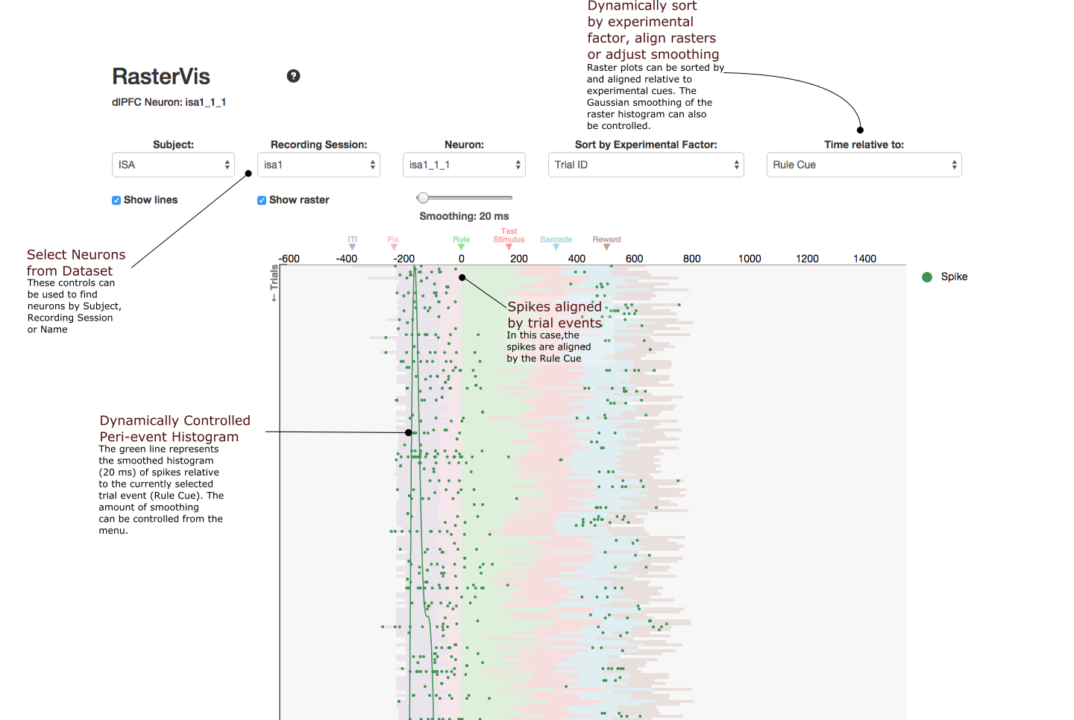

Figure 3: A static screenshot of the RasterVis interface.

#### glmVis

We also will build an interactive visualization for the generalized linear models that will: (1) show the relationship between the multiple dimensions of the model fit over time, (2) show the relationship between multiple models, and (3) show the relationship between multiple brain areas. To show the relationship between multiple dimensions, we will use the parallel coordinate plots (Wegman, 1990).

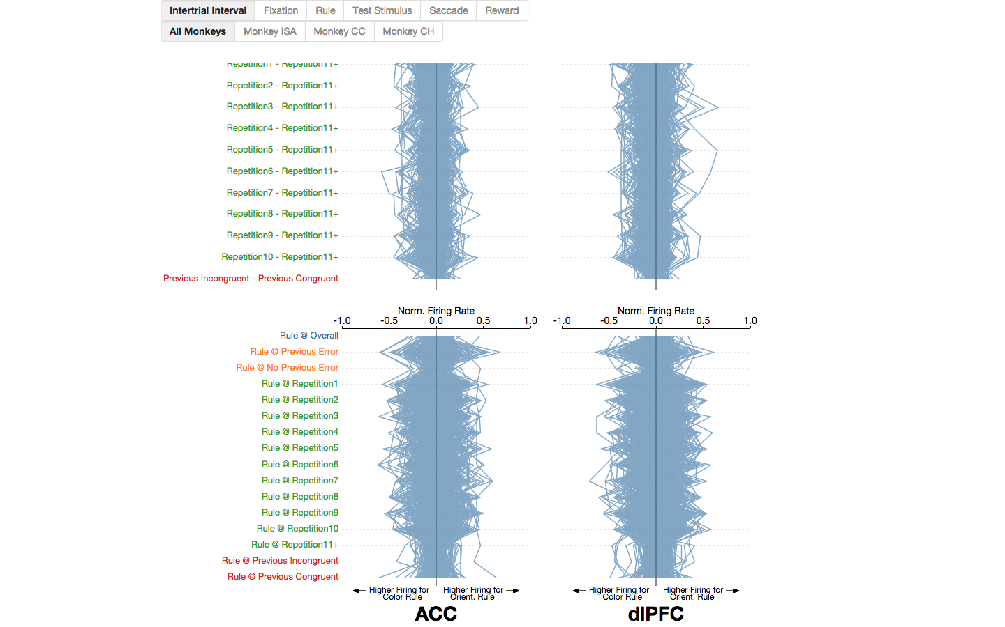

Figure 4: A static screenshot of the glmVis interface.

#### SpectraVis

Finally, we will build an interactive visualization aimed at capturing functional connectivity between neurons/electrodes. Functional network analysis is a growing area of neuroscience research, driven in part by technological improvements allowing us to record from more sensors simultaneously. However, as researchers record from more sensors, network analyses can become unwieldy and hard to interpret, because the number of possible network connections scales quadratically with the number of sensors (e.g. electrodes). Further, we expect neural processes to form dynamic networks that vary over time, frequency, and spatial scales (e.g. within and between brain regions), adding complexity to network analyses.

SpectraVis is an interactive web-based visualization application that: (1) displays task-related functional networks over time and frequency, (2) compares individual and associative measures on sensor pairs (e.g. spectra, coherences), (3) compares different measures of association (e.g. correlation vs. coherence, binary vs. weighted networks), and (4) views networks at two spatial scales (sensor- and region-of-interest-level). The different modules of SpectraVis are dynamically linked, highlighting relationships between the metrics in response to user interaction.

Figure 5 shows a typical view of SpectraVis. The network view shows the anatomical location of the sensors (circles with sensor number) and edges (lines) weighted by the edge statistic. In this example, the edges are binary, representing significant changes in local field potential coherence between *Speech* — subjects reading aloud the words of the Gettysburg Address — and *Silence* at a particular frequency (10 Hz) and time (187.5 ms after speech onset)[1]. The network has dense connectivity within and between primary motor and primary somatosensory cortices (M1 and S1). The controls can be used to play a movie of the network over time, showing increased connectivity starting within M1 300 ms before speech onset and spreading to S1 100 ms before speech onset. Below the network view is a sensor view (dotted box) which depicts the relationship (spectra, coherences) between a selected pair of sensors (circled in black, network view, sensors 85 and 90) at all times and frequencies. Here, the edge between M1 (sensor 90) and S1 (sensor 85) represents a 10 Hz increase in speech coherence relative to silence. The increase co-occurs with higher frequency beta (15-25Hz) power suppression on the M1 sensor. Mousing over these displays updates the network view to the time-frequency bin under the cursor.

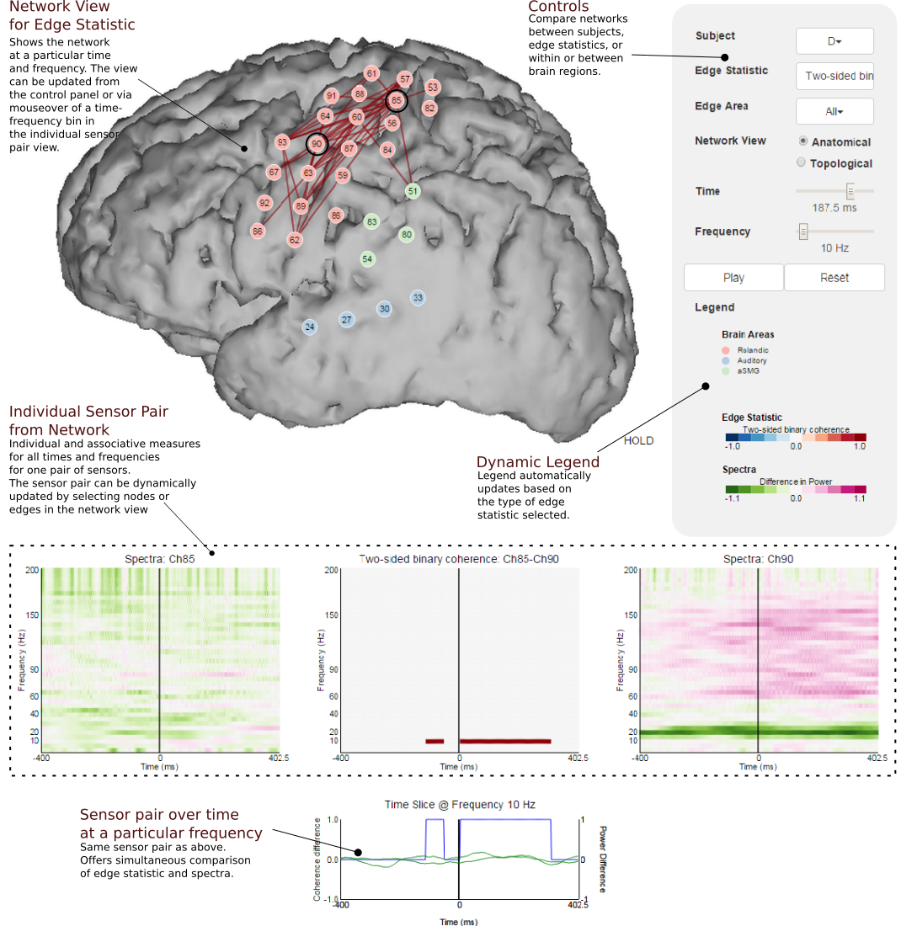

Figure 5: A static screenshot of the SpectraVis interface with the ECOG overt reading data.

#### Potential Pitfalls

A challenge for building software tools is making them easy enough to install and use while making them flexible enough to account for a variety of use cases. Our solution to this is to try to set smart defaults so that the visualization can run without much alteration and to provide extensive documentation and examples via the Github repository for the project. Additionally, we provide Matlab scripts that can help organize data into the correct format.

## Studies Completed and In Progress

Aim #1 has been completed and was published as a paper in 2012 [(Buschman et al., 2012)](http://dx.doi.org/10.1016/j.neuron.2012.09.029).

Aim #2 had preliminary results appear in two Society for Neuroscience (SFN) posters (abstracts available [here](http://www.abstractsonline.com/Plan/ViewAbstract.aspx?sKey=3000f50b-7c71-42da-9796-a7da6471f141&cKey=6356905f-39f3-4b1b-9cda-bd137b07725e&mKey=%7B70007181-01C9-4DE9-A0A2-EEBFA14CD9F1%7D) and [here](http://www.abstractsonline.com/Plan/ViewAbstract.aspx?sKey=3000f50b-7c71-42da-9796-a7da6471f141&cKey=a103e157-9bfe-469d-8a24-4e4e4c663d51&mKey=%7B70007181-01C9-4DE9-A0A2-EEBFA14CD9F1%7D)), but final results are still in progress.

Aim #3 is 66% completed with Github repositories and functioning prototypes for all three proposed visualizations (see [SpectraVis](https://github.com/edeno/SpectraVis), [RasterVis](https://github.com/edeno/RasterVis), and [glmVis](https://github.com/edeno/glmVis)) and a rough draft of the thesis chapter (included in submitted materials).

## References

Ainsworth, M., Lee, S., Cunningham, M.O., Traub, R.D., Kopell, N.J., and Whittington, M. (2012). Rates and Rhythms: A Synergistic View of Frequency and Temporal Coding in Neuronal Networks. Neuron *75*, 572–583.

Akam, T., and Kullmann, D.M. (2010). Oscillations and Filtering Networks Support Flexible Routing of Information. Neuron *67*, 308–320.

Akam, T.E., and Kullmann, D.M. (2012). Efficient “Communication through Coherence” Requires Oscillations Structured to Minimize Interference between Signals. PLoS Comput Biol *8*, e1002760.

Alexander, W.H., and Brown, J.W. (2011). Medial prefrontal cortex as an action-outcome predictor. Nature Neuroscience *14*, 1338–1344.

Anscombe, F.J. (1973). Graphs in statistical analysis. The American Statistician *27*, 17–21.

Bates, J.F., and Goldman-Rakic, P.S. (1993). Prefrontal connections of medial motor areas in the rhesus monkey. Journal of Comparative Neurology *336*, 211–228.

Bostock, M., Ogievetsky, V., and Heer, J. (2011). D³ data-driven documents. Visualization and Computer Graphics, IEEE Transactions on *17*, 2301–2309.

Botvinick, M.M., Braver, T.S., Barch, D.M., Carter, C.S., and Cohen, J.D. (2001). Conflict monitoring and cognitive control. Psychological Review *108*, 624.

Botvinick, M.M., Cohen, J.D., and Carter, C.S. (2004). Conflict monitoring and anterior cingulate cortex: an update. Trends in Cognitive Sciences *8*, 539–546.

Brown, J.W., and Braver, T.S. (2005). Learned predictions of error likelihood in the anterior cingulate cortex. Science *307*, 1118–1121.

Brutlag, J. (2009). Speed matters for Google web search. Google. June.

Burchell, T.R., Faulkner, H.J., and Whittington, M.A. (1998). Gamma frequency oscillations gate temporally coded afferent inputs in the rat hippocampal slice. Neuroscience Letters *255*, 151–154.

Buschman, T.J., and Miller, E.K. (2007). Top-Down Versus Bottom-Up Control of Attention in the Prefrontal and Posterior Parietal Cortices. Science *315*, 1860–1862.

Buschman, T., Denovellis, E., Diogo, C., Bullock, D., and Miller, E. (2012). Synchronous Oscillatory Neural Ensembles for Rules in the Prefrontal Cortex. Neuron *76*, 838–846.

Bush, G., Luu, P., and Posner, M.I. (2000). Cognitive and emotional influences in anterior cingulate cortex. Trends in Cognitive Sciences *4*, 215–222.

Buzsáki, G., and Mizuseki, K. (2014). The log-dynamic brain: how skewed distributions affect network operations. Nat Rev Neurosci *15*, 264–278.

Carter, C.S., Braver, T.S., Barch, D.M., Botvinick, M.M., Noll, D., and Cohen, J.D. (1998). Anterior Cingulate Cortex, Error Detection, and the Online Monitoring of Performance. Science *280*, 747–749.

DeFelipe, J., and Fariñas, I. (1992). The pyramidal neuron of the cerebral cortex: morphological and chemical characteristics of the synaptic inputs. Progress in Neurobiology *39*, 563–607.

Dias, R., Robbins, T.W., and Roberts, A.C. (1996). Dissociation in prefrontal cortex of affective and attentional shifts. *380*, 69–72.

Elston, G.N. (2003). Cortex, Cognition and the Cell: New Insights into the Pyramidal Neuron and Prefrontal Function. Cerebral Cortex *13*, 1124–1138.

Fries, P. (2005). A mechanism for cognitive dynamics: neuronal communication through neuronal coherence. Trends in Cognitive Sciences *9*, 474–480.

Friston, K.J. (2000). The labile brain. I. Neuronal transients and nonlinear coupling. Phil. Trans. R. Soc. Lond. B *355*, 215–236.

Fuster, J.M. (1973). Unit activity in prefrontal cortex during delayed-response performance: neuronal correlates of transient memory. Journal of Neurophysiology.

Gehring, W.J., and Fencsik, D.E. (2001). Functions of the Medial Frontal Cortex in the Processing of Conflict and Errors. J. Neurosci. *21*, 9430–9437.

Gelman, A. (2004). Exploratory Data Analysis for Complex Models. Journal of Computational and Graphical Statistics *13*, 755–779.

Gelman, A., Meng, X.-L., and Stern, H. (1996). Posterior predictive assessment of model fitness via realized discrepancies. Statistica Sinica *6*, 733–760.

Gregoriou, G.G., Gotts, S.J., Zhou, H., and Desimone, R. (2009). High-Frequency, Long-Range Coupling Between Prefrontal and Visual Cortex During Attention. Science *324*, 1207–1210.

Holroyd, C.B., and Coles, M.G.H. (2002). The neural basis of human error processing: reinforcement learning, dopamine, and the error-related negativity. Psychol Rev *109*, 679–709.

Holroyd, C.B., and Yeung, N. (2012). Motivation of extended behaviors by anterior cingulate cortex. Trends in Cognitive Sciences *16*, 122–128.

Jacobson, S., and Trojanowski, J.Q. (1977). Prefrontal granular cortex of the rhesus monkey. I. Intrahemispheric cortical afferents. Brain Research *132*, 209–233.

Johnston, K., Levin, H.M., Koval, M.J., and Everling, S. (2007). Top-Down Control-Signal Dynamics in Anterior Cingulate and Prefrontal Cortex Neurons following Task Switching. Neuron *53*, 453–462.

Kelly, R., Smith, M., Kass, R., and Lee, T.S. (2010). Accounting for network effects in neuronal responses using L1 regularized point process models. In Advances in Neural Information Processing Systems, pp. 1099–1107.

Lakatos, P., Chen, C.-M., O’Connell, M.N., Mills, A., and Schroeder, C.E. (2007). Neuronal Oscillations and Multisensory Interaction in Primary Auditory Cortex. Neuron *53*, 279–292.

Liu, Z., and Heer, J. (2014). The effects of interactive latency on exploratory visual analysis. Visualization and Computer Graphics, IEEE Transactions on *20*, 2122–2131.

Luks, T.L., Simpson, G.V., Feiwell, R.J., and Miller, W.L. (2002). Evidence for Anterior Cingulate Cortex Involvement in Monitoring Preparatory Attentional Set. NeuroImage *17*, 792–802.

McCullagh, P., and Nelder, J.A. (1989). Generalized linear models (CRC press).

Medalla, M., and Barbas, H. (2009). Synapses with Inhibitory Neurons Differentiate Anterior Cingulate from Dorsolateral Prefrontal Pathways Associated with Cognitive Control. Neuron *61*, 609–620.

Medalla, M., and Barbas, H. (2010). Anterior Cingulate Synapses in Prefrontal Areas 10 and 46 Suggest Differential Influence in Cognitive Control. J. Neurosci. *30*, 16068–16081.

Miller, E.K., and Cohen, J.D. (2001). An integrative theory of prefrontal cortex function. Annual Review of Neuroscience *24*, 167–202.

Monsell, S. (2003). Task switching. Trends in Cognitive Sciences *7*, 134–140.

Nettleton, J.S., and Spain, W.J. (2000). Linear to Supralinear Summation of AMPA-Mediated EPSPs in Neocortical Pyramidal Neurons. Journal of Neurophysiology *83*, 3310–3322.

Pesaran, B., Nelson, M.J., and Andersen, R.A. (2008). Free choice activates a decision circuit between frontal and parietal cortex. Nature *453*, 406–409.

Pillow, J.W., Shlens, J., Paninski, L., Sher, A., Litke, A.M., Chichilnisky, E.J., and Simoncelli, E.P. (2008). Spatio-temporal correlations and visual signalling in a complete neuronal population. Nature *454*, 995–999.

Rigotti, M., Rubin, D.B.D., Wang, X.-J., and Fusi, S. (2010). Internal representation of task rules by recurrent dynamics: the importance of the diversity of neural responses. Frontiers in Computational Neuroscience *4*.

Rigotti, M., Barak, O., Warden, M.R., Wang, X.-J., Daw, N.D., Miller, E.K., and Fusi, S. (2013). The importance of mixed selectivity in complex cognitive tasks. Nature *advance online publication*.

Rubin, D.B. (1984). Bayesianly justifiable and relevant frequency calculations for the applied statistician. The Annals of Statistics *12*, 1151–1172.

Rushworth, M.F.S., and Behrens, T.E.J. (2008). Choice, uncertainty and value in prefrontal and cingulate cortex. Nat Neurosci *11*, 389–397.

Rushworth, M., Noonan, M., Boorman, E., Walton, M., and Behrens, T. (2011). Frontal Cortex and Reward-Guided Learning and Decision-Making. Neuron *70*, 1054–1069.

Salazar, R.F., Dotson, N.M., Bressler, S.L., and Gray, C.M. (2012). Content-Specific Fronto-Parietal Synchronization During Visual Working Memory. Science *338*, 1097–1100.

Salinas, E., and Sejnowski, T.J. (2000). Impact of Correlated Synaptic Input on Output Firing Rate and Variability in Simple Neuronal Models. J. Neurosci. *20*, 6193–6209.

Schwartz, M.L., and Goldman-Rakic, P.S. (1984). Callosal and intrahemispheric connectivity of the prefrontal association cortex in rhesus monkey: relation between intraparietal and principal sulcal cortex. Journal of Comparative Neurology *226*, 403–420.

Shenhav, A., Botvinick, M., and Cohen, J. (2013). The Expected Value of Control: An Integrative Theory of Anterior Cingulate Cortex Function. Neuron *79*, 217–240.

Singer, W. (2013). Cortical dynamics revisited. Trends in Cognitive Sciences *17*, 616–626.

Stuss, D.T., and Benson, D.F. (1984). Neuropsychological studies of the frontal lobes. Psychological Bulletin *95*, 3.

Wallis, J.D., Anderson, K.C., and Miller, E.K. (2001). Single neurons in prefrontal cortex encode abstract rules. Nature *411*, 953–956.

Wegman, E.J. (1990). Hyperdimensional data analysis using parallel coordinates. Journal of the American Statistical Association *85*, 664–675.

Wickham, H., Cook, D., and Hofmann, H. (2015). Visualizing Statistical Models: Removing the Blindfold. Statistical Analysis and Data Mining: The ASA Data Science Journal.

Yeterian, E.H., and Pandya, D.N. (1994). Laminar origin of striatal and thalamic projections of the prefrontal cortex in rhesus monkeys. Experimental Brain Research *99*, 383–398.

1. Details of network construction methodology can be found [here](http://search.proquest.com/docview/1731940762?accountid=9676).