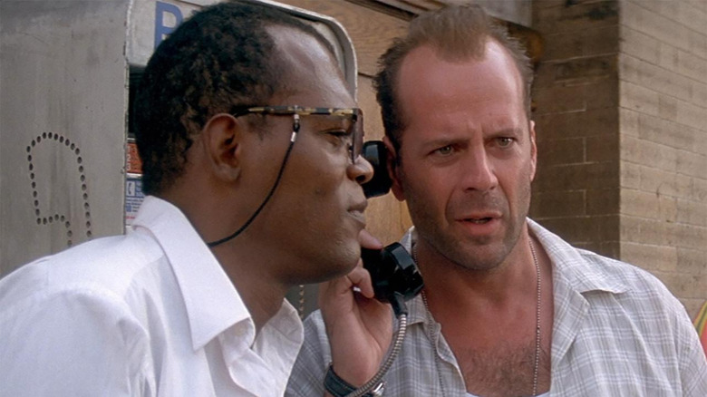

SIMON: Why was the phone busy? Who are you calling?

JOHN: The psychic hotline.

SIMON: I’d advice you to take this more seriously.

JOHN: Look, this is a public phone, what do you want me to say?

SIMON: You could simply say that there was a fat women on it and it took you a minute to get her off. Now John, there's a significant amount of explosive in the trash receptacle next to you. Try to run and it goes off now.

JOHN: Nobody's gonna run, but I've got a hundred people out here.

SIMON: That's the point. Now, do I have your attention? As I was going to St-Ives, I meet a man with 7 wives, every wife had 7 sacks, every sack had 7 cats, every cat had 7 kittens. Kittens, cats, sacks and wives, how many were going to St-Ives? My phone number is 555-...

JOHN: No, no, wait. I didn't get all that. Say it again.

SIMON: Not a chance. My phone number..

JOHN: What? I didn't...

SIMON: is 555 followed by the answer in 4 digits. Call me in 30 seconds or die.

JOHN: All right, 7 guys with 7 wives.