Task 2.2: Analysis of cancer-associated muscle wasting
    - Task Overview
This program was designed to analyse cancer patient urine metabolite data and its relationship to cachexia, including building a machine learning prediction model.
    - Program design
After cleaning and filtering, the data was log10 transformed to allow for meaningful visualisation in boxplots. A pseudocount value of 1x10⁻⁶ was added to each value to prevent a log of 0 from occurring. The log10 data was then also used for the rest of the visualisation process for consistency.
The random states of the test/train data split and ML model functions were set to an arbitrary value (15) to ensure reproducibility across multiple executions of the code for editing or future application.
Scalers and imputers were added to each machine learning model. The scaler prevents high-concentration metabolites from overwhelming low-concentration metabolites in the training; the imputer protects against any missing values in future data. These were added to the models using the pipeline module. The scores were calculated and displayed using the roc_auc_score module for simplicity; the roc_curve and auc modules were used later for generating the ROC graph.
The best-performing model by AUC is stored to a variable, which is then used throughout the rest of the code. This allows for reuse of the program with different data or random states, with the best model still being used for downstream output no matter which model performs best.

Pseudocode:
- Load data into dataframe and check
- Add column to numerically store cachexia status
- Initialise metabolite list and check for compatibility with dataframe
- Convert dataframe values to log10
- Create boxplot of metabolite distributions overall and per metabolite by cachexia
- Create correlation heatmap of metabolites
- Perform PCA of top 30 metabolites
- Split data into proportional training and test sets (70/30 split)
- 5-fold cross validation training for 5 models
- Sort the models by highest AUC and lowest SD
- Save the highest-performing model to a variable
- Train the best performing model on the entire test set
- Create and output classification table and ROC curve of best performing model

    - Program execution demonstration
Data import and examination, showing first 4 columns:
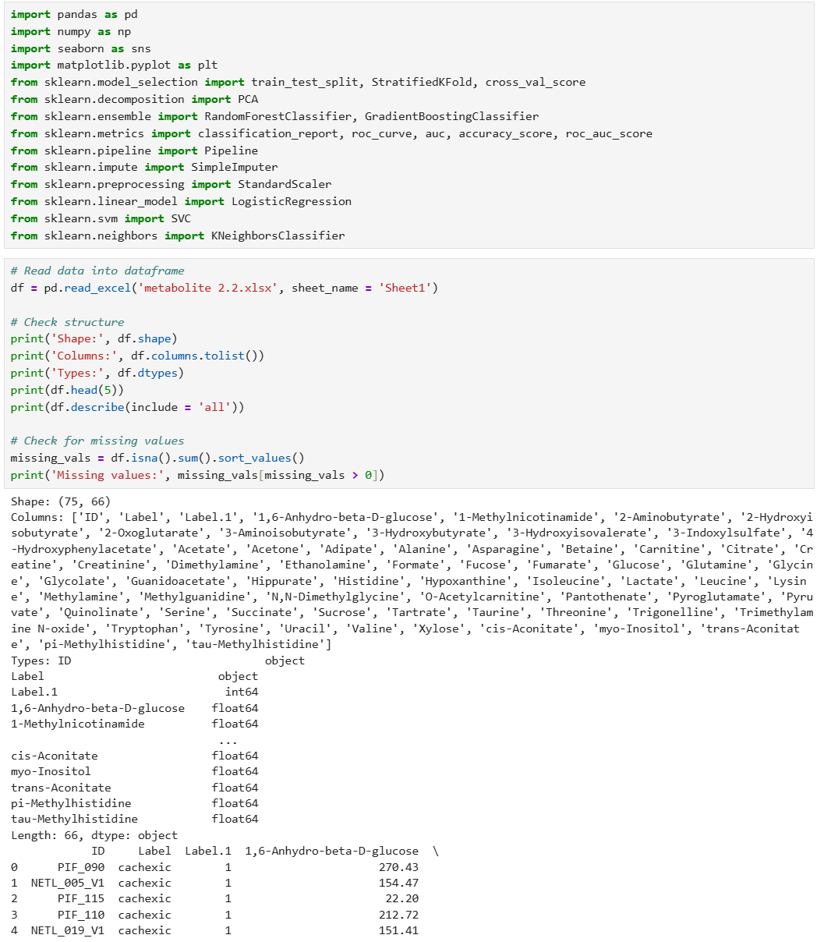

Cachexia status refactoring with checks:
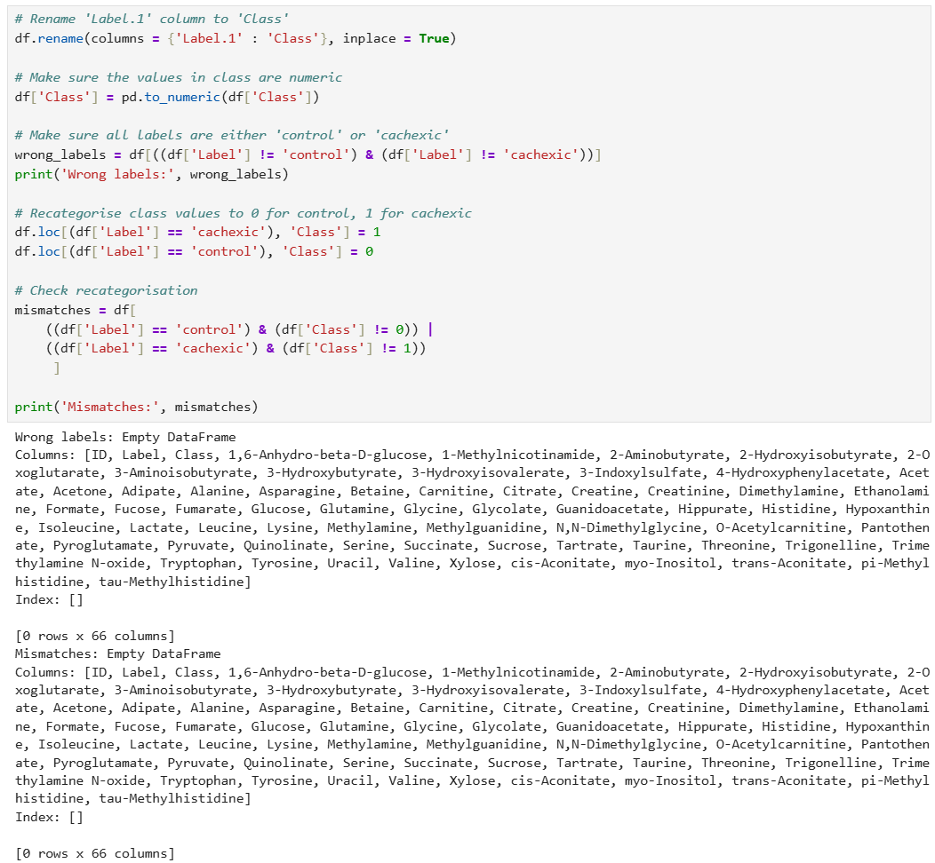
Metabolite list initialisation with check:
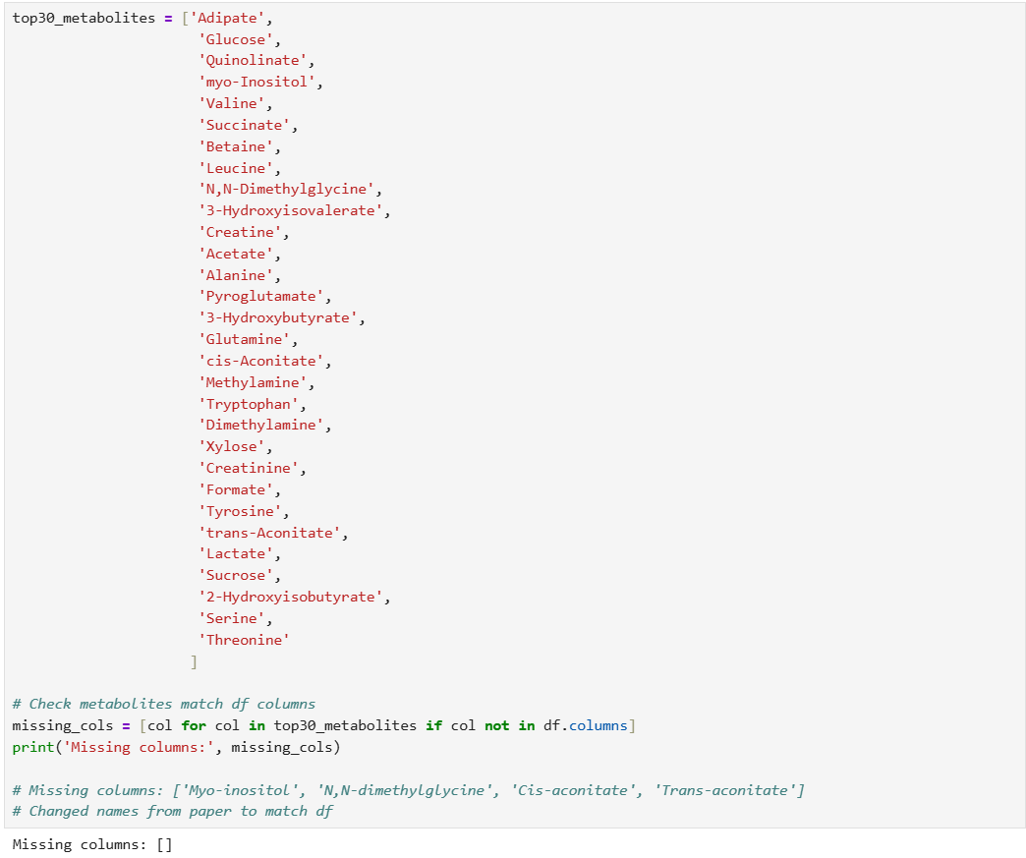
Log10 transformation and overall metabolite concentration plot:
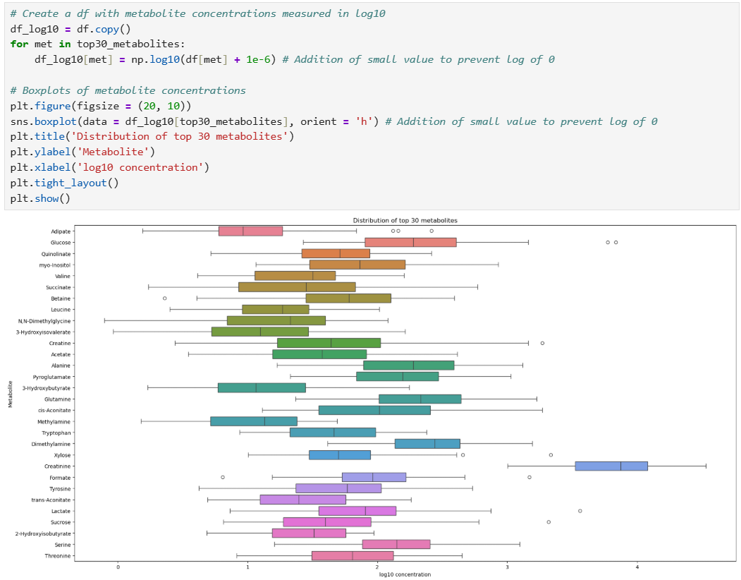
Boxplots of metabolite concentration by cachexia status:
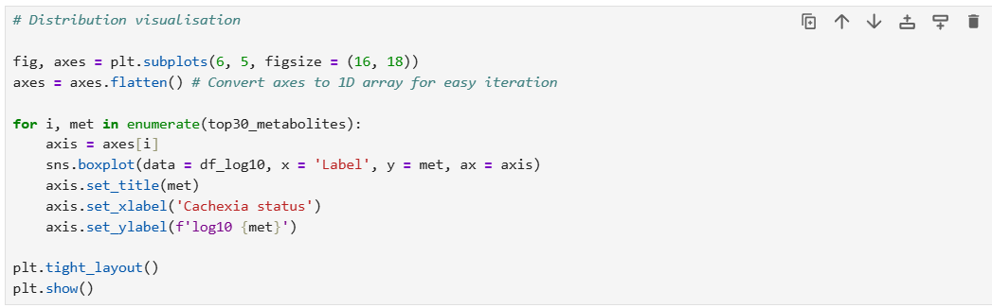
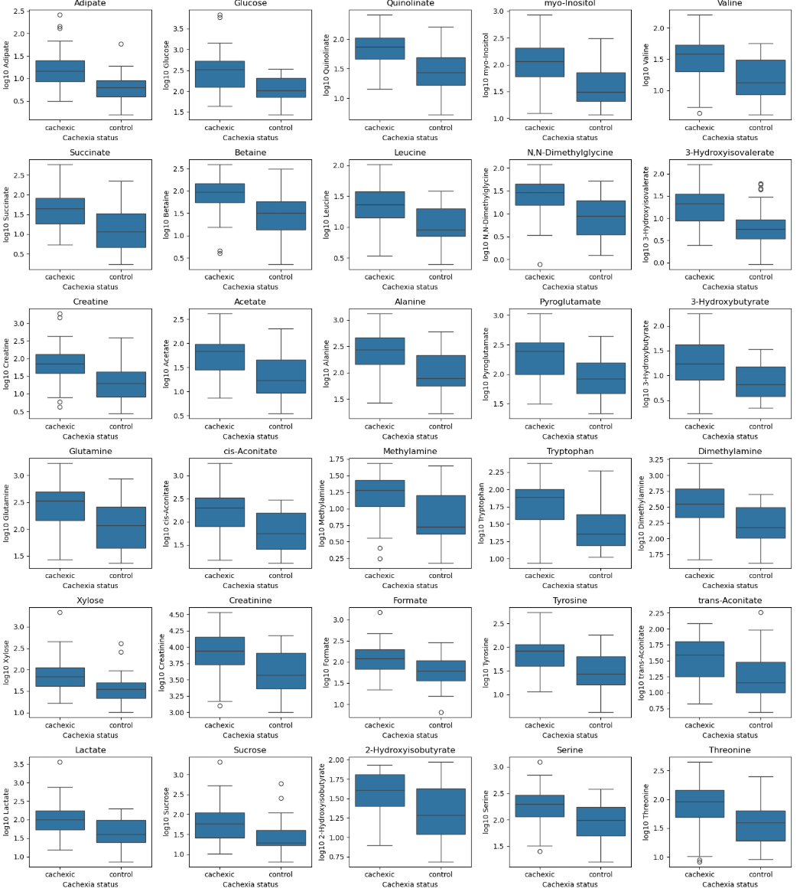

All metabolites appear elevated in cachexic patients, with varying degrees of overlapping interquartile ranges. Note that y-axis scales vary by metabolite.

Correlation heatmap:
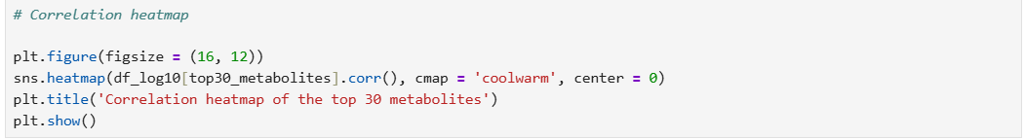
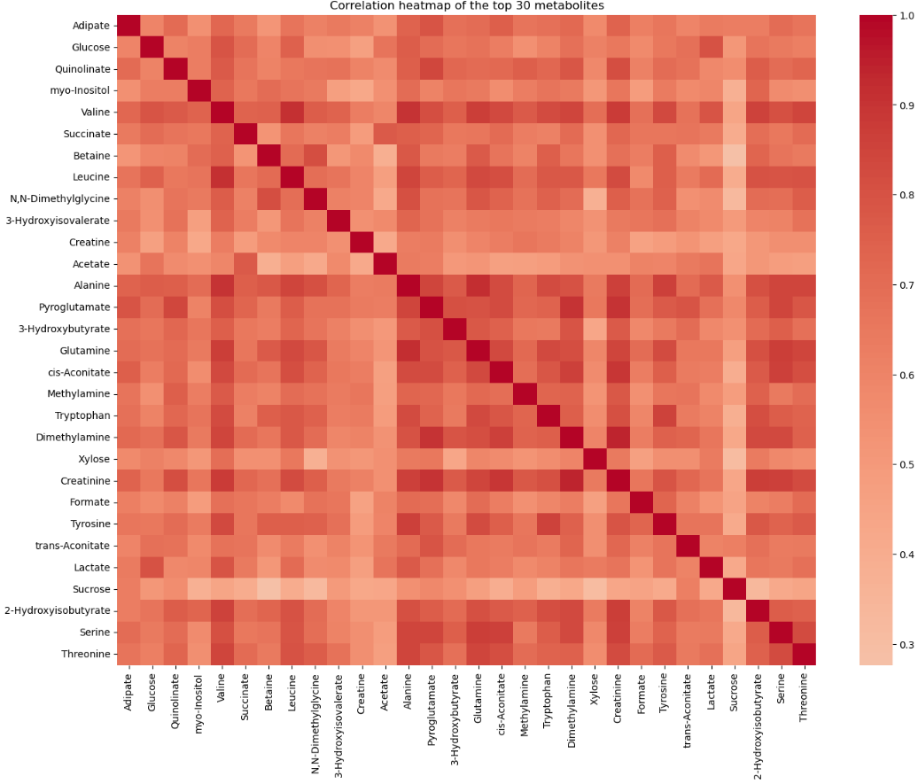

Acetate and sucrose appear in general to have weaker correlations with other cachexia-associated metabolites than the others.

PCA:
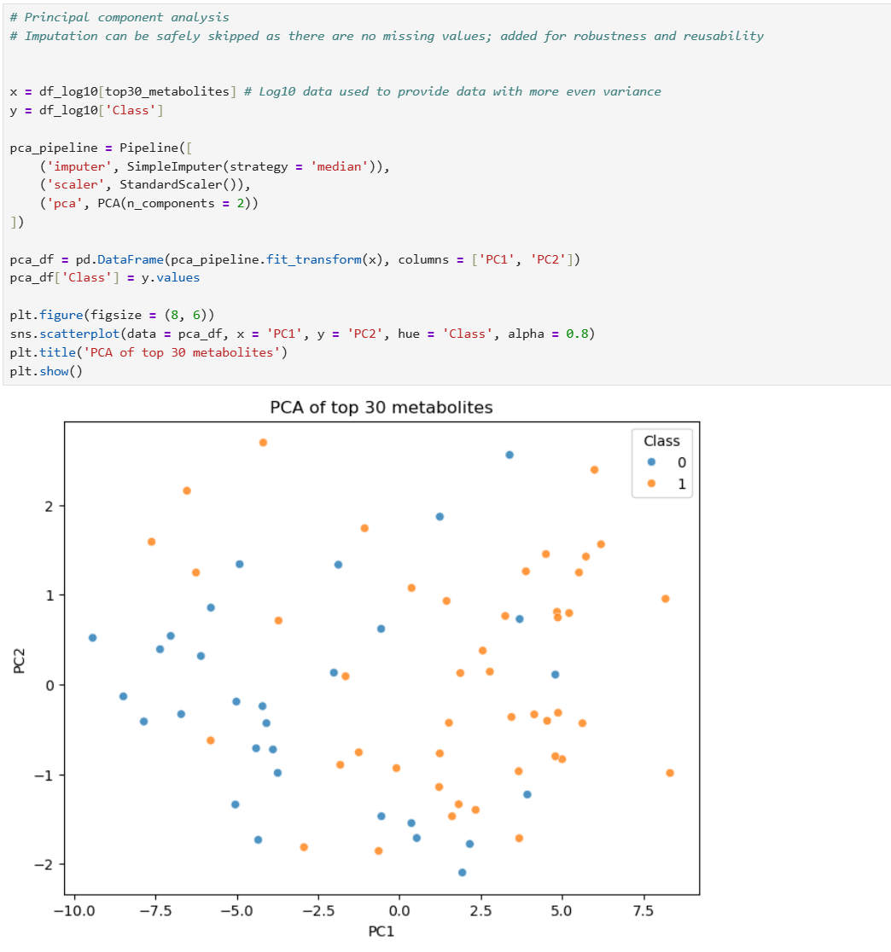
Clustering is not strong; however, patterns are visible. The metabolite profile of cachexic patients appears to tend towards higher values of both PC1 and PC2. This effect is more pronounced along PC1.

Training/test data split and equal proportions check:
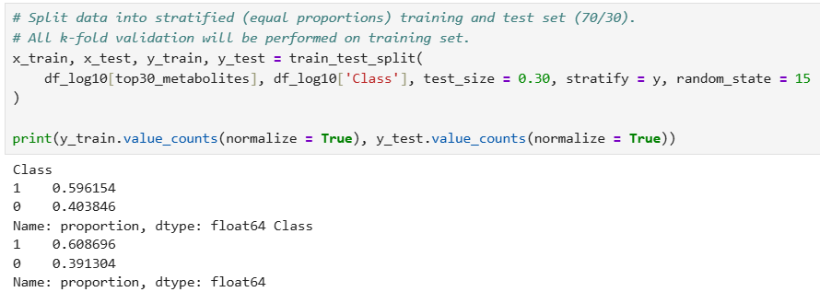
5-fold cross-validation and best model selection:
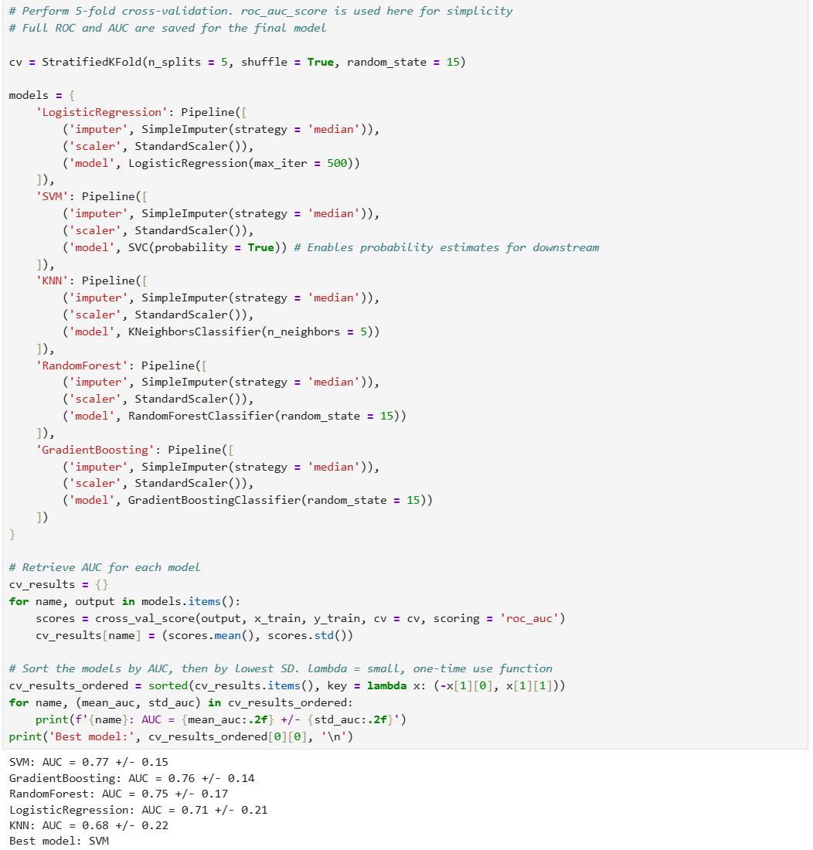

Whole test set training and classification report:
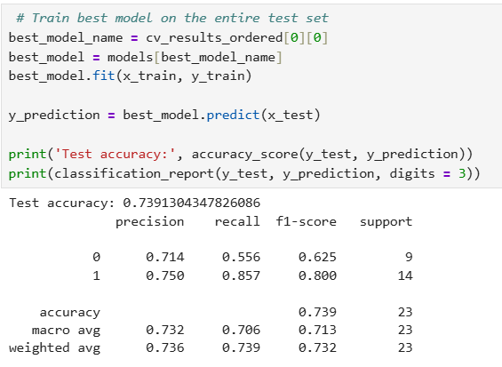
These results show high sensitivity (0.857) but low specificity (0.556); this is preferable for a diagnostic tool, as false negatives (missing a case and affecting outcomes) are worse than false positives (running unnecessary further tests). However, the small test set (n = 23) make these results questionable.
ROC curve:
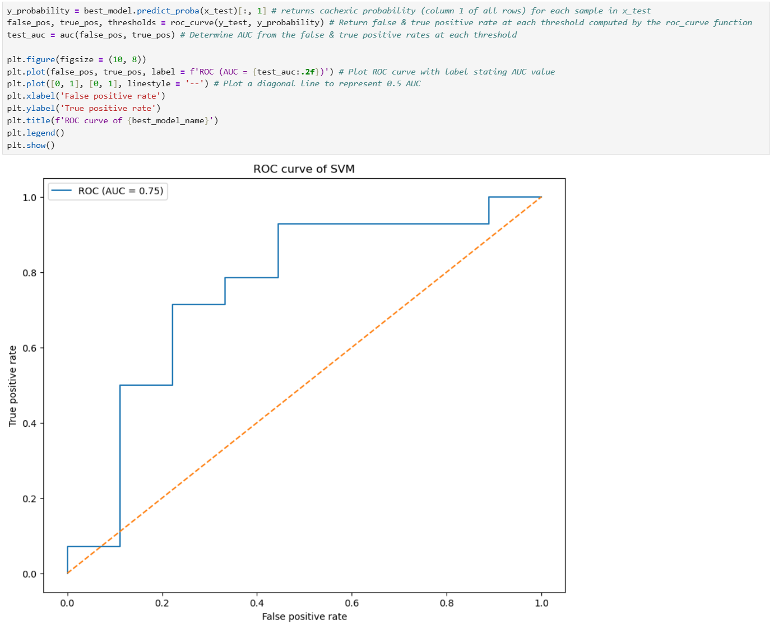
An AUC of 0.75 indicates a reasonable discriminatory ability, but not one suitable to clinical use. The small sample size here is seen in the steep steps of the ROC curve. Implementation of this process on a larger dataset of the same metabolites is recommended.
2.2.4 Program test, debug and optimization
The top 30 metabolites list was tested for missing columns using a list comprehension. Missing columns were then checked, revealing a discrepancy in capitalisation formats between the paper and the data. The list was corrected to match the data column headers, and the list was re-initialised.
The importing of data into a Pandas dataframe involved thorough cleaning and checks for missing values and correct labels before and after recategorization.
ML model training was repeated using varied random states to ensure the code correctly selected and displayed the top-performing model regardless of type. This test was successful.
This program was refactored, debugged and optimised repeatedly throughout development, particularly during the machine learning stage, as I had not used these tools before.
2.2.5 Task summary
2.2.5.1 Program advantages
The program thoroughly checks for potential sources of model corruption during data cleaning, and is robust to some missing values if necessary via the use of imputers.
Clean and easily interpretable visualisations are produced
Model selection is strong, based on 5-fold cross validation of 5 model types. It is easily transferable to new data or repeat runs with different random states as the best model is automatically stored and used downstream.
2.2.5.2 Program limitations
Some metabolites have very low concentrations, meaning that the use of log10 data with a pseudocount may introduce minor distortions.
The model parameters were not tuned, instead being compared, selected, and displayed using default values.

