
Eden House
November 2026

Eden House Care Home | 5016 Wellington Road 29 | N1H| Other information
Celebrating November  Diabetes Awareness Month  Fall Prevention Month  Model Railway Month  All Saint’s Day  November 1  Remembrance Day  November 11  World Kindness Day  November 13  National Hike Day  November 17  Happy Birthday Mickey Mouse!  November 18  World Television Day  November 21st  National Cake Day  November 26th |   “Lest we forget —  November reminds us that freedom has a heartbeat, and it echoes in the bravery of our veterans.”  🍁 Welcome November! 🍁  As the colourful leaves begin to fall and the crisp autumn air settles in, we warmly welcome the month of November to Eden House! November is a time to slow down, enjoy the simple comforts of the season, and reflect on the memories and moments that make this time of year special. This month brings opportunities for remembrance, gratitude, kindness, and togetherness. From honouring our veterans on Remembrance Day to enjoying cozy activities, delicious treats, music, laughter, and time spent with friends and family, there is plenty to look forward to.  We hope November brings everyone at Eden House warm hearts, happy memories, good health, and many reasons to smile. 🍁❤️  Happy November, everyone!
🌟 November Highlights at Eden House (for times of events please refer to the calendar  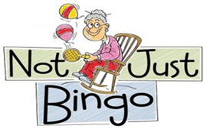  1. Remembrance Day- November 11th  You are warmly invited to join us as we gather in honour and remembrance of the brave men and women who served our country with courage and sacrifice.  2. Entertainment- Mary’s Melodies will be here on November 4th. Bob McLean will be here on November 10th. Paul N Friends will be performing on November 13th and Barry in RH will be here in November 18th. Jimmy’s Old Tyme Radio will be here on November 28th for our monthly Birthday Party!  3. Music Therapy- Music Therapy will be hosted on November 24th.  4. Bookmobile- Bookmobile will be here on November 6th and 20th. We are starting to go inside for the remainder of the colder months!  5. Bake Sale Baking- We will be doing Bake Sale Baking throughout the month of November including: November 3rd, 19th, 23rd and 25th.  November 2025  6. Lunch In: Soup for the Soul for 6 people- will be starting in November. We will be rotating new recipes and new residents each month throughout the winter.  7. Church Services- Duff’s Presbyterian Church will be here on November 1st. Catholic Communion will be held on November 6th. Salvation Army will be here on November 24th. | Resident Council News  Resident’s Council is a place where residents have the right and opportunity to speak about whatever they wish. They are welcome to share their opinions, ideas and suggestions. Healthy respectful debate is welcome. This is your home. We have a council that meets monthly in both our Retirement and Long-Term Care Homes. The meetings are always on the first Monday of every month at 10:00am (LTC) & 1:30pm (RH) in our respective Activity Rooms. Next meeting is November 2nd (LTC & RH).  Family Council News  A friendly reminder that all family members and friends are welcome to join Family Council meetings. Family Council is a great way to foster community here at Eden House, to share any concerns you have and to work together to help in continuing to make Eden House a great place for your loved ones to be. Please contact Cody, Resident Programs Manager for more information on Family Council!  Next Family Council Meeting:  November 18th at 1:30pm (RH)  November 28th at 10am (LTC)  
  Annual Christmas Market 🎄  🎄 Annual Christmas Market 🎄  We are excited to invite everyone to our Annual Christmas Market with Vendors!  Sunday, December 6th from10:00 AM – 3:00 PM  Come enjoy a festive day of shopping, visiting, and getting into the Christmas spirit! We will have a variety of vendors offering wonderful items that make perfect gifts for family, friends, or yourself.  💵 Please try to bring cash, as some vendors may not accept other forms of payment. Residents will be billed through regular billing for any items purchased at the market.  Participating Vendors:  Eden House Residents Bake Sale  Jane MacNeil Home Made Crafts  Jean Woods Crafty Creations  *If you know a vendor, we have a few Spots left. Please reach out to our Recreation Manager with information*  🧁 Bake Sale  This year, we will also be having a Bake Sale featuring homemade goodies made by our wonderful residents in the Long Term Care Home! Come by and pick up some delicious treats while supporting the creativity and talents of our residents.  We look forward to seeing everyone and celebrating the holiday season together!  🎄✨  Mark your calendars and join us for a festive day of shopping, treats, and Christmas cheer!  November 2026 | Recipe Of the Month:  Classic Apple Crisp  Nothing says November quite like the warm smell of apples and cinnamon baking in the oven! This classic apple crisp is a comforting, old-fashioned dessert that is perfect for enjoying with a cup of tea or coffee.  🛒 Ingredients  For the apple filling:  - 6 cups peeled and sliced apples  - ¼ cup white sugar  - 1 teaspoon cinnamon  - 1 tablespoon all-purpose flour  - 1 tablespoon lemon juice  For the crisp topping:  - 1 cup rolled oats  - ¾ cup all-purpose flour  - ½ cup packed brown sugar  - ½ teaspoon cinnamon  - ½ cup butter, softened  - ½ cup chopped walnuts or pecans (optional)  👩‍🍳 Directions  - Preheat oven to 350°F (175°C).  - Place sliced apples in a greased baking dish.  - Sprinkle the apples with sugar, cinnamon, flour, and lemon juice. Gently toss to combine.  - In a separate bowl, mix the oats, flour, brown sugar, and cinnamon.  - Add the softened butter and mix until the topping becomes crumbly.  - Sprinkle the topping evenly over the apples.  - Bake for 35–45 minutes, or until the apples are tender and the topping is golden brown.  - Let cool slightly before serving.  🍦 Serving Suggestion  Serve warm with a scoop of vanilla ice cream, a dollop of whipped cream, or simply enjoy it on its own with a warm cup of tea.
🦫 Animal of the Month: The Beaver
Beavers are fascinating animals with some incredible adaptations for surviving the Canadian winter. As the weather gets colder, they become especially busy preparing their homes and food supplies.
A beaver's large front teeth never stop growing! Their teeth are strong enough to chew through tree trunks and branches. They use the wood not only to build their famous dams and lodges, but also as an important food source.
Beavers are excellent swimmers and can stay underwater for several minutes at a time. Their thick, waterproof fur helps keep them warm, while their large, flat tails serve several purposes. A beaver uses its tail as a rudder while swimming, as a support when sitting upright, and even as an alarm signal when it slaps the water to warn other beavers of danger.
🍁 Getting Ready for Winter
Unlike many animals, beavers do not hibernate. Instead, they spend the colder months safely inside their lodges and rely on food they have stored underwater.
Before winter arrives, beavers gather branches and store them beneath the surface near their lodge. This allows them to have access to food even when the pond is covered with ice.
Their lodges are surprisingly cozy! They are built from branches, logs, and mud and can provide a warm, protected home for the beaver family during Canada's cold winter months.
Did You Know?
The beaver has been an important symbol of Canada for hundreds of years. It was featured on the Hudson's Bay Company coat of arms, appeared on Canada's first postage stamp in 1849, and was officially recognized as Canada's national animal in 1975.
Why Do Beavers Cut Down Trees?
Beavers don't cut down trees just because they can! They use branches and logs for several important reasons.
🌳 Building: Wood is used to build dams and lodges.
🍎 Food: They eat the bark, leaves, and twigs of certain trees.
🏠 Home repairs: Beavers constantly maintain and repair their dams and lodges.
Their favourite trees include aspen, poplar, birch, willow, and maple.
🏠 A Beaver's Home
A beaver's home is called a lodge. Lodges can be built in the middle of a pond or along the shoreline. They have underwater entrances, which help protect the beavers from predators.
Inside, the lodge contains a dry living area where the family can rest and stay warm.


Our Team  You can reach Eden House’s main number (519) 856- 4622, then dial any of our team members by calling the extension of the person you are trying to reach.  Lisa Holisek ext.222- Administrator  admin@edenhousecarehome.ca  Sandy Pooni ext 223- Director of Care  doc@edenhousecarehome.ca  Amanda Brubacher ext 232 – Associate Director of Care  adoc@edenhousecarehome.ca  Kathy Onifrichuk ext. 228- Unit Clerk  clerk@edenhousecarehome.ca  BJ Oates ext. 246- Laundry & Housekeeping  nursing@edenhousecarehome.ca  Chris Westwood-Maintenance Manager  maintenance@edenhousecarehome.ca  Prakriti Chapagain ext. 233- Business Services Manager  bookkeeper@edenhousecarehome.ca  ext. 225- Food Services  dietary@edenhousecarehome.ca  Susan Toogood ext. 247-Associate Director of Infection, Prevention and Control  clinical@edenhousecarehome.ca  Cody Cowbrough ext. 224- Recreational Programs Manager recreation@edenhousecarehome.ca    This Photo by Unknown Author is licensed under CC BY-NC | Eden House November Birthday    This month, we extend our heartfelt birthday greetings to all our wonderful seniors celebrating another year of life, wisdom, and joy.  Wishing you good health, happiness, and hoping you have a beautiful day!  Happy Birthday! Long Term Care  - Aziza Hassannian- November 8th  - Regina Smania- November 11th  - Marie Oswin- November 18th  - Sal Valente- November 18th  - Grace Renouf- November 30th  Retirement Home:  No Retirement Home Birthdays!  .  . 
News from IPAC  Hand hygiene is the single most important way to prevent infections and outbreaks. Visitors, please wash/sanitize your hands before and after contact with residents.  Respiratory viruses such as influenza (flu), COVID-19, and Respiratory Syncytial Virus (RSV) are more common in the fall and winter months. Residents of long-term care and retirement homes are at higher risk for these infections, making vaccination one of the most effective ways to stay protected.  Consent forms for Influenza and COVID-19 vaccines were emailed to POAs in October. Please return the signed consent form as soon as possible to ensure your loved one receives the vaccine as soon as possible. Another option is to sign a paper copy of the consent forms. Please ask the charge nurse for a paper form if needed.  If you have any questions, please feel free to reach out to Susan, Infection Prevention and Control Manager, 519-856-4622 extension 247 or clinical@edenhousecarehome.ca  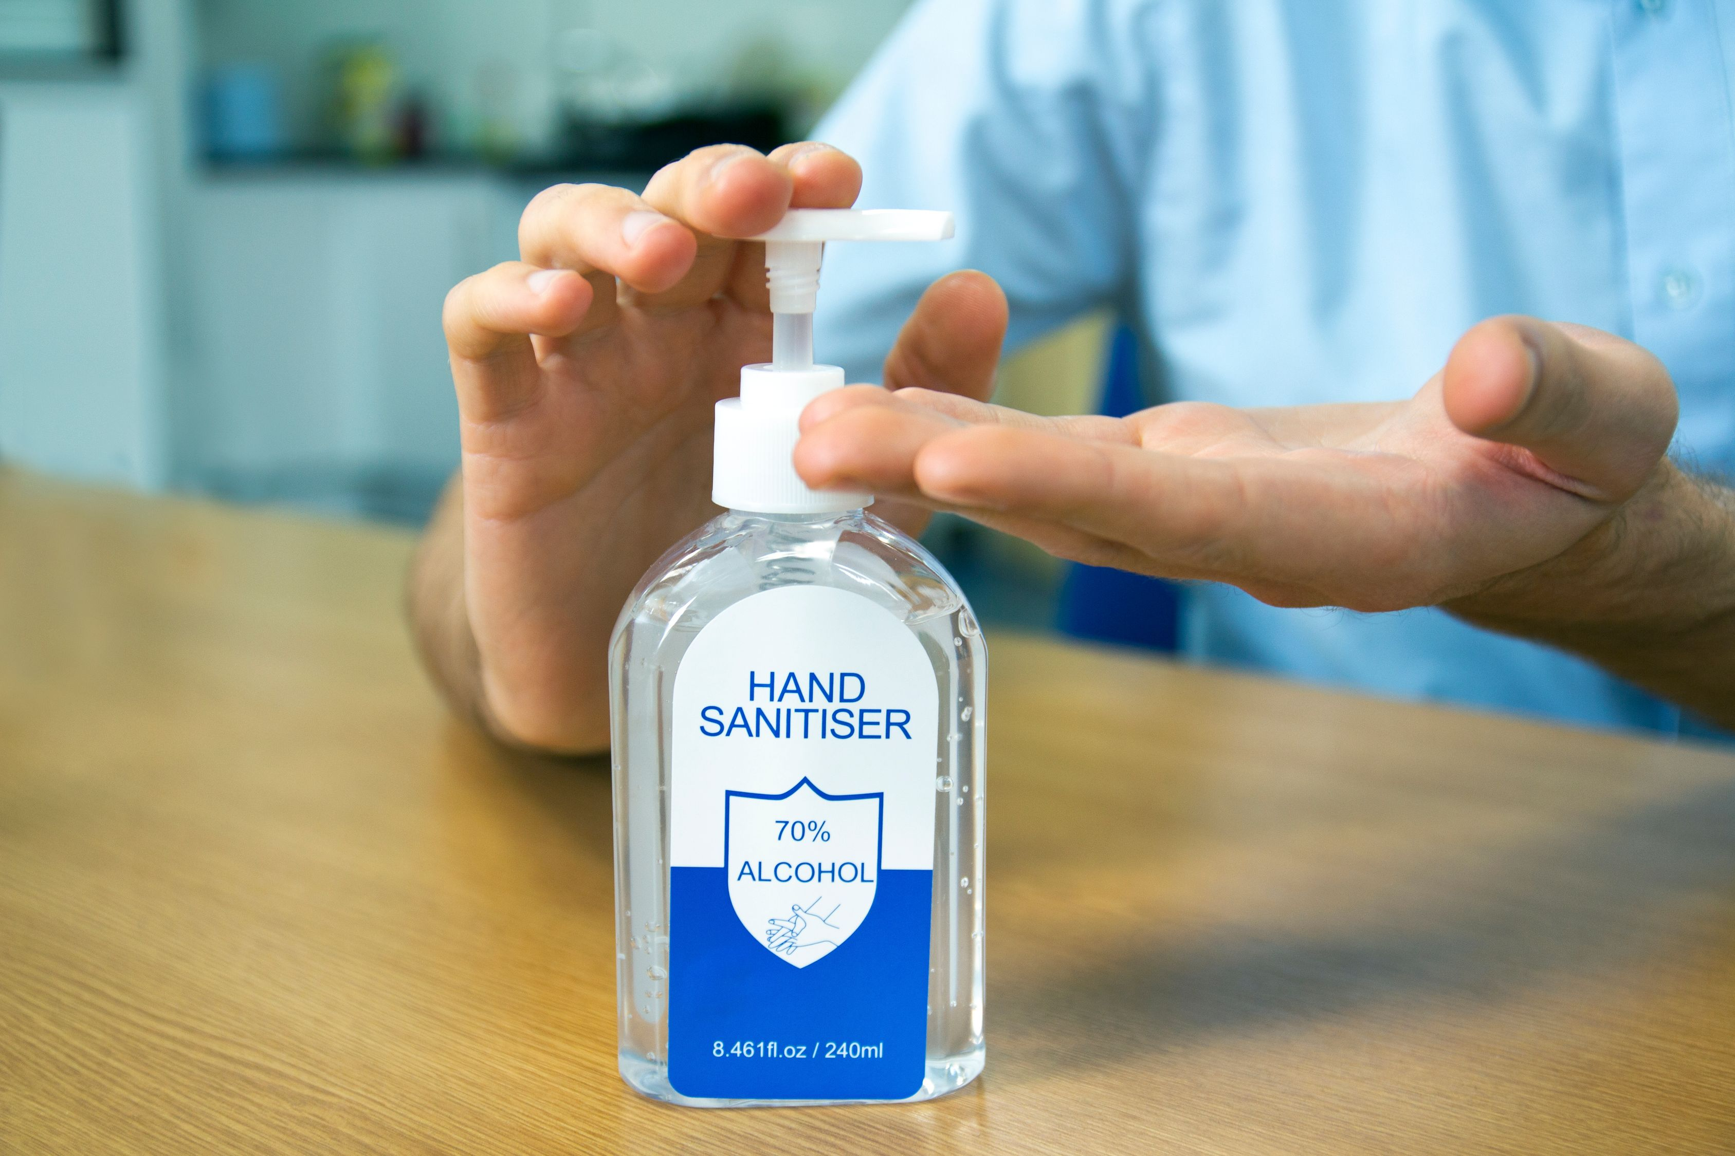 | 


