מגישים:

עדן דדון – 207279183

אביחי ממן – 205506413

נופר אלבז – 316580562

דודי ביטון – 314963141

LINKS:

Heroku: <https://projects-management-ade.herokuapp.com/>

Github: <https://github.com/edenvvv/Projects-Management>

CircleCi: <https://app.circleci.com/pipelines/github/edenvvv/Projects-Management>

We performed an initial installation of the project (as per the requirements).

We created a landing page and a login page, we used EJS to avoid reusing the navigation bar and footer code.

We performed checks on the integrity of response codes from the server

In addition, we ran validation tests for email and password.

We used JavaScript's Express.js framework and also bootstrap.

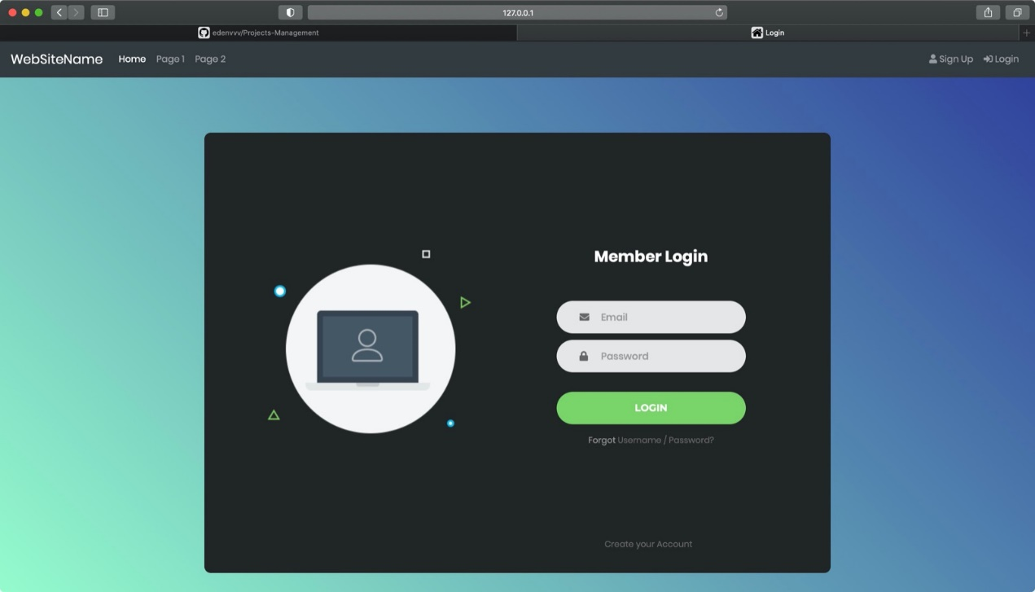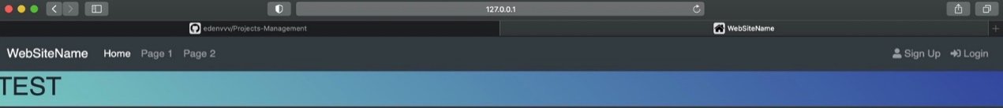

Login page must include validation:

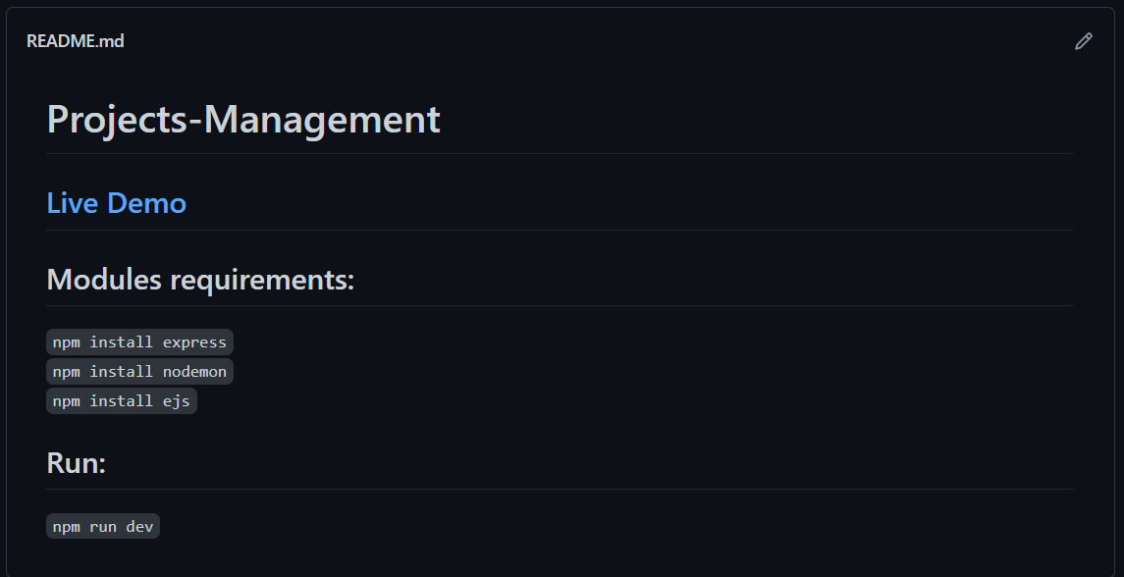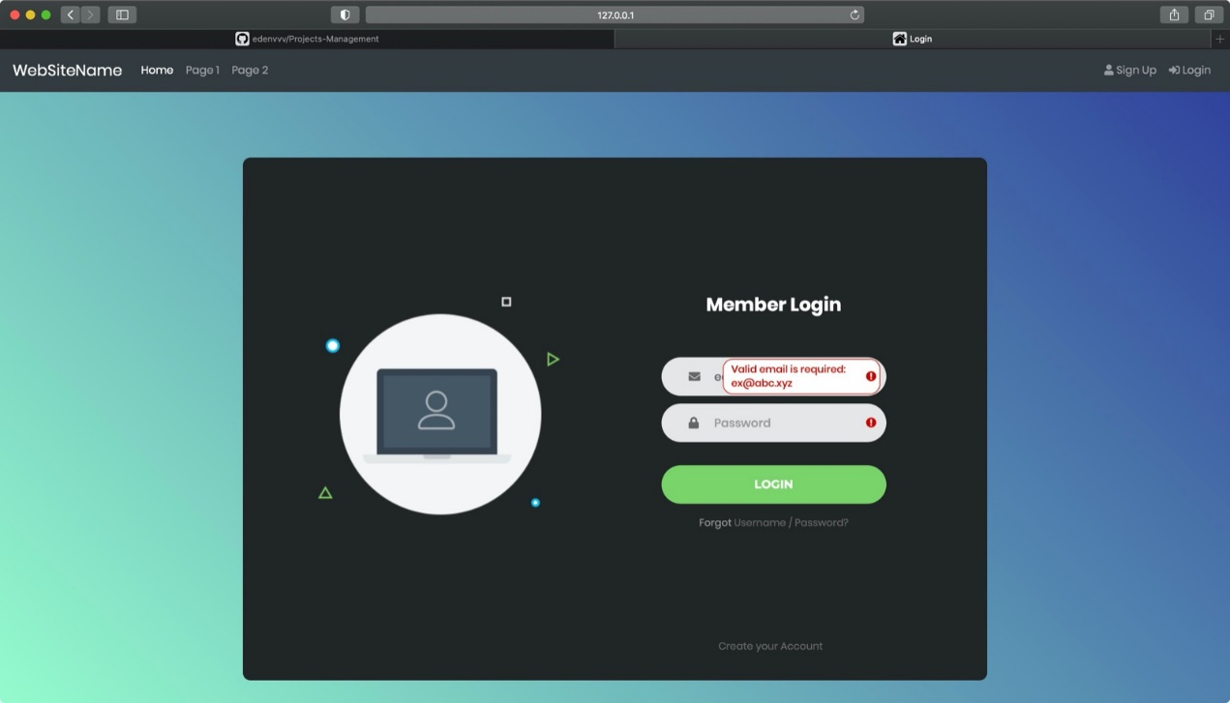We have added a README.md file which explains which modules should be installed before running the project and how to run the project:

We connected the CI / CD to our project using circleci and heroku:



