**User Manual for the “Super Li” System**

Ids:206510885,207328618,212698336,207441627

Super Li is a unified platform that streamlines both HR and delivery workflows in a single application. On the HR side, it manages each employee’s roles, weekly constraints, and shift history. On the delivery side, it handles drivers, trucks, shipments, and service areas—matching transport staff to jobs based on their licenses and current assignments. By sharing core employee data (such as role lists), Super Li provides a consistent interface for administrative tasks, shift scheduling, and delivery coordination.

System Launch:

1. To launch the application, open the ADSS_Group_AG folder.
2. Then open the release folder, where you will find the file adss2025_v02.jar.
3. To start the system, run the following command: Java -jar adss2025_v02.jar.

Now you must log in using the username and password provided to you. The task menus available to you will then appear, based on the permissions associated with your profile. After entering your password, the system detects your role and displays one of the following menus:

**System Manager**  
You have System Manager privileges. Choose menu:

1. HR Manager Menu
2. Employee Menu
3. Transport Manager Menu
4. Transport Employee Menu
5. Delete All Data
6. Return to Start Menu

**HR Manager**  
You have HR Manager privileges. Choose menu:

1. HR Manager Menu
2. Employee Menu
3. Return to Start Menu

**Transport Manager**  
You have Transport Manager privileges. menu:

1. Transport Manager Menu
2. Regular Employee Menu
3. Return to Start Menu

**Transport Employee**  
You are a Transport Employee. menu:

1. Transport Employee Menu
2. Regular Employee Menu
3. Return to Start Menu

**Regular Employee (any other role)**  
Directly enter the Regular Employee Menu.

After login, an HR Manager has extra permissions. You will be prompted to choose one of the following modes:

1. Enter HR Manager Mode (HR Mode)
2. Enter Regular Employee Mode (Employee Mode)

If you select Regular Employee Mode (or log in as a user without HR privileges), the Regular Employee Menu will appear immediately.

**HR Manager Menu Options**

1. **Workers Management** (Add / Delete / Update / Show) – invokes the WorkersManage module
2. **Shift Management** (Add / Delete / Edit / Publish) – invokes the ShiftManage module
3. **View Inbox Message**
4. **Exit System** (Exit the application)

**Workers Management Menu**

**Hire Employee**  
When you select “Hire Employee,” you will be prompted to enter:

* + **Employee ID:** A nine-digit number (e.g. 123456789).
  + **Password:** A four-character string (letters and/or digits).
  + **Full Name:** The employee’s full name (e.g. Jane Doe).
  + **Positions (Roles):**
    - The system will show a numbered list of all available roles.
    - Enter each role’s ID number to assign it; enter 0 when finished.
  + **License Types (only if “Driver” was chosen):**
    - If you included “Driver” among the roles, you will be prompted to “Enter license types for driver (separated by commas).”
    - Provide one or more license identifiers (e.g. B1234, C5678).
  + **Salary:** A decimal number (e.g. 4500.00).
  + **Bank Account:** A ten-digit number (e.g. 1234567890).
  + **Monthly Working Hours:** An integer (e.g. 160).
  + **Location (only if the chosen roles require a location):**
    - If any selected role is “Driver” or “WareHouse Worker,” you will see a numbered list of available locations (area name and address).
    - Enter the number corresponding to your chosen location.
    - If no role requires a location, the system will automatically assign a default “General Location.”

**Fire Employee**  
When you select “Fire Employee,” you will be prompted to enter:

* + **Employee ID:** A nine-digit number of the employee you wish to remove.

**Edit Employee**  
When you select “Edit Employee,” you will first be asked for:

* + **Employee ID:** A nine-digit number of the employee whose details you wish to edit.

Then you will see a menu with these options:

**Update Password:** The system will ask you to enter a new four-character password.

**Update Full Name:** The system will ask you to enter the employee’s new full name.

**Update Positions (Roles):**

* + - The system will show the list of available roles again.
    - Enter each role’s ID to assign it to the employee; enter 0 when finished.

**Update Salary:** The system will ask you to enter a new salary (decimal number).

**Update Bank Account:** The system will ask you to enter a new ten-digit bank account number.

**Update Monthly Hours:** The system will ask you to enter a new number of monthly working hours (integer).

**Update License Types:**

* + - The system will repeatedly prompt you to “Enter license type (or ‘done’ to finish).”
    - Type each license identifier (non-empty, not purely numeric) and press Enter; when finished, type done.

**Update Location:**

* + - The system will check the employee’s current roles.
    - If any role requires a location (Driver or WareHouse Worker), you will see a numbered list of available locations and must choose one by number.
    - If no role requires a location, the system will inform you that no location assignment is needed.

**Exit Edit Menu:** Returns to the main Workers Management Menu.

**Show Employee**  
When you select “Show Employee,” you will be prompted to enter:

* + **Employee ID:** A nine-digit number.  
    The system will then display that employee’s current information if found.

**Show Former Employee:**  
When you select “Show Former Employee,” you will be prompted to enter:

* + **Employee ID:** A nine-digit number of a previously fired employee.  
    The system will display that former employee’s information if it exists.

**Exit**  
Returns to the previous menu without asking for further input.

**Shift Management Menu**  
After selecting “Shift Management,” you will see the following options. For each option, the system will prompt you exactly as described.

Manage a Single Shift

When you choose “Manage a Single Shift,” you will see this menu:

1. Add Shift

2. Remove Shift

3. Edit Shift

4. Show Shift Details

0. Exit Single Shift Management Menu

**Add Shift**

* + **Enter Day (1 = Sunday, … 7 = Saturday):** A number between 1 and 7.
  + **Enter Shift (1 = Morning, 2 = Evening):** Type 1 for Morning or 2 for Evening.
  + The system will create a new (empty) shift for that day/time.

**Remove Shift**

* + **Enter Day (1 = Sunday, … 7 = Saturday):** A number between 1 and 7.
  + **Enter Shift (1 = Morning, 2 = Evening):** Type 1 for Morning or 2 for Evening.
  + The system will delete the existing shift for that day/time.

**Edit Shift**

* + First you will be prompted:

Do you wish to edit published or unpublished shifts?

1 for published, 2 for unpublished

Enter your choice:

Type 1 to edit a published shift, or 2 to edit an unpublished (draft) shift.

* + Then you must enter:
    - **Day (1 = Sunday … 7 = Saturday)**
    - **Shift (1 = Morning, 2 = Evening)**
  + Next, you will see the current details of that shift and the following edit options:

1. Assign Employee

2. Remove Employee

3. Add Required Role

4. Remove Required Role

5. Update Number of Required Employees for Role

0. Exit

Your choice:

**Assign Employee**

* + - * **Enter Employee ID (9 digits).**
      * **Enter Role ID** (select from the printed list of roles).
      * The system assigns that employee (and role) to the shift.

**Remove Employee**

* + - * **Enter Employee ID (9 digits).**
      * The system removes that employee from the shift.

**Add Required Role**

* + - * **Enter Role ID** (select from the printed list of roles).
      * **Enter Number of Employees Required for This Role** (an integer).
      * The system marks that this shift now requires “N” employees in that role.

**Remove Required Role**

* + - * **Enter Role ID** (select from the printed list of roles).
      * The system deletes that role’s requirement from this shift.

**Update Number of Required Employees for Role**

* + - * **Enter Role ID** (select from the printed list of roles).
      * **Enter New Number of Employees Required** (an integer).
      * The system updates the required headcount for that role.

**Exit**

* + - * Returns you to the “Single Shift Management” menu.

**Show Shift Details**

* + First you will be prompted:

Do you wish to view published or unpublished shifts?

1 for published, 2 for unpublished

Enter your choice:

Type 1 to view a published shift or 2 to view an unpublished (draft) shift.

* + Then you must enter:
    - **Day (1 = Sunday … 7 = Saturday)**
    - **Shift (1 = Morning, 2 = Evening)**
  + The system will display all assigned employees and required roles for that shift.

1. **Exit Single Shift Management Menu**

* Returns you to the main “Shift Management Menu.”

Manage Weekly Shifts

When you choose “Manage Weekly Shifts,” you will see this menu:

--- Weekly Shifts Management Menu ---

1. View Published Weekly Shift

2. View Unpublished Weekly Shift

3. Publish Weekly Shift

0. Exit Weekly Shifts Management Menu

1. **View Published Weekly Shift**
   * No further input. The system displays the entire week’s shifts already published.
2. **View Unpublished Weekly Shift**
   * No further input. The system displays the current (draft) week’s shifts, not yet published.
3. **Publish Weekly Shift**
   * No further input. The system publishes all drafted shifts for the week and resets the schedule for next week.
4. **Exit Weekly Shifts Management Menu**

* Returns you to the main “Shift Management Menu.”

Manage Weekly Constraints

When you choose “Manage Weekly Constraints,” you will see this menu:

--- Weekly Constraints Management Menu ---

1. View Weekly Constraints

2. Set Next Week Constraints

3. Change Constraints Deadline

0. Exit Weekly Constraints Management Menu

1. **View Weekly Constraints**
   * No further input. The system displays all employee-submitted constraints for the upcoming week.
2. **Set Next Week Constraints**
   * No further input. The system collects and saves all submitted constraints for next week, then reopens constraint submission for employees.
3. **Change Constraints Deadline**
   * **Enter Day of Week** (e.g. MONDAY, TUESDAY, etc.).
   * **Enter Hour** (0 – 23).
   * **Enter Minute** (0 – 59).
   * The system updates the deadline for when employees must submit their weekly constraints.
4. **Exit Weekly Constraints Management Menu**

* Returns you to the main “Shift Management Menu.”

Manage Company Roles

When you choose “Manage Company Roles,” you will see this menu:

--- Roles Management Menu ---

1. Add Role

2. Remove Role

3. Show All Roles

4. Show Role Permissions

5. Add Permission to Role

6. Remove Permission from Role

0. Exit Roles Management Menu

**Add Role**

* + **Enter Role Name:** A name composed only of letters (e.g. ShiftManager).
  + Next, you will be asked:

Do you want to add special permissions to the new role?

1 for yes, 2 for no

Enter your choice:

* + - If you type 1 (yes):
      * The system repeatedly prompts:

Type a Role permission:

Enter any permission string (e.g. CAN_PUBLISH_SHIFT).  
After each entry, it prompts:

Type another permission or 'exit' to finish:

Keep entering permissions one by one; when done, type exit.

* + - If you type 2 (no), the role is created without any special permissions.

**Remove Role**

* + **Enter Role ID:** A number identifying which role to delete.
  + The system removes that role from the company’s list.

**Show All Roles**

* + No further input. The system prints every role’s ID and name.

**Show Role Permissions**

* + **Enter Role ID:** A number identifying which role to inspect.
  + The system displays all permissions currently assigned to that role.

**Add Permission to Role**

* + **Enter Role ID:** A number identifying which role to modify.
  + Then you will enter one or more permission strings exactly as in “Add Role.”
    - After each permission, the system prompts for another permission or exit to finish.

**Remove Permission from Role**

* + **Enter Role ID:** A number identifying which role to modify.
  + The system lists all permissions assigned to that role, each with its own number.
  + **Enter Permission Number to Remove:** Type the number corresponding to the permission you wish to delete.

**Exit Roles Management Menu**

* Returns you to the main “Shift Management Menu.”

Exit Shift Management Menu

Selecting **0** at the main “Shift Management Menu” will return you to the previous (HR) menu without further prompts.

### **View Inbox Messages**

When you select “View Inbox Messages,” the system displays this sub-menu:

What do you want to read?

1. Unread messages

2. Read messages

3. All messages

4. Inbox statistics

5. Clear inbox

6. Back to HR Menu

• **Unread Messages**

* The system asks: “How many messages would you like to read?”
* Enter an integer (e.g. 5).
* The system then displays up to that many unread messages from the HR inbox.

• **Read Messages**

* The system asks: “How many messages would you like to read?”
* Enter an integer (e.g. 5).
* The system then displays up to that many messages that have already been marked as read.

• **All Messages**

* No additional input is required.
* The system displays every message in the inbox, regardless of read/unread status.

• **Inbox Statistics**

* No additional input is required.
* The system shows summary statistics, such as total messages, number of unread messages, and number of read messages.

• **Clear Inbox**

* No additional input is required.
* The system deletes all messages from the HR inbox and prints “Inbox cleared.”

• **Back to HR Menu**

* No additional input is required.
* Returns to the main HR Manager Menu.

**Employee Menu**  
After logging in as any employee (or selecting “Employee Mode” from a managerial menu), you will see:

== Employee Menu ===

1. Edit Full Name

2. Edit Bank Account

3. Edit Password

4. Update Constraint

5. Upload Constraint

6. Show My Details

7. Show Weekly Shift

8. Show Shifts History

9. Show Another Employee’s Details ← (only visible if you have the ShiftManager role)

0. Exit

**Edit Full Name**

* + When you select “Edit Full Name,” you will be prompted to enter your new full name (e.g., Jane Doe).

**Edit Bank Account**

* + When you select “Edit Bank Account,” you will be prompted to enter a new ten-digit bank account number (e.g., 1234567890).

**Edit Password**

* + When you select “Edit Password,” you will be prompted to enter a new four-character password.

**Update Constraint**

* + When you select “Update Constraint,” you will first enter the number of constraints (0–12).
  + Then, for each constraint, you will enter:
    - A **day** number (1 = Sunday … 7 = Saturday).
    - A **shift** number (1 = Morning, 2 = Evening).
  + You may not select more than six distinct days.

**Upload Constraint**

* + When you select “Upload Constraint,” the system immediately submits whatever constraints you have already entered for next week.

**Show Details**

* + When you select “Show Details,” the system displays your current employee information (ID, name, roles, bank account, etc.).

**Show Weekly Shift**

* + When you select “Show Weekly Shift,” the system displays your assigned shift(s) for the current week.

**Show Shifts History**

* + When you select “Show Shifts History,” the system displays all past shifts you have worked.

**Show An Employee Details** (only visible if you hold the ShiftManager role)

* + When you select “Show An Employee Details,” you will be prompted to enter a nine-digit employee ID.
  + The system then displays that employee’s details.

**Exit**

* + When you select “Exit,” you leave the Employee Menu and return to the previous menu.

**Transportation System Instructions**

**Overview**

This guide will help you navigate the Transportation Management System menu. The system has two user types:

* **Transport Manager**: Full access to all system functions
* **Employee**: Limited access to essential operations

**Transport Manager Menu (Full Access)**

**1. Add Area**

Creates a new delivery area in the system.

* Enter the area name
* Add locations to the area (optional but recommended)
* For each location, provide:
  + Address
  + Contact name
  + Contact number
* **Note**: Area names must be unique

**2. Add Location to Area**

Adds a new location to an existing area.

* Enter the existing area name
* Provide location details:
  + Address (must be unique within the area)
  + Contact name
  + Contact number

**3. Add Delivery**

Creates a new delivery request. **Required Information:**

* Delivery date (year, month, day)
* Source area and address
* Destination area and address
* Number of items and their details:
  + Item name
  + Item weight (must be positive)
* **Important**: All areas and locations must exist in the system

**4. Assign Delivery to Truck**

Links a delivery to a specific truck.

* Enter delivery ID
* Enter truck ID
* **Handling Weight Issues**: If the truck can't carry the weight, you'll get options to:
  + Change to a different truck
  + Cancel the delivery
  + Remove items from truck/delivery

**5. Get Truck Deliveries**

View all deliveries assigned to a specific truck.

* Enter truck ID
* System displays all associated deliveries with destinations

**6. Change Delivery Destination**

Modify the destination of an existing delivery.

* Enter delivery ID
* Provide new area name
* Provide new destination address
* **Note**: New location must exist in the system

**7. Cancel Delivery**

Remove a delivery from the system.

* Enter delivery ID
* Delivery will be permanently removed

**8. Update Document**

Comprehensive document modification tool. **Options Available:**

* **Add/Remove Items**: Modify the item list
* **Change Origin**: Update pickup location
* **Change Destination**: Update delivery location
* **Weight Handling**: System will alert if weight limits are exceeded

**9. Change Truck**

Reassign a delivery to a different truck.

* Enter delivery ID
* Enter new truck ID
* System validates weight capacity

**10. Remove Items from Delivery**

Remove specific items from a delivery.

* Enter delivery ID
* System shows all items with numbers
* Specify how many items to remove
* Select items by their numbers

**11. Add Truck**

Register a new truck in the system. **Required Information:**

* Truck model
* Dry weight (empty truck weight)
* Maximum load capacity (including truck weight)
* License type (single capital letter: A, B, C, etc.)
* **Validation**: Max load must exceed dry weight

**12. Send Truck to Distribute Deliveries**

Dispatch a truck for delivery runs.

* Enter truck ID
* Choose day of the week
* Enter hour (must be within 8-20 working hours)
* **Requirements**:
  + Available driver with proper license
  + Storage worker available for the shift

**13. List All Deliveries by Time**

View deliveries sorted chronologically.

* Enter number of deliveries to display
* System shows delivery details including dates and locations

**14. Complain on Driver**

Submit a complaint about a driver to HR.

* Enter driver ID
* Enter complaint details
* Complaint is forwarded to HR supervisor

**15. Delete Truck**

Remove a truck from the system.

* Enter truck ID
* **Important**: System will list all deliveries assigned to this truck
* You must reassign these deliveries to other trucks

**16. Delete Area**

Remove an entire area and all associated data.

* Enter area name
* **Warning**: This deletes ALL locations and deliveries in the area

**17. Delete Location**

Remove a specific location from an area.

* Enter area name
* Enter location address
* **Warning**: This deletes ALL deliveries to/from this location

**18. Supplier Pick Up Items**

Process item pickup by suppliers.

* Enter delivery ID
* System processes the pickup and displays confirmation

**19. Get Shift Assignments for the Day**

View employee work schedules.

* Enter day of the week
* System displays:
  + Morning shift assignments
  + Evening shift assignments
  + Employee roles (driver/storage worker)

**20. Exit**

Return to the login screen.

**Employee Menu (Limited Access)**

Employees have access to these essential functions:

**1. Get Truck Deliveries**

Same as Manager option #5 - view deliveries for a specific truck.

**2. Update Document**

Same as Manager option #8 - modify delivery documents.

**3. List All Deliveries by Time**

Same as Manager option #13 - view deliveries chronologically.

**4. Supplier Pick Up Items**

Same as Manager option #18 - process supplier pickups.

**5. Exit**

Return to login screen.

**Important Tips**

**Input Validation**

* **Numbers**: Always enter valid integers where requested
* **Dates**: Use proper date format (year, month, day)
* **Text**: Avoid empty inputs for required fields
* **Yes/No Questions**: Type "yes" or "no" exactly as shown

**Error Handling**

* System will show specific error messages
* Invalid inputs will prompt you to try again
* Weight capacity issues provide multiple resolution options

**Weight Management**

* Truck dry weight = empty truck weight
* Max load = total capacity including truck weight
* Item weights must be positive integers
* System automatically checks capacity limits

**Working Hours**

* Delivery dispatching: 8 AM to 8 PM (8-20 hours)
* Days: Sunday through Saturday (case-insensitive)

**Data Dependencies**

* Areas must exist before adding locations
* Locations must exist before creating deliveries
* Trucks must exist before assigning deliveries
* Employees must be available for their assigned shifts

**Troubleshooting**

**Common Issues**

1. **"Area not found"**: Ensure the area name is spelled correctly and exists
2. **"Location not found"**: Check both area name and address spelling
3. **"Truck overweight"**: Use the provided options to resolve weight issues
4. **"Invalid day/hour"**: Check spelling and ensure hours are 8-20
5. **"No driver available"**: Try different day/time or check employee schedules

**Best Practices**

* Create areas and locations before adding deliveries
* Regularly check truck capacities when assigning deliveries
* Verify employee availability before dispatching trucks
* Keep delivery information updated and accurate
* Use the list functions to review data before making changes

**Navigation**

* Follow menu numbers exactly as shown
* Use the Exit option to return to login when switching users
* Read all prompts carefully before entering data
* System will guide you through multi-step processes

**Additional Important Information about the System:**

* Employees may submit their constraints up until the configured deadline. By default, when the system is first initialized, this deadline is Thursday at 16:00.
* The HR manager may adjust the deadline backwards only on the same day. On any other day, HR can change it only to a future weekday/time.
* After the deadline has passed:
  + Employees can no longer add or edit constraints.
  + Only HR may collect all submitted constraints and then publish the weekly shifts.
* Once the weekly shifts are published:
  + The deadline is automatically reset to the same weekday and time for the following week.

**System Requirements:**

* Java 17 or newer must be installed on your machine.
* A terminal or command‐line environment capable of running JAR files.

**Summary:**  
This application provides:

* Full employee management.
* Weekly shift management and publication.
* Constraint submission by employees and intelligent scheduling.
* A clear deadline workflow between employees and HR.
* Comprehensive transportation management, including area and location setup, delivery creation, truck assignment, load capacity checks, and dispatch scheduling.

Enjoy using the system!

**All packages we used :**

package Backend;

package Backend.PresentationLayerHR;

package Backend.Mappers;

package Backend.DataAccessLayer;

package Backend.DomainLayer.DomainLayerHR;

import Backend.DomainLayer.DomainLayerHR.ConstraintsFacade;  
import Backend.DomainLayer.DomainLayerHR.WeeklyConstraints;  
import Backend.ServiceLayer.DataService;

import Backend.DTO.AreaDTO;  
import Backend.DTO.LocationDTO;  
import Backend.DTO.TransportationEmployeeDTO;  
import Backend.DomainLayer.DomainLayerHR.*;  
import Backend.ServiceLayer.DataService;  
import Backend.ServiceLayer.ServiceLayerHR.HRService.DeliveryEmployeeService

import Backend.ServiceLayer.ServiceLayerHR.LoginService;  
import Backend.ServiceLayer.ServiceLayerHR.PermissionLevel;  
import Backend.ServiceLayer.ServiceLayerHR.PermissionService;  
import Backend.ServiceLayer.ServiceLayerHR.Response;

import Backend.DTO.*;  
importBackend.ServiceLayer.ServiceLayerHR.EmloyeeService.EmployeeManageService;  
import java.util.ArrayList;  
import java.util.Scanner;  
import Backend.ServiceLayer.ServiceLayerHR.HRService.HRInboxService;  
import Backend.ServiceLayer.ServiceLayerHR.Response;  
import Backend.ServiceLayer.ServiceLayerT.ManagerService;  
import org.junit.jupiter.api.BeforeEach;  
import org.junit.jupiter.api.Test;  
import java.time.DayOfWeek;  
import java.time.LocalDate;  
import java.time.LocalTime;  
import java.util.HashMap;  
import static org.junit.jupiter.api.Assertions.*;   
import Backend.DomainLayer.DomainLayerHR.Constraint;  
import java.util.Arrays;  
import java.util.List;  
import java.lang.reflect.Field;  
import java.time.LocalDate;  
import java.util.*;

import java.time.DayOfWeek;  
import java.time.temporal.TemporalAdjusters;  
import java.util.stream.Collectors;

import java.util.LinkedList;

import Backend.DataAccessLayer.JdbcConstraintsDAO;  
import Backend.DataAccessLayer.JdbcHRInboxDAO;  
import Backend.Mappers.ConstraintMapper;

import java.util.Objects;  
import java.util.Map;

import Backend.DataAccessLayer.JdbcEmployeeDAO;  
import Backend.Mappers.EmployeeMapper;

import Backend.DTO.RoleDTO;  
import Backend.DataAccessLayer.JdbcRoleDAO;

import Backend.DataAccessLayer.JdbcShiftDAO;

import Backend.DataAccessLayer.JdbcShiftDAO;  
import Backend.Mappers.ShiftMapper;

**Database Initialization Tables with Seed Data**

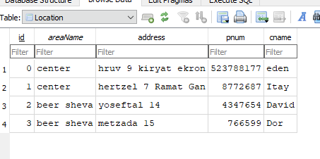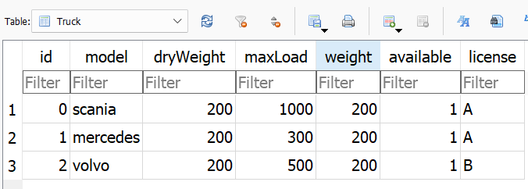 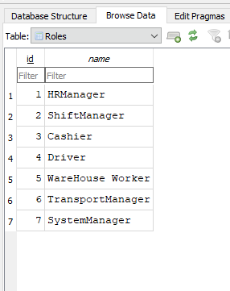 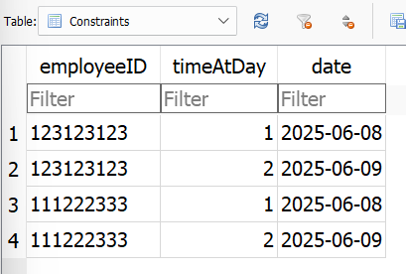

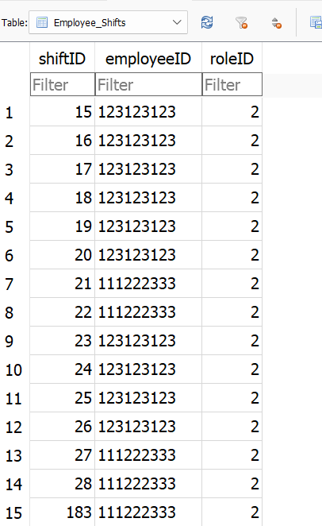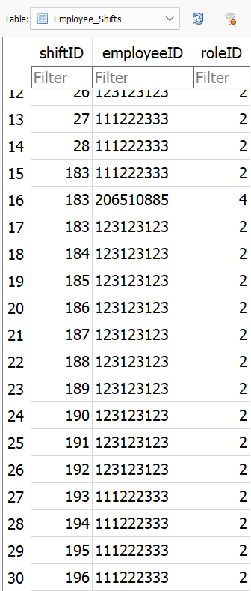

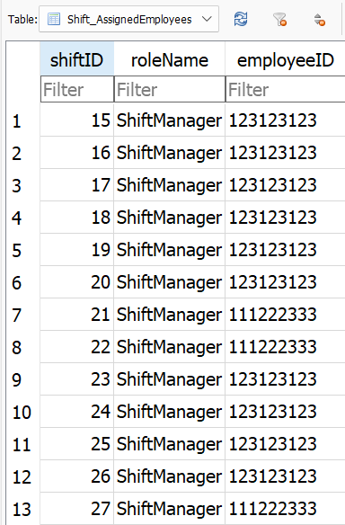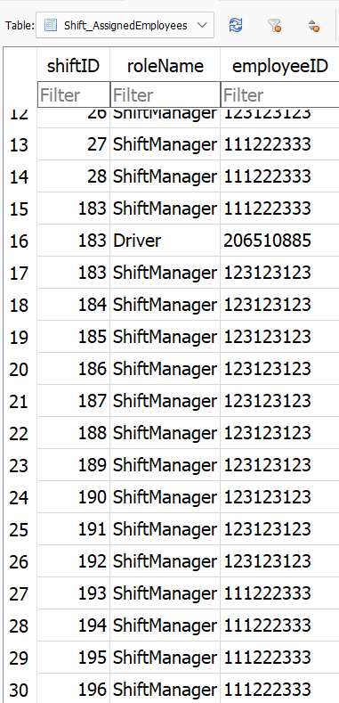

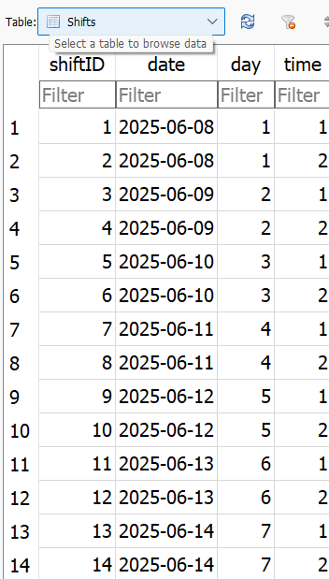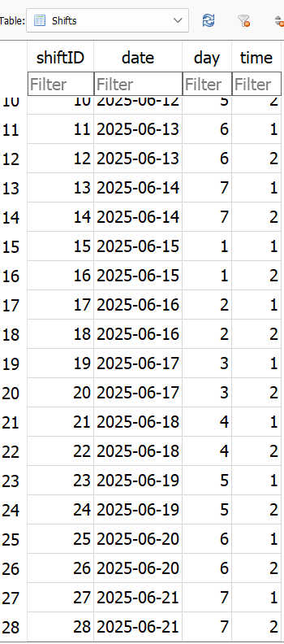

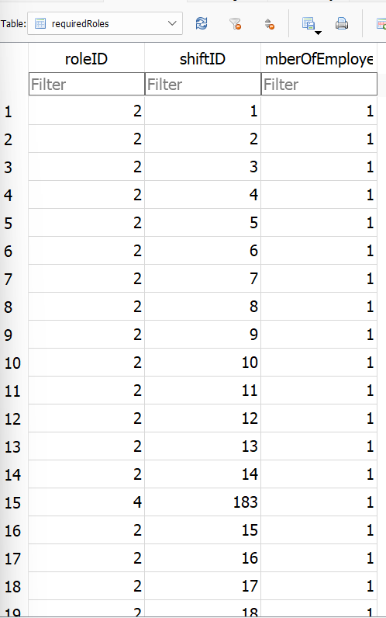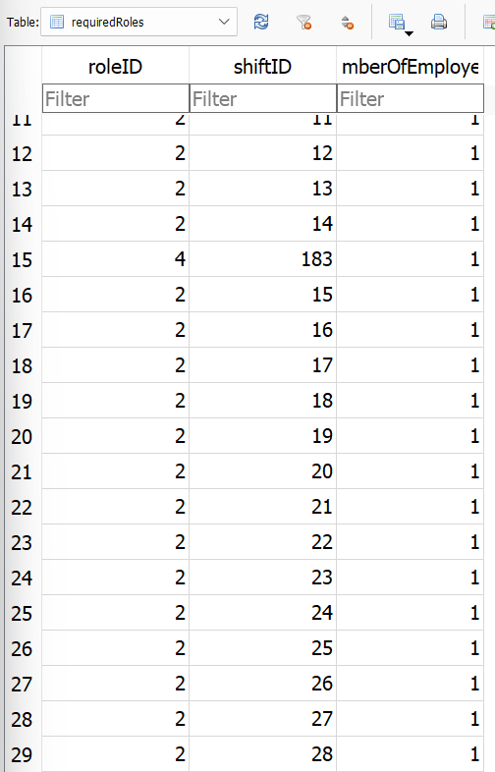

The tables:

Truck_Product, Inbox_Message, HR_Table, HR_Messages, Former_Employees, Document, Delivery_Product, Delivery. Are empty at the beginning of the program.