Laravel 6 Advanced - e7 - Repository Pattern

<https://www.youtube.com/watch?v=93ZhGkFIwbA&list=PLpzy7FIRqpGD5pN3-Y66YDtxJCYuGumFO&index=7>

UTILIZANDO REPOSITORY

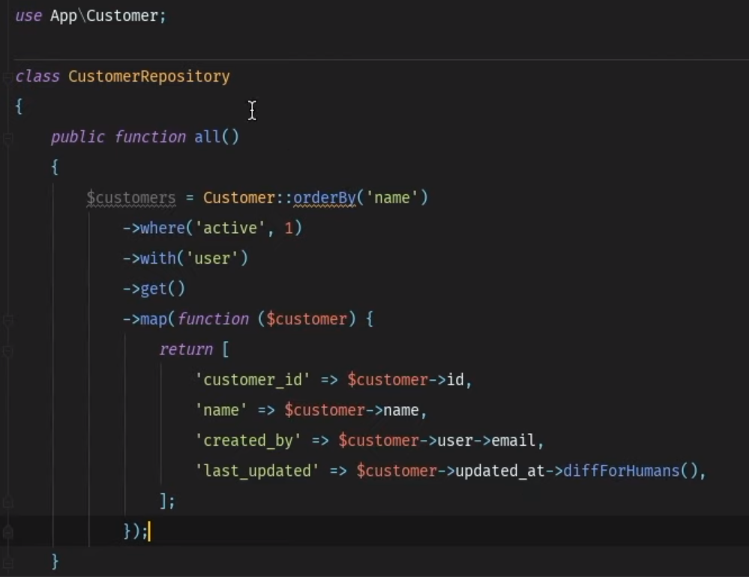

OU

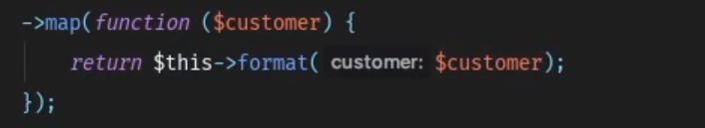

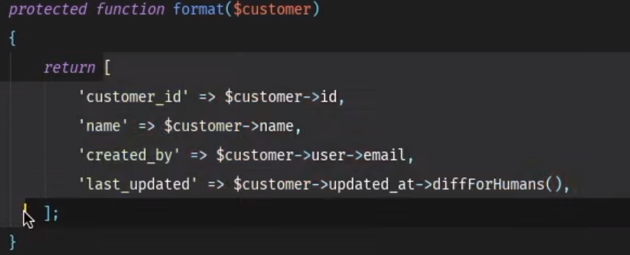

<https://www.youtube.com/watch?v=93ZhGkFIwbA&list=PLpzy7FIRqpGD5pN3-Y66YDtxJCYuGumFO&index=7>

