|  |  |
| --- | --- |
| **Title:** | **Basic Scheduler**  **Manual** |
|  |  |

|  |  |  |  |  |
| --- | --- | --- | --- | --- |
| **History** | | | | |
| **Issue status**  (Index) | **Maturity/Date**  (draft/invalid/valid)  (dd-mmm-yyyy) | **Author**  Department | **Check/Release**  Department | **Description** |
| 1.0 | Draft  13-11-15 | Edgar Escayola | Edgar Escayola | Creation of the document |
| 1.1 | Draft  15-11-15 | Adrián Zacarías | Adrián Zacarías | General description. |
| 1.2 | Draft  17-11-15 | Edgar Escayola | Edgar Escayola | Format |

**Table of Contents**

Section 1. Purpose 4

Section 2. Definitions and abbreviations 4

Section 3. General information 4

Section 4. Add a new task 4

# Section 1. Purpose

This document was designed to aid the developer on the implementation of the basic scheduler.

# Section 2. Definitions and abbreviations

**Abbreviations**

ms - milisecond (1E-3 seconds)

|  |  |  |
| --- | --- | --- |
|  |  |  |

# Section 3. General information

**Tick period = 1 ms**

|  |  |  |
| --- | --- | --- |
| Files | Description | Modifiable |
| Kernel.h and Kernel.c | Kernel of scheduler | No |
| Init_Tasks.h and Init_Tasks.c | Definition of tasks | Yes |
| Tasks.h and Tasks.c | Implementation of tasks | Yes |
| HAL.h and HAL.c | Hardware Application Layer | Yes |

# Section 4. Add a new task

1. **Modify Init_Tasks.h**

* The enumeration E_TASKS must be updated using the following format: E_TSK_TASKn where “n” is the number of the new TASK.

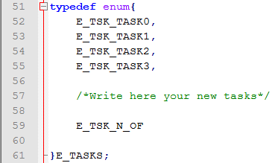

* The array cas_STAT must be updated. The set should contain the name of the function pointer, the period and the offset. The function pointer should use the following format: Task_n where “n” is the number of the task added. The period and the offset is in ms according to the Tick rate.

**Note:** It shouldn’t be forgotten to add the comma before the last task.

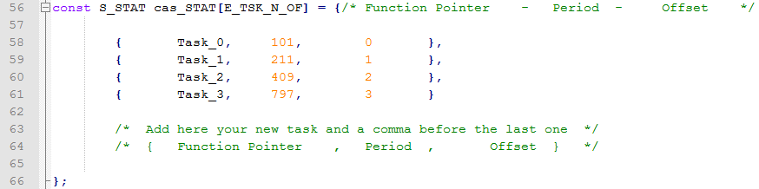

1. **Modify Tasks.h**

* The prototype of the new task must be added using the following format: *void Task_n (void)* where n is the where “n” is the number of the new TASK.

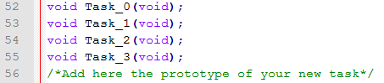

1. **Modify Tasks.c**

* The implementation of the new task must be added at the end of this document following the next example:

