Title: | Electronic instrument cluster  SW Component Cluster_EA V1.2

History
Issue status  (Index) | Maturity/Date  (draft/invalid/valid)  (dd-mmm-yyyy) | Author  Department | Check/Release  Department | Description
1.0 | Draft  08-Jan-2016 | Edgar Escayola | Adrián Zacarías | Creation of the document
1.1 | Draft  11-Jan-2016 | Adrián Zacarías | Edgar Escayola | Addition of the architecture and deployment diagram.
1.2 | Draft  12-Jan-2016 | Edgar Escayola | Adrián Zacarías | Addition of the functional decomposition diagram and names of the functions.

Table of Contents
1 Purpose 6
2 Definitions and abbreviations 6
2.1 Definitions 6
2.2 Type name definition 6
3 Realization constraints and targets 6
3.1 TRK-MPC5606B’s features 6
4 SW Conceptual design 7
4.1 Architecture design 7
4.2 Deployment Diagram 7
4.3 Use case diagram 8
4.4 Sequence diagram 8
5 SW Component internal breakdown 9
5.1 Functional Decomposition 9
5.2 TASKS 11
5.2.1 Function void Task0_3ms (void) 11
5.2.2 Function void Task1_5ms (void) 11
5.2.3 Function void Task2_50ms (void) 11
5.2.4 Function void Task3_100ms (void) 11
5.2.5 Function void Task4_200ms (void) 12
5.2.6 Function void Task5_250ms (void) 12
5.3 Init_Tasks 12
5.3.1 Function void Global_Init (void) 12
5.4 TIMER 12
5.4.1 Function void InitPIT (void) 12
5.4.2 Function void InitPITChannel (T_UBYTE) 13
5.4.3 Function void InitSTM (void) 13
5.4.4 Function void Clear_STM (void) 14
5.5 GPIO_Manager - Shall be updated. 14
5.5.1 Function void Init_GPIO (void) 14
5.5.2 Function void Set_LCD_Data_Output (void) 14
5.5.3 Function void Set_LCD_Data_Input (void) 14
5.5.4 Function void Set_LCD_E (T_UBYTE) 14
5.5.5 Function void Set_LCD_RW (T_UBYTE) 15
5.5.6 Function void Set_LCD_RS (T_UBYTE) 15
5.5.7 Function T_UBYTE Read_LCD_Data (void) 15
5.5.8 Function void Set_LCD_Data (T_UBYTE, T_UBYTE) 15
5.5.9 Function T_UBYTE Read_BAT (void) 15
5.5.10 Function T_UBYTE Read_IGN (void) 15
5.5.11 Function void Get_PushButtons_State (void) 16
5.5.12 Function void Get_Switches_State (void) 16
5.5.13 Function void Display_Fuel_State (T_UBYTE) 16
5.5.14 Function void Display_Speed (T_UWORD) 16
5.6 GPIO 16
5.6.1 Function void Set_Pin_State (T_UBYTE, T_UBYTE) 16
5.6.2 Function void Set_Pin_Mode (T_UBYTE, T_UBYTE) 17
5.6.3 Function T_UBYTE Get_Pin_State_IN (T_UBYTE) 17
5.6.4 Function T_UBYTE Get_Pin_State_OUT (T_UBYTE) 17
5.7 KERNEL 17
5.7.1 Function void Tick_ISR (void) 17
5.7.2 Function void main_Scheduler (void) 18
5.8 Main 18
5.8.1 Function void main (void) 18
5.9 System_Initialization 18
5.9.1 Function void System_Init (void) 18
5.9.2 Function void ModeEntry (void) 18
5.10 Cluster_EA 19
5.11 CAN 19
5.11.1 Function T_UBYTE CAN_SendFrameInt (T_UBYTE, T_UBYTE, T_UBYTE *, T_UBYTE) 19
5.11.2 Function void CANB_Isr (void) 19
5.11.3 Function void CAN_IO_Config (void) 19
5.11.4 Function void CAN_Initialization (CAN_ConfigType *) 19
5.11.5 Function void CAN_SendFrame (CAN_PduType *) 19
5.11.6 Function T_UBYTE CAN_ReceiveFrame (T_UBYTE, CAN_MessageDataType *) 19
5.11.7 Function void CAN_Stop (void) 19
5.12 CAN_Manager 19
5.12.1 Function void CanManager_Receive_Fuel_Level (CAN_MessageDataType) 19
5.12.2 Function void CanManager_Receive_Odometer_Increment (CAN_MessageDataType) 19
5.12.3 Function void CanManager_Receive_Speed (CAN_MessageDataType) 19
5.12.4 Function void CanManager_Receive_Indicators_Status (CAN_MessageDataType) 19
5.13 D_FLASH 20
5.13.1 Function void Init_DFLASH (void) 20
5.13.2 Function void Func_Write_DFLASH (void) 20
5.13.3 Function void Func_Erase_DFLASH (T_ULONG) 20
5.14 Bspimain 20
5.14.1 Function void InitDSPI_1 (void) 20
5.14.2 Function void ReadDataDSPI_1 (void) 20
5.14.3 Function void ConfigureMZC33905DSPI_1 (void) 20
5.15 LCD 20
5.15.1 Function void LCDInit (void) 21
5.15.2 Function void LCDWriteStringXY (T_UBYTE, T_UBYTE, const char *) 21
5.15.3 Function void LCDWriteIntXY (T_UBYTE, T_UBYTE, T_UWORD, T_SBYTE) 21
5.15.4 Function void LCDByte (T_UBYTE, T_UBYTE) 21
5.15.5 Function void LCDWriteString (const char *) 21
5.15.6 Function void LCDWriteInt (T_UWORD, T_SBYTE) 21
5.15.7 Function void LCDGotoXY (T_UBYTE, T_UBYTE) 21
5.15.8 Function void LCDBusyLoop (void) 21
5.15.9 Function void delay_1us (void) 21
5.15.10 Function void delay_500ns (void) 21
5.15.11 Function void delay_30ms (void) 21

Purpose
This document has been created to describe the design specifications of the application LIN Driver. It consists on the implementation of the LIN protocol in the TRK-MPC5606B development board and an application, which will be a slave number 1 in a group of one master and four slaves.

Req. Id. 1.0, 1.1, 1.2

Definitions and abbreviations

Definitions
Cmd_NONE | Command to do nothing.
Req. Id. 1

Type name definition
Req. Id. 1

References
N° | Document name | Reference | Revision
1 | Traceability Matrix – Cluster_EA | Final_Project/Documents/Requirements/Traceability Matrix – Cluster_EA.xls | 1.1
2 | MPC5607B Microcontroller Reference Manual | Final_Project/Documents/MPC5607BRM_Reference_Manual.pdf | 7.2
3 | Quick Start Guide TRK-MPC5606B | Final_Project/Documents/Quick_Start_Guide.pdf | 3
5 | ID_Cluster_Requirements | Final_project/Documents/ID_Cluster_Requirements.docx | 1.0

Realization constraints and targets

TRK-MPC5606B’s features

- MPC5606B MCU (144-pin LQFP).
- On-board JTAG connection via open source OSBDM circuit using the MPC9S08JM MCU.
- MCZ3390S5EK system basis chip with advanced power management and integrated CAN transceiver and LIN 2.0 interface.
- CAN interface.
- LIN interface with 1.3, 2.0, 2.1, and J2602 protocol versions supported.
- Analog interface with potentiometer.
- High-efficency green LEDs.
- 4 PushButtons.
- Serial communication interface.
- External power 9V DC to 12V DC regulated down to 5V DC.

Req. Id.

SW Conceptual design

Architecture design
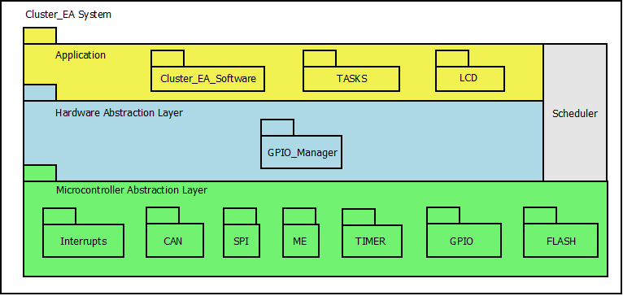

Deployment Diagram

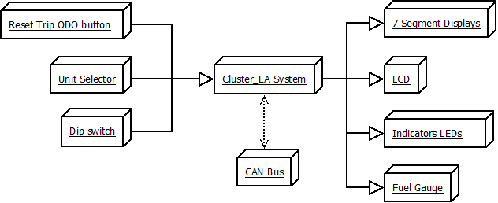

Use case diagram

Sequence diagram

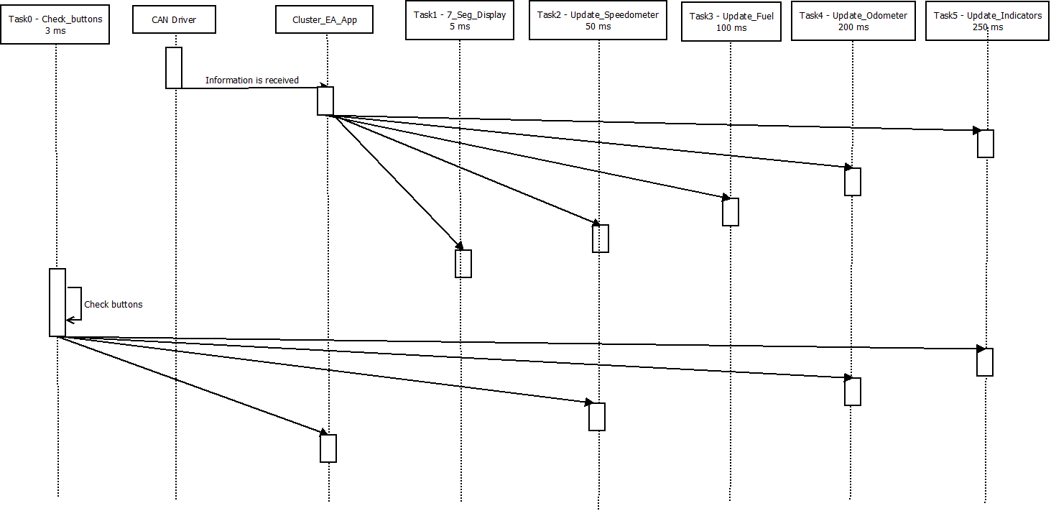

SW Component internal breakdown

Functional Decomposition
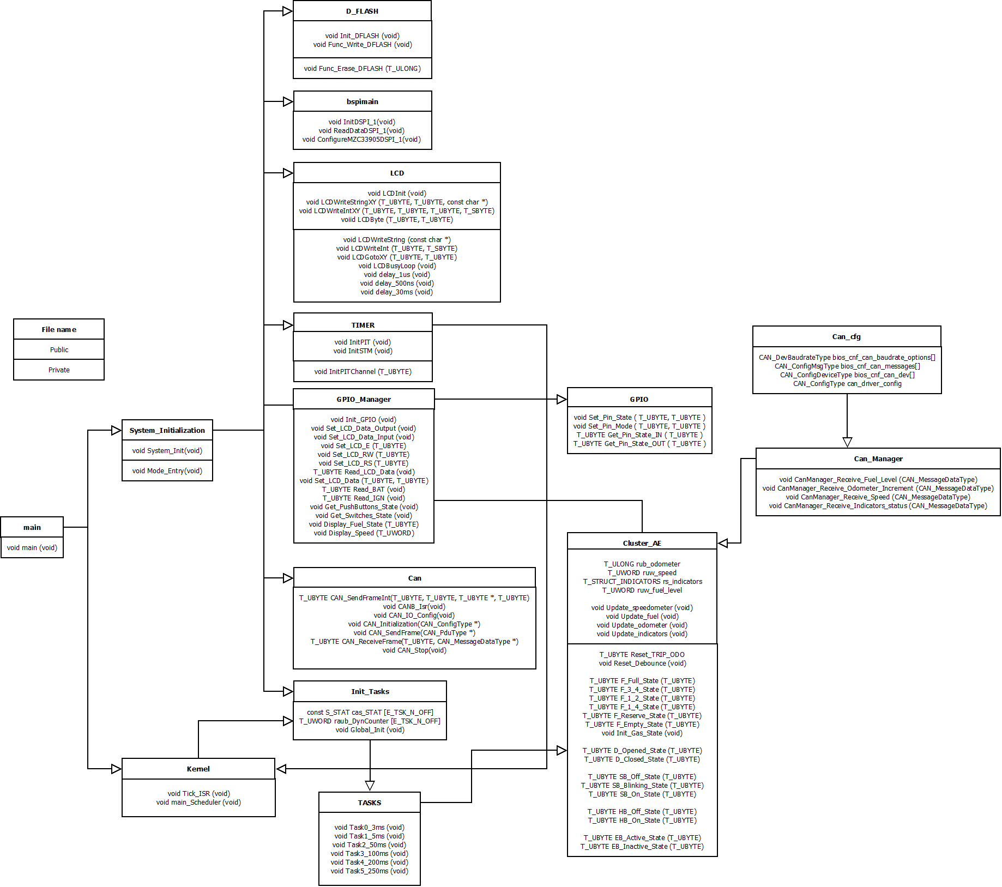

File | Description
Main | Main module that runs the main function. It is divided in system’s initialization and execution of the scheduler.
System_Initialization | The function of this module is to call the functions that initializes the mode of operation, peripherals, and the scheduler.
LIN_EA | It is in charge of executing the main application of the program. It contains two main functions, which also contain the state machines to control the LED status and the slave state.
Kernel | The scheduler is being executed here. It handles the main configurations and the tick interrupt.
TASKS | This module contains the periodic tasks that are executed by the scheduler.
Init_Tasks | This module contains the global initializations which are needed for the correct execution of the scheduler.
LIN | This module contains the LIN driver. It consists of an initialization of the LIN controller and an interrupt for reception.
TIMER | This file contains the configurations that must be done to achieve the periodic interrupt that gives the Ticks to the scheduler.
GPIO | This module handles the registers needed to configure ports and change state of pins.
LED | This module configures and handles the state of the LED.

Function Description and Dynamic Behavior

TASKS

Function void Task0_3ms (void)
Description | This task is executed every 3 milliseconds. Its main function is to check the state of the push buttons.
Parameter 1 | Void
Return Value | Void
Precondition | Does not apply
Post condition | Does not apply
Error Conditions | Does not apply

Function void Task1_5ms (void)
Description | This task is executed every 5 milliseconds. Its main function is to refresh the 7 segments displays.
Parameter 1 | Void
Return Value | Void
Precondition | Does not apply
Post condition | Does not apply
Error Conditions | Does not apply

Function void Task2_50ms (void)
Description | This task is executed every 50 milliseconds. Its main function is to update the speedometer.
Parameter 1 | Void
Return Value | Void
Precondition | Does not apply
Post condition | Does not apply
Error Conditions | Does not apply

Function void Task3_100ms (void)
Description | This task is executed every 100 milliseconds. Its main function is to update the fuel level.
Parameter 1 | Void
Return Value | Void
Precondition | Does not apply
Post condition | Does not apply
Error Conditions | Does not apply

Function void Task4_200ms (void)
Description | This task is executed every 200 milliseconds. Its main function is to update the value of the odometers.
Parameter 1 | Void
Return Value | Void
Precondition | Does not apply
Post condition | Does not apply
Error Conditions | Does not apply

Function void Task5_250ms (void)
Description | This task is executed every 250 milliseconds. Its main function is to update the state of the indicators.
Parameter 1 | Void
Return Value | Void
Precondition | Does not apply
Post condition | Does not apply
Error Conditions | Does not apply

Init_Tasks

Function void Global_Init (void)
Description | This function initializes the scheduler.
Parameter 1 | Void
Return Value | Void
Precondition | This function should be called before executing the scheduler.
Post condition | The scheduler’s functionalities can be used.
Error Conditions | Does not apply.

TIMER

Function void InitPIT (void)
Description | PIT is initialized.
Parameter 1 | Void
Return Value | Void
Precondition | This function is called in the beginning of the main program to initialize the PIT.
Post condition | The interrupts every 5ms will be generated.
Error Conditions | Does not apply

Dynamic Behavior
Activity diagram

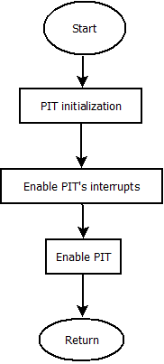

Function void InitPITChannel (T_UBYTE)
Description | This function configures the given channel of the PIT timer.
Parameter 1 | T_UBYTE PIT channel which must be configured.
Parameter 2..n | Does not apply
Return Value | Void
Precondition | This function should be called in the beginning of the main application.
Post condition | The initialized channel of the PIT will be ready to use.
Error Conditions | Does not apply.

Function void InitSTM (void)
Description | STM is initialized.
Parameter 1 | Void
Return Value | Void
Precondition | This function is called in the beginning of the main program to initialize the STM.
Post condition | The STM counter will be incrementing its value at all times.
Error Conditions | Does not apply

Function void Clear_STM (void)
Description | The STM counter is cleared.
Parameter 1 | Void
Return Value | Void
Precondition | Does not apply.
Post condition | The STM counter will be equal to 0.
Error Conditions | Does not apply

GPIO_Manager - Shall be updated.

Function void Init_GPIO (void)
Description | This function initializes
Parameter 1 | Void
Return Value | Void
Precondition | Does not apply
Post condition | The LED will be able to be changed.
Error Conditions | Does not apply

Function void Set_LCD_Data_Output (void)
Description | This function returns the state of the LED.
Parameter 1 | Void
Return Value | T_UBYTE. Corresponds to the logic state of the LED. It can be either 0 or 1, meaning off or on, respectively.
Precondition | Does not apply
Post condition | Does not apply
Error Conditions | Does not apply

Function void Set_LCD_Data_Input (void)
Description | This function
Parameter 1 | Void
Return Value | Void
Precondition
Post condition
Error Conditions | Does not apply

Function void Set_LCD_E (T_UBYTE)
Description | This function
Parameter 1 | Void
Return Value | Void
Precondition
Post condition
Error Conditions | Does not apply

Function void Set_LCD_RW (T_UBYTE)
Description | This function
Parameter 1 | Void
Return Value | Void
Precondition
Post condition
Error Conditions | Does not apply

Function void Set_LCD_RS (T_UBYTE)
Description | This function
Parameter 1 | Void
Return Value | Void
Precondition
Post condition
Error Conditions | Does not apply

Function T_UBYTE Read_LCD_Data (void)
Description | This function
Parameter 1 | Void
Return Value | Void
Precondition
Post condition
Error Conditions | Does not apply

Function void Set_LCD_Data (T_UBYTE, T_UBYTE)
Description | This function
Parameter 1 | Void
Return Value | Void
Precondition
Post condition
Error Conditions | Does not apply

Function T_UBYTE Read_BAT (void)
Description | This function
Parameter 1 | Void
Return Value | Void
Precondition
Post condition
Error Conditions | Does not apply

Function T_UBYTE Read_IGN (void)
Description | This function
Parameter 1 | Void
Return Value | Void
Precondition
Post condition
Error Conditions | Does not apply

Function void Get_PushButtons_State (void)
Description | This function
Parameter 1 | Void
Return Value | Void
Precondition
Post condition
Error Conditions | Does not apply

Function void Get_Switches_State (void)
Description | This function
Parameter 1 | Void
Return Value | Void
Precondition
Post condition
Error Conditions | Does not apply

Function void Display_Fuel_State (T_UBYTE)
Description | This function
Parameter 1 | Void
Return Value | Void
Precondition
Post condition
Error Conditions | Does not apply

Function void Display_Speed (T_UWORD)
Description | This function
Parameter 1 | Void
Return Value | Void
Precondition
Post condition
Error Conditions | Does not apply

GPIO

Function void Set_Pin_State (T_UBYTE, T_UBYTE)
Description | Changes the logic level of the output pin selected.
Parameter 1 | T_UBYTE. Corresponds to the pin number that should be affected.
Parameter 2 | T_UBYTE. It can receive either 0 or 1 to turn the pin off or on respectively.
Return Value | Void
Precondition | The mode of the pin selected should be OUTPUT.
Post condition | The logic level for the selected pin, will be the one selected in the second parameter.
Error Conditions | Does not apply

Function void Set_Pin_Mode (T_UBYTE, T_UBYTE)
Description | This function changes the pin mode of the selected pin to the selected mode.
Parameter 1 | T_UBYTE. Corresponds to the pin number that should be affected.
Parameter 2 | T_UBYTE. It can receive a value according to the following definitions: 0 -> OUTPUT, 1 -> INPUT, 2 -> LIN_TX, 3 -> LIN_RX.
Return Value | Void
Precondition | Does not apply
Post condition | The selected pin will act as the selected pin mode.
Error Conditions | Does not apply

Function T_UBYTE Get_Pin_State_IN (T_UBYTE)
Description | This function returns the state of the given pin.
Parameter 1 | T_UBYTE. Corresponds to the pin number which state is unknown.
Return Value | T_UBYTE. Corresponds to the logic state of the pin. It can be either 0 or 1, meaning off or on, respectively.
Precondition | Does not apply
Post condition | Does not apply
Error Conditions | Does not apply

Function T_UBYTE Get_Pin_State_OUT (T_UBYTE)
Description | This function returns the state of the given pin.
Parameter 1 | T_UBYTE. Corresponds to the pin number which state is unknown.
Return Value | T_UBYTE. Corresponds to the logic state of the pin. It can be either 0 or 1, meaning off or on, respectively.
Precondition | Does not apply
Post condition | Does not apply
Error Conditions | Does not apply

KERNEL

Function void Tick_ISR (void)
Description | This function is the one that handles the clock Ticks in order to trigger the tasks. This interrupt runs periodically every 5 milliseconds according to the configuration of the PIT.
Parameter 1 | Void
Return Value | Void
Precondition | This function is called when a PIT interrupt is generated.
Post condition | It will literally interrupt the flow of the program to implement its code.
Error Conditions | Does not apply

Function void main_Scheduler (void)
Description | This function contains the main function of the scheduler which controls the timing for each of the tasks.
Parameter 1 | Void
Return Value | Void
Precondition | The Global_Init function should be executed before.
Post condition | Does not apply
Error Conditions | Does not apply

Main

Function void main (void)
Description | This function runs first by default. It is divided in system initialization and execution of the scheduler.
Parameter 1 | Void
Parameter 2 | Does not apply.
Return Value | Void
Precondition | Does not apply.
Post condition | Does not apply.
Error Conditions | Does not apply.

System_Initialization

Function void System_Init (void)
Description | This function calls the functions that initializes the mode of operation, peripherals, and the scheduler.
Parameter 1 | Void
Parameter 2 | Does not apply.
Return Value | Void
Precondition | This should be the first function called in the main program.
Post condition | It will be possible to use the microcontroller with the configurations done.
Error Conditions | Does not apply.

Function void ModeEntry (void)

Description | It initializes the mode of operation.
Parameter 1 | Void
Parameter 2 | Does not apply.
Return Value | Void
Precondition | This should be the first function called in the main program.
Post condition | It will be possible to use the microcontroller with the configurations done.
Error Conditions | Does not apply.

Cluster_EA

CAN

Function T_UBYTE CAN_SendFrameInt (T_UBYTE, T_UBYTE, T_UBYTE *, T_UBYTE)

Function void CANB_Isr (void)

Function void CAN_IO_Config (void)

Function void CAN_Initialization (CAN_ConfigType *)

Function void CAN_SendFrame (CAN_PduType *)

Function T_UBYTE CAN_ReceiveFrame (T_UBYTE, CAN_MessageDataType *)

Function void CAN_Stop (void)

CAN_Manager

Function void CanManager_Receive_Fuel_Level (CAN_MessageDataType)

Function void CanManager_Receive_Odometer_Increment (CAN_MessageDataType)

Function void CanManager_Receive_Speed (CAN_MessageDataType)

Function void CanManager_Receive_Indicators_Status (CAN_MessageDataType)

D_FLASH

Function void Init_DFLASH (void)

Function void Func_Write_DFLASH (void)

Function void Func_Erase_DFLASH (T_ULONG)

Bspimain

Function void InitDSPI_1 (void)

Function void ReadDataDSPI_1 (void)

Function void ConfigureMZC33905DSPI_1 (void)

LCD

Function void LCDInit (void)

Function void LCDWriteStringXY (T_UBYTE, T_UBYTE, const char *)

Function void LCDWriteIntXY (T_UBYTE, T_UBYTE, T_UWORD, T_SBYTE)

Function void LCDByte (T_UBYTE, T_UBYTE)

Function void LCDWriteString (const char *)

Function void LCDWriteInt (T_UWORD, T_SBYTE)

Function void LCDGotoXY (T_UBYTE, T_UBYTE)

Function void LCDBusyLoop (void)

Function void delay_1us (void)

Function void delay_500ns (void)

Function void delay_30ms (void)

