Chat Application

Requirements Document
Table of Contents
1 Introduction 3
1.1 Purpose and Scope 3
1.2 Target Audience 3
1.3 Terms and Definitions 3
2 Product Overview 5
2.1 Users and Stakeholders 5
2.1.1 Developer 5
2.1.2 Graders 5
2.2 Use cases 5
2.2.1 Register New Account 7
2.2.2 Log In 8
2.2.3 Log Out 9
2.2.4 Delete Account 10
2.2.5 Send Public Message 11
2.2.6 Send Private Message 11
2.2.7 Retrieve Message Log 12
3 Functional Requirements 13
3.1 Register new account 13
3.2 Log User In 13
3.3 Log User Out 13
3.4 Delete Account 13
3.5 Notify Users of New Login 14
3.6 Notify Users of New Logout 14
3.7 Send Public Message 14
3.8 Send Private Message 14
3.9 Send Chat History 15
4 Nonfunctional Requirements 16
4.1 Chat History Persists 16
4.2 Client and Server Run on Java SE 8 on Windows and Linux 16
4.3 Multiple Client Connections Per Server 16
5 Milestones and Deliverables 17
5.1 Requirements Specification Complete – 4/25/2017 17
5.2 Design Documentation Complete – 5/9/2017 17
5.3 Test Plan Complete – 5/30/2017 17
5.4 Project Report and Final Deliverables – 6/8/2017 17

Introduction
This document presents the software requirements specification for the CS 300 Spring 2017 term project, referred to in this document as a “chat application.” The chat application consists of two executables: a server program accepts connections from an indeterminate number of users, while the client program allows one user to connect to one server. Once users authenticate with the server, they can exchange messages both chat room style (public messages) and one-on-one (private messages). As of this writing, only text messages are planned. Both programs will be written in Java and intended for use on modern desktop operating systems, e.g. Windows 10 and recent Linux releases.

The requirements specification below consists primarily of general specifications, use cases, and both functional and non-functional requirements, presented in this order.

Purpose and Scope
The purpose of this software requirements specification document is to identify and detail the features, functions, and requirements of the chat application project in sufficient detail to advance to the analysis phase. The document is limited in scope to software requirements pertaining directly to the chat application. It does not address other aspects of the application or the software stack on which the application will run (i.e. operating system, virtual machine, etc.)

Target Audience
This document is intended for use primarily by the developer and secondarily by project stakeholders to review the progress of the project.

Terms and Definitions
User – generic term for an account stored on the server. A user is defined by its association with various server-side data, particularly a User ID, Password, and Chat History. A User is uniquely identified by its associated User ID.
Unregistered User – a nonexistent User, i.e. a User ID and Password that do not correspond to an existing record on the server.
Registered User – a User that is logged out, i.e. a User that does not fall into the category of Logged-In User. When an actor is indicated to be a Registered User, only a Registered User may perform this action.
Logged-In User – a User that is logged in. When an actor is indicated to be a Logged-In User, only a Logged-In User may perform this action.
User ID – a user name that is unique within the scope of the server’s User accounts. A User ID consists of text characters a through z (inclusive), A through Z (inclusive), 0 through 9 (inclusive), and _ (underscore). No other characters are allowed. A User ID must be between 3 and 16 characters in length (inclusive). The User ID is the name by which Users identify and interact with one another.
Password – a combination of alphanumeric-symbolic characters between 8 and 32 characters long (inclusive). Passwords are stored in plaintext within User records; however, a future revision of the software product will implement Password storage in a secure manner to be defined later.
Chat History – a complete record of the text to which a specific User has been privy over the life of the User’s account on the server. Chat History consists of a chronologically ordered sequence of text entries, one per line. Each text entry is the text of a Public Message or Private Message the User has received, along with the User ID of the User that sent the message and whether the message was public or private.
Public Message – a text-only message sent by one Logged-In User and visible to all other Logged-In Users.
Private Message – a text-only message sent by one Logged-In User and visible only to one other Logged-In User.

Product Overview
The product is a simple, text-only chat application implemented using a client-server architecture over TCP/IP. An indeterminate number of clients will be able to connect to a server to exchange messages both publicly and privately as well as view their chat histories. The product does not allow for non-text communication, such as sending files or uploading videos.

Users and Stakeholders
This section identifies the key stakeholders for the product. For the purpose of this document, stakeholders are defined to be persons or groups who have an interest in the development of the product. Users of the eventual product are not considered to be stakeholders.

Developer
The developer, Dylan Laufenberg, is the primary stakeholder in the product. He is solely responsible for engineering all phases of the product from requirements through maintenance and is the author of this document.

Graders
The graders responsible for reviewing the product at each stage of its development are additional stakeholders in the product. The professor and class TA are the graders for this project.

Use cases
The following subsections describe use cases, which are specific user interactions that the product will support. Each use case lists its actors (the users involved in the interaction), provides a brief description of the interaction, and outlines the interaction in detail in the step-by-step description. On the next page is the use case diagram to which the use case subsections refer.
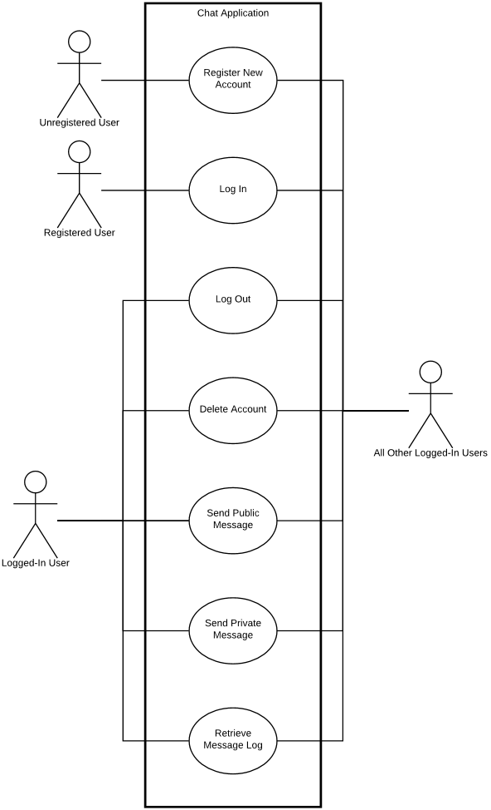

Register New Account
Actors: Unregistered User.
The Unregistered User activates a Create Account control in the client application. The client application switches to an account creation page containing the required credentials, e.g. a User ID and Password. The Unregistered User enters the required information and activates a Submit control. The client sends the credentials to the server, which verifies that the User ID does not already exist in the server’s records. If the User ID does not already exist, it is stored, along with the Password and any other data sent from the client application. The server sends the client a message indicating that the request either succeeded or failed. In case of success, the server flags the user as a Logged-In user and the client switches to its logged-in state. In case of failure, the server makes no changes to its records and the client displays an error message, remaining at the account creation page.
Step-By-Step Description:
- The Unregistered User activates a Create Account control in the client application.
- The client application switches to an account creation page.
- The Unregistered User enters the required information on the account creation page (User ID and Password) and activates a Submit control.
- The client application sends a message to the server containing the information entered by the Unregistered User and awaits a response.
- The server checks for the existence of a User with the User ID contained in the client application’s message.
  - If the password does not meet the Password criteria (see Terms and Definitions), the server:
    - Makes no changes to its internal data.
    - Sends a message to the client indicating a password failure.
  - If the User ID is already assigned to an existing User, the server:
    - Makes no changes to its internal data.
    - Sends a message to the client indicating duplicate account failure.
  - If the User ID is not already assigned to an existing user, the server:
    - Registers a new User in its system and saves the received account details under that user.
    - Sends a message to the client indicating success. The message contains a current list of Logged-In Users.
    - Flags the new User as a Logged-In User.
    - Sends messages to all Logged-In Users’ client applications indicating that this User is now logged in.
- The client receives the message from the server.
  - If the server message indicates failure, the client:
    - Displays an error message reflecting the cause of the failure as reported by the server.
    - Remains at the account creation prompt.
  - If the server message indicates success, the client switches to its logged-in state, displaying the main chat interface and unlocking controls that are available to Logged-In Users.
- In the case of successful account creation, the client applications of all other Logged-In Users receive the server message and each display a message indicating that the newly created User is now a Logged-In User.

Log In
Actors: Registered User, all other Logged-In Users.
The Registered User enters a User ID and password into a login prompt and submits these credentials to the application. The User ID and password are checked against the application’s records. If the supplied credentials match, the user is flagged as a Logged-In User and gains access to application features that are restricted to such users, e.g. sending messages, receiving messages, retrieving chat history, and deleting the user account. The server notifies all other Logged-In Users and tells the client application the login attempt was successful. The client application switches to its logged-in state, exposing the chat interface.
Step-By-Step Description:
- The Registered User enters a User ID and Password into a login prompt in the client application and activates a Submit control.
- The client application sends the User ID and Password to the server and awaits a response.
- The server receives the message and checks it against its record of existing Users:
  - If the User ID does not match an existing User’s User ID, the server sends a message to the client indicating this.
  - If the User ID matches an existing User’s User ID and the Password does not match, the server sends a message to the client indicating this.
  - If the User ID matches an existing User’s User ID and the Password matches, the server:
    - Sends a message to the client indicating success. The message contains a current list of Logged-In Users.
    - Flags the Registered User as a Logged-In User.
    - Sends messages to all Logged-In Users’ client applications indicating that this User is now logged in.
- The client receives the server’s response.
  - If the message indicates failure, the client:
    - Displays an error message indicating the cause of the failure.
    - Remains at the login prompt.
    - If the message indicates success, the client switches to the primary chat interface.
- In the case of successful login, the client applications of all other Logged-In Users receive the server message and each display a message indicating that the Registered User is now a Logged-In User.

Log Out
Actors: Logged-In User.
The Logged-In User actives a Log Out control in the client application. The client application indicates this intent to the server, which records that the user is no longer logged in and should no longer be granted access to application features that are restricted to logged-in users. The client application is notified and returns to its initial state.
Step-By-Step Description:
- The Logged-In User activates a Log Out control in the client application.
- The client application sends a message to the server requesting to log out.
- The server clears the flag indicating that this User is a Logged-In User. Henceforth, the User is considered a Registered User.
- The server sends messages to all remaining Logged-In Users’ client applications indicating that this User is no longer a Logged-In User.
- The server sends a message to the User’s client application indicating success.
- The Logged-In User’s client application receives the server’s confirmation message and switches to its initial state.
- The client applications of all remaining Logged-In Users receive the server’s message and each display a message indicating the specified user is no longer a Logged-In User.

Delete Account
Actors: Logged-In User.
The Logged-In User activates a Delete Account control in the client application, confirms that he or she wishes to delete this account, and upon confirmation is removed from the server’s user registry. All user files on the server are removed, but other users’ logs are not affected.
Step-By-Step Description:
- The Logged-In User activates a Delete Account control in the client application.
- The client application displays a confirmation page.
  - If the Logged-In User confirms that he or she wishes to delete this account:
    - The client application sends a message to the server indicating this.
    - The server removes the User from its registry of Users, deleting all files associated with the User. References to the User in other files are not modified.
    - The server sends a response to the client application indicating success.
    - The server sends a message to all remaining Logged-In Users indicating that this User is no longer a Logged-In User.
    - The client application of the User returns to its initial state.
    - The client applications of all remaining Logged-In Users receive this message and each display a message indicating that this User is no longer a Logged-In User.
  - If the Logged-In User cancels the request, the client returns to its previous state.

Send Public Message
Actors: sending Logged-In User, all other Logged-In Users.
The sending Logged-In User enters a text message into the client application and activates a Send control. The client application sends the message to the server, which routes the message to all other Logged-In Users’ client applications and logs the message in those users’ Chat Histories as well as the sender’s Chat History. The client applications that receive the message display it and indicate the User ID of the sender.
Step-By-Step Description:
- The sending Logged-In User enters a text message into the client application and activates a Send control.
- The client application sends the message to the server.
- The server sends the message to all other Logged-In Users’ client applications.
- The server logs the message in those users’ Chat Histories as well as the sender’s Chat History.
- The client applications that receive the message display it and indicate the User ID of the sender.

Send Private Message
Actors: sending Logged-In User, receiving Logged-In User.
The sending Logged-In User double-clicks on the name of another Logged-In user in the client application, thereby designating the receiving Logged-In User. The sender enters a text message into the client application and activates a Send control. The client application sends the Private Message to the server, which records the message in both users’ Chat Histories and dispatches the message to the receiver’s client application. The receiver’s client application displays the message and indicates the User ID of the sender, as well as the fact that the message was private.
Step-By-Step Description:
- The sending Logged-In User double-clicks on the name of another Logged-In user in the client application, thereby designating the receiving Logged-In User.
- The sender enters a text message into the client application and activates a Send control.
- The client application sends the Private Message to the server.
- The server sends the message to the receiver’s client application.
- The server records the message in both users’ Chat Histories.
- The receiver’s client application displays the message and indicates the User ID of the sender, as well as the fact that the message was private.

Retrieve Message Log
Actors: Logged-In User.
A Logged-In User activates a View Log control in the client application. The client application sends a request to the server to retrieve Chat History. The server sends the Chat History to the client. The client displays the Chat History.
Step-By-Step Description:
- The Logged-In User activates a View Log control in the client application.
- The client application sends a request to the server to retrieve Chat History.
- The server sends the Chat History to the client.
- The client displays the Chat History in a separate page.
- The Logged-In User activates a control to close the Chat History view.
- The client returns to its logged-in state.

Functional Requirements
Describe the purpose of this section and outline its contents. Only a few sentences are expected here. It may help to define a functional requirement.

Register new account
Input: unique User ID, Password
Output: new User account entry created on server corresponding to the provided User ID and Password, and that User is flagged as a Logged-In User.
Given a User ID and Password that conform to the specifications listed under Terms and Definitions, and given that the User ID does not already correspond to a User account on the server, create a new User account on the server and immediately log that user in.

Log User In
Input: User ID and Password corresponding to a Registered User on the server that is not currently logged in
Output: The Registered User is flagged as a Logged-In User.
Given a User ID and Password pair that correspond to a known set of account credentials on the server, flag said User as a Logged-In User.

Log User Out
Input: logout request from a client known to correspond to a Logged-In User
Output: The Logged-In User corresponding to the client that sent the request is no changed from a Logged-In User to a Registered User.
Given a logout request from a client known by the server to correspond to a specific Logged-In User, unset the flag identifying the user as a Logged-In User.

Delete Account
Input: delete account request from a client known to correspond to a single Logged-In User
Output: The User account corresponding to the client that sent the request is removed from the server.
Given a delete account request by a client corresponding to a Logged-In User, the server deletes the account on the server, including User ID, Password, and Chat History.

Notify Users of New Login
Input: Logged-In User
Output: all other Logged-In Users receive messages indicating that this User is logged in.
Given a Logged-In User, send messages to all other Logged-In Users that this User is now logged in and available to chat.

Notify Users of New Logout
Input: Registered User
Output: all Logged-In Users receive messages indicating that this User is no longer logged in.
Given a Registered User, send messages to all Logged-In Users that this User is no longer logged in or available to chat.

Send Public Message
Input: Logged-In User, text message
Output: all other Logged-In Users receive the text message, identified as a message from the sending user.
Given a Logged-In User and a text message, send that text message to all other Logged-In Users.

Send Private Message
Input: Logged-In User (sender), Logged-In User (recipient), text message
Output: recipient receives the text message, identified as a private message from the sending user.
Given a sender, a recipient, and a text message, send the text message specifically to the recipient.

Send Chat History
Input: request for Chat History by a client known to be associated with a single Logged-In User.
Output: User’s Chat History transmitted and displayed.
Given a request by a Logged-In User for his or her Chat History, send the Chat History, in full, from the server to that User’s client, and display the record in that client.

Nonfunctional Requirements
This section outlines the basic nonfunctional requirements of the chat application. The requirements below do not correspond to specific program functions but instead govern the behavior and design of the system overall.

Chat History Persists
Each User’s Chat History persists on the server for the life of that User account. It persists across chat sessions as well as server cycles. When deleting a user, messages from that user must still be available to other users, and the messages’ sender must still be recorded and reported as that User ID of the deleted user.

Client and Server Run on Java SE 8 on Windows and Linux
Both the client and server programs must run on the Java SE 8 Virtual Machine on both Windows and Linux desktop operating systems. Compatibility with previous versions of Java is not required, and operating systems on which Java SE 8 does not run are not supported.

Multiple Client Connections Per Server
The server program must accept and correctly handle an arbitrary number of client connections. While the performance of the server may limit the number of client connections on a given hardware and network configuration, the program itself must correctly handle an arbitrary number of connections simultaneously.

Milestones and Deliverables
The following are the project milestones, reflecting the due dates assigned as part of the CS 300 course materials. All required deliverables are to be pushed to the main branch of the project repository before the dates listed, and some documents may need to be printed per grader instructions.

Requirements Specification Complete – 4/25/2017
Complete the software requirements specification document (this document).

Design Documentation Complete – 5/9/2017
Complete the design documentation per the provided design documentation template.

Test Plan Complete – 5/30/2017
Complete the test plan documentation. The format is to be announced. In addition, approximately 50% or greater progress on the client and server implementations in Java.

Project Report and Final Deliverables – 6/8/2017
Fully implement and test the client and server, including multiple client connections both locally and across TCP/IP networks. Complete project report per specifications to be announced.

