Arizona Fatal Accidents Analysis Report

For this report, we analyzed Fatal Traffic Accidents in the State of Arizona from 2012-2016. The main objective of this analysis was to determine various factors involving fatal accidents including, city, county, and road analysis. We looked into accident causation, time of day, and into the funding of money allocated to improve highway safety.

**County Data Analysis:**

We looked into identifying which counties had the highest fatal accidents and the highest fatalities per capita. Not surprisingly Maricopa and Pima county led the way in total fatalities. These two counties are the most populated counties in Arizona, and we expected them to lead the way.

What was surprising, was the county fatality rate per 100,000. We imported county population data from 2016 to identify the highest fatality rate per 100,000 people in each Arizona county. Smaller counties along the eastern side of Arizona had much high fatalities per capita. We did filter out 6 fatal accidents of county data because those accidents were not filtered with a specific county. 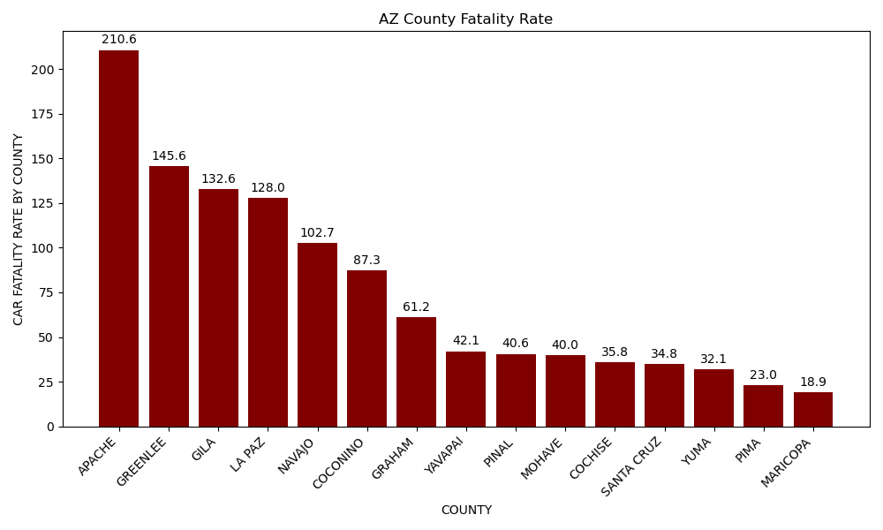

**City Data Analysis:**

We wanted to look at the cities with the most fatalities as well. In order to do this we had to group our data by city_name. There were 874 rows of fatal accidents that did not have an associated city attached to it. These accidents we can conclude occurred on highways outside city limits. One flaw to our data set, was that many crashes were identified as Pheonix being the main city, but many suburbs reside within Phoenix and weren’t listed as the primary city.

**Road Data Analysis:**

We wanted to find the roads where the most fatal accidents occurred in our data set. After filtering our data frame to include only road names that were identifiable, we removed 36 rows of data from our analysis. We included the top 15 roads by fatal accidents. One. interesting point about the roads is that 3 out of the top 4 roads don’t go through the Phoenix metropolitan area. These roads all traverse the eastern side of Arizona, which correlates to the county fatality rate graph.

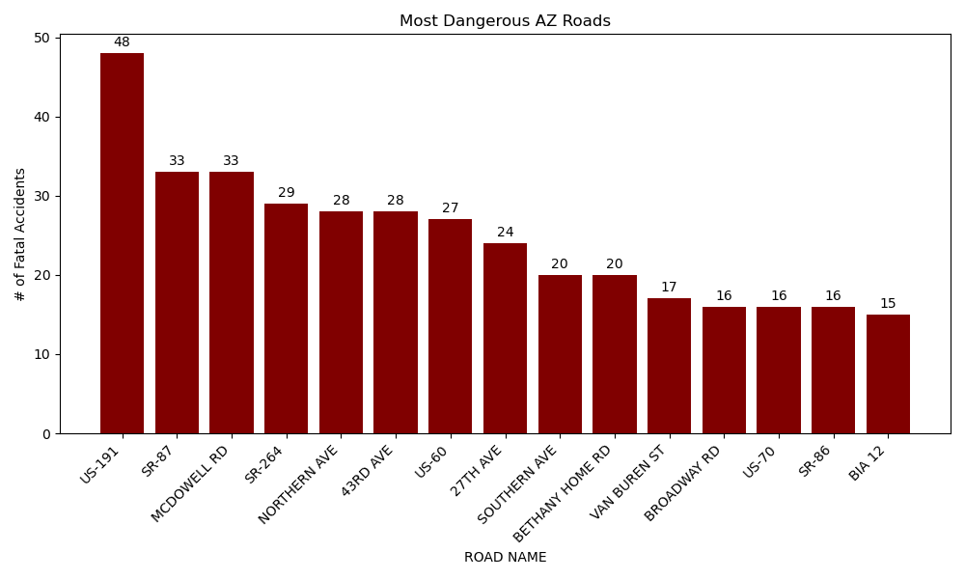

**Daylight Accident Analysis:**

We looked into determining if the amount of daylight had any effect on the number of fatal accidents. We discovered that when combined across all dark with various lighting conditions had about the same number of accidents as the daylight section. Across each year there wasn’t a specific year that saw a significant reduction in fatalities in any lighting condition. We determine that lighting doesn’t have a significant impact on fatal accidents.

**Age Factor Analysis:**

We looked into age fatalities and looked to determine if there were certain age groups more at risk into being involved in a fatal accident. By far 16-30 years of age were the most involved in fatal accidents. There are many factors that can contribute to this that we weren’t able to dig into but considered new drivers, aggressive and speeding drivers, and drunk drivers as being the highest cause for being involved in these fatal accidents.

**Accident Causation Analysis:**

We looked into the primary cause of fatal accidents. We filtered our dataframe by each accident cause. In our dataframe each column was specified for speed or other crash, and the next column was drunk or other crash, and so on. After we calculated the sums of each of the 4 columns we created a graph to represent primary crash causes. Based on our analysis Speeding and Drunk driving accounted for 85% of all fatal accidents during this timeframe.

**Vehicle Make Analysis:**

We looked into vehicle makes that were involved in fatal accidents to determine if specific vehicles were more likely to be involved in fatal car accidents. Chevy and Ford led the way significantly as the vehicles most involved in car accidents. This wasn’t all that surprising as those are two of the biggest market share leaders in the United States.

**HSIP Funding Review Conclusion:**

The two graphs above have an inverse relationship concluding that as funding for roadway safety increases, this may be a factor contributing to the decrease in overall fatal accidents per year. The decrease in overall fatal accidents was not major, but any decrease in overall fatalities per year and any measures that can contribute to a solution is important.

**Intersection Review Conclusion:**

* + Of the total 1,860 rows included in the data for 2012-2016, 773 total rows of accidents did not include the roadway type. Due to this, the data was dropped to 1,087 rows.
  + For the reduced data recorded, the Urban-Minor Arterial has the most overall fatal accidents. This type of road is a major roadway connecting local neighborhoods to highways. It’s not necessarily possible to limit this as these roadways are necessary for people living within a small urban area to navigate to other locations outside of their neighborhood.
  + One possible solution would be to pave more collector streets as these are less common for fatal accidents. Collector streets are roads that connect the arterials, so paving more of these would provide additional options for people to avoid the arterials for a portion of their trip and only use them when necessary.

REFERENCES

Dataset

* Size of Dataset : 3.62 MB
* Content: This dataset provides detailed information about fatal car accidents that occurred in the state of Arizona. Data points such as location, time, weather, contributing factors and demographic info of the motorists involved have been parsed out of the dataset.
* Number of records: 18360 rows
* Number of columns: 309 columns
* Source: available on Kaggle

<https://www.kaggle.com/datasets/thedevasta>tor/fatal-traffic-accidents-in-arizona-2012-2016

HSIP – Highway Safety Improvement Program:

[chrome-extension://efaidnbmnnnibpcajpcglclefindmkaj/https://highways.dot.gov/media/10071](chrome-extension://efaidnbmnnnibpcajpcglclefindmkaj/https:/highways.dot.gov/media/10071)  
[chrome-extension://efaidnbmnnnibpcajpcglclefindmkaj/https://highways.dot.gov/media/10616](chrome-extension://efaidnbmnnnibpcajpcglclefindmkaj/https:/highways.dot.gov/media/10616)  
[chrome-extension://efaidnbmnnnibpcajpcglclefindmkaj/https://safety.fhwa.dot.gov/hsip/reports/pdf/2015/az.pdf](chrome-extension://efaidnbmnnnibpcajpcglclefindmkaj/https:/safety.fhwa.dot.gov/hsip/reports/pdf/2015/az.pdf)  
[chrome-extension://efaidnbmnnnibpcajpcglclefindmkaj/https://highways.dot.gov/sites/fhwa.dot.gov/files/2022-06/hsip_reports_2016_az.pdf](chrome-extension://efaidnbmnnnibpcajpcglclefindmkaj/https:/highways.dot.gov/sites/fhwa.dot.gov/files/2022-06/hsip_reports_2016_az.pdf)

Arizona County Population:

[https://www.mapsofworld.com/usa/states/arizona/population.html#google_vignette](https://www.mapsofworld.com/usa/states/arizona/population.html)