Exam Shared Notes
General Tasks
- Understand for each of the 500 Russian tourist applicants, how much profit they are likely to generate.
- Understand for each of the 500 Russian tourist applicants, whether they are likely to generate any damage and if so, how much damage they are likely to generate.

The general hotel rationale is:
- Predict potential income from the tourist (Continuous Variable).
- Predict whether the tourist is going to damage something (Binary) or the likelihood of damaging something (Probability/Continuous).
- Predict the potential damage cost of the tourist (Continuous Variable).
- Predict net hotel income per tourist (Continuous Variable).

Expected Net Value=Expected Profit−Expected Damage Cost

Descriptive of Train_V2
- N.B The observations in the dataset are not 500 but 5000, with 53 variables (predictors and outcomes).
- Most variables are nearly complete and contain only a small proportion of missing observations. In contrast, the staff rating variables (e.g. score1_pos) show substantial missingness (approximately 70–76%).
- The outcome variable outcome_profit contains a substantial number of high-profit outliers, indicating that a small group of guests generates disproportionately large profits.

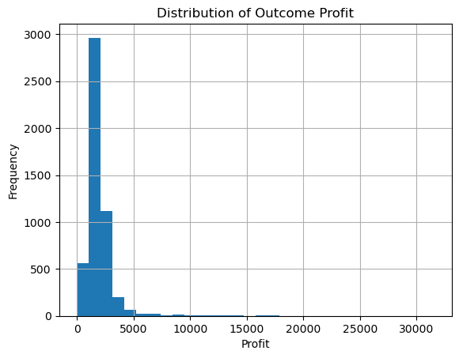

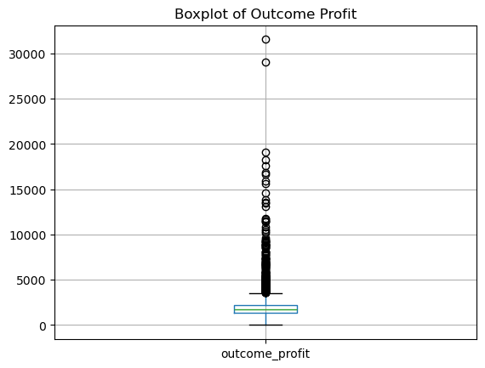
- The outcome variable outcome_damage_inc is a binary indicator of whether a guest caused damage during their last stay. Approximately 25.5% of guests were associated with a damage incident, while 74.5% were not. Although the classes are somewhat imbalanced, the minority class remains sufficiently represented for classification modelling.
- The outcome variable outcome_damage_amount exhibit a strongly right-skewed distribution. While most damage incidents result in relatively modest costs, a small number of guests generate exceptionally large damage expenses (75th percentile ≈ €203 vs Maximum = €3,157). Although the distribution contains many extreme observations, these values likely represent genuine high-cost damage incidents and therefore carry important business information. Consequently, they should not be removed without careful consideration.

