Homework 3 Solutions:
Reading Between the Lines:
Predicting Supreme Court Votes Based on Oral Argument Emotions
Quantitative Methods II - Winter 2025
March 12, 2025
Acknowledgments
Insert your acknowledgments here.

3.1 Preliminaries
Q1: Write a concise, 3-sentence description of the dataset as if you were explaining it to a colleague. What kind of information does each row represent?
A1: The data set is comprised mainly of voice pitch data for a set of 18 supreme court justices from the years 1982 to 2014. Each row shows the year, case id, docket, and which justice it is along with their voting pattern and pitch when addressing petitioner or respondent.
Q2: What is the unit of observation in this dataset? In other words, what does each observation (or row) correspond to?
A2: Each row in the data set represents a specific justice’s vote, along with that justice’s average voice pitches when speaking to respondents and petitioners.
Q3: What does it mean when a Supreme Court justice votes in favor of the petitioner? Why is accurately predicting this decision important for policy and legal outcomes? (Hint: Refer to the authors’ article for insights.)
A3: If the Supreme Court Justice votes in favor of the petitioner, it means that they align with the petitioner of the court case. Essentially, they are voting to overturn the lower court’s ruling on the matter and side with the petitioner. Accurately predicting this decision for policy and legal outcomes could allow stakeholders to move on information earlier if the pitch of the judge could be tied to whether they will vote for or against the petitioner, since only audio is ever released pertaining to Supreme Court hearings.
Q4: How many missing values are there in the dataset? Identify which variables have missing data and explain why this might matter for your analysis.
A4: There are 5,568 variables missing, in a myriad of columns, this matters as when we run regressions it only uses complete cases by default, therefor we need to drop these missing variables. Especially if they are in variables we will not use within our regression.

3.2 Getting to Know the Data and Descriptive Statistics
Q5: Describe the general distribution of the variables petitioner vote, pitch diff, and petitioner harvard pos. Are there any patterns in how these values are spread out? Do you notice any missing data or extreme values that might be important for analysis?
A5: Justices seemed to side with petitioner and votes in their favor 54.52% of the time. The average pitch difference was slightly negative, showing a slightly lower pitch was used on average when addressing the petitioner rather than the respondent. There may be a high pitch difference of 3.84 and a semi high 90 for the positive words used when addressing the petitioner. More importantly there are 232 missing variables in the petitioner_harvard_pos variable. If we are to use them for the regression as a control or explanatory variable we would need to see if the missing variables are systemic in nature to avoid contaminating the data set with any specific biases.
Q6: The dataset includes variables based on justices’ speech patterns and word choice during oral arguments. How was pitch diff measured, and why was it standardized? How was petitioner harvard pos created, and what are some potential challenges of using a predefined list of positive words? Could this approach misinterpret tone or context, such as when a justice uses sarcasm?
A6: Pitch difference was measured by first finding the average pitch difference of that specific justice, when comparing their pitch to the petitioner and respondent. This sets a baseline from which we can compare individual pitch differences and classify them as above average or not.
The petitioner_harvard_pos was created using the number of positive words addressed to petitioner according to Harvard IV-4 Dictionary. Using a predefined list of positive words in isolation could be mis construed as the full context of the sentence is missed. If for example someone said, “Your analysis is fairly good at first glance” then the tone of the sentence is missed and 2 words counted in a positive light is recorded.

Q7: The petitioner harvard pos variable is based on a predefined dictionary of positive words. What are some ways this method might introduce errors? How could these errors impact the interpretation of the results?
A7: False positives are type 1 errors. Therefor giving evidence to disprove the null hypothesis that differences in vocal pitch have no effect on judge voting outcomes. Giving researchers a false sense that these differences in vocal pitch change the outcome for petitioners. The use of the Harvard variable also can introduce false negatives or type 2 errors which can give researchers the impression that vocal pitch is not correlated with voting patterns of Supreme Court Justices.
Q8: The bar chart compares the proportion of votes in favor of the petitioner across three chief justices, depending on whether the Solicitor General submitted an amicus brief. What trends do you observe in how each justice responded to amicus support?
What factors might explain differences in their voting patterns?
A8: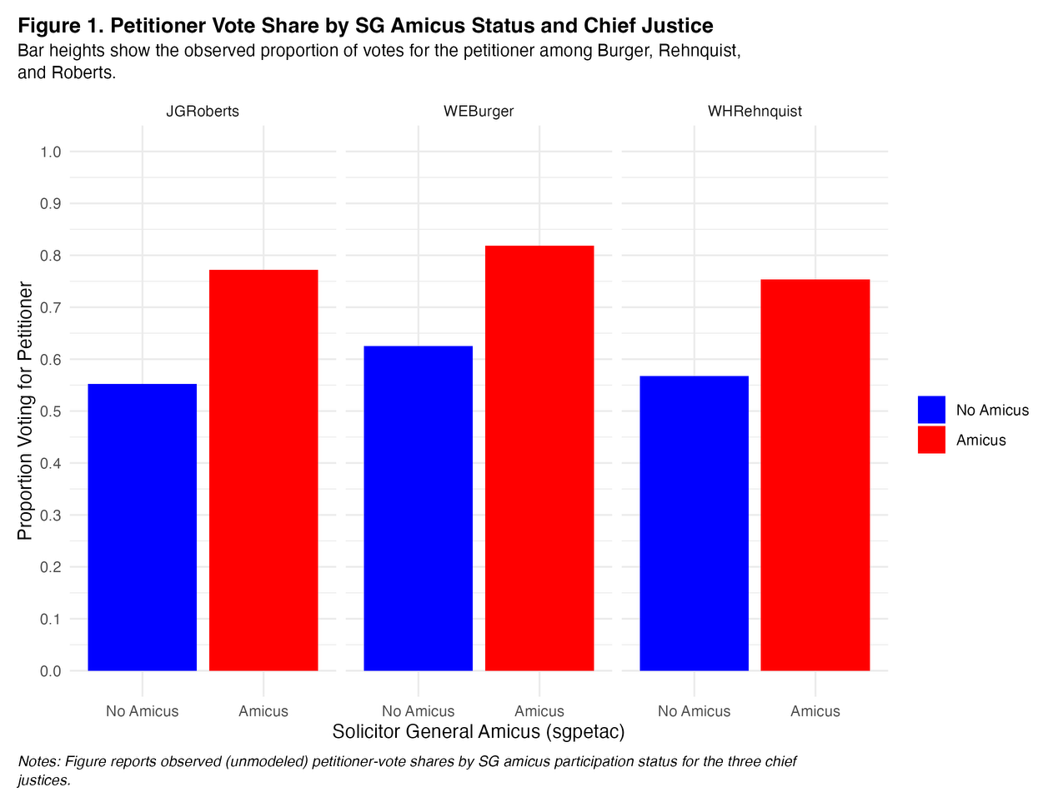
On average it seems that cases with an Amicus brief had a higher propensity of the Justices voting in favor of the petitioner. In terms of the specific justices, it seems all justices responded fairly similar to an Amicus brief, increasing their likelihood to vote in favor of the petitioner by 20%. Since the Amicus brief is the same for all justices, it is a blanket treatment. Justices also receive more information from a qualified entity that has more tradecraft, in the kinds of evidence and arguements Justices may be seeking. The SG also has an incentive to make compelling briefs to maintain their reputation.
Q9: The second bar chart examines how pitch differences in justices’ speech relate to their votes across different court periods. What does the chart suggest about the relationship between pitch and voting behavior during the Burger, Rehnquist, and Roberts courts? Do you see any shifts in this pattern over time?
A9: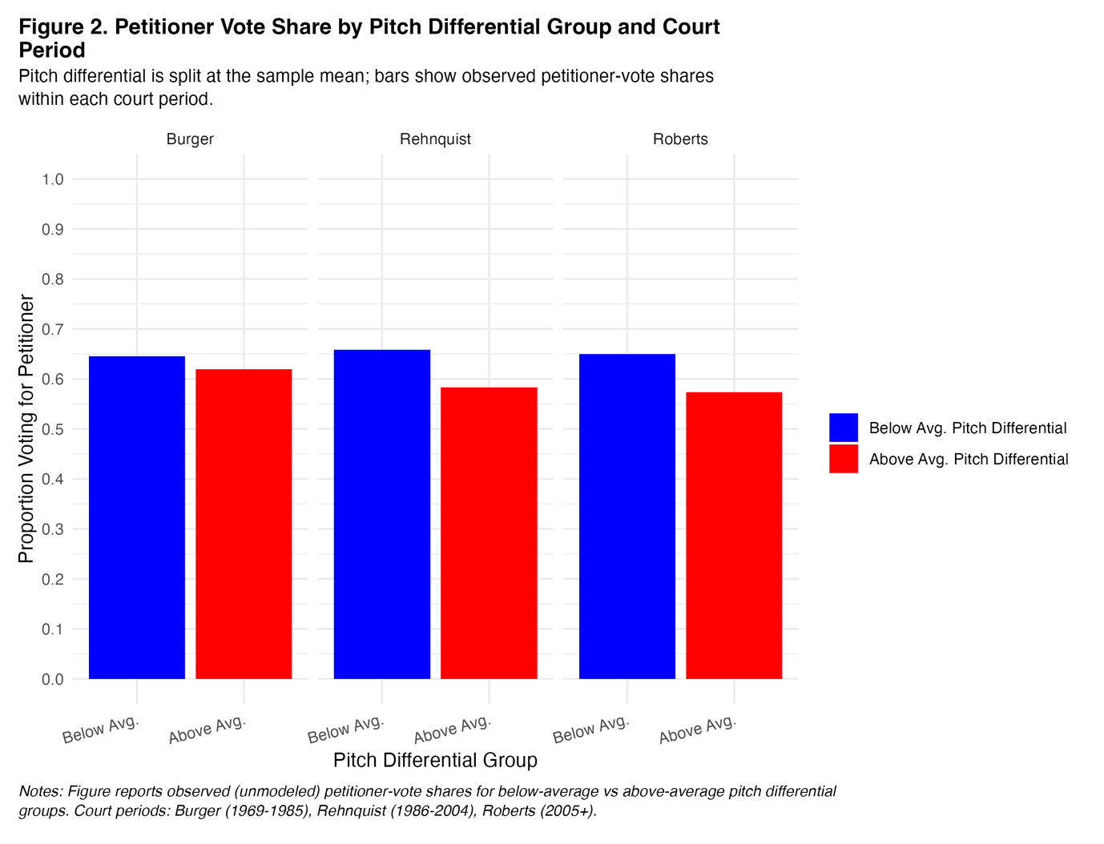
The bar chart seems to show that on average, when Justices use a pitch above their normal, they are less likely to vote in favor of the petitioner. While the effect is slight, less than 8%, it is a consistent pattern across all 3 Justices. The pattern is consistent across all 3 eras, and seems to be more pronounced over time, when comparing Justice Roberts to Justice Burger.

3.3 Regression Analyses
Q10: What do you learn from the first regression (predicting petitioner vote using pitch diff and pr petitioner pos)? How do these predictors relate to justices’ voting behavior?
A10:
[Include HW3 Table1.txt]
Q11: Why is it important to control for justice-specific effects when running the regression? How do the results change when these controls are added?
A11:
Q12: How does adding court term indicators change the model’s explanatory power? What does the adjusted R² tell us?
A12:
Q13: In the interaction model for pitch diff and court period, what patterns do you observe? Does the relationship between vocal pitch and voting behavior change across different Supreme Court periods?
A13:
[Include HW3 Fig4.png]
Q14: Compare the six progressively built regression models. What do you learn from the addition of each new predictor or interaction term? How does controlling for these factors refine our understanding of justices’ voting behavior?
A14:
[Include HW3 Table2.txt]
Q15: Based on the interaction plots, how does the Solicitor General’s amicus support influence justices’ voting behavior across different court periods? Similarly, how does the relationship between vocal pitch and sentiment differ based on the use of positive words?
A15: IGNORE. Not answerable.

3.3 Outlier Analysis and Threats to Validity
Q16: Based on the outlier diagnostics (Studentized residuals, leverage, Cook’s distance, and DFFITS), which observations stand out as extreme? Do any specific cases appear as outliers across multiple measures? [Include HW3 Fig6.png] A16:
Q17: How does removing outliers affect the regression results? Compare the coefficients and standard errors from the full dataset and the outlier-excluded model. Does removing outliers meaningfully change the conclusions, or are the results largely robust? [Include HW3 Table3.txt]
A17:
Q18 (BONUS): Suppose that the measured pitch differential is related to the true difference in pitch as follows:
pitch diffi = δ0 + δ1True pitch diffi + ui
where u_{i} is an error term with mean zero and is independent of the true pitch differential. How does this type of measurement error affect your estimates? What would happen if u_{i} had a nonzero mean? What might this indicate about the accuracy of the sounddetection algorithm?
A18:
Q19 (BONUS): Identify two additional sources of measurement error in this study. For each one:
- Name the type of measurement error (e.g., random error, systematic bias).
- Explain how it might arise in the data collection or processing.
- Describe its likely effect on the regression results and the interpretation of findings. A19:
Q20 (BONUS): Beyond measurement error, what other limitations could affect the validity of this analysis? Consider potential omitted variables, issues with the study design, or alternative explanations for the observed relationships. How would you refine the research to better address the initial question of whether voice pitch predicts justices’ votes?
A20:

