Ecology journal - Concepts & Synthesis

**Terrestrial animals on the move: motion process concepts, biases, and scales**

Alessandra Bertassoni, Cristiano H. G. M. Filho, Edgar Luiz de Lima, Felipe Pessoa da Silva, Filipe Guimarães Lima, Paulo De Marco Júnior

**APPENDIX S2**

**Appendix S2: Figure S1.** The motion process's annual scientific production (red) and the comparative annual growth of scientific production in the Ecology and Zoology field (black) for the same period.

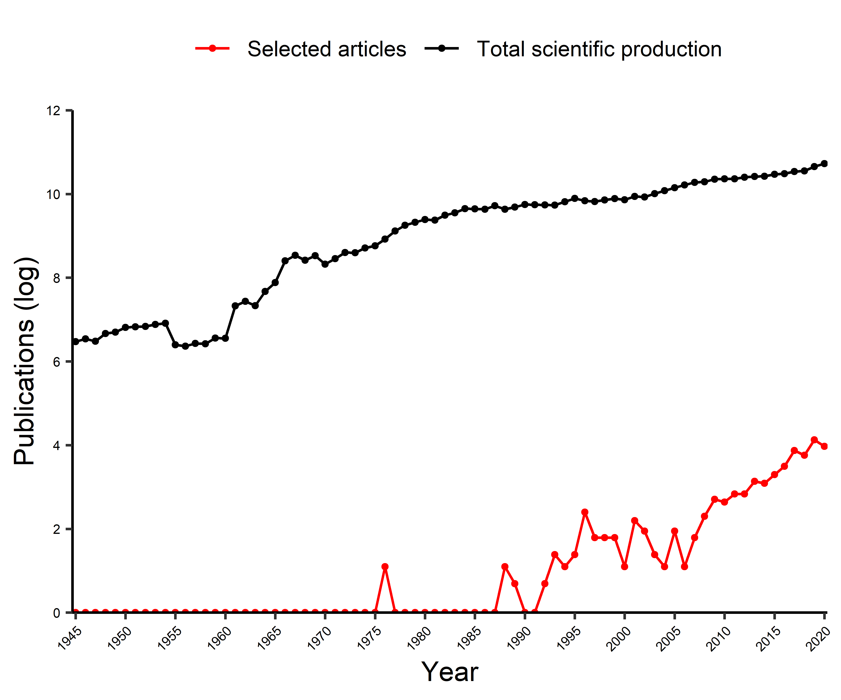

**Appendix S2: Figure S2.** Annual scientific production of motion process publications in concerns to the method applied (A), scale (B), and the term used (C).

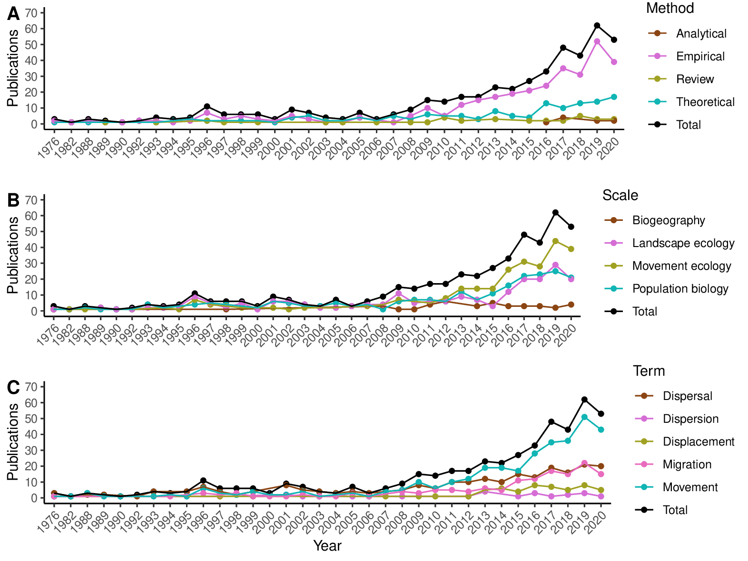

**Appendix S2: Figure S3.** Connectedness of the most recurrent words in regarding the motion processes of ‘movement’, ‘migration’ and ‘dispersal’ based on the Similitude Analysis. Thicker lines represent more connectivity between words, and larger words represent greater co-occurrence.

