How to use the Flight API

Saving data (this is optional but I created an API anyway)

Double click on AddFlight.html from the root folder where you extract the zip file



You shall have the form, fill in some values:

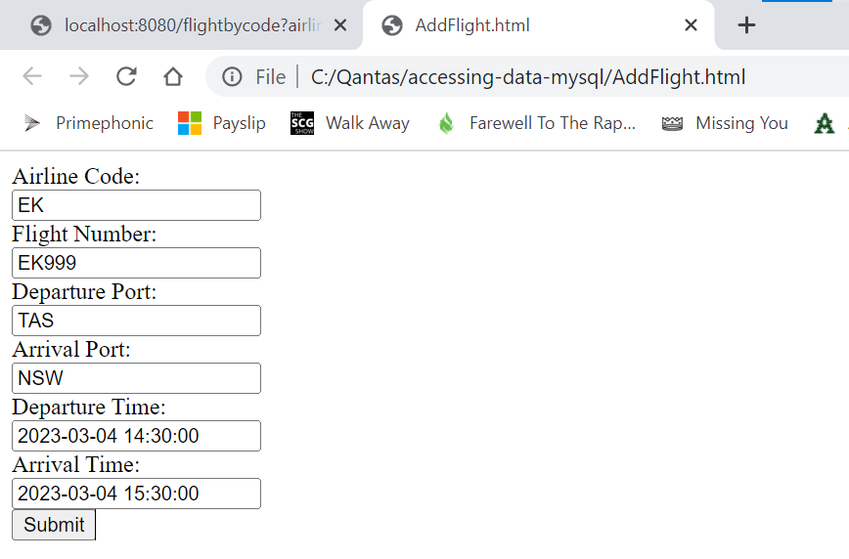

**Note: There are some limitations though, as per table definition the maximum string for the textfield:**

airline code: 2

flight number: 5

departure port: 3

arival port: 3

departuretime: YYYY-MM-dd HH:mm:ss

arrivaltime: YYYY-MM-dd HH:mm:ss

Click on Submit button, you can see the OK !! text on the browser

Check on the database, the value is saved

Query by Flight Code (read instructions from READ.ME)

Check all available flights

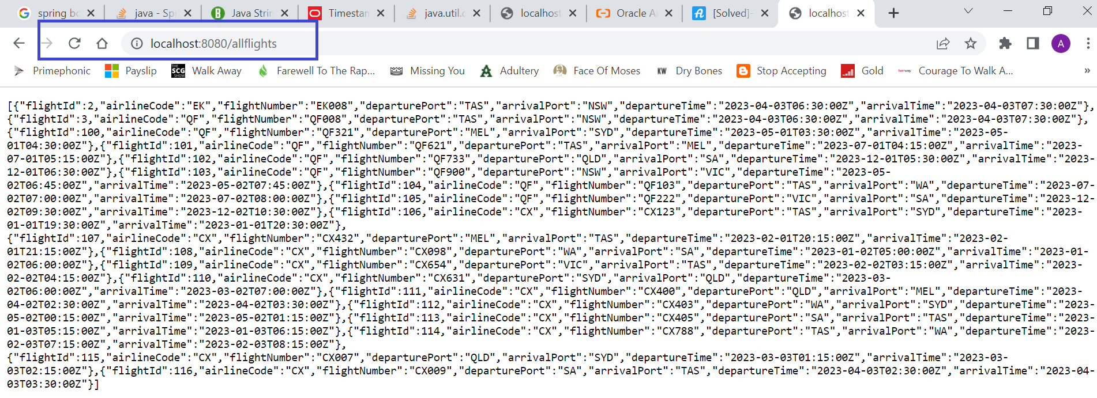

Check flight by flight code (CX)

Check flight by flight code (EK)

Check by flight code (QF)

