SELECT C.MATNR AS MATERIAL, C.MTART AS MAT_TYPE, D.MAKTG AS MAT_DESCRIPTION, C.MEINS AS UOM, E.VERPR AS AVERAGE_PRICE, E.PEINH AS PER, C.MTART AS MTYPE,  
F.WERKS AS PLANT, G.LAbST AS STOCK_ON_HAND, G.LGORT AS STORAGE_LOCATION  
FROM MARA C, MAKT D, MBEW E, MARC F, MARD G WHERE C.MATNR = D.MATNR AND C.MATNR = F.MATNR AND F.MATNR = E.MATNR AND F.MATNR = G.MATNR  
AND F.WERKS = E.BWKEY AND F.WERKS = G.WERKS  
AND F.WERKS in ('M001','M002','S001','WJ16')  
AND C.MTART in ('NOVA','CRIB');

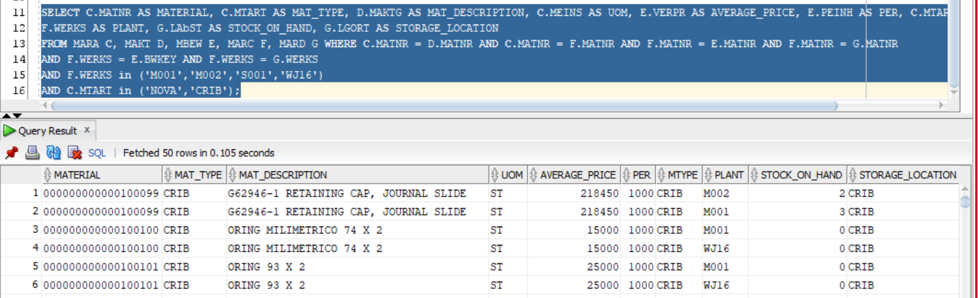

El Precio unitario es = Average_Price/Per

Conexion es al server 10.110.3.1 con Usuario SICAF password SICAF

