<http://localhost:8080/v1/customers>

GET – Consultar todos os clientes

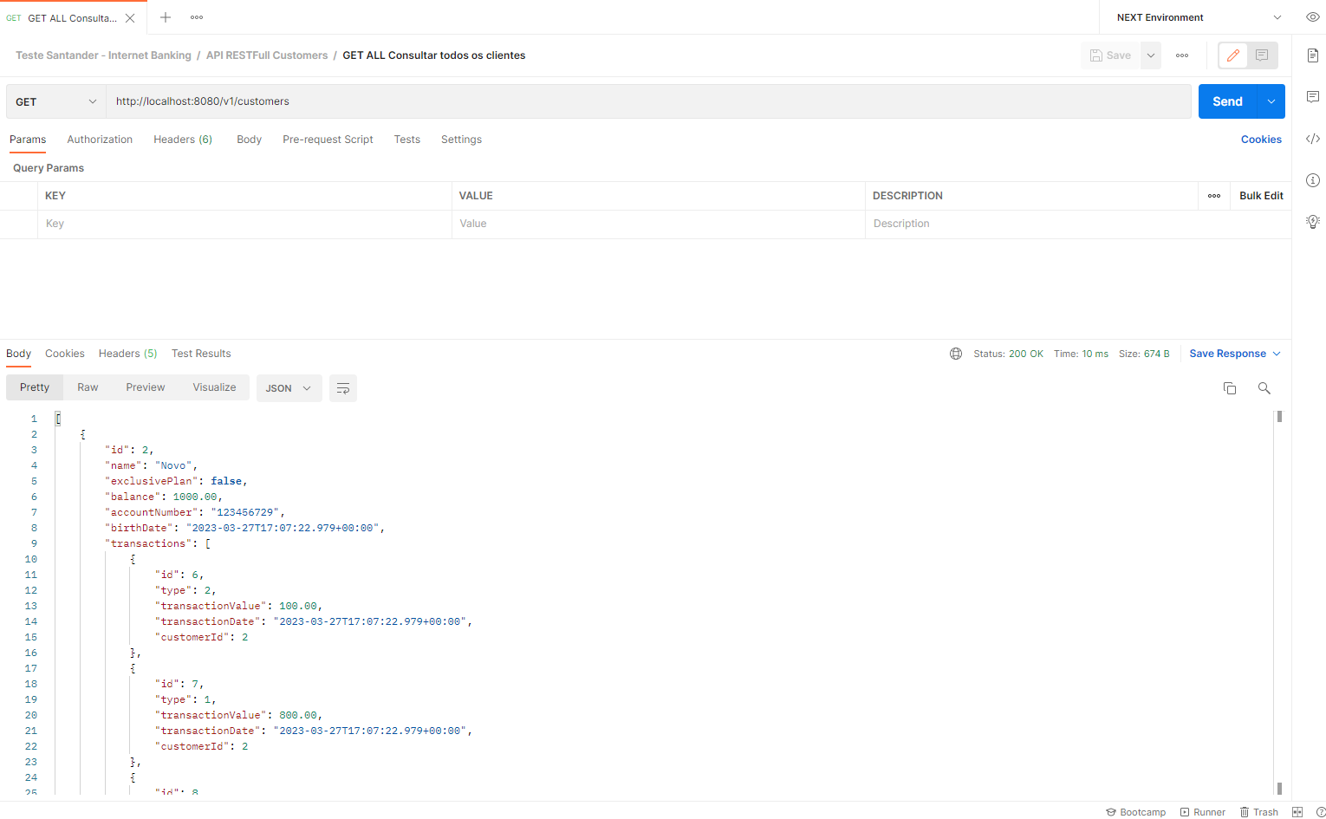

<http://localhost:8080/v1/customers/2>  
GET – Consultar Cliente por id

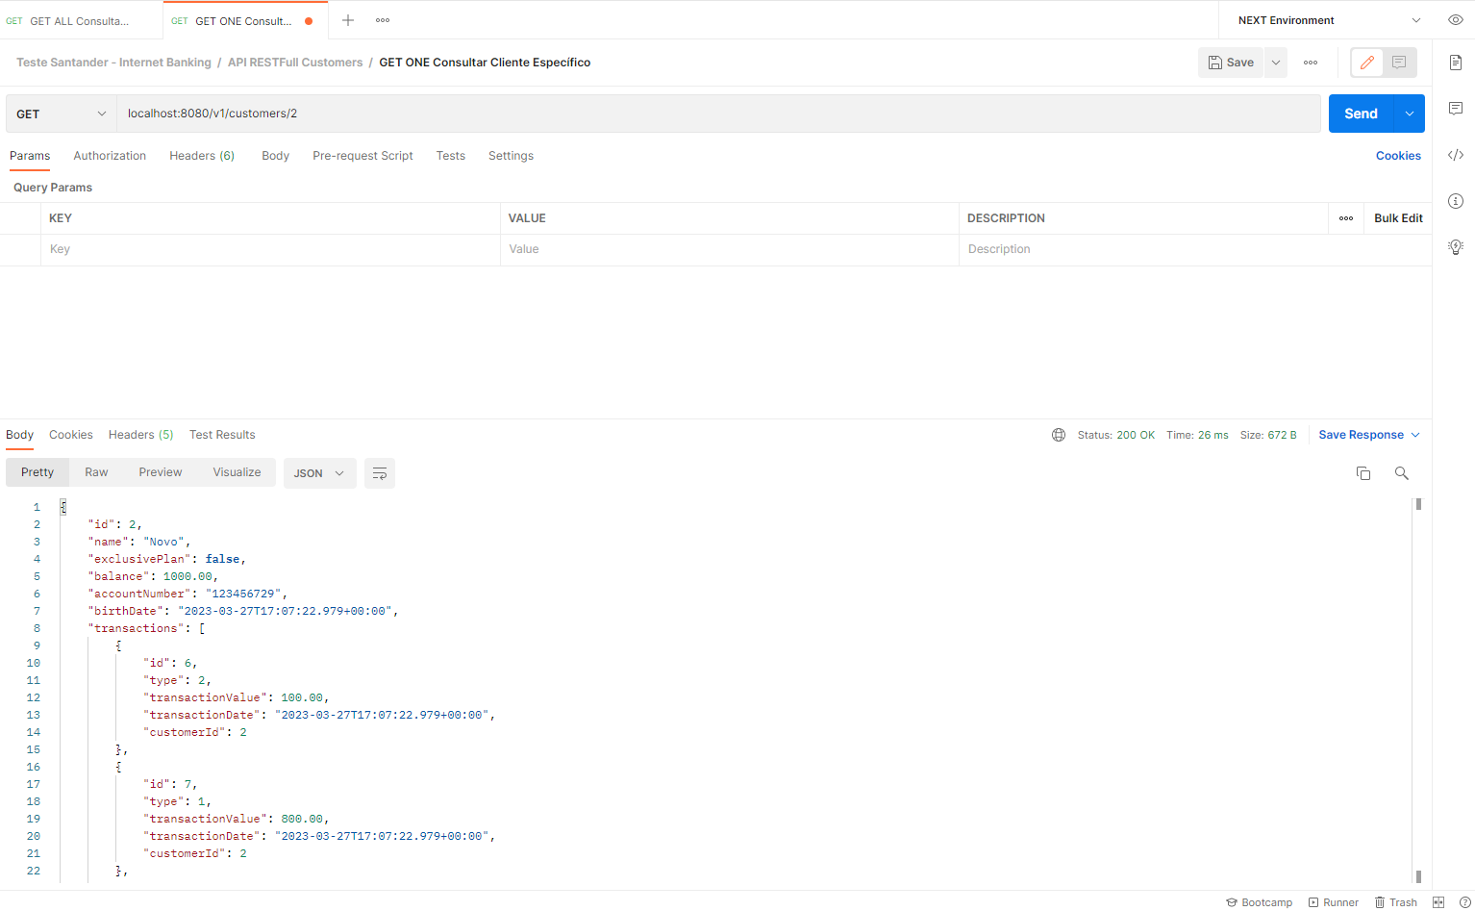  
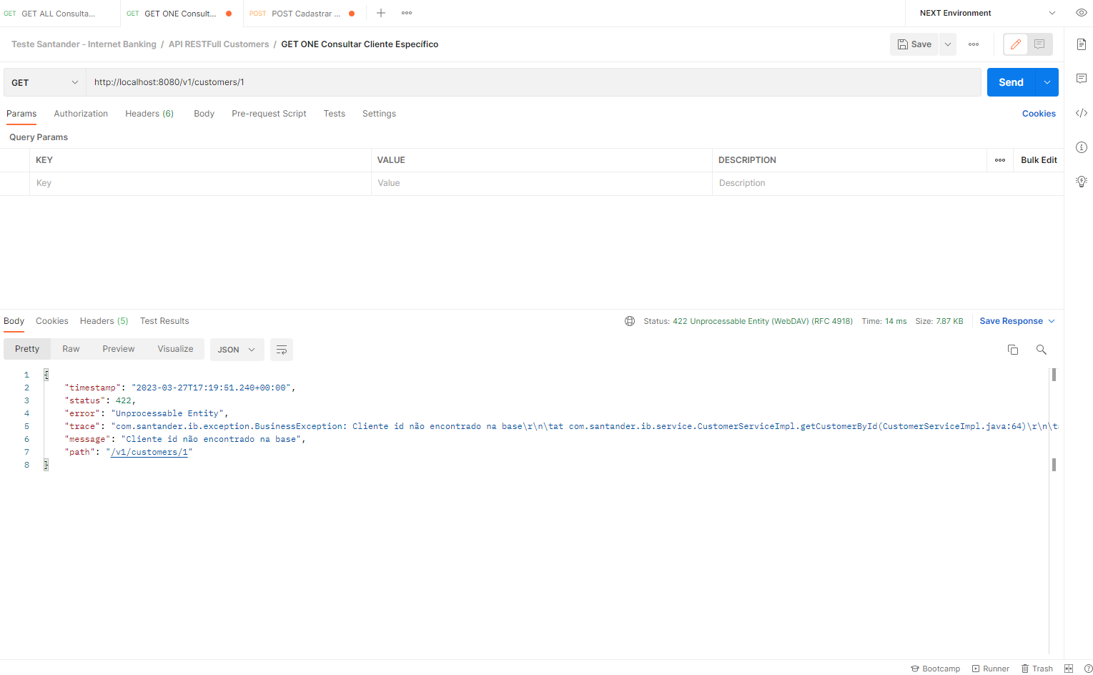  
  
<http://localhost:8080/v1/customers>  
POST – Cadastrar Cliente

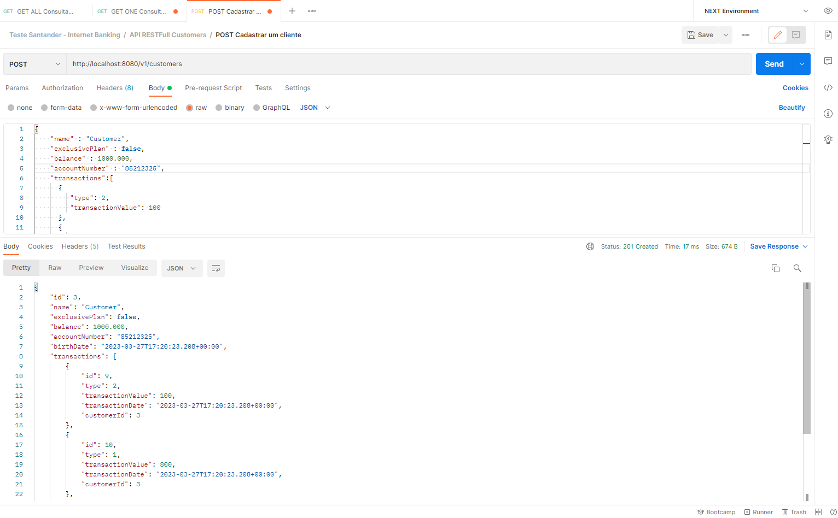  
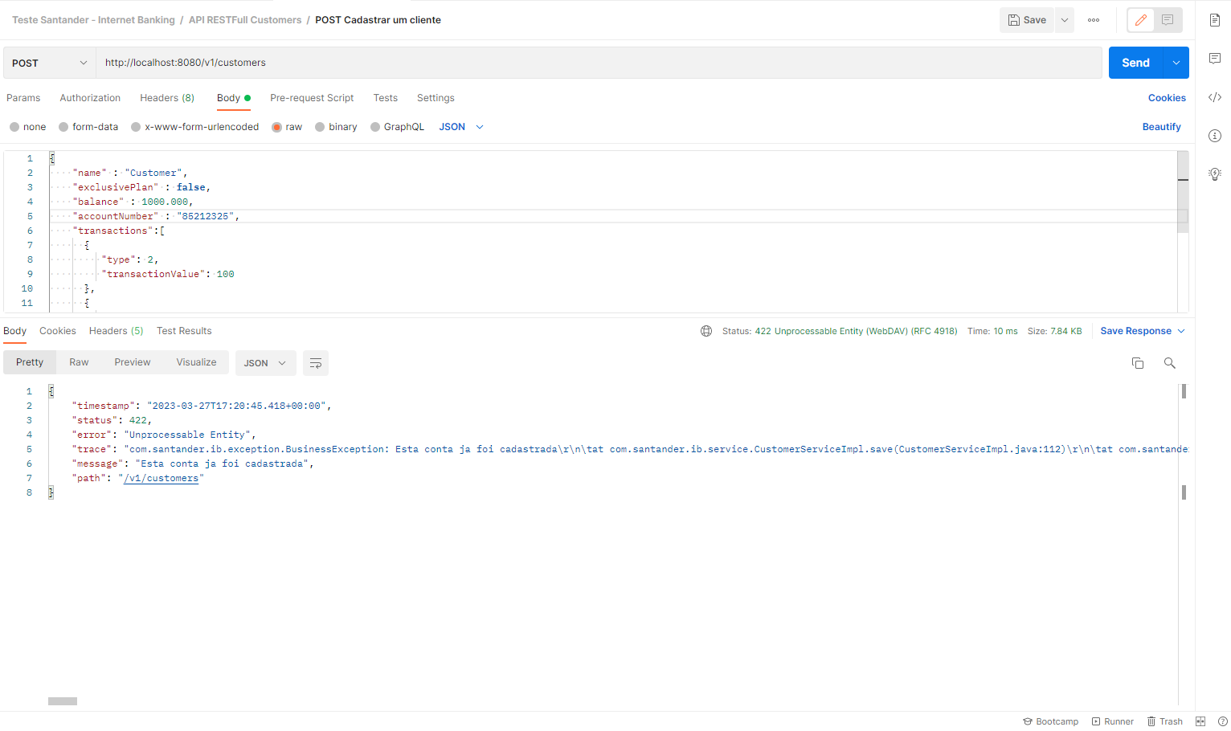

<http://localhost:8080/v1/customers/2>  
PUT – Update Cliente Específico

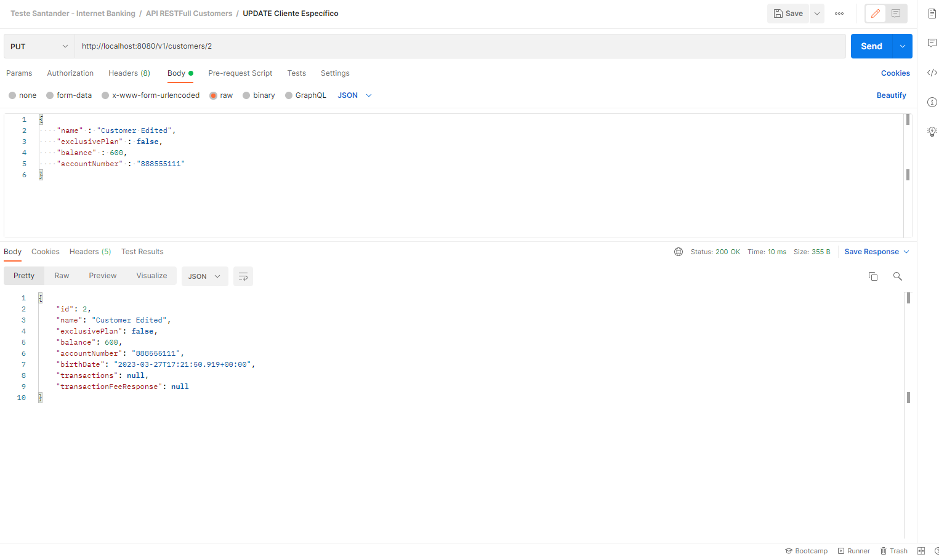

<http://localhost:8080/v1/customers/4>

DELETE

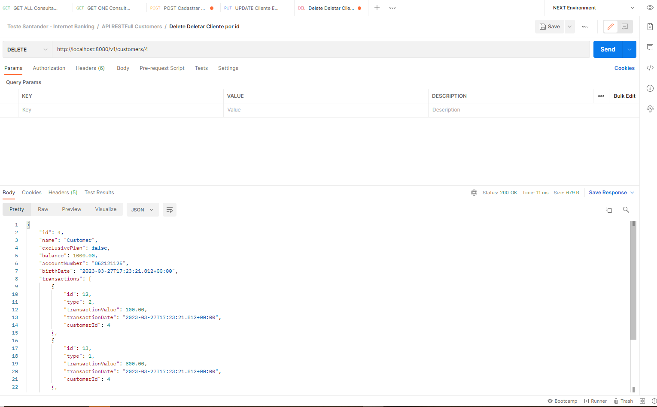

<http://localhost:8080/v1/customers/performBankTransaction/3>

PUT – Efetuar Saque ou Depósito para um cliente especifico

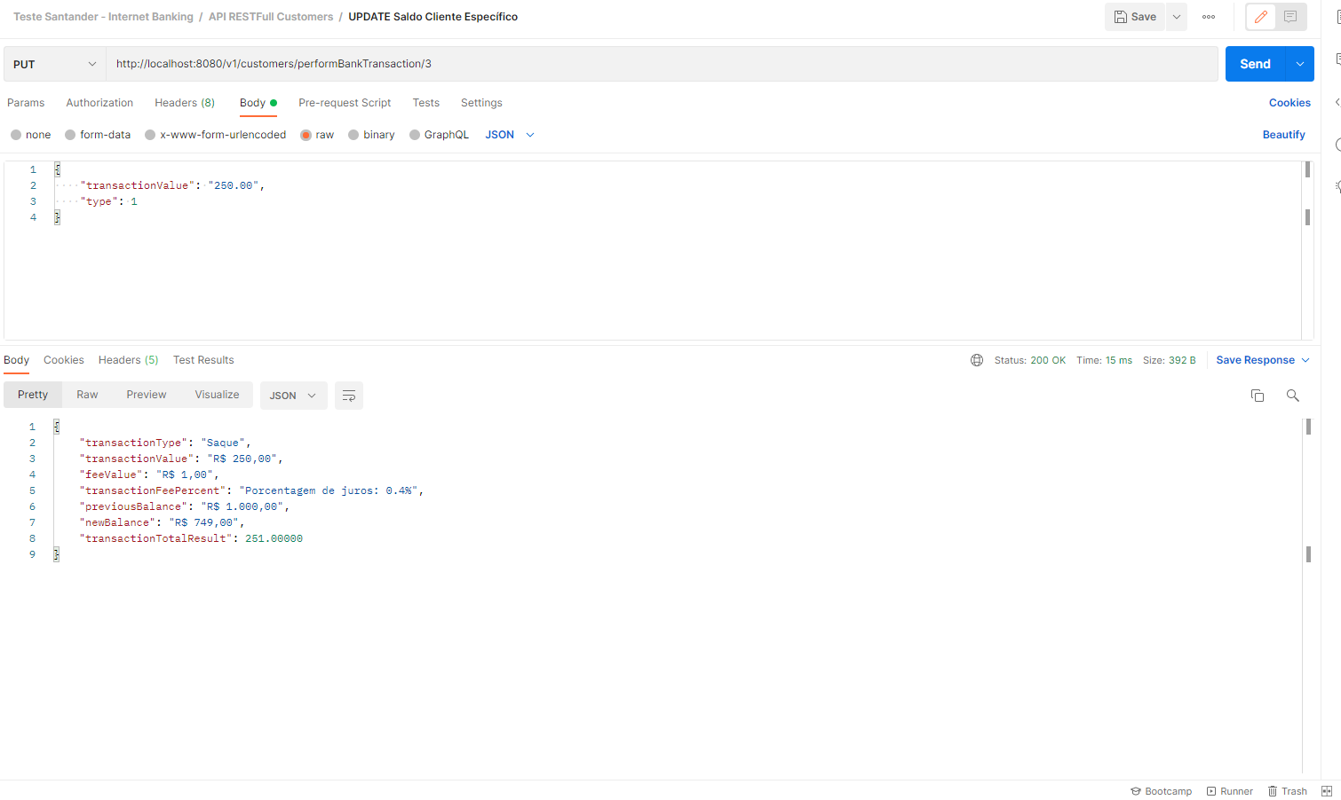

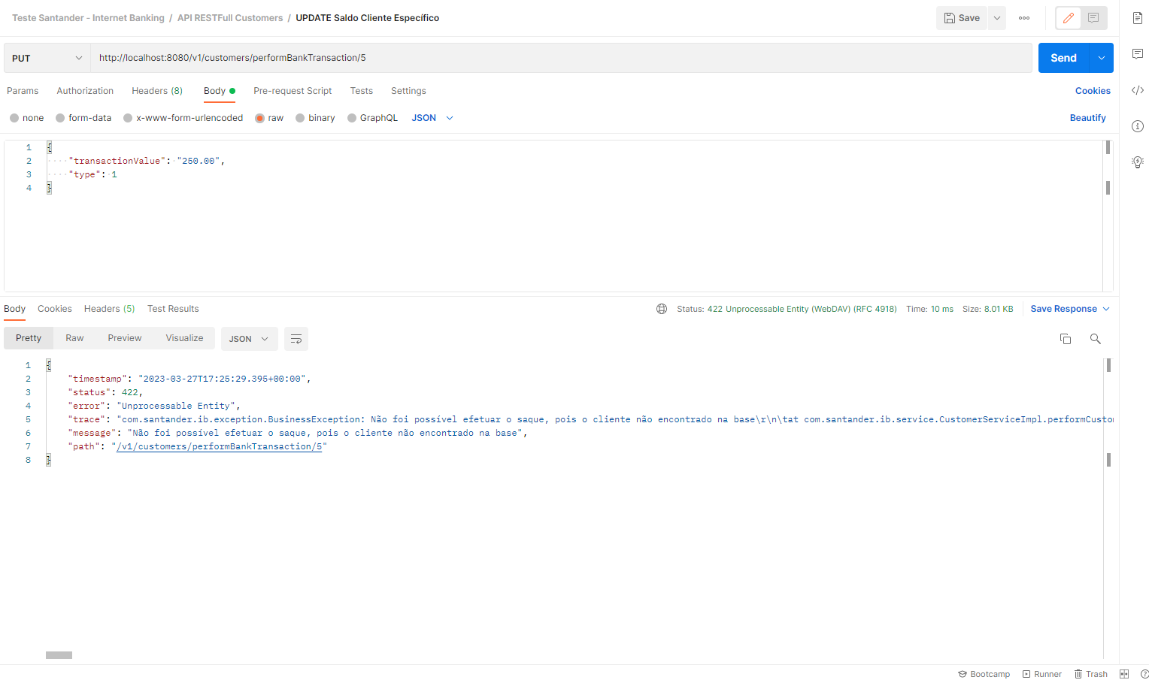

<http://localhost:8080/v1/customers/transactionsHistory/3>  
GET – Consultar Histórico Transações

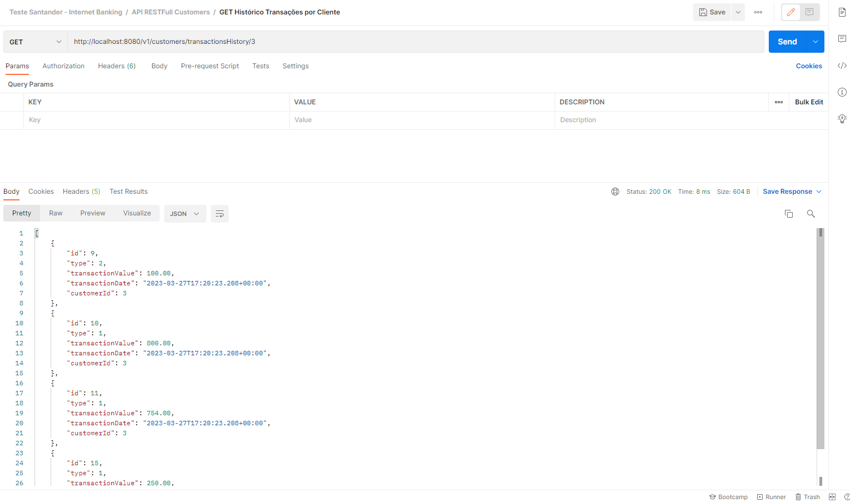

Swagger.

