Assessing the Performance of Machine Learning Models for Disease Prediction:

A Comparative Analysis of Breast Cancer and Diabetes Diagnosis

Edgard Cuadra and Barbara Perevalov
Lehigh University
ISE 364
9 December 2025

A Comparative Analysis of Breast Cancer and Diabetes Diagnosis

Abstract
This study evaluates the performance and generalizability of various Machine Learning (ML) models (Logistic Regression, SVM, KNN, Random Forest, Naive Bayes) for diagnosing breast cancer and Type 2 diabetes across three different datasets. Models achieved near-perfect performance on the highly separable breast cancer data (e.g., Logistic Regression: Accuracy ~0.98, Sensitivity ~0.996). However, performance significantly deteriorated on the complex Pima Indians Diabetes dataset. To improve results on the challenging diabetes data, an ensemble stacking approach combined with domain-specific feature engineering was implemented, which significantly boosted the sensitivity to 0.7407.The results confirm that model efficacy is highly dependent on data characteristics. Simple models excel with well-defined data, while complex or noisy data requires advanced techniques like ensemble methods and targeted feature engineering for clinically acceptable sensitivity. The findings underscore the need to select ML tools based on their specific application in a medical context, balancing sensitivity for early screening against accuracy for diagnosis confirmation.

Introduction
The early and accurate diagnosis of disease is paramount for effective treatment and patient survival. Machine Learning (ML) has emerged as a powerful tool in the medical field, offering the potential to assist clinicians in making diagnosis decisions. There is a wide distribution of machine learning methods used to aid in diagnosis, depending on the condition being evaluated [1]. Some of the most commonly used models include Support Vector Machine (SVM), Random Forest (RF), and Convolutional Neural Network (CNN), with CNN being a prime choice for unstructured data, while traditional ML models were found to outperform for structured data. In evaluating literature on specific diseases, it was observed that previous research has demonstrated the effectiveness of various ML algorithms, particularly GLM and SVM, in classifying breast cancer tumors as benign or malignant [2]. This paper claims to validate these findings and explore the generalizability of these models to another prevalent disease: type 2 diabetes. Through the adoption of external research, we have implemented additional machine learning models and techniques to evaluate the performance of diagnosis prediction for three different datasets. The initial hypothesis determines that there are expectations of machine learning models to perform drastically differently through different illnesses and different types of data; following this, we explore how different models and techniques make better predictions on different situations.

Methodology

Breast Cancer Diagnosis
We first tested the Wisconsin Diagnosis Data, first considering the overlap of the data with the class distinctions. The focus of this dataset is to classify tumors as benign or malignant. It consists of 569 samples of a fine needle aspirate (FNA) of breast masses with several numeric features describing them. We used this dataset to train and evaluate several machine learning models: Logistic Regression (GLM), SVM (Linear) and RBF kernels with hyperparameter tuning. The primary evaluation metric was sensitivity (recall for the malignant class), as minimizing false negatives is crucial in cancer diagnosis to ensure no positive cases are missed.

Type 2 Diabetes Prediction
To assess the transferability of these models, we applied the same set of algorithms to the Pima Indians Diabetes dataset. This dataset is slightly larger than the Wisconsin Breast Cancer data, consisting of 768 samples. The target for this dataset is to predict whether an individual has diabetes or not. The defining features are various diagnostic measurements, including glucose, BMI, age, and insulin levels. This dataset presents a different set of challenges, including a higher degree of feature overlap between the classes, signaling a loss in predictive power per feature for the class predictions. Further research by Dritsas and Trigka [3] shows how an expansion of model comparison scope into classification models could perhaps show better performance for the prediction exercise versus GLM and SVM. This approach delineates the use of Synthetic Minority Oversampling Technique (SMOTE) class balancing to reduce bias in class weights and the implementation of various classification models which include KNN, Random Forest, and Naive Bayes. We then proceeded to create pipelines for these models utilizing the rebalancing techniques in order to evaluate the performance of the models through 10-fold CV. This allows us to consider the usual performance of the models through various trials instead of just 1.
After identifying a loss in model performance for this data, we considered additional techniques in order to compensate for the loss in feature predictive power. An approach by Daza, Sanchez, et. al [4] shows how ensemble stacking can aid in the diagnosis prediction process. To implement this approach, we first defined alternative Naive Bayes models: Gaussian, Multinomial, and Bernoulli. In his research, Konenko (2001), identified that doctors had a positive view of Naive Bayes and viewed it to be similar to the way they diagnose [5]. In the Naive Bayes models, use feature selection to use only the most significant feature by ANOVA. We then expanded on the previous set of model implementations (GLM, SVM, RF) by standardizing the implementations of feature engineering, SMOTE rebalancing, preprocessing and pipeline creation, and stacking classification for model fitting. For choosing the models in the ensemble, various combinations were tested. It was observed that a combination of SVM, MLP, and tree-based algorithms may work well [4], so in the final result, SVM, RF, MLP, and DT were implemented. Generic feature engineering was used in this dataset, including sample interactions, ratios, and polynomial features. This method was run as an initial test. In general, such a model may prove to be particularly useful when the data is unstructured or unknown. We then developed another similar stacked ensemble model, but rather than having generic feature engineering, we implemented domain-specific feature engineering. One of the features added was the insulin resistance measure, HOMA-IR. Insulin resistance can often be a precursor to Type 2 diabetes, making it a notable measure [6]. The critical glucose level for a 2-hour plasma glucose test was also added [7]. To account for potential interactions and non-linearities, while keeping the number of added engineered features low, two of each were added. For interactions, the interaction of BMI and glucose and that of age and BMI was added. With BMI potentially being linked to insulin resistance and thus glucose levels, this interaction was added to distinguish patients with similar glucose levels yet different BMI, as that can significantly change their risk of diabetes [8]. With the understanding that BMI is significantly impacted by age due to hormonal changes and changes in muscle mass, the interaction of BMI and age was included as well [9]. For nonlinearities, BMI and glucose were chosen as the two most significant features, based on the R- squared results.

Early Diabetes Classification
We explored an additional diabetes dataset, the Early Diabetes Classification data. This dataset consisted of 520 samples, with the key features of various genetic markers, early indicators, and risk factors. Following the research by Dritsas and Trigka, we reintroduced the same models (GLM, SVM, SVM RBF, KNN, Random Forest, and Naive Bayes) to this dataset to explore the performance on discrete data that belongs to the same medical disease. By importing the data from Kaggle, we explored different variables in a yes/no metric. Like the previous datasets, we wanted to evaluate the predictive power of the features, instead of plotting the feature distributions and their classification, we plotted AUC, which would be a better metric for the discrete data we are evaluating in this case. Like the previous exercise with the PIMA dataset, we implemented 6 different models and used 10-fold CV to evaluate the model performance.
Data Preprocessing and Feature Engineering
For both datasets, we performed standard preprocessing steps, including handling missing values and scaling numerical features. For the diabetes dataset, we also employed SMOTE (Synthetic Minority Over-sampling Technique) to address the class imbalance and prevent model bias towards the majority class. Additionally, we explored advanced feature engineering techniques, including feature scaling and selection, to enhance model performance.

Results
Breast Cancer Diagnosis
Our analysis of the breast cancer data yielded highly promising results. The models achieved high accuracy and, more importantly, exceptional sensitivity. Logistic regression, in particular, stood out with the highest overall accuracy (~0.98) and only one false negative, demonstrating an optimal balance between sensitivity and specificity. The SVM models also performed well, with the linear kernel achieving higher accuracy and the RBF kernel showing high sensitivity but a slightly higher false positive rate.
Diabetes Prediction
The results for the diabetes datasets were not as consistent. While the models achieved reasonable accuracy, the sensitivity (recall for the positive diabetes class) was significantly lower than in the previous exercise. The initial baseline models struggled to identify a large proportion of positive cases, with false negative rates hovering around 30%. Furthermore, we implemented additional models that could perhaps have better performance given the nature of the data. Following the research by Dritsas and Trigka [3], we implemented KNN, Random Forest, Naive Bayes, and the previously implemented models to evaluate what works better for continuous data types.

Discussion
We aimed to explore the performance of machine learning algorithms on various datasets. In the initial Wisconsin Breast Cancer dataset, we implemented a Logistic Regression model, SVM linear model, and SVM RBF model, all of which had very good performance, yielding sensitivity of approximately 0.99 or higher. When we explored the performance of these models on the Pima Indians Diabetes data, the results were very different, with the models performing much worse. In large part, this is likely due to the nature of the two datasets. The breast cancer dataset is ideal for classification. The data includes measurements of cell characteristics. With cancerous cells being vastly different from noncancerous cells, this makes the data more reliable for analysis. Pima data is a different story. It contains multiple features, all of which may contribute to increasing the risk of diabetes, making it difficult to define a clear separation as in the breast cancer data. There are likely feature interactions and non-linearities that make prediction even more complex. Apart from that, it has numerous zero values, which are clearly inaccurate as none of the measures can be zero. As a result, this fundamental flaw in the data makes it complicated to predict. After expanding to observe the performance of more models through a 10-fold CV, we observed that SVM linear had the highest accuracy and AUC, but KNN had the highest sensitivity (the primary measure we were looking for). This was a counterintuitive result, as the expectation was that Random Forest would perform the best, given the structured nature of the data and a previous finding that RF performs well with diabetes diagnosis [1]. However, this may be due to the smaller size of the Pima Diabetes data. It is also possible that RF is overfitting on some of the noisier data. Following the 10-fold CV, we implemented a new stacked ensemble model to explore the idea of combining multiple algorithms and seeing if they outperform the individual models. With the initial stack ensemble model with generic feature engineering, we observed higher precision and higher accuracy but a lower sensitivity than seen in some of the other models. However, due to the medical nature of this data, we aimed to address some of the anticipated complexities of the data through feature engineering. The data-specific feature engineering made a significant difference in the results. There was a significant increase across all measures, but the most important change to note is sensitivity. As mentioned, in medical data, one of the primary focuses is the minimization of false negatives. Ensuring that patients are properly diagnosed, so that they can immediately start receiving the proper care that they require is critical. The stacked ensemble with feature engineering resulted in the highest sensitivity of all the models of 0.7407. Although this remains low for clinical standards, it is a step in the right direction and an indication of the potential benefits of stacked ensemble approach and data-specific feature engineering for more complex data. In the Early Classification Diabetes data, the standard performance of the SVM RBF, RF, SVM Linear, Logistic Regression, Naive Bayes, and KNN lineup was much better. This dataset does not contain flaws like Pima data, and it also has more features, which aids in prediction. In this data, SVM RBF had the highest sensitivity, but RF had the highest accuracy and precision. This would mean that SVM RBF may be better at catching early cases, while RF is a bit more conservative and fairly accurate but tends to avoid “false alarms,” resulting in lower sensitivity. RF relies on the input of multiple trees, which helps to improve accuracy, but the smaller size of this dataset may not make it ideal for RF. SVM, on the other hand, tends to work well with smaller datasets and can account for nonlinearities, which are likely to occur in diabetes data.

Conclusion
With exploring these different datasets, it was concluded that the type of model is highly dependent upon multiple factors. Simple models should not be underestimated. For breast cancer data, a dataset with highly specified features at a molecular level, a simple model is good enough to achieve the highest classification. A simple model is also easiest to interpret and thus easier to generalize. When there are uncertainties in the data, including flaws and potential interactions, it may be worth exploring a variety of models. We found that feature engineering and a stacked ensemble approach can improve the results of independent models. We observed a precision-recall tradeoff in the early diabetes dataset, but this provided significant insight. The goal of implementing machine learning in medical diagnosis is not to replace doctors but rather function as a supplemental tool, aiding in screening, early intervention, and confirmation of a diagnosis. In this case, an RF model may help in confirming a diagnosis, while SVM may be beneficial in early detection as a screening tool.

Appendix
Figure 1:
Breast Cancer Data Model Results Table

Model | Accuracy | AUC | Sensitivity | Precision
Logistic Regression | 0.977244 | 0.9936 | 0.996 | 0.97034
SVM Linear | 0.969744 | 0.992267 | 0.992 | 0.962494
SVM RBF (Tuned) | 0.972244 | 0.994381 | 0.988 | 0.97034

Figure 2:
Pima Indian Data Model Results Table

Model | Accuracy | AUC | Sensitivity | Precision
KNN | 0.728337 | 0.770192 | 0.727485 | 0.593188
Logistic Regression | 0.746855 | 0.825673 | 0.712281 | 0.62317
SVM Linear | 0.75615 | 0.822882 | 0.707018 | 0.64064
Random Forest | 0.748847 | 0.809486 | 0.669591 | 0.63373
Naive Bayes | 0.745108 | 0.81457 | 0.66462 | 0.636081
SVM RBF (Tuned) | 0.67624 | 0.749657 | 0.332456 | 0.562933
Stacked Ensemble with Generic Feature Engineering | 0.7576 | 0.8415 | 0.6545 | 0.6543
Stacked Ensemble with Domain Feature Engineering | 0.7922 | 0.8515 | 0.7407 | 0.6897

Figure 3:
Type 2 Diabetes Results Table

Model | Accuracy | AUC | Sensitivity | Precision
SVM RBF (Tuned) | 0.91479 | 0.990006 | 0.986561 | 0.891105
Random Forest | 0.967042 | 0.999054 | 0.959684 | 0.987652
SVM Linear | 0.939565 | 0.967758 | 0.94664 | 0.955929
Logistic Regression | 0.92042 | 0.971189 | 0.91087 | 0.958533
Naive Bayes | 0.873574 | 0.952167 | 0.892688 | 0.906522
KNN | 0.903604 | 0.98587 | 0.869763 | 0.973085

Figure 4:
Breast Cancer Feature Distribution
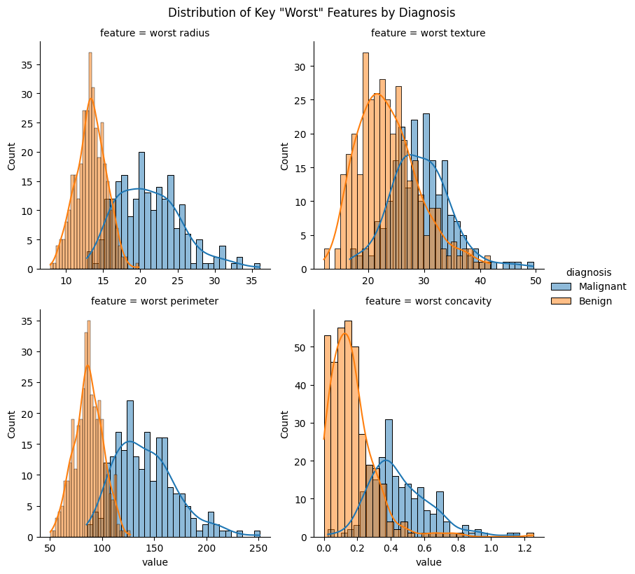
Figure 5:
PIMA Diabetes Feature Distribution
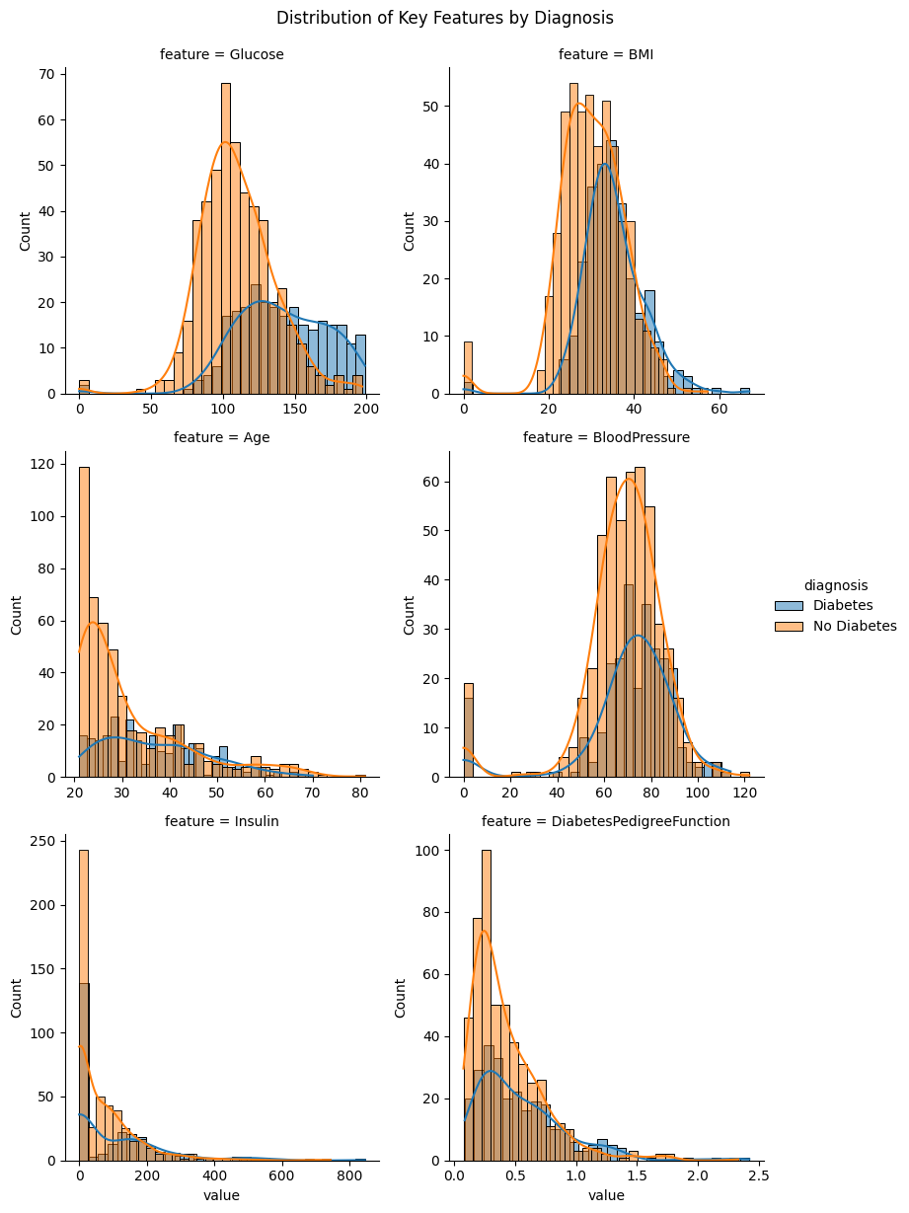

Project Contributions
Edgard Cuadra - Code Development and Model Implementation, Research
Barbara Perevalov - Research expansions and Literature Comparison, Model Implementation

References
[1] Kaustubh, A., Bhavsar, Abugabah, A., Singla, J., Alzubi, A., Kashif Bashir, A., Bhavsar, K., Arun, Ali, Bashir, A., & Kashif. (n.d.). A comprehensive review on medical diagnosis using machine A comprehensive review on medical diagnosis using machine learning learning Recommended Citation Recommended Citation “A comprehensive review on medical diagnosis using machine learning” (. https://zuscholars.zu.ac.ae/cgi/viewcontent.cgi?article=5101&context=works
[2] Verplancke, T., Van Looy, S., Benoit, D., Vansteelandt, S., Depuydt, P., De Turck, F., & Decruyenaere, J. (2008). Support vector machine versus logistic regression modeling for prediction of hospital mortality in critically ill patients with haematological malignancies. BMC Medical Informatics and Decision Making, 8(1). https://doi.org/10.1186/1472-6947-8-56
[3] Dritsas, E., & Trigka, M. (2022). Data-Driven Machine-Learning Methods for Diabetes Risk Prediction. Sensors, 22(14), 5304. https://doi.org/10.3390/s22145304
[4] Daza, A., Fidel, C., Apaza-Perez, G., Pinto, J., & Karoline Zavaleta Ramos. (2024). Stacking ensemble approach to diagnosing the disease of diabetes. Informatics in Medicine Unlocked, 44, 101427–101427. https://doi.org/10.1016/j.imu.2023.101427
[5] ‌Kononenko, I. (2001). Machine learning for medical diagnosis: history, state of the art and perspective. Artificial Intelligence in Medicine, 23(1), 89–109. https://doi.org/10.1016/s0933-3657(01)00077-x
‌[6] HOMA-IR Score: What It Is and Why It Matters. (2025). Docus. https://docus.ai/glossary/biomarkers/homa-ir
‌[7] UpToDate. (n.d.). Www.uptodate.com. https://www.uptodate.com/contents/image?imageKey=ENDO/61853
[8] ‌Mahmuda Islam Bonna, Akter, R., Samiha Kaisar, Refat Zahan, Parvin, R., & Mostafa, S. (2024). The BMI-Glucose Connection: Investigating the Association between Body Weight and Blood Sugar Levels. IAHS Medical Journal, 6(1), 47–49. https://doi.org/10.3329/iahsmj.v6i1.75660
[9] BMI Changes with Age: Understanding the Impact of Muscle Loss and Aging on Body Mass Index - Good BMI. (2025, January 20). Good BMI. https://goodbmi.com/bmi-changes-with-age/

Refer to figure 4 in the appendix.
Refer to figure 5 in the appendix.
Refer to Breast Cancer Results Data table (figure 1) in the appendix.
Refer to figure 2 and figure 3 for PIMA and Type 2 Diabetes Model Table in the appendix.

