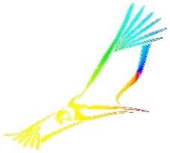

[T U P Ã](https://es.wikipedia.org/wiki/Tup%C3%A3)

*Oculis ad Caelum Spectanti*

# *Eyes Looking Towards the Sky*