I7 Image of Home page
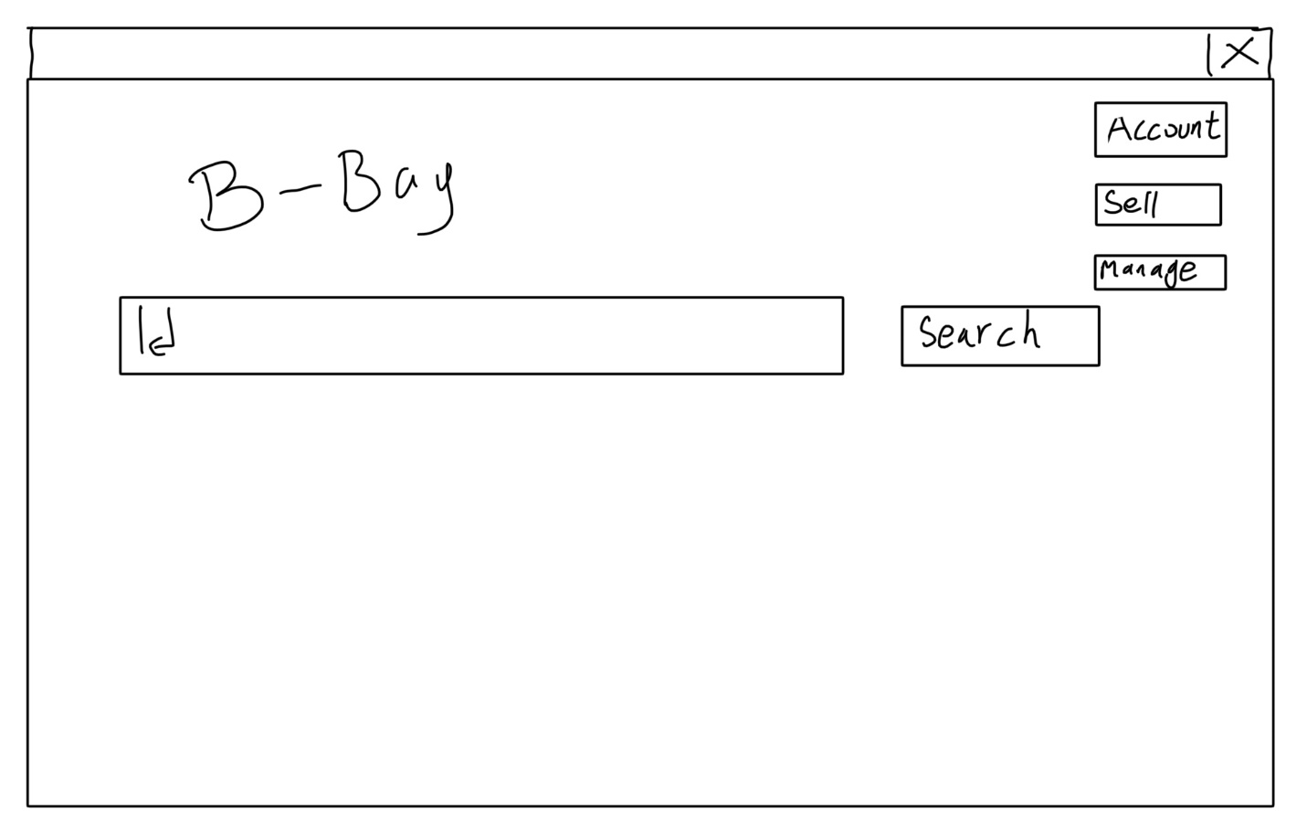
No. | Name&Describe | Input | Input Type | Output
FR2 | Offer sell options | User click "sell" button in I7 |  | Navigate to sell request page as I8. Including two buttons: "Consignment" and "Auction"
FR2.1 | offer "Submit consignment request" page | user click "Consignment" button in I8 |  | Navigate to consignment request page as I9. Including filling boxs of Name, description and price and a "submit" button
FR2.1.1 | Submit consignment request | user click "submit" button, 3 strings | strings | If string not empty, call FR2.1.1.1, or back to FR2.1
FR2.1.1.1 | Save reqest | Strings of selling detail | Strings | save informations to database
FR2.2 | offer "Submit auction request" page | user click "Auction" button in I8 |  | Navigate to auction request page as I10. Including filling boxs of Name, description, base price, up limit, deadline and a "submit" button
FR2.2.1 | Submit auction request | user click "submit" button, 5 strings | strings | If string not empty, call FR2.1.1.1, or back to FR2.2
I8 image of Sell options page
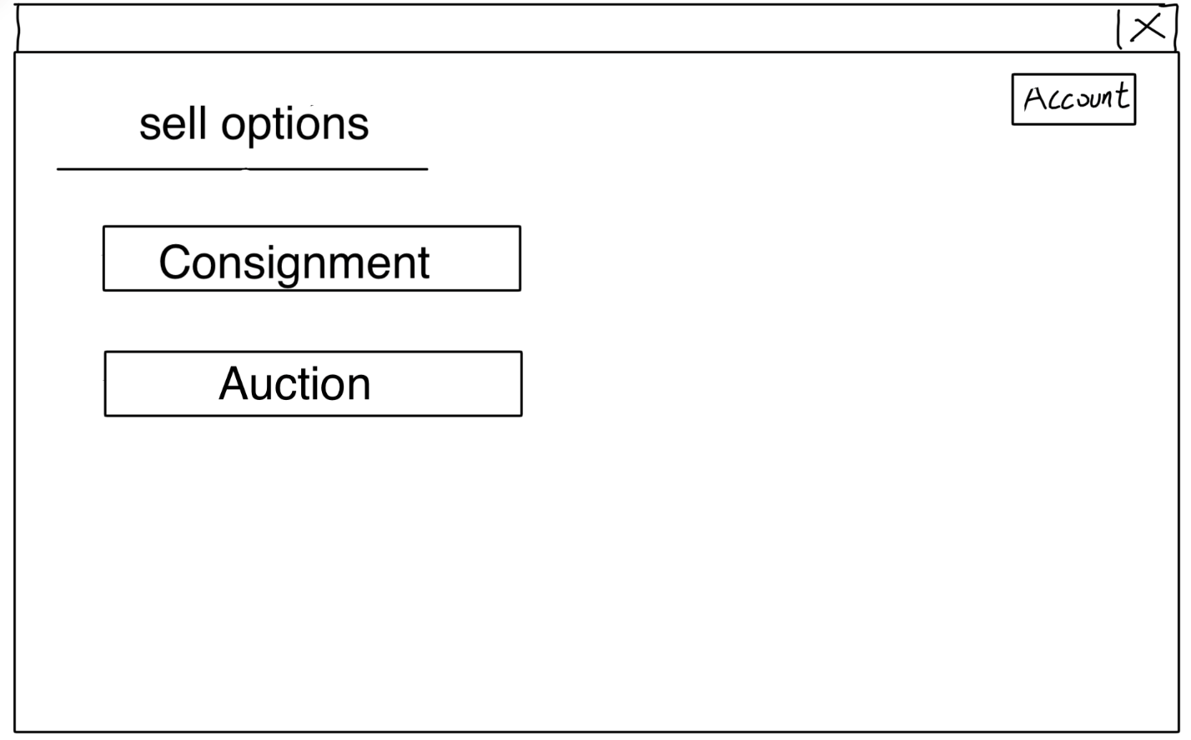
I9 Image of consignment request filling
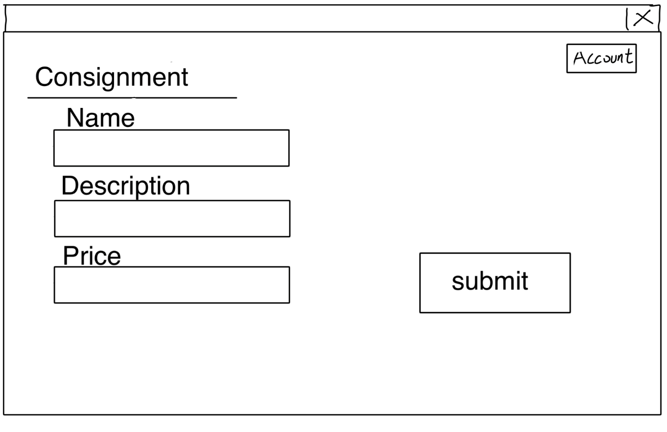
I10 Image of Auction request filling
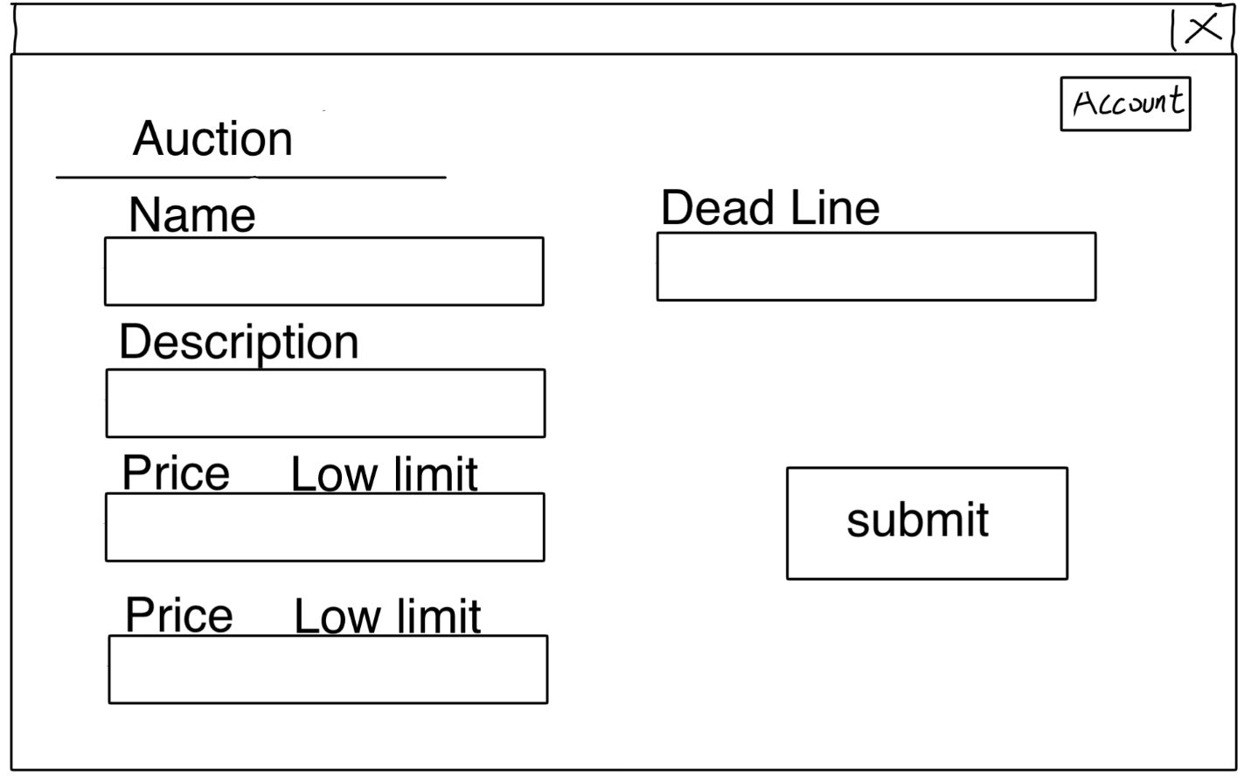
Data Flow Char for FR2 Offer sell options
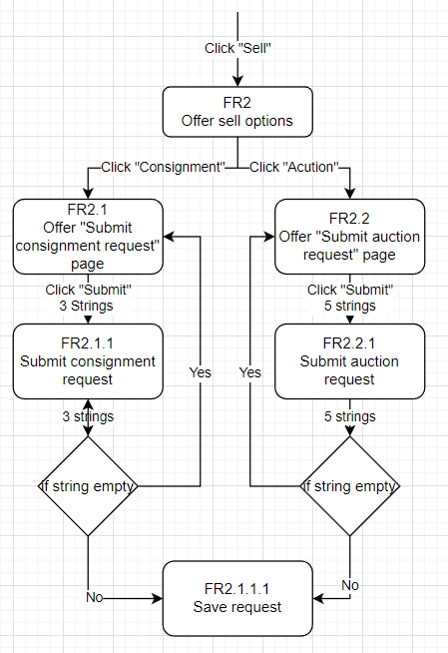
No. | Name&Describe | Input | Input Type | Output
FR3 | Offer Administrator interface | User click "manage" button in I7 |  | Navigate to Administrator page as I11. Including three bottons: "Selling requests", "Returns" and "reports"
FR3.1 | Offer selling request list | User click "selling requests" button in I11 |  | Navigate to requests list page as I11.1, showing requests in database, each request is in a editable box and have "approve" button beside, having a save button below list
FR3.1.1 | Edit item info | User click "save" in I11.1, all strings in list of I11.1 are inputs | strings | Save all strings, overwrite the orignal strings
FR3.1.2 | Approve unproved reqeust | User click any "approve" button in I11.1 |  | call FR3.1.2.1 with clicked item id, and then reflash the list I11.1
FR3.1.2.1 | Change merchandise state to "selling" | item id | integer | overwirete orignal string, if request type is "auction" call FR3.1.2.1.1
FR3.1.2.1.1 | Set timer for auction | item id | integer | Set timer based on data, call FR3.1.2.1.1.1 when times up
FR3.1.2.1.1.1 | Get paid and notice seller | item id | integer | if buyer exist, call GetPaid(), then write notice with item seller id to database
FR3.2 | Offer error reports list | User click "reports" in I11 |  | navigate to Error report list, display errors as I11.2
FR3.3 | View returning request List | User click "Returns" in I11 |  | Navigate to return request page as I11.3, include each report in each box and "confirm" button and a "save" button
FR3.3.1 | Edit return requests | User click "save" in I11.3, all string in list | strings | Save all strings, overwrite the orignal strings
FR3.3.2 | Call payback() | User clike any"confirm" button in I11.3 |  | Call FR3.3.2.1 with item id
FR3.3.2.1 | Save information of return | Item id | integer | Save information to database, call FR3.3.2.1.1
FR3.3.2.1.1 | Update the reputation | item id | integer | save new calculated reputation with seller id
I11 Image of manage interface manu
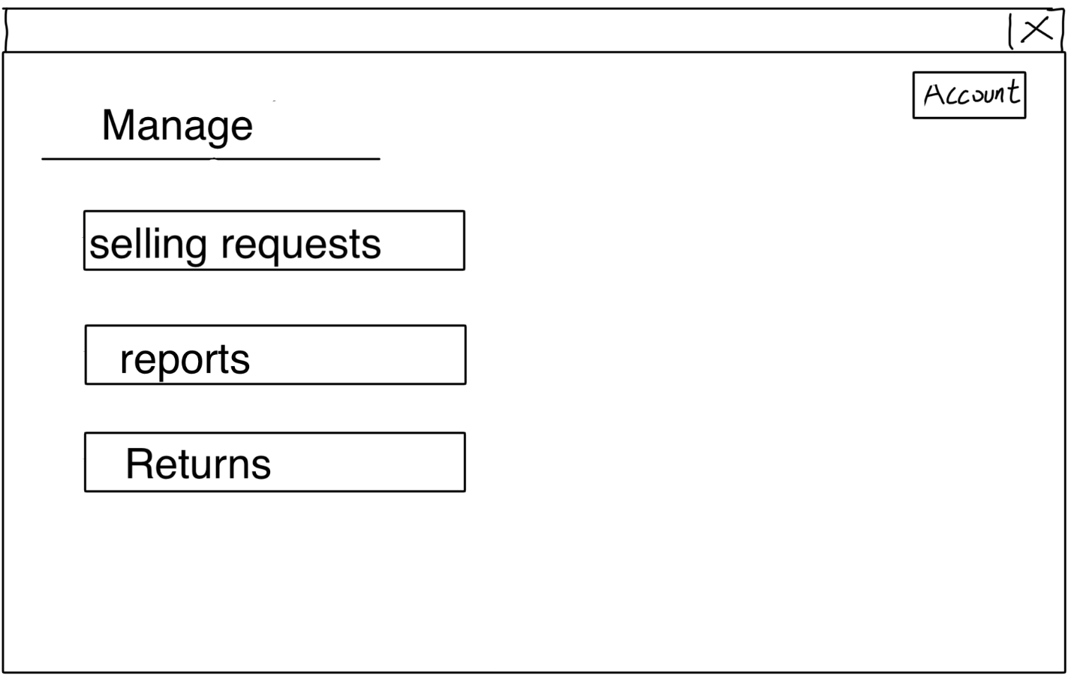
I11.1 Image of selling requests page
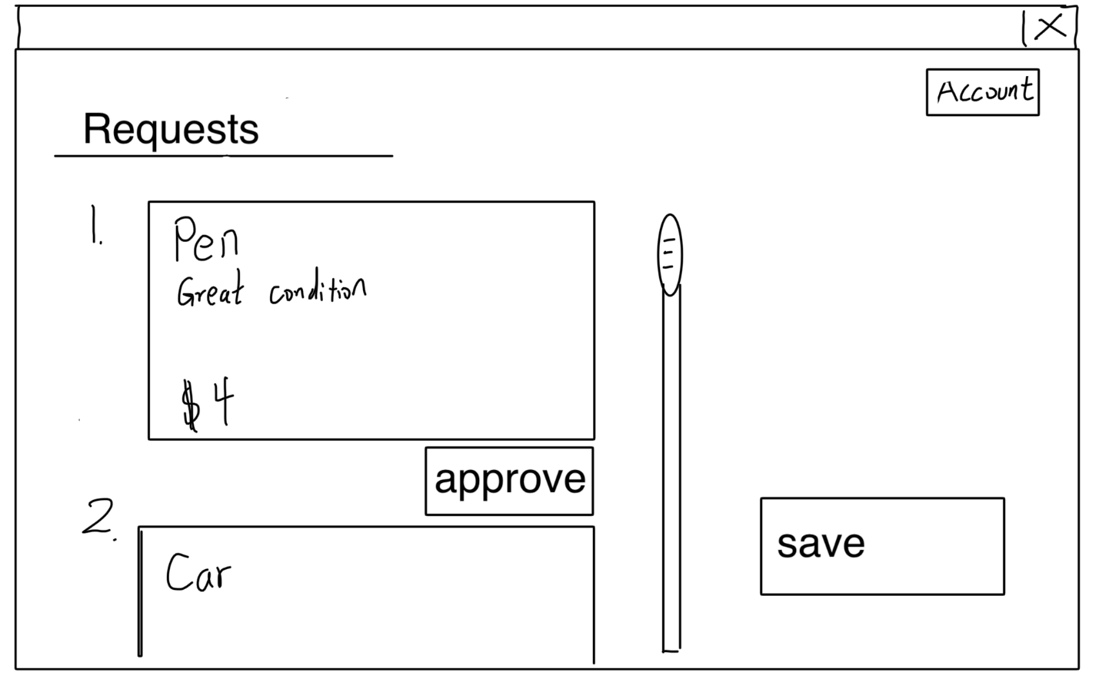
I11.2 Image of reports
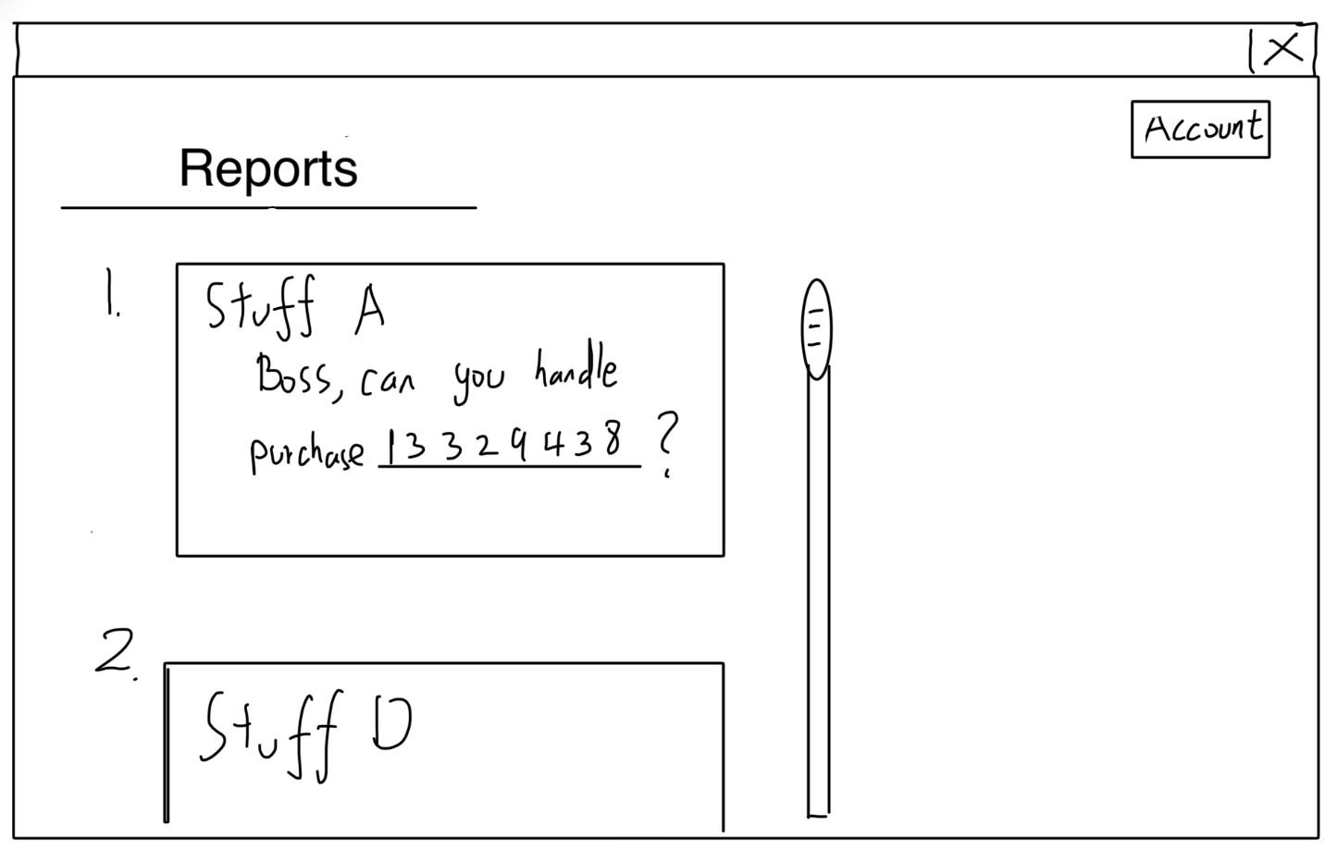
I11.3 Image of Return requests
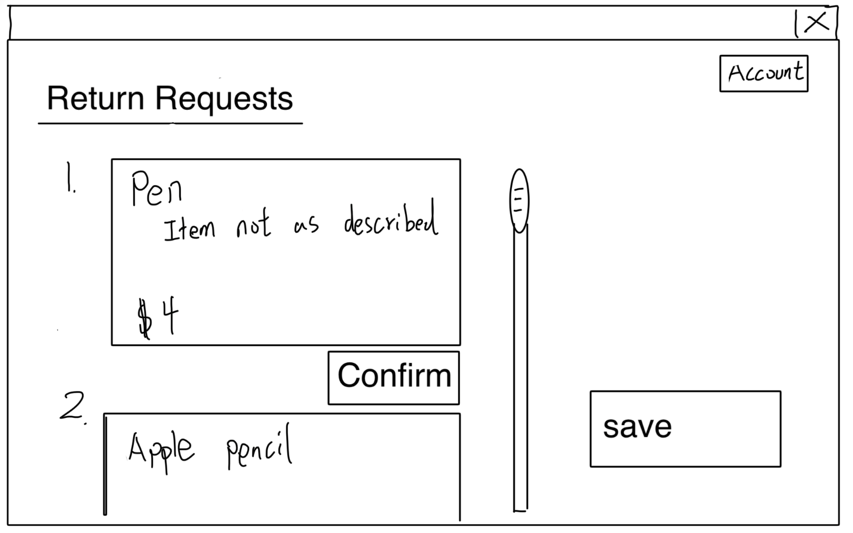
Image of Data Flow Char for FR Offer Administrator interface
