
B-BAY ECOMMERCE SYSTEM
Acceptance Test
Plan
Prepard By
Fatoumata, Ceesay
Habiba Karim, Rinky
Linsong, Li
Project Team
Delivery Date
January 3rd, 2023
PREPARED FOR:
Sung, Shin
Owner of
Sung’s & Co Limited
550 Main Avenue
Brookings SD, 57007
605-456-7890
Sung.Shin@Outlook.com
November 18, 2022
Table of content
Introduction 1
Purpose of Acceptance Test 1
Proposed System Overview 2
Acronyms 3
List of Abbreviations 3
Definitions 3
Testing Principles Used 3
Overview of Rest of ATP 3
Hardware and Software used for testing 4
Test Schedule&Test Sets table 5
Error Handling Policy 6
Individual Test cases 6
Log of Meetings 12
Project Acceptance Signatures for Client and Developer 13

Introduction
Purpose of Acceptance Test

The aim of this document is to legally ensure that all requirements are addressed fully and to the satisfaction of the client. It will contain different test cases to show how the product works in an ideal environment.
ATP is intended to get “written statement” from the user that the product was delivered as promised therefore, both parties will have to sign at the end of each individual test case and finally at the end of the document.

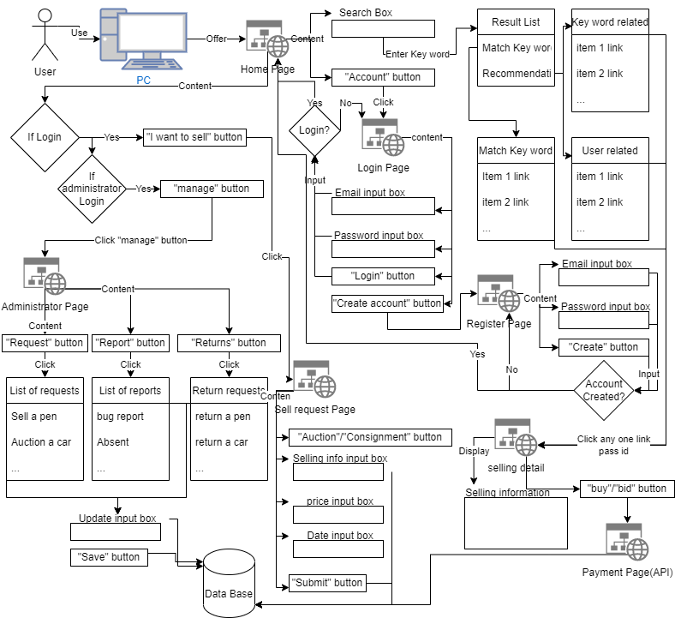
Proposed System Overview

Acronyms

ATP: Acceptance Test Plan

CPU: Central processing unit

OS: Operating system

List of Abbreviations

API Application programming interface

B Bay Brookings Bay

Bid Auction

DB Database

ID Identification number

SS Screenshot

Definitions

Working days = Mon 8am-5pm, Tue 8am-5pm, Wed 8am-5pm, Thur 8am-5pm
Testing Principles Used

Assigned project team’s member will demo the product to the user and he (she) will be going to describe the user requirements along with the input and the expected outputs to the user using a computer. And also both the party should be aware of the assumptions and constraints of the test. These assumptions and constraints include timing and available resources, as well as test documentation processes.

Overview of Rest of ATP

The rest of ATP will clarify hardware and software used for testing, test schedule, error handling policy, test sets, individual test cases, log of meetings, project acceptance signatures for client and developer and appendix.

Hardware and Software used for testing

CPU:
- Dual-core 1.8GHz processor or Quad-core 2.4-3.5GHz CPU, (3.Intel - Core i9-9900X recommended.
- Must 64-Bit CPU and required for VMWare Workstation 8

RAM:
- 4GB DDR3 (32GB recommended)

Network Interface:
- Network interface for BACSS test software port 1(must be wired to connect to the DUT)

OS:
- Windows 10 Version (1903.18362.592)

Web Browser:
- Google Chrome (Version 80.0.3987.87)

Test Schedule&Test Sets table

No. | FWBS No. | Test description | Executor | Date | P/F
FT1 | 1.1 | Create administrator account | Linsong | 5/1/2023
FT2 | 1.3 | Create Buyer/Seller account | Habiba | 5/2/2023
FT3 | 1.2 | Login with Buyer/seller account | Fatoumata | 5/3/2023
FT4 | 2 | Create a request of auction or consignment | Linsong | 5/7/2023
FT5 | 3 | Check the function of the 3 types of lists | Fatoumata | 5/9/2023
FT6 | 4.1 | Try search a item in Home page | Habiba | 5/12/2023
FT7 | 4.2 | Check if Notificaiton/FAQs/Policy is working | Fatoumata | 5/13/2023
FT8 | 5.4 | Check if wish list display correctly | Linsong | 5/16/2023
 | 4.3
FT9 | 5.3 | Check if Cart list is working | Habiba | 5/17/2023
 | 4.4
FT10 | 5.5 | Try if chat allow communication to right target | Habiba | 5/20/2023
 | 4.7
FT11 | 4.8 | Check if history purchase display correctly | Fatoumata | 5/21/2023
FT12 | 5.1  5.3  5.4  5.6 | Check if merchandise info display correctly | Linsong | 5/22/2023
FT13 | 5.2 | Try to Buy a consignment/auction item | Habiba | 5/23/2023
FT14 | 5.5 | Check if chat with seller function works | Habiba | 5/27/2023

Error Handling Policy

Error Type No. | Category | Actions
ET1 | errors that can be fixed in 5 working hours | After discussion with client, fix errors within 2 working days
ET2 | Functional errors that can be fixed in 5 working days | After discussion with client, fix errors within 8 working days
ET3 | errors that can be fixed in 20 working days | Discuss with client, do nothing if errors are acceptable, else fix errors within 22 working days
ET4 | Any unacceptable errors that can’t be fixed in 20 working days | Give up on project and pay compensation that equel to 80% of fees Qnet got from this project.

Individual Test cases

T1
Test Number | T1
FWBS Module | Create Administrative Account
FWBS Number(s) | 1.1(1.1.1, 1.1.1.1, 1.1.1.1.1)
Purpose | Allow a user to create an account.
Setup | Software: Computer windows 10 and above, Chrome 10.2 and above  Hardware: Intel Core i7 and above
Interactive Demo | https://xd.adobe.com/view/9208aa1d-d2e6-4dde-59ca-efd716b9d8ff-e439/?fullscreen&hints=off

T1 Action
Case: Correct username and password.
User Action | Input
type email in appropriate field | John.Doe@gmail.com
type password in appropriate field | John123@
button click | Click ‘Register’
Input as SS1
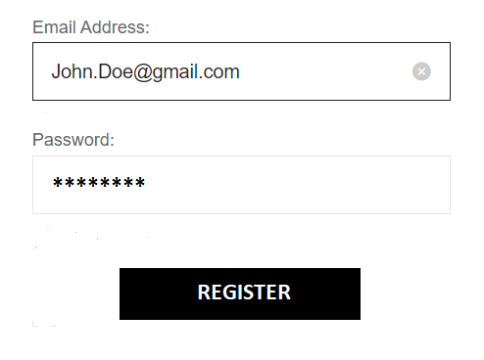
Pic: SS1

Output as SS2
system message | Display confirmation message.
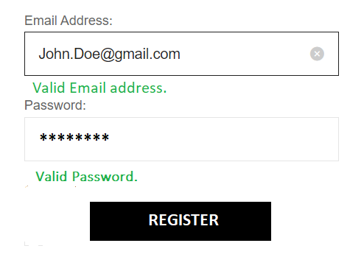
Pic: SS2
Signatures
User: ________________________ Project Team: ________________________ Date: _______________ Comments:__________________________

T1 Action
Case: incorrect email and password.
User Action | Input as SS3
type password in appropriate field | John123@
type email in appropriate field | John111@gmail.com
button click | Click ‘Register’
Input as SS3
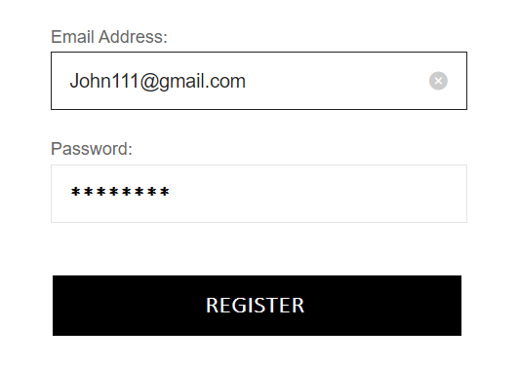
Pic: SS3

Output as SS4
system message | Display the expected error message of invalid email.
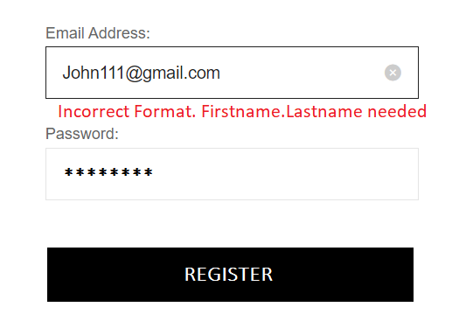
Pic: SS4

Signatures
User: ________________________ Company: ________________________ Date: _______________ Comments:________________________

T2
Test Number | T2
FWBS Module | Login
FWBS Number(s) | 1.2(1.2.1, 1.2.1.1, 1.2.1.1.1, 1.2.1.1.1.1, 1.2.1.1.1.1.1, 1.2.1.1.1.1.2, 1.2.1.1.1.1.3, 1.2.1.1.1.1.2.1, 1.2.1.1.2, 1.2.1.1.3, 1.2.1.1.3.1, 1.2.1.1.3.1.1, 1.2.1.1.3.1.1.1)
Purpose | This is to test with both valid and invalid data to see what the output looks like. Correct data means a valid username and valid password. Incorrect data means an invalid username and/or invalid password.
SET UP | Software: Computer windows 10 and above, Chrome 10.2 and above  Hardware: Intel Core i7 and above
Interactive Demo | https://xd.adobe.com/view/9208aa1d-d2e6-4dde-59ca-efd716b9d8ff-e439/?fullscreen&hints=off

User Action1 | Input
Email address field | John.Doe@gmail.com
password field | Valid1233
button | ‘Login’
Input as SS5
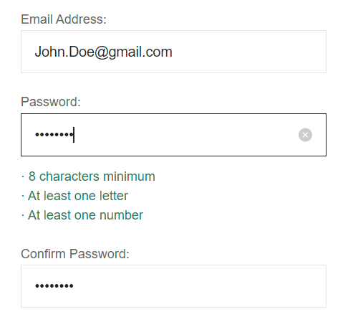
Pic: SS5

Output as SS6
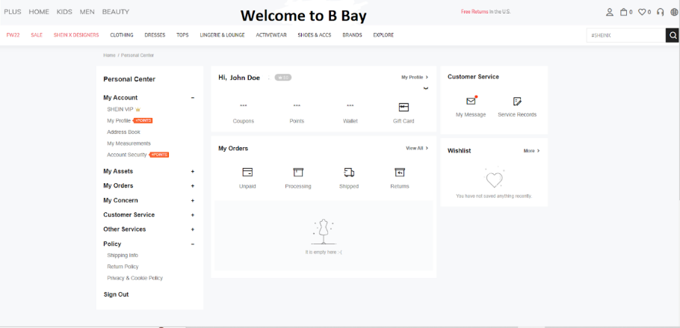

Pic: SS6

User Action2 | Input
Email address field | John111@gmail.com
password field | Invalid1233
button | ‘Login’
Input as SS7
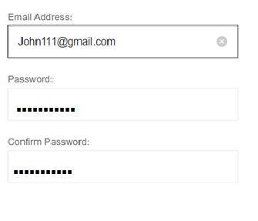
Pic: SS7

Output as SS8
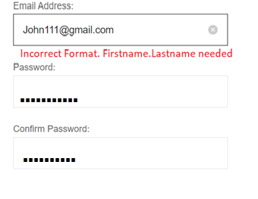
Pic: SS8

User Action3 | Input
Email address field | John.Doe@gmail.com
password field | Inv111
button | ‘Login’
Input as SS9
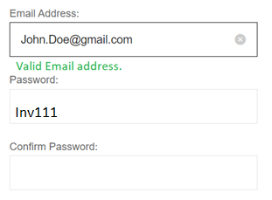
Pic: SS9

Output as SS10
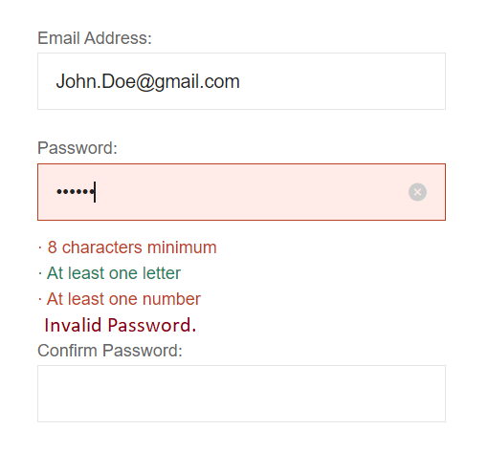
Pic: SS10
Signatures
User: ________________________ Company: ________________________ Date: _______________
Comments:

Log of Meetings
Meeting 10/27 10:50 AM
Goal:Understand and build outline of ATP
Member: ALL
Result: Linsong: do test plan and test sets
Fatoumata: Individual test case 1
Habiba: Individual test case 2
Meeting 11/03 10:50 AM
Goal: Finsh work split of rest of ATP
Member: ALL
Result: Linsong: do Error handling policy, work of combine
Fatoumata&Habiba: do intro
Meeting 11/10 10:50 AM
Goal: Meet with client
Member: ALL
Result: Push back to 11/15/2022

Project Acceptance Signatures for Client and Developer

Company ____________________________ City ______________________________________

State ________________________________ Postal Code _______________________________

Phone _______________________________

Acceptance of Agreement:

I certify that I have received all project deliverables from Qnet Company and that all deliverables have been demonstrated, delivered or otherwise completed to my satisfaction. I further certify and release Qnet Company, from any further obligation, support or duty concerning this project, including any and all continued support services. I understand that by signing this agreement, I release Qnet Company from any and all liability, tort or claim concerning this project, its files, source code, object code, programming or other materials, whether printed or digital, provided to the client. I further understand that all files provided to me under this or any other agreement are to be used at my sole risk and responsibility and all files should be tested prior to publication or any mass distribution in any format.

Qnet Company is not responsible for any results obtained from the use of any software, materials, presentation or products provided to the client under this agreement.

Client’s Signature ______________________________________________________________
Developer Signature ____________________________________________________________

