
B-BAY ECOMMERCE SYSTEM
Acceptance Test
Plan
Prepard By
Fatoumata, Ceesay
Habiba Karim, Rinky
Linsong, Li
Project Team
Delivery Date
January 3rd, 2023
PREPARED FOR:
Sung, Shin
Owner of
Sung’s & Co Limited
550 Main Avenue
Brookings SD, 57007
605-456-7890
Sung.Shin@Outlook.com
November 8, 2022
Table of Contents
Introduction 3
Purpose of Document 3
Scope of Product 4
Acronyms 4
List of Abbreviations 5
Definitions 5
References 5
Overview of Rest of Document 5
Test Items 5
Requirements to be tested 5
Requirements not tested 6
Approach 6
Software Testing Team 6
Software Testing Process 7
Hardware & Software Requirements for Testing 7
System Test Schedule table 7
Transaction flow testing 8
FT8. FWBS4.1 Item search and recommendation 8
FT9. FWBS4.2, 4.5, 4.6 (Display Notifications, Display FAQs and Display Policy) 11
FT10. FWBS4.3 Display User’s Wish List 15
FT11. FWBS4.4 Display Cart List 17
FT12. FWBS4.7 Offer “Chat” Button 19
FT13. FWBS4.8Offer “History Purchase” Button 24
FT14. FWBS5.1,5.3,5.4,5.6 Offer “History Purchase” Button 26
FT15. FWBS 5.2 Buy or Bid Button 30
FT16. FWBS5.5 Offer “Chat with Seller” Button 33
Non-Functional Requirement Test 37
a. Compatibility Test 37
b. Regression Test with Policy 39
c. Stress and Performance Test 41
d. Back-up and Recovery Test 41
e. Security Test 42

Introduction
Purpose of Document

This document is important as it entails all the details of system testing and shows how our company meets the client’s requirement needs. The requirements were divided into their functionalities which will be seen later in this documentation.
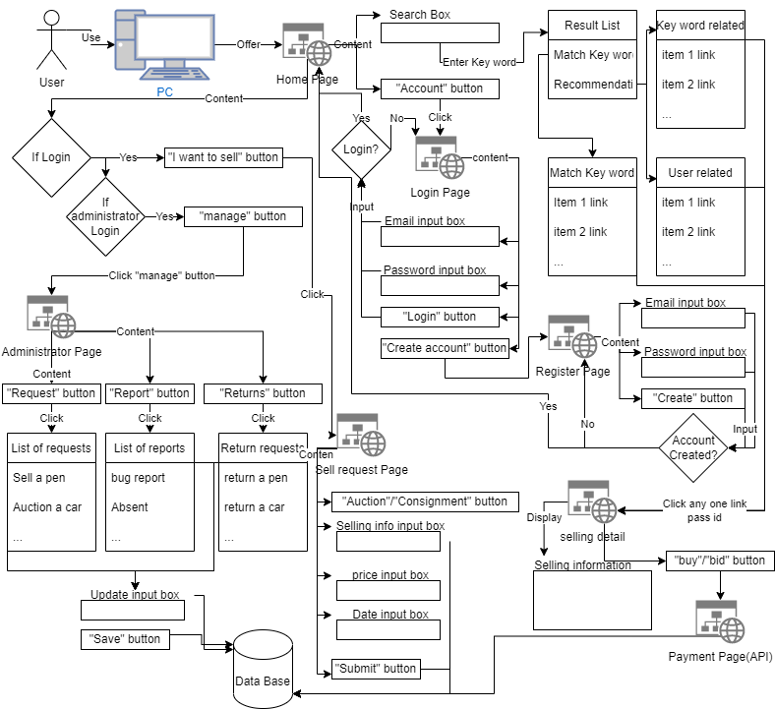
Scope of Product

Acronyms

STP: System Test Plan

CPU: Central processing unit

OS: Operating system

List of Abbreviations

API Application programming interface

B Bay Brookings Bay

Bid Auction

DB Database

ID Identification number

SS Screenshot

Definitions

Working days = Mon 8am-5pm, Tue 8am-5pm, Wed 8am-5pm, Thur 8am-5pm
References
Portico Regression Testing Policy. (n.d.). Retrieved March 27, 2016, from https://www.portico.org/wp-content/uploads/2017/12/Portico-Regression-Testing-Guidelines-Operations.pdf
Overview of Rest of Document
The rest of STP will clarify details of software testing with list of requirements coverage, approaches and test cases for transaction flow test, non-functional requirements using black box test techniques.

Test Items
Requirements to be tested
No. | FWBS No. | Test description
FT4 | 2 | Create a request of auction or consignment
FT6 | 4.1 | Try search a item in Home page
Requirements not tested
No. | FWBS No. | Test description
FT1 | 1.1 | Create administrator account
FT2 | 1.3 | Create Buyer/Seller account
FT3 | 1.2 | Login with Buyer/seller account
FT5 | 3 | Check the function of the 3 types of lists
FT7 | 4.2 | Check if Notificaiton/FAQs/Policy is working
FT8 | 5.4 | Check if wish list display correctly
 | 4.3
FT9 | 5.3 | Check if Cart list is working
 | 4.4
FT10 | 5.5 | Try if chat allow communication to right target
 | 4.7
FT11 | 4.8 | Check if history purchase display correctly
FT12 | 5.1  5.3  5.4  5.6 | Check if merchandise info display correctly
FT13 | 5.2 | Try to Buy a consignment/auction item
FT14 | 5.5 | Check if chat with seller function works

Approach
Software Testing Team
The Qnet test team is concurrently handled by our manager of security as the following chart of organization shown.
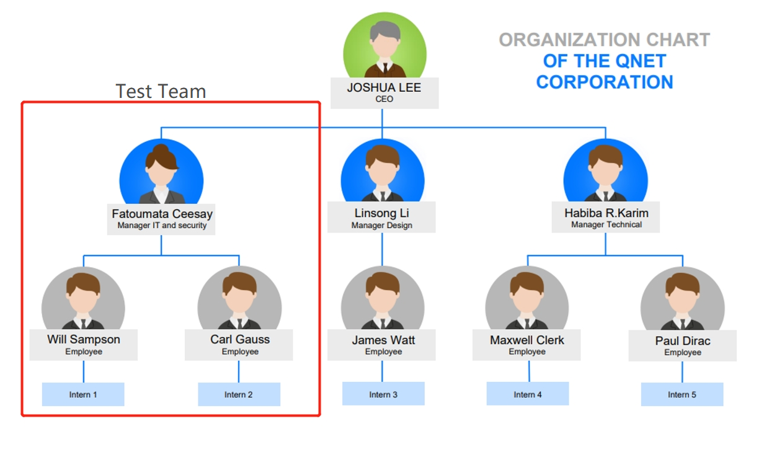

Software Testing Process
Test team should setup test environment before ST1, then follow test schedule, execute final test cases for each claster and record results.

Hardware & Software Requirements for Testing
CPU:
- Dual-core 1.8GHz processor or Quad-core 2.4-3.5GHz CPU, (3.Intel - Core i9-9900X recommended.
- Must 64-Bit CPU and required for VMWare Workstation 8
RAM:
- 4GB DDR3 (32GB recommended)
Network Interface:
- Network interface for BACSS test software port 1(must be wired to connect to the DUT)

OS:
- Windows 10 Version (1903.18362.592)
Web Browser:
- Google Chrome (Version 80.0.3987.87)

System Test Schedule table
No. | FWBS No. | Test description | Executor | Date | P/F
FT1 | 1.1 | Create administrator account | Linsong | 5/1/2023
FT2 | 1.3 | Create Buyer/Seller account | Habiba | 5/2/2023
FT3 | 1.2 | Login with Buyer/seller account | Fatoumata | 5/3/2023
FT4 | 2 | Create a request of auction or consignment | Linsong | 5/7/2023
FT5 | 3 | Check the function of the 3 types of lists | Fatoumata | 5/9/2023
FT6 | 4.1 | Try search a item in Home page | Habiba | 5/12/2023
FT7 | 4.2 | Check if Notificaiton/FAQs/Policy is working | Fatoumata | 5/13/2023
FT8 | 5.4 | Check if wish list display correctly | Linsong | 5/16/2023
 | 4.3
FT9 | 5.3 | Check if Cart list is working | Habiba | 5/17/2023
 | 4.4
FT10 | 5.5 | Try if chat allow communication to right target | Habiba | 5/20/2023
 | 4.7
FT11 | 4.8 | Check if history purchase display correctly | Fatoumata | 5/21/2023
FT12 | 5.1 5.3 5.4 5.6 | Check if merchandise info display correctly | Linsong | 5/22/2023
FT13 | 5.2 | Try to Buy a consignment/auction item | Habiba | 5/23/2023
FT14 | 5.5 | Check if chat with seller function works | Habiba | 5/27/2023

Transaction flow testing

FT8. FWBS4.1 Item search and recommendation
This allows users to search for what they are looking for. We use the data to give recommendations in the future.
a. Requirement based testing
RTM
Test data | Expected output | Actual output
Click “Search Item” as IMG8.1 | A page that shows with a panel where product can be search by its name
Click “Save” as IMG8.2 | A page that shows the saved search history
Click “Do not save search history” as IMG8.2 | A page that shows no search history
Clicks on “Item” from “Item List” as IMG8.1 | A page that shows item’s information IMG8.3

b. Negative testing
Test data | Expected output | Actual output
Type “^&({$” on search panel as IMG8.1 | A page that shows orange but might get error search.

c. User documentation testing
User documentation | Test data | Expected output | Actual output
Go to search bar and search desired item | Click “Search Item” as IMG8.1 | A page that shows with a panel where product can be search by its name
Select item from item list | Clicks on “Item” from “Item List” as IMG8.1 | A page that shows item’s information IMG8.3

Final test cases:
Test case No. | Test data | Expected output | Actual output
TF8-1 | Click “Search Item” as IMG8.1 | A page that shows with a panel where product can be search by its name as IMG8.1
TF8-2 | Click “Save” as IMG8.2 | A page that shows the saved search history as IMG8.2
TF8-3 | Click “Do not save search history” as IMG8.2 | A page that shows no search history as IMG8.1
TF8-4 | Clicks on “Item” from “Item List” as IMG8.1 | A page that shows with a panel where product can be search by its name and its information as IMG8.3
TF8-5 | Type “^&({$” on search panel as IMG8.1 | A page that shows orange but might get error search.

Input and expected output images:
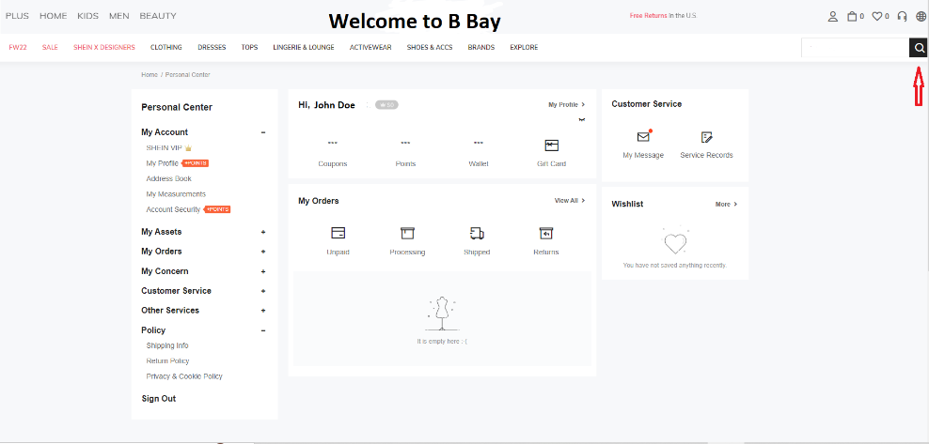
Pic: IMG8.1

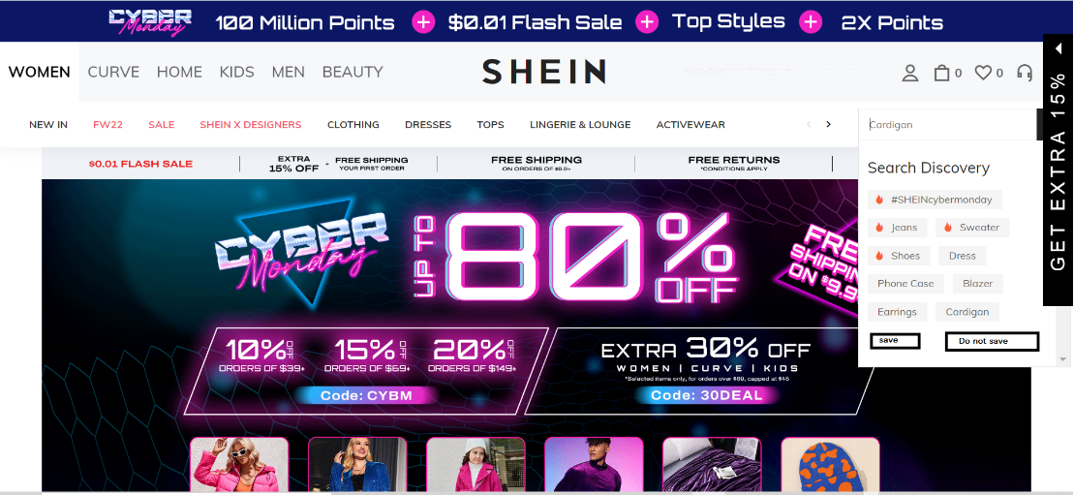
Pic: IMG8.2

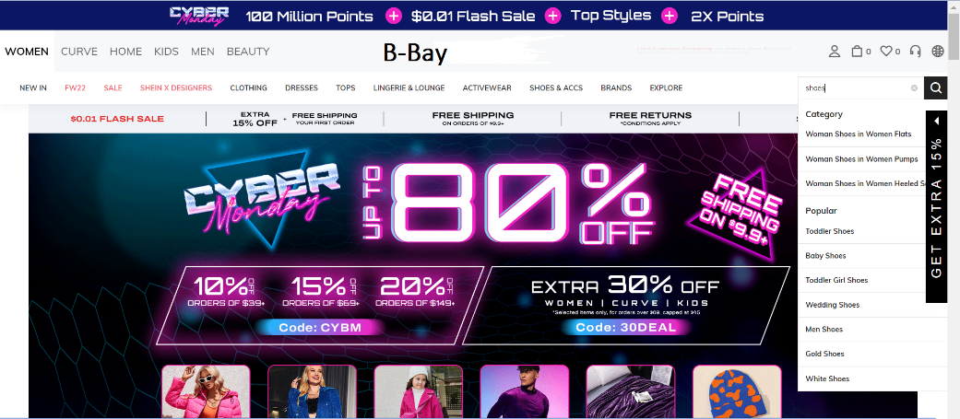
Pic: IMG8.3

FT9. FWBS4.2, 4.5, 4.6 (Display Notifications, Display FAQs and Display Policy)
This cluster merges the notification functionality, FAQs functionality and policy functionality.
a. Requirement based testing
RTM
Test data | Expected output | Actual output
Clicks on “Notification” as IMG9.1 | A page that shows all the notification as IMG9.2
Clicks on “FAQs” as IMG9.1 | A page that shows all the FAQs as IMG9.3
Clicks on “Policy” as IMG9.1 | A page that shows all the policy of B-Bay as IMG9.4

b. Negative testing
Test data | Expected output | Actual output
Clicks on “Register” as IMG9.1 | A page that shows “FAQs” as IMG9.3
Put water on the keyboard | A page that shows “FAQs” as IMG9.3

c. User Documentation testing
User documentation | Test data | Expected output | Actual output
Go to “FAQs” to see the FAQs | Clicks on “Notification” as IMG9.1 | A page that shows all the notification as IMG9.2
Go to “Notification” to see the most recent notification | Clicks on “FAQs” as IMG9.1 | A page that shows all the FAQs as IMG9.3
Go to “Policy” to see the policy of B-Bay | Clicks on “Policy” as IMG9.1 | A page that shows all the policy of B-Bay as IMG9.4

Final test cases:
Test case No. | Test data | Expected output | Actual output
TF9-1 | Clicks on “Notification” as IMG9.1 | A page that shows all the notification as IMG9.2
TF9-2 | Clicks on “FAQs” as IMG9.1 | A page that shows all the FAQs as IMG9.3
TF9-3 | Clicks on “Policy” as IMG9.1 | A page that shows all the policy of B-Bay as IMG9.4
TF9-4 | Clicks on “Register” as IMG9.1 | A page that shows “FAQs” as IMG9.3
TF9-5 | Put water on the keyboard | A page that shows “FAQs” as IMG9.3

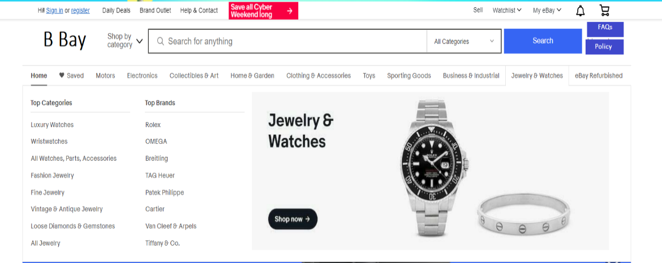
Pic: IMG9.1
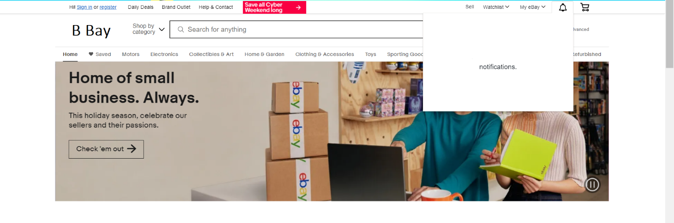
Pic: IMG9.2
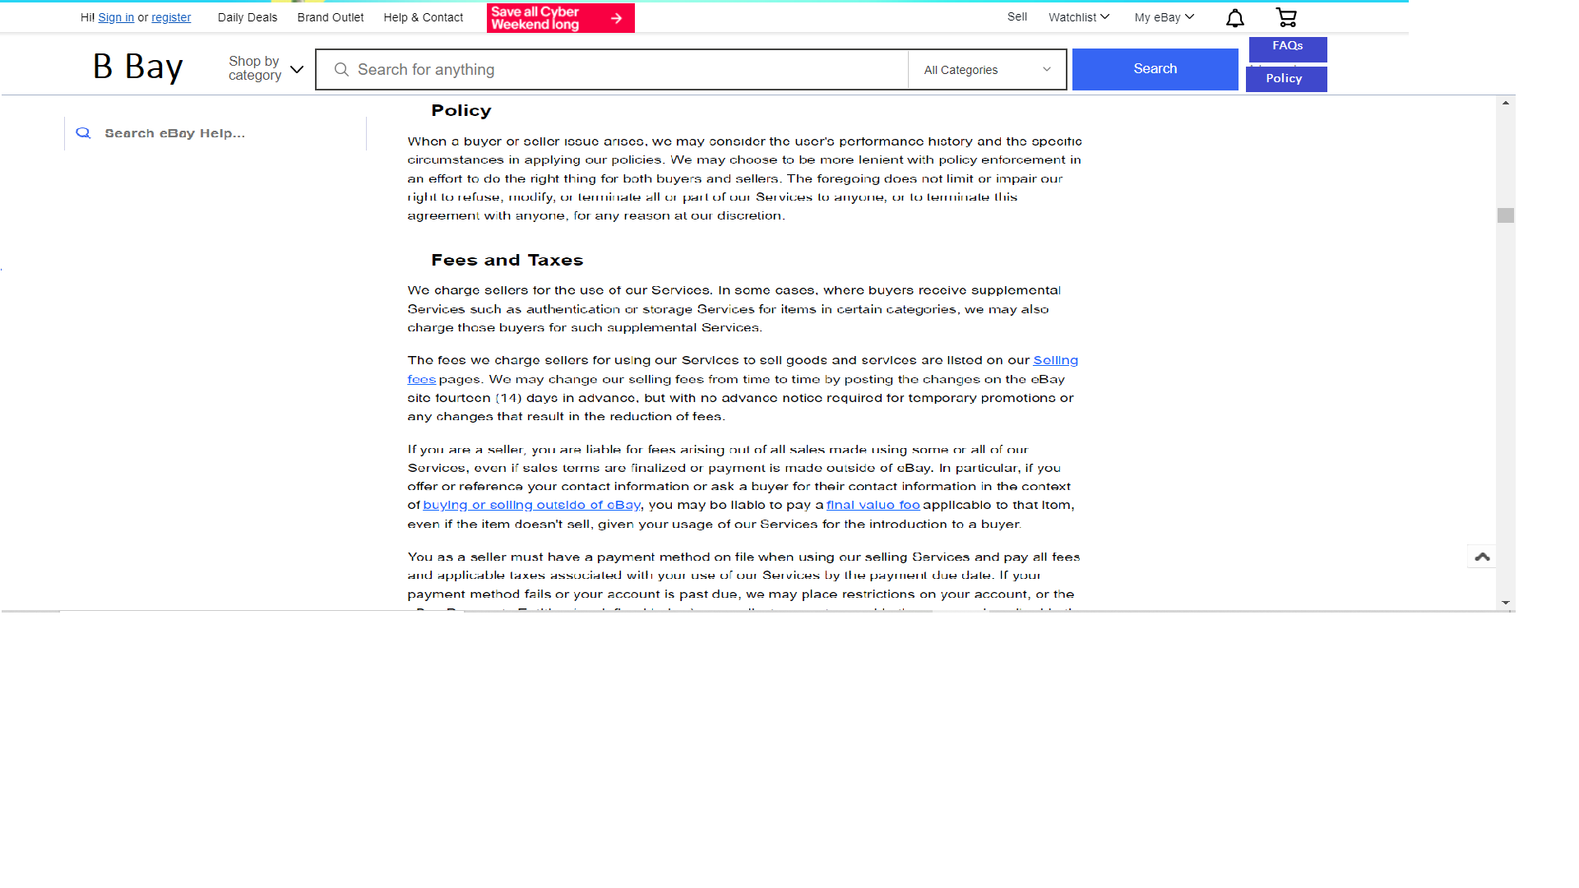
Pic: IMG9.3
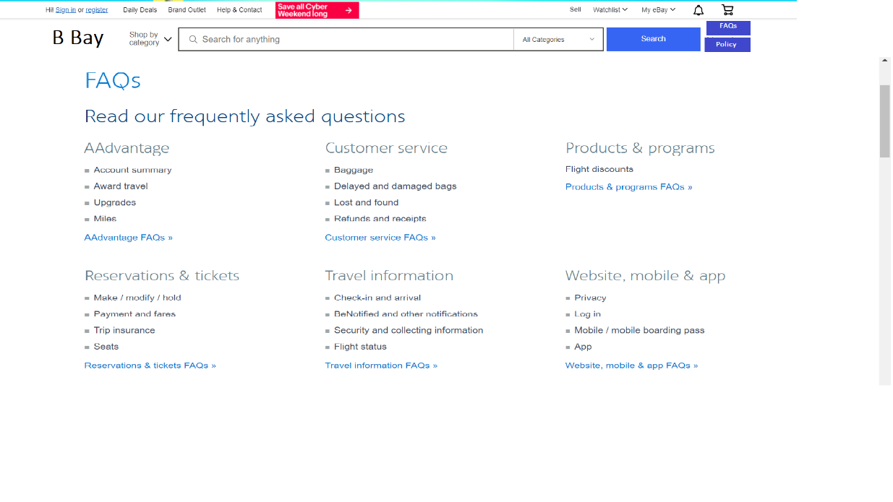
Pic: IMG9.4

FT10. FWBS4.3 Display User’s Wish List
This allows users to show the wish list and also allows them to edit the wish list. And this will offer adding to cart options.
a. Requirement based testing
RTM
Test data | Expected output | Actual output
Clicks on “Wish list” as IMG10.1 | A page that shows wish list as IMG10.2
Clicks on “Add to wish list” as IMG10.2 | A page that shows wish list as IMG10.2

b. Negative Testing
Test data | Expected output | Actual output
Clicks on “My Orders” | A page that shows wish list as IMG10.2
Throw mouse through the window | A page that shows wish list as IMG10.2

c. State Based testing
Current state | Test data | Expected next state | Expected output | Actual output
Wish list icon | Clicks on “Wish list” as IMG10.1 | Wish list | A page that shows wish list as IMG10.2
My Orders icon | Clicks on “My Orders” | Wish list | A page that shows wish list as IMG10.2

Final test cases:
Test case No. | Test data | Expected output | Actual output
TF10-1 | Clicks on “Wish list” as IMG10.1 | A page that shows wish list as IMG10.2
TF10-2 | Clicks on “Add to wish list” as IMG10.2 | A page that shows wish list as IMG10.2
TF10-3 | Clicks on “My Orders” | A page that shows wish list as IMG10.2
TF10-4 | Throw mouse through the window | A page that shows wish list as IMG10.2

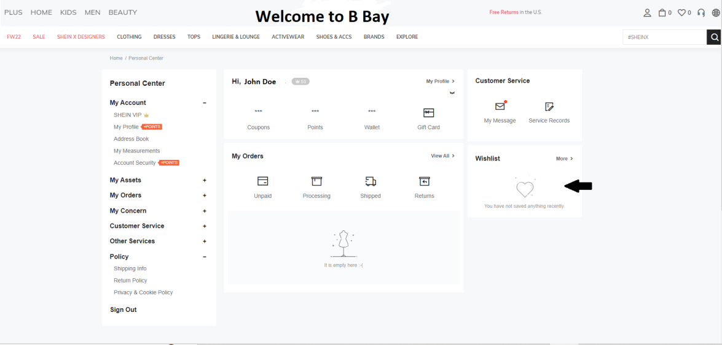
Pic: IMG10.1
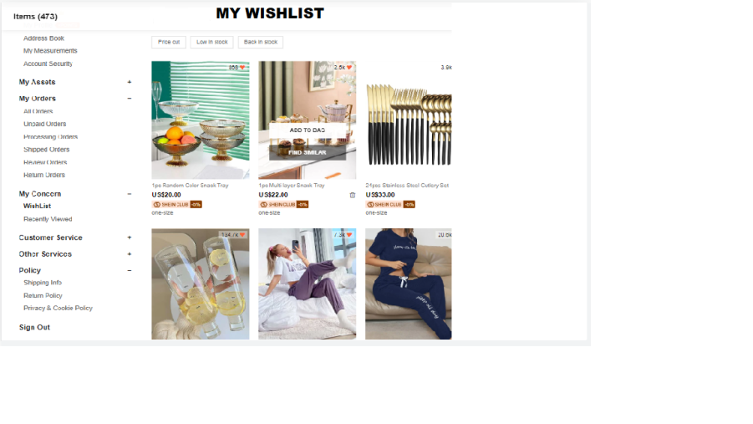
Pic: IMG10.2

FT11. FWBS4.4 Display Cart List
This will show the user list of products they bought and it will also allow the user
to edit the cart list.
a. Requirement based testing
RTM
Test data | Expected output | Actual output
Clicks on “Cart list” as IMG11.1 | A page that shows cart list as IMG11.2
Clicks on “Buy” as IMG11.2 | A page that shows buying information as IMG11.2

b. Negative Testing
Test data | Expected output | Actual output
Clicks on “My Orders” | A page that shows cart list as IMG11.2
Throw mouse through the window | A page that shows cart list as IMG11.2

c. State based testing
Current state | Test data | Expected next state | Expected output | Actual output
Cart list icon | Clicks on “Cart list” as IMG11.1 | cart list | A page that shows cart list as IMG11.2
My Orders icon | Clicks on “My Orders” | Cart list | A page that shows cart list as IMG11.2

Final test cases:
Test case No. | Test data | Expected output | Actual output
TF10-1 | Clicks on “Cart list” as IMG11.1 | A page that shows cart list as IMG11.2
TF10-2 | Clicks on “Add to cart list” as IMG11.2 | A page that shows buying information as IMG11.2
TF10-3 | Clicks on “My Orders” | A page that shows wish list as IMG11.2
TF10-4 | Throw mouse through the window | A page that shows wish list as IMG11.2

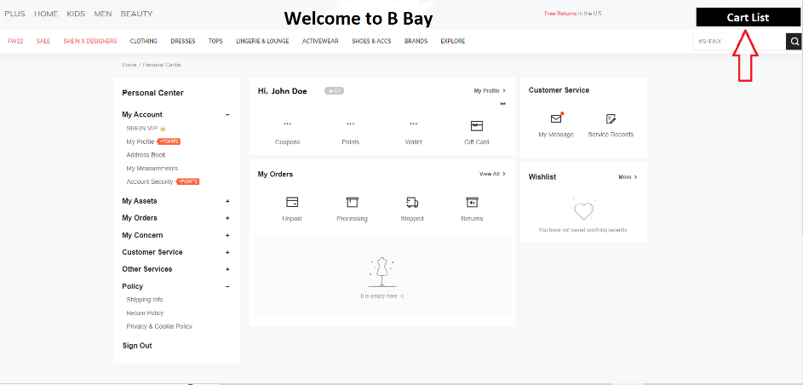
Pic: IMG11.1
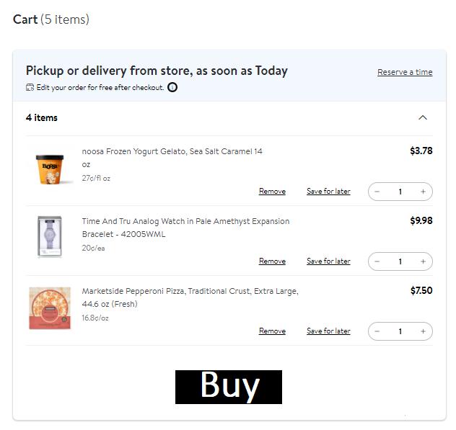
Pic: IMG11.2

FT12. FWBS4.7 Offer “Chat” Button
This enables the user to send and receive messages. It also shows message history.
a. Requirement based testing
RTM
Test data | Expected output | Actual output
Click on “Chat” button as IMG12.1 | A page that shows a chat box as IMG12.2
Enter message “” on chat box as IMG12.2 | A page that prints “Invalid Message” as IMG12.4
Enter message “Hi!” on the chat box as IMG12.2 | A page that prints “Send” as IMG12.3
Enter message over 10000 characters as IMG12.2 | A page that prints “Invalid Message” as IMG12.4

b. Negative testing
Input | Expected output | Actual output
Enter “” for title as IMG12.1 | A page that print “Invalid message ” as IMG12.2
Enter “한국어” as IMG12.1 | A page that is printing “Send” but might see garbled while viewing as IMG12.3

c. CEG & DT with BVA
Causes Effect
C1: select enter message E1: invalid message
C2: Empty message E2: valid message
C3: 1-10000 characters for message
C4: 10001- infinity characters for message

Cause and Effect Graph
C2
E1
C1
E2
C3

C4

Decision Table
 | P1 | P2 | P3 | P4
Cause
C1 | 1 | 0 | 0 | 0
C2 | 0 | 1 | 0 | 0
C3 | 0 | 0 | 1 | 0
C4 | 0 | 0 | 0 | 1
Effect
E1 | 1 | 1 | 0 | 1
E2 | 0 | 0 | 1 | 0

Partitions | Test data | Expected output | Actual output
P1 | Select chat box as IMG12.2 | A page that printing chat box as IMG12.2
P2 | Empty chat box and try to send it as IMG12.2 | A page that printing “Invalid message” as IMG12.4
P3 | Enter message between 1-10000 characters as IMG12.1 | A page that printing “Send” as IMG12.3
P4 | Enter message over 10000 characters as IMG12.1 | A page that printing “Invalid message” as IMG12.4

Final test cases:
Test case No. | Test data | Expected output | Actual output
TF12-1 | Click on “Chat” button as IMG12.1 | A page that shows a chat box as IMG12.2
TF12-2 | Enter message “” on chat box as IMG12.2 | A page that prints “Invalid Message” as IMG12.4
TF12-3 | Enter message “Hi!” on the chat box as IMG12.2 | A page that prints “Send” as IMG12.3
TF12-4 | Enter message over 10000 characters as IMG12.1 | A page that prints “Invalid Message” as IMG12.4

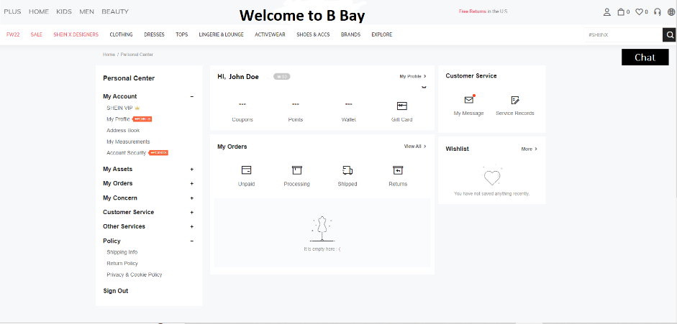
Pic: IMG11.1
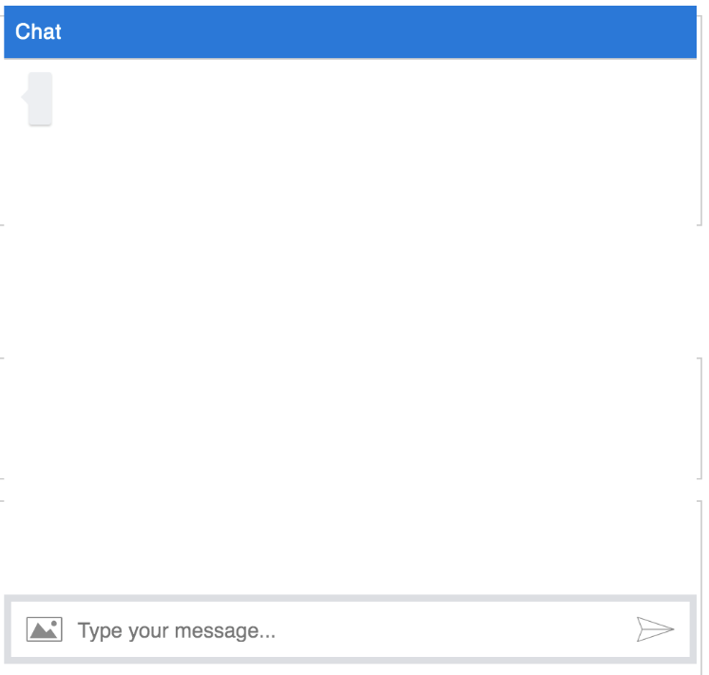
Pic: IMG11.2
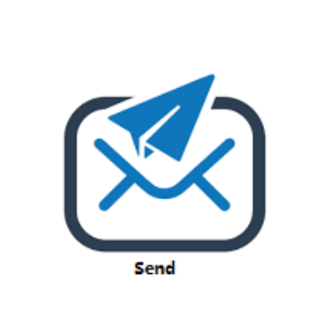
Pic: IMG11.3
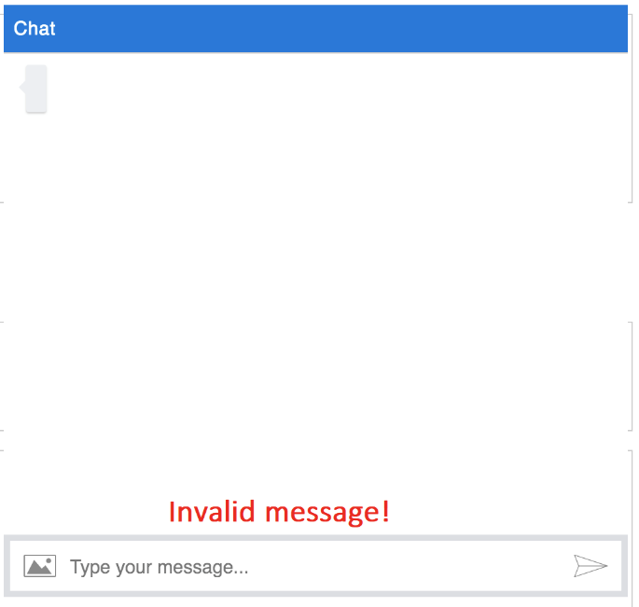
Pic: IMG11.4

FT13. FWBS4.8Offer “History Purchase” Button
This will show the user's purchase history and return policy.
a. Requirement based testing
RTM
Test data | Expected output | Actual output
Clicks on “History purchase” button as IMG13.1 | A page that shows history of purchase as IMG13.2
Clicks on “Report error” button as IMG13.1 | A page that shows error reporting page as IMG13.3
Clicks on “Return” button | A page that shows return option as IMG13.4

b. Negative testing
Test data | Expected output | Actual output
Clicks on “My Orders” | A page that shows purchase history as IMG13.2
Throw mouse through the window | A page that shows return option as IMG13.4

c. State based testing
Current state | Test data | Expected next state | Expected output | Actual output
History purchase icon | Clicks on “History purchase” as IMG13.1 | History purchase list | A page that shows history of purchase as IMG13.2
My Orders icon | Clicks on “My Orders” | History purchase list | A page that shows cart list as IMG13.2
Report error button | Clicks on “Report error” button as IMG13.1 | Error report | A page that shows error reporting page as IMG13.3
Return button | Clicks on “Return” button | Return option | A page that shows return option as IMG13.4

Final test cases:
Test case No. | Test data | Expected output | Actual output
TF13-1 | Clicks on “History purchase” button as IMG13.1 | A page that shows history of purchase as IMG13.2
TF13-2 | Clicks on “Report error” button as IMG13.1 | A page that shows error reporting page as IMG13.3
TF13-3 | Clicks on “Return” button | A page that shows return option as IMG13.4
TF13-4 | Clicks on “My Orders” | A page that shows purchase history as IMG13.2
TF13-5 | Throw mouse through the window | A page that shows return option as IMG13.4

FT14. FWBS5.1,5.3,5.4,5.6 Offer “History Purchase” Button
This is a merged cluster consisting of the user's purchase history, user’s reputation and functionalities that will allow users to view items information and add to cart. And this merged cluster is also called History Purchase button.
a. Requirement based testing
RTM
Test data | Expected output | Actual output
Clicks on “Item information”  As IMG14.1 | A page that shows item information14.2
Clicks on “Add to cart” button  As IMG14.3 | A page that shows cart list as IMG14.4
Clicks on “Add to Wish list” button as IMG14.5 | A page that shows wish list as IMG14.6
Clicks on “Reputation” as IMG14.7 | A page that shows user’s reputation

b. Negative testing
Test data | Expected output | Actual output
Clicks on “Register” as IMG14.4 | A page that shows cart list as IMG14.4
Put water on the keyboard | A page that shows wish list as IMG14.6

c. State based testing
Current state | Test data | Expected next state | Expected output | Actual output
Item information icon | Clicks on “Item information”  As IMG14.1 | Item information | A page that shows item information14.2
Cart button | Clicks on “Add to cart” button  As IMG14.3 | Cart list | A page that shows cart list as IMG14.4
Wish list | Clicks on “Add to Wish list” button as IMG14.5 | Wish list | A page that shows wish list as IMG14.6
Reputation | Clicks on “Reputation” as IMG14.7 | Reputation page | A page that shows user’s reputation
Register icon | Clicks on “Register” as IMG14.4 | Cart list | A page that shows cart list as IMG14.4

Final test cases:
Test case No. | Test data | Expected output | Actual output
TF14-1 | Clicks on “Item information”  As IMG14.1 | A page that shows item information14.2
TF14-2 | Clicks on “Add to cart” button  As IMG14.3 | A page that shows cart list as IMG14.4
TF14-3 | Clicks on “Add to Wish list” button as IMG14.5 | A page that shows wish list as IMG14.6
TF14-4 | Clicks on “Reputation” as IMG14.7 | A page that shows user’s reputation
TF14-5 | Clicks on “Register” as IMG14.4 | A page that shows cart list as IMG14.4
TF14-6 | Put water on the keyboard | A page that shows wish list as IMG14.6

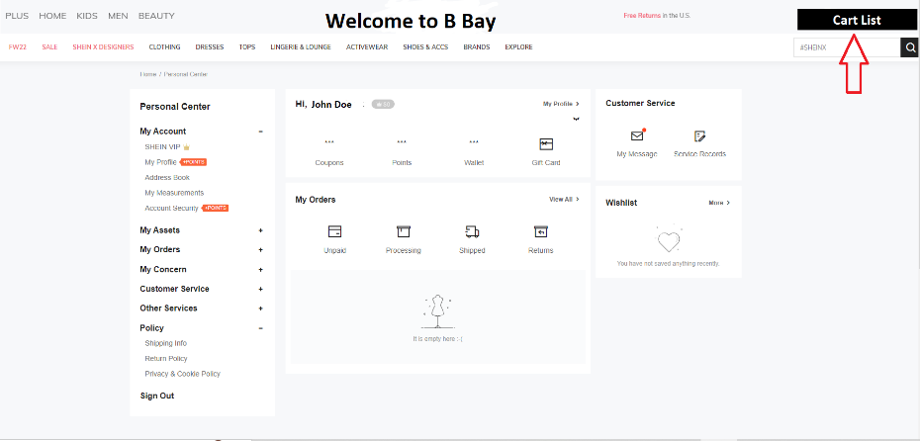
Pic: IMG14.3

Pic: IMG14.4
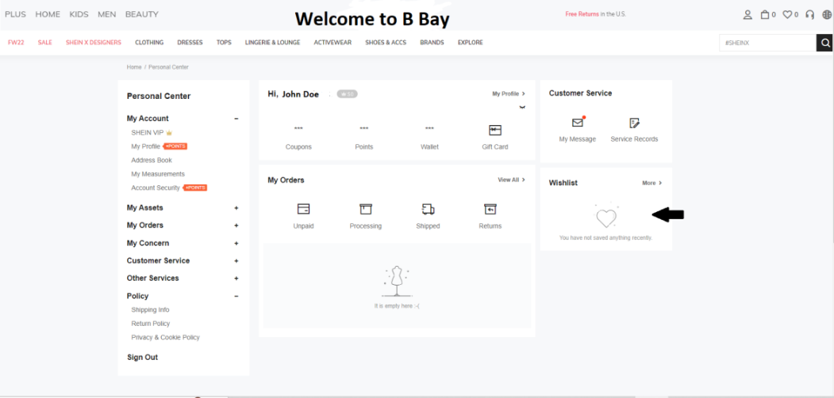
Pic: IMG14.5

Pic: IMG14.6

FT15. FWBS 5.2 Buy or Bid Button
This functionality allows buyers to choose between the buy or bid option.
a. Requirement based testing
RTM
Test data | Expected output | Actual output
Click on Buy or Bid
User selects Bid button
User enters bid price
User enters char as bid price
User enters negative bid price
User selects Buy button
User enters right payment information
Wrong payment information

b. State based Test
Input | State | Expected output | Actual output
Enters Bid/payment price as negative value | No change | Error is displayed. No state change?
Enters bid/payment price as char | No change | Error is displayed. No state change?
Enters Bid/payment price as positive value | Change | User proceeds to submit

c. Negative testing
Input | Description | Expected output | Actual output
Enters Bid/payment price <= $0 | Price that is below minimum | Error is displayed. No state change?
Enters bid/payment price as char | Unacceptable format | Error is displayed. No state change?
Enters Bid/payment price as > $50 | Acceptable format within range | User proceeds to submit

Test case table
Partitions | Test data | Expected output | Actual output
P1 | Clicks on Buy/Bid | Separate Buy or Bid button present
P2 | User selects Bid button | Text box populates for the user to enter bid price
P3 | User enters bid price as positive float | Accepted and submitted
P4 | User enters char as bid price | Rejected and asked to re-enter price
P5 | User enters negative float bid price | Rejected and asked to re-enter price
P6 | User selects buy button | Text box populates for the user to enter payment information
P7 | User fills in right payment information | Payment done
P8 | User fills in wrong payment information | Error page?

Final test cases
Test case No. | Test data | Expected output | Actual output
TFT6-1 | User clicks on Buy or Bid | See SS
TFT6-2 | User selects Bid button | See SS
TFT6-3 | User enters -$1 as bid price | See SS
TFT6-4 | User enters $0 as bid price | See SS
TFT6-5 | User enters $4000 as bid price | See SS
TFT6-6 | User enters $50 as bid price | See SS
TFT6-7 | Proceeds to submission | See SS
TFT6-8 | Select Buy button | See SS
TFT6-9 | choose valid payment method | See SS
TFT6-10 | Enter card details | See SS

FT16. FWBS5.5 Offer “Chat with Seller” Button
This will show user buy and auction options and show payment interface.
a. Requirement based testing
RTM
Test data | Expected output | Actual output
Click on “Chat with Seller” button as IMG16.1 | A page that shows a chat box as IMG16.2
Enter “New Message” button as IMG16.2 | A page that shows a chat box as IMG16.2
Enter message “” on chat box during chat with seller as IMG16.2 | A page that prints “Invalid Message” as IMG16.2
Enter message “Hi!” on the chat box during chat with seller as IMG16.2 | A page that prints “Send” as IMG16.3
Enter message over 10000 characters as IMG16.2 | A page that prints “Invalid Message” as IMG16.4

b. Negative testing
Input | Expected output | Actual output
Enter “” for title as IMG12.1 | A page that print “Invalid message ” as IMG12.2
Enter “한국어” as IMG12.1 | A page that is printing “Send” but might see garbled while viewing as IMG12.3

c. CEG & DT with BVA
Causes Effect
C1: select enter message E1: invalid message
C2: Empty message E2: valid message
C3: 1-10000 characters for message
C4: 10001- infinity characters for message

Cause and Effect Graph
C2
E1
C1
E2
C3

C4

Decision Table
 | P1 | P2 | P3 | P4
Cause
C1 | 1 | 0 | 0 | 0
C2 | 0 | 1 | 0 | 0
C3 | 0 | 0 | 1 | 0
C4 | 0 | 0 | 0 | 1
Effect
E1 | 1 | 1 | 0 | 1
E2 | 0 | 0 | 1 | 0

Partitions | Test data | Expected output | Actual output
P1 | Select chat box as IMG16.1 | A page that printing chat box as IMG16.2
P2 | Empty chat box and try to send it as IMG16.2 | A page that printing “Invalid message” as IMG16.4
P3 | Enter message between 1-10000 characters as IMG16.1 | A page that printing “Send” as IMG16.3
P4 | Enter message over 10000 characters as IMG16.1 | A page that printing “Invalid message” as IMG16.4

Final test cases:
Test case No. | Test data | Expected output | Actual output
TF12-1 | Click on “Chat with Seller” button as IMG16.1 | A page that shows a chat box as IMG16.2
TF12-2 | Enter message “” on chat box as IMG16.2 | A page that prints “Invalid Message” as IMG16.4
TF12-3 | Enter message “Hi!” on the chat box as IMG16.2 | A page that prints “Send” as IMG16.3
TF12-4 | Enter message over 10000 characters as IMG16.1 | A page that prints “Invalid Message” as IMG16.4


Pic: IMG16.1

Pic: IMG16.2

Pic: IMG16.3

Pic: IMG16.4

Non-Functional Requirement Test
a. Compatibility Test

Test environment |  |  | Test Input&Expected output | Pass/Fail
Browsers | OS | Devices
Chrome | Win 10 22H2 | Acre predator 300 2019 | As TFT1.3
 |  |  | As TFT1.2
 |  |  | As TFT2.1
 |  |  | As TFT3.1.2
 |  |  | As TFT4.1.1.1
 |  |  | As TFT5.1
 |  |  | As TFT5.2
 | ios 16.1.1 | iPhone xr | As TFT1.3
 |  |  | As TFT1.2
 |  |  | As TFT2.1
 |  |  | As TFT3.1.2
 |  |  | As TFT4.1.1.1
 |  |  | As TFT5.1
 |  |  | As TFT5.2
 | Android 13 | Huawei honor 2020 | As TFT1.3
 |  |  | As TFT1.2
 |  |  | As TFT2.1
 |  |  | As TFT3.1.2
 |  |  | As TFT4.1.1.1
 |  |  | As TFT5.1
 |  |  | As TFT5.2
 | Mac OS 13.0.1 | Mac air 2020 | As TFT1.3
 |  |  | As TFT1.2
 |  |  | As TFT2.1
 |  |  | As TFT3.1.2
 |  |  | As TFT4.1.1.1
 |  |  | As TFT5.1
 |  |  | As TFT5.2
IE | Win 10 22H2 | Acre predator 300 2019 | As TFT1.3
 |  |  | As TFT1.2
 |  |  | As TFT2.1
 |  |  | As TFT3.1.2
 |  |  | As TFT4.1.1.1
 |  |  | As TFT5.1
 |  |  | As TFT5.2
 | ios 16.1.1 | iPhone xr | As TFT1.3
 |  |  | As TFT1.2
 |  |  | As TFT2.1
 |  |  | As TFT3.1.2
 |  |  | As TFT4.1.1.1
 |  |  | As TFT5.1
 |  |  | As TFT5.2
 | Android 13 | Huawei honor 2020 | As TFT1.3
 |  |  | As TFT1.2
 |  |  | As TFT2.1
 |  |  | As TFT3.1.2
 |  |  | As TFT4.1.1.1
 |  |  | As TFT5.1
 |  |  | As TFT5.2
 | Mac OS 13.0.1 | Mac air 2020 | As TFT1.3
 |  |  | As TFT1.2
 |  |  | As TFT2.1
 |  |  | As TFT3.1.2
 |  |  | As TFT4.1.1.1
 |  |  | As TFT5.1
 |  |  | As TFT5.2

b. Regression Test with Policy
RT1. Policy Statement
RT1.1. To ensure the integrity of ingested content, Unlimited will conduct regression testing in the Setup environment before deploying any transform or profile to BAC scheduling system for publisher content that is already in production. When necessary, regression testing will also be conducted Unlimited to deploying system changes to BAC scheduling system.
RT 2. Implementation Examples
RT 2.1. A test suite for each publisher stream where content is being ingested has been created and is used whenever regression testing is required. Test suites include content that originally processed without problems as well as content that had validation and/or other issues that were resolved programmatically.
• The files for each batch in the test suite should be copied from their storage location to the appropriate publisher-named regression directory. From there they will be loaded into BAC scheduling system.
RT 2.2. Transform Changes:
• Regression testing is done by default whenever a transform change is deployed to the Setup environment.
• Where a transform is used for only one publisher, that publisher’s test suite is used for regression testing.
• Where a transform is used for multiple publishers (typically publishers whose content comes from the same publishing platform), the test suites of all publishers sharing the transform are used for regression testing.
• The correct publisher profile(s) must also be added to the Provider Mapping under the correct publisher-specific regression testing entry in order to complete testing.
• Each batch must process successfully until reaching the “Inspect” activity, or, if known problems exist, must make it to the activity at which it previously failed.
• If the data team has recommended visual inspection of certain components, inspection must occur, otherwise testing is considered complete once “Inspect” is reached. The nature and degree of inspection needed will be specified by the data team.
• If any batch does is not tested successfully, and the failure is deemed to be due to a problem with the transform, the problems must be reported through tester and additional changes must be made to the transform.
• Deployment of the transform software to the Production environment will occur only when the entire test suite processes cleanly with both auto and manual QC checks completed. 2.3. Profile Changes:
• All profile changes are made in the Setup environment.
• Regression testing using the profile and appropriate transform must be successfully completed before the profile is deployed to the Ingest environment.
o Each batch must process successfully until reaching the “Inspect” activity, or, if known problems exist, must make it to the activity at which it previously failed.

RT 2.4. System Changes:
• The decision as to whether or not to conduct regression testing in the Setup environment prior to the deployment of system changes to the Production environment is made on a case-by-case basis by the technology team.
• The technology team will also advise as to which or how many publishers require testing.
• Regression testing is considered successful if all batches make it to the “Inspect” activity or, at a minimum, make it past the activity that is affected by the system change.
c. Stress and Performance Test
Test Input&Expected output | Pass/Fail
Do 10 TFT1.3 at the same time
Do 10 TFT1.3 at the same time
Do 10 TFT1.3 at the same time
Do 10 TFT1.3 at the same time
Do 10 TFT4.1.1.1 at the same time
Do 10 TFT5.1 at the same time
Do 10 TFT5.2 at the same time
Do 1000 TFT1.3 at the same time
Do 1000 TFT1.3 at the same time
Do 1000 TFT1.3 at the same time
Do 1000 TFT1.3 at the same time
Do 1000 TFT4.1.1.1 at the same time
Do 1000 TFT5.1 at the same time
Do 1000 TFT5.2 at the same time
d. Back-up and Recovery Test
Test Input | Expected outcome | P/F
Manager A shall copy and zip file “B-Bay.dbo” from “C:\Program Files\B-Bay”, and paste it to “C:\Program Files\B-Bay\back-up”, rename as the date | Find .zip file in “C:\Program Files\B-Bay\back-up”
Create a account as TFT1.3 using ID “TestID” and PassWord “TestPassWord”.  Open “C:\Program Files\B-Bay\back-up”, selete .zip file that the name is “2022.12”, unzip and cover the “B-Bay.dbo” from“C:\Program Files\B-Bay”  Login as TFT1.2 using “TestID” and “TestPassWord” | Login failed.
e. Security Test

Test | Input | Expected outcome | Pass/Fail
Try to edit database (change the schedule list) without manager ID. | Create and login as TFT1 | Won’t be able to find way to edit schedule list.
Try to login manager ID with Wrong Passwrod | Try to Login as TFT1.2 with “Linsong” and “1234” | Login fail
Vulnerability Scanning | Run a vulnerability scanner | 0 vulnerability signature
Security Scanning | Run a security scanner | 0 weaknesses
Penetration testing | Try to hack the webpage, for this case: try Worm | Unable to hack.

