
B-BAY ECOMMERCE SYSTEM
Unit InterATION Test Plan
Prepard By
Fatoumata, Ceesay
Habiba Karim, Rinky
Linsong, Li
Project Team
Delivery Date
January 3rd, 2023
PREPARED FOR:
Sung, Shin
Owner of
Sung’s & Co Limited
550 Main Avenue
Brookings SD, 57007
605-456-7890
Sung.Shin@Outlook.com
November 29, 2022
Table of Contents
a.1.2.1.1.1 Enter password 1
b. 1.2.1.1.2 Forgot password button 6
c. Integration Test Plan 10

a.1.2.1.1.1 Enter password
Date: November 30th 2022
Name: Habiba Karim Rinky
Objective: Write a test case to check if the user can enter a password. The user is expected to enter a password.
Coverage Measurement:
1. Compound Condition: 100%
2. Loop: 80%
3. Basis Test:80%

Individual Test Cases

1. Compound Condition
a. Test case 1: Enter correct password
Input data: password= “John123@”
Expected output: See the picture below SS1
Actual output: Matches the expected output.
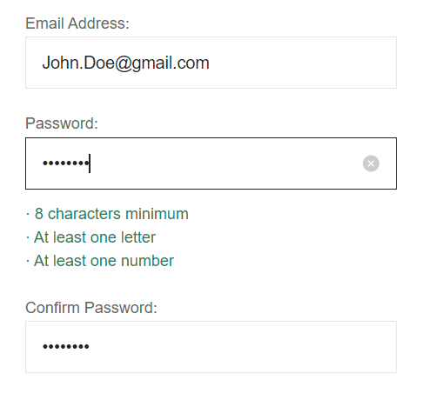
Pic: SS1
b. Test case 2: Enter invalid password
Input data: password = “123456ht”
Expected output: See the picture below SS2
Actual output: Matches the expected output.
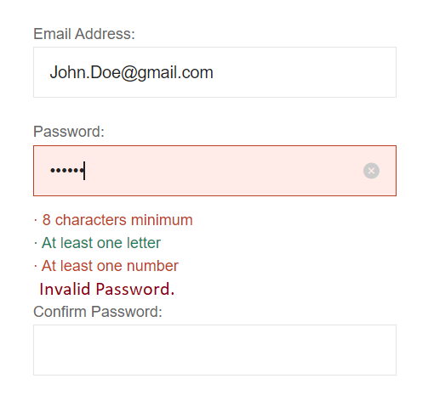
Pic: SS2

2. Branch Coverage
For the if statement, has 2 possibilities
a. If password is valid
b. If password is not valid

3. Basis Test
4 nodes and 3 edges.
V(G) = E-N+2 = 1
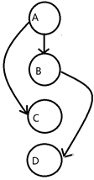
Test Path: A->C
Input: Password =”John123@”
Expected output: see the pictures below SS3
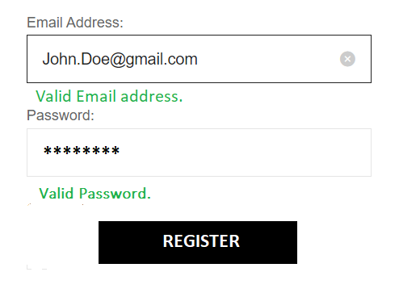
Pic: SS3
4.Final test case:
Test Case 1
Enter correct password
Input data: password= “John123@”
Expected output: See the picture below SS4
Actual output: Matches the expected output.

Pic: SS4

Test Case 2
Enter invalid password
Input data: password = “123456ht”
Expected output: See the picture below SS5
Actual output: Matches the expected output.

Pic: SS5


b. 1.2.1.1.2 Forgot password button
Date: November 30th 2022
Name: Fatoumata Ceesay
Objective: Write a test case to check if the user can generate a new password when they forget their password.

Coverage Measurement:
1. Compound Condition: 100%
2. Principal Path: 80%
3. Basis Test:80%

Individual Test Cases
1. Compound Condition
a. Test case 1: Forgot password button
Input data = “Forget Password” Button
Expected output: See the picture below SS6
Actual output: Matches the expected output.

Pic: SS6
b. Test case 2: Send email to email address
Input data: Click to “Continue” button on forgotten password
Expected output: See the picture below SS7
Actual output: Matches the expected output.
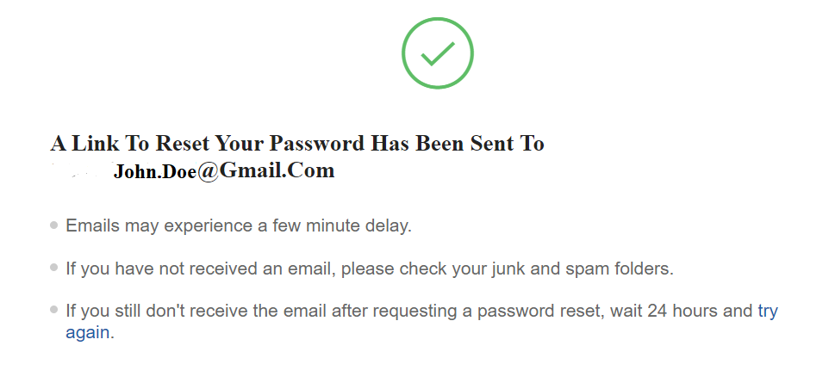
Pic: SS7

2. Branch Coverage
For the if statement, has 2 possibilities
a. If clicked on “Forget Password” button
b. If email is sent to email address

3. Basis Test
8 nodes and 8 edges.
V(G) = E-N+2
V(G) =8-8+2=2
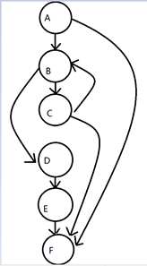
Test Path： A -> B -> D -> E -> F
Test Data: Click to “Forget Password” Button
Expected output: See below SS8
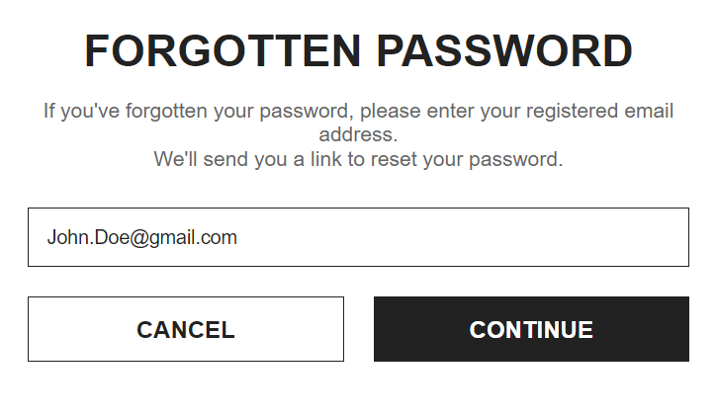
Pic: SS8

4.Final test case:
Test case 1: Forgot password button
Input data = “Forget Password” Button
Expected output: See the picture below SS6
Actual output: Matches the expected output.

Pic: SS6
Test case 2: Send email to email address
Input data: Click to “Continue” button on forgotten password
Expected output: See the picture below SS7
Actual output: Matches the expected output.

Pic: SS7

c. Integration Test Plan
FWBS number & name 1.2.1.1.1 Enter Password & 1.2.1.1.2 Forgot password button
Date : November 30th 2022
Name: Habiba Karim Rinky
Purpose To test the entering password interface of the user
Coverage Measurement (%)
a. Compound Conditions (90%)
b. Branch Coverage (80%)
c. Basis Test (100%)
Individual Test Cases

1. Compound Condition
a. Test case 1: Enter correct password
Input data: password= “John123@”
Expected output: See the picture below SS1
Actual output: Matches the expected output.

Pic: SS1
b. Test case 2: Send email to email address
Input data: Click to “Continue” button on forgotten password
Expected output: See the picture below SS7
Actual output: Matches the expected output.

3. Basis Test



10 nodes 11 edges
V(G) = E – N + 2 = 3
Test path: A->C
A -> B -> D -> E -> F
A -> B -> C -> F
4.Final test case:
a. Test case 1: Enter correct password
Input data: password= “John123@”
Expected output: See the picture below SS1
Actual output: Matches the expected output.

Pic: SS1
b. Test case 2: Send email to email address
Input data: Click to “Continue” button on forgotten password
Expected output: See the picture below SS7
Actual output: Matches the expected output.


