Hwk1 - Install/run R, RStudio, Rmarkdown

Spring 2021

Edgar Perez

June 1, 2021

#Part 1

## Read file

Read in the hwk 1 data csv file from working directory.

# Note that every chunk must have a different name  
# read file  
hwk1.dat <- read.csv('hwk1-115.csv')  
View(hwk1.dat)  
summary(hwk1.dat)

## X Y   
## Min. : 55.0 Min. : 6.00   
## 1st Qu.:121.0 1st Qu.: 52.00   
## Median :156.0 Median : 84.00   
## Mean :155.2 Mean : 92.59   
## 3rd Qu.:184.0 3rd Qu.:138.00   
## Max. :260.0 Max. :210.00

## Plot data

Be sure to replace with your actual name.

title=c("Edgar is a Coug!!")  
plot(hwk1.dat, asp=1, col="#981e32", pch=15, cex=.2, main=title, bty="n")

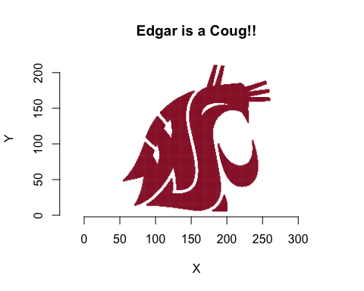

There are many graphics tools and options in R. You will learn more through the semester.

Always put your answers, discussions and interpretations outside of the chunks. Only put comments that directly related to the code inside chunks.

#Part 2

## Bullets

Bullet the statements below by starting each line with an asterisk. **Bold** “Coug”. Put your name in *italics*.

* *Edgar* is a **Coug**.
* But *Edgar* thinks this **Coug** stuff is a bit silly.

## Block quote

Put the following statements in a **block quote** by starting each line with “>”.

If at first you don’t succeed, try, try again.

Or you can email the instructor for help. :)

## Equations

You are all familiar with the equation for the area of a circle, $A=π*r^{2}$.

### Equation block

You can also set an equation in a block. Use two dollar signs on front and back to put Einstein’s mass-energy equivalent equation E=mc2 in an equation block.

$E=m*c^{2}$

**Note**: Always put an extra line after chunks and before style changes like bullets and block quotes.