## Microcontroller Nordic Semiconductor

### Connect and test the nRF52 DK

<https://www.nordicsemi.com/eng/Products/Getting-started-with-the-nRF52-Development-Kit/(language)/eng-GB>

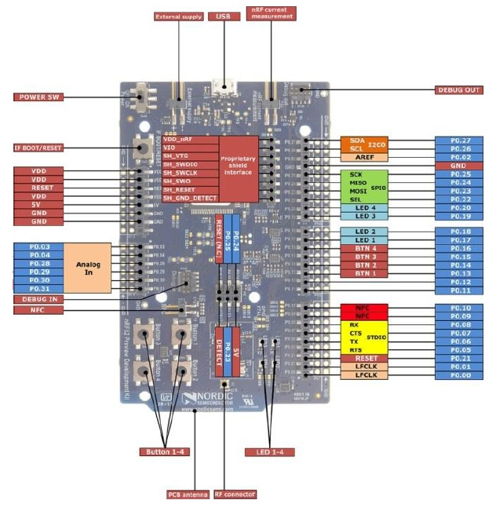

|  |  |  |
| --- | --- | --- |
| |  |  | | --- | --- | |  | Nordic Semiconductor Tech Support and Developer Community | |
| Hi edgarnyhus, Just to let you know:  A support engineer has been assigned to your ticket [nRF52-DK does not show as a removeable drive in Windows File Explorer.](https://devzone.nordicsemi.com/f/nordic-q-a/37895/nrf52-dk-does-not-show-as-a-removeable-drive-in-windows-file-explorer).  Best regards; The Nordic DevZone Team |

Hi edgarnyhus,

I would suggest that you turn on your nrf52DK ON then open "J-Link Commander" and write the command: **msdenable**

You should get "*Probe configured successfully*" response from the terminal.

Then power cycle the board. (Turn OFF, then ON)

The board should now appear as "JLINK".